GLOBAL ROBOTICS
MARKET INTELLIGENCE
Big Data Analytics & DBMS Project
GLOBAL ROBOTICS MARKET INTELLIGENCE
An end-to-end analytical workflow using Python, PostgreSQL, DBeaver, Databricks, Delta Lake and Power BI
Prepared by: Nikith Pagadala
Roll Number: 25024
Programme: PGDM | Batch: 2025–2027
Institution: Badruka School of Management, Hyderabad
Dataset integrity note: The supplied dataset contains synthetic/illustrative transaction and prospect records. Financial values and company details must not be represented as verified real-world robotics-market sales or actual NVIDIA customer/prospect data.

ABSTRACT / EXECUTIVE SUMMARY
This project demonstrates a structured approach to business data management and analytics using a robotics-market intelligence dataset supplied as a CSV file. The objective is to convert a multi-field dataset into a documented, quality-checked analytical asset and to show how database queries, Python-based exploratory analysis, distributed processing concepts and dashboard design can support business interpretation.
The file contains 50,000 records and 35 fields. The order-date field parses from 01 January 2024 to 26 September 2026; 0 rows have an unparsed or missing date value. The dataset contains 7 distinct country labels, 10 industry labels and 5 product-category labels. The file has 0 missing cells (0.000% of all cells) and 0 exact duplicate rows.
Summed values in the dataset's USD-labelled fields are revenue $2,037,809,509.07, estimated cost $1,573,618,885.20 and estimated gross profit $464,190,623.87. These are arithmetic summaries of synthetic records, not estimates of actual market size. The aggregate estimated margin is 22.78% where calculable.
The workflow is designed around data profiling, field documentation, SQL-based aggregation, Python charts and a proposed Databricks/Delta Lake transformation path. A Power BI dashboard can present headline KPIs, monthly trends and category/geography comparisons. The report distinguishes computed dataset facts from implementation steps that still require execution evidence in the relevant software.
Before submission, add genuine screenshots or exported evidence from PostgreSQL/DBeaver, Databricks/Delta Lake and Power BI, plus the final GitHub repository URL. Do not claim that a tool ran successfully unless you personally executed and verified it.

INTRODUCTION: CONTEXT AND RATIONALE

1.1 Background
Robotics markets involve several interconnected dimensions: product categories, application industries, geography, sales channels, company segments and commercial assumptions. A structured dataset can help analysts compare patterns across these dimensions, monitor changes over time and identify areas for further investigation.
In practice, analytics quality depends on more than charts. Data definitions, source reliability, currency consistency, missing values, duplicate identifiers and verification status all affect how results should be interpreted. This project therefore treats data governance and analytical caution as part of the technical workflow.

1.2 Project rationale
The project provides an applied learning exercise in moving from a flat file to a relational database, exploratory analysis, scalable data-processing concepts and a business-facing dashboard. Each tool has a distinct role: PostgreSQL stores structured data and supports SQL; DBeaver provides a graphical database client; Python supports repeatable profiling and visualisation; Databricks supports Spark-based processing; Delta Lake adds table reliability features; and Power BI supports interactive reporting.

1.3 Intended users
Potential users include market researchers, sales operations analysts, product managers and management students. The dataset can help demonstrate analytical questions, but its synthetic nature means it cannot independently substantiate real market-share, competitor, customer or revenue claims.

BUSINESS PROBLEM AND QUESTIONS

2.1 Problem statement
The central problem is how to organise a multi-dimensional robotics-market dataset and turn it into a repeatable analytical workflow while preserving the limitations of synthetic and unverified fields. Without consistent definitions and validation, users may misinterpret illustrative revenue values, mix currencies, or treat prospect notes as confirmed facts.

2.2 Business questions
- Which country and regional labels contribute the largest sums of synthetic recorded revenue?
- How do synthetic recorded revenue values differ by industry, product category and sales channel?
- What monthly patterns appear in the supplied order-date field?
- What data-quality issues—missing values, duplicate rows, date parsing and identifier duplication—need attention before reporting?
- How can a governed pipeline and dashboard make assumptions, definitions and limitations visible to users?

2.3 Value of the analysis
The value lies in demonstrating a transparent method, not in presenting the file as a source of verified market truth. The analysis can reveal how a decision-support workflow is designed and what additional validation would be needed before commercial use.

OBJECTIVES, SCOPE AND LIMITATIONS

3.1 Objectives
- Inspect the CSV structure and document the meaning and limitations of its fields.
- Measure missingness, exact duplicate rows, transaction-ID duplication and date-parsing quality.
- Calculate descriptive summaries for revenue, estimated cost, estimated gross profit and quantity.
- Compare records by country, region, industry, product category and sales channel.
- Define PostgreSQL tables and reusable SQL queries for common analytical questions.
- Create Python-based visualisations and a proposed Spark/Delta Lake transformation workflow.
- Specify Power BI KPI definitions, visuals and slicers suitable for management review.

3.2 Scope
The analysis is limited to the uploaded file, its recorded field definitions and the computations reproduced from it. It does not establish actual market size, real company identity, verified product compatibility, actual NVIDIA relationships, or forecast accuracy.

3.3 Limitations
The dataset includes explicit synthetic/illustrative status notes and placeholder website links. Some fields have similar names but different roles (for example, country_name and country_name_country). Financial fields are labelled in USD while currency_code varies by country; this creates a currency-consistency issue that must be resolved before cross-market financial comparison. Fit scores and prospect verification labels are not independent evidence of technical fit or real prospect status.

DATASET OVERVIEW

4.1 File and record structure
Source file used for this report: global_robotics_market_intelligence_master(1).csv. The complete CSV contains 50,000 rows and 35 columns. The file size is approximately 28.9 MB. The date field spans 01 January 2024 through 26 September 2026 after parsing valid values.

4.2 Data domains
The fields fall into several broad domains: transaction identifiers and dates; company and prospect descriptors; product/SKU attributes; commercial quantities, prices, costs and revenue; geography and currency; channel and lead-source descriptors; and data-quality/verification notes.

4.3 Synthetic-data warning
The dataset includes text such as “Synthetic transaction; not actual NVIDIA sales”, “Synthetic company record; not a real prospect”, placeholder websites and “Synthetic representative SKU”. These labels are material data-provenance information and must remain visible in the report, repository and dashboard.

4.4 Reproducibility
Store the original CSV separately from any cleaned derivative. Record the file name, date accessed, row and column counts, transformation rules and output file names. If the source is distributed with permission, include it in the repository; otherwise publish a sample and explain how to obtain the full file.

DATA DICTIONARY AND QUALITY PROFILE
The full field-level data dictionary is supplied as a companion CSV file. The following representative fields are especially important for interpretation:
Field | Interpretation | Caution
transaction_id | Synthetic transaction identifier | Check duplicates before treating as a primary key.
order_date | Order date in supplied text format | Parse with day-first handling; retain invalid-date count.
quantity | Recorded quantity | Check for nulls, zeroes and negative values.
revenue_usd | Revenue amount labelled USD | Synthetic; validate currency basis and arithmetic.
estimated_cost_usd | Estimated transaction cost | Not an audited cost measure.
estimated_gross_profit_usd | Estimated gross profit | Check whether revenue minus cost reconciles.
country_name / region | Geographic labels | Standardise spelling and confirm mapping.
product_category / industry | Classification dimensions | Check categories for inconsistent naming.
currency_code | Country/market currency label | Do not assume USD-labelled fields are converted correctly.
verification_status | Verification state | Unverified records must not be presented as confirmed prospects.
Overall, 0 cells are missing (0.000% of all cells). There are 0 exact duplicate rows and 0 duplicated transaction_id values.
The detailed data_quality_profile.csv and data_dictionary.csv companion files provide per-field counts and observed data types. Review the profile before finalising any cleaned data model.

METHODOLOGY AND END-TO-END WORKFLOW

5.1 Analytical design
The method follows a controlled sequence: preserve the raw file; profile the schema and data quality; define field semantics; load a relational copy into PostgreSQL; query with SQL through DBeaver; use Python for repeatable cleaning, aggregation and charts; process the same logical dataset in Databricks with Spark; store cleaned and aggregated layers in Delta format where the environment supports it; and present validated outputs in Power BI.

5.2 Workflow
Stage | Purpose | Output / evidence
Raw data | Preserve supplied file unchanged | Original CSV + file metadata
Profiling | Measure schema, missingness and duplicates | Data-quality profile + data dictionary
PostgreSQL | Structured storage and SQL aggregation | DDL, loaded table, row-count checks
DBeaver | Execute and save SQL queries | SQL scripts + query-result screenshots
Python | Cleaning, EDA and charting | Notebook/script + charts
Databricks / Spark | Distributed-processing workflow demonstration | Notebook export + execution output
Delta Lake | Versioned table storage where supported | Delta table path/details
Power BI | Interactive management-facing view | PBIX or screenshots, KPI definitions
GitHub | Versioned project documentation | Repository, README and organised files

5.3 Validation principle
The same definitions should be used across SQL, Python, Spark and Power BI. Before comparing outputs, confirm the same input file, row filters, date parsing, treatment of nulls and aggregation logic. Screenshots and logs should show actual execution rather than planned execution.

POSTGRESQL DESIGN AND IMPLEMENTATION

6.1 Role of PostgreSQL
PostgreSQL provides a structured, queryable copy of the dataset. It is suitable for schema definition, data-type control, filtering, grouping and repeatable SQL analysis. It also provides a checkpoint against which Python and Spark results can be compared.

6.2 Suggested database design
For a time-limited project, a single fact-style table is acceptable if the original dataset is retained and data types are set deliberately. A more normalised model can separate transaction facts from company, product, geography and date dimensions, but it should not be introduced unless the joins and key relationships can be validated.
Column group | Suggested type | Design note
transaction_id, company_id, product_id | VARCHAR | Preserve identifier formatting; test uniqueness.
order_date | DATE | Load parsed dates; retain a raw date column if needed.
quantity | INTEGER | Check range and null handling.
prices, revenue, cost, profit | NUMERIC(18,2) | Avoid floating-point for currency-like fields.
discount_pct, fit score | NUMERIC(8,4) | Document whether stored as decimal or percentage.
country, region, industry, category, channel | TEXT | Standardise category labels after preserving raw values.
status and research notes | TEXT | Retain provenance and verification notes.

6.3 Loading and validation
Create a project database and a staging table. Import the CSV using a method supported by the local PostgreSQL setup, then compare PostgreSQL row count with the source row count. Validate date parsing, numeric conversions, duplicate transaction IDs and a small set of known records. Avoid declaring transaction_id a primary key until uniqueness is proven.
Add screenshots of the actual database, successful import, row-count query and query results before submission. This report does not claim that PostgreSQL execution has already been verified.

POSTGRESQL SQL ANALYSIS AND DBeaver

7.1 Query patterns
The following query patterns are appropriate for the dataset once its table and column names are confirmed. Use a schema-qualified table name consistently in the final scripts.
SELECT COUNT(*) AS record_count FROM public.robotics_market;
SELECT country_name, SUM(revenue_usd) AS synthetic_revenue
FROM public.robotics_market
GROUP BY country_name
ORDER BY synthetic_revenue DESC;
SELECT product_category, COUNT(*) AS records,
SUM(revenue_usd) AS synthetic_revenue,
SUM(estimated_gross_profit_usd) AS estimated_profit
FROM public.robotics_market
GROUP BY product_category
ORDER BY synthetic_revenue DESC;
SELECT DATE_TRUNC('month', order_date) AS month,
SUM(revenue_usd) AS synthetic_revenue
FROM public.robotics_market
WHERE order_date IS NOT NULL
GROUP BY 1 ORDER BY 1;

7.2 DBeaver role
DBeaver is the graphical client used to connect to PostgreSQL, inspect tables, run SQL, review result grids and save scripts. It is not a separate database engine. Use saved .sql files so the analysis can be reproduced outside the graphical interface.

7.3 Interpretation and safeguards
All output labels should call the revenue “synthetic recorded revenue” or “revenue field total” rather than “market sales”. For a currency-sensitive dashboard, either analyse one currency at a time or create a documented conversion process with a dated exchange-rate source. Do not silently sum mixed-currency amounts.

SQL VALIDATION, KEYS AND RECONCILIATION

8.1 Validation checks
- Compare source CSV and database row counts.
- Count null or unparsable order dates and confirm the chosen handling rule.
- Check duplicated transaction IDs and exact duplicate rows separately.
- Compare SUM(revenue_usd), SUM(estimated_cost_usd) and SUM(estimated_gross_profit_usd) across SQL and Python.
- Check whether row-level estimated gross profit reconciles to revenue less estimated cost, allowing for rounding and documented exceptions.
- Review whether country labels, region labels and currency codes are consistent.

8.2 Primary and foreign keys
A primary key should only be applied after uniqueness and non-nullness are confirmed. company_id and product_id may be repeated naturally across transactions, so they should not be treated as unique transaction keys. If dimensions are separated, verify that each dimension key maps to one consistent record.

8.3 Reconciliation outcomes
The final submission should include a compact reconciliation table with counts and sums from the CSV/Python, PostgreSQL and Spark outputs. Record any difference and its cause. Since the report generation did not execute your external database or Databricks workspace, actual reconciliation evidence must be filled in after execution.

PYTHON ANALYTICS: PROFILING AND CLEANING

9.1 Why Python
Python enables repeatable profiling, data-type conversion, missingness analysis, descriptive statistics and chart generation. A notebook also preserves the code, outputs and commentary needed for review.

9.2 Profiling steps
- Read the CSV with pandas and record the row count, column count and column names.
- Inspect dtypes and sample records before changing values.
- Count missing values by field and calculate the proportion of missing cells.
- Check exact duplicate rows and transaction_id duplicates.
- Parse order_date using day-first parsing and record unparsed values.
- Convert financial and quantity columns to numeric values with coercion diagnostics.

9.3 Cleaning policy
Keep a raw copy. Create a separate cleaned dataframe. Standardise whitespace in categorical strings, normalise missing markers only when justified, parse dates explicitly and convert numeric fields safely. Do not delete duplicates automatically: inspect whether they are accidental copies or legitimate repeated transactions. Preserve provenance/status fields because they signal the synthetic nature of the data.

PYTHON ANALYTICS: DESCRIPTIVE RESULTS

10.1 Overall metrics
Metric | Computed value
Records | 50,000
Fields | 35
Missing cells | 0 (0.000%)
Exact duplicate rows | 0
Duplicate transaction IDs | 0
Valid order-date range | 01 January 2024 to 26 September 2026
Unparsed/missing order dates | 0
Sum of revenue_usd field | $2,037,809,509.07
Sum of estimated_cost_usd field | $1,573,618,885.20
Sum of estimated_gross_profit_usd field | $464,190,623.87
Aggregate estimated gross margin | 22.78%
These metrics are computed from the uploaded CSV. Because the records are synthetic, they describe the file rather than the real robotics industry. The aggregate margin is calculated as total estimated gross profit divided by total revenue, not as the unweighted average of row-level margins.

10.2 Checks that need interpretation
The presence of a numeric value does not guarantee validity. Investigate negative amounts, zero revenue, unusually large quantity, discount rates outside expected bounds, and estimated profit values that do not reconcile. Use business rules only when supported by field documentation; otherwise flag potential anomalies rather than automatically correcting them.

PYTHON ANALYTICS: GEOGRAPHIC AND INDUSTRY PATTERNS

11.1 Geography
Country and region aggregations can show where the synthetic records are concentrated. They should be used to demonstrate grouping and comparison rather than to infer real demand or market share.
Country | Revenue field total
India | $567,976,040.69
China | $306,587,972.17
Taiwan | $258,992,808.32
South Korea | $247,068,853.24
Australia | $244,039,924.31
Japan | $236,948,978.16
Singapore | $176,194,932.18

11.2 Industry
Industry-level aggregation compares the recorded values associated with each industry label. Because the company and industry fields include synthetic descriptors, the results should be interpreted as patterns within the generated dataset.
Industry | Revenue field total
Robotics OEM | $390,950,850.35
Industrial Automation | $311,829,207.53
Warehouse Automation | $238,549,575.95
Machine Vision | $236,532,862.41
Research Institution | $201,528,062.73
Agricultural Technology | $180,803,254.12
Embedded Systems | $168,507,041.69
Mining Automation | $105,212,243.15

11.3 Management implication
If one geography or industry dominates the file, the first question should be whether that concentration reflects the dataset-generation design, sample construction or actual observations. In a real commercial setting, analysts would require validated orders, common currency conversion, clear inclusion rules and independently sourced market context before recommending resource allocation.

PYTHON ANALYTICS: PRODUCT, CHANNEL AND TIME

12.1 Product category
Product-category totals provide a view of how synthetic revenue is distributed among the supplied categories. The category label is useful for segmentation, but the representative product descriptions are explicitly illustrative.
Product category | Revenue field total
AI Infrastructure | $1,423,562,712.38
GPU Workstations | $363,795,740.33
Industrial Edge | $115,514,693.28
Robotics Development | $91,631,694.15
Edge AI Computing | $43,304,668.93

12.2 Sales channel
Sales channel | Revenue field total
OEM/Integrator | $661,567,767.11
Distributor | $603,772,584.00
Direct | $558,386,190.38
Online | $214,082,967.58

12.3 Time series
Monthly aggregation can reveal fluctuations in the file over the parsed date range. Before interpreting peaks or dips, confirm that each month is fully represented and that dates were parsed consistently. A trend in synthetic records is not a forecast and should not be treated as evidence of seasonality in the real market.

12.4 Suggested charts
- Bar chart: top countries by sum of revenue_usd.
- Bar chart: industry or product-category totals.
- Line chart: monthly sum of revenue_usd.
- Bar chart: revenue by sales channel.
- Histogram: row-level estimated gross margin, with outlier checks.

PYTHON ANALYTICS: VISUALISATIONS
The following figures were generated directly from the uploaded CSV for this report. Axis labels intentionally refer to the field totals rather than verified market sales.
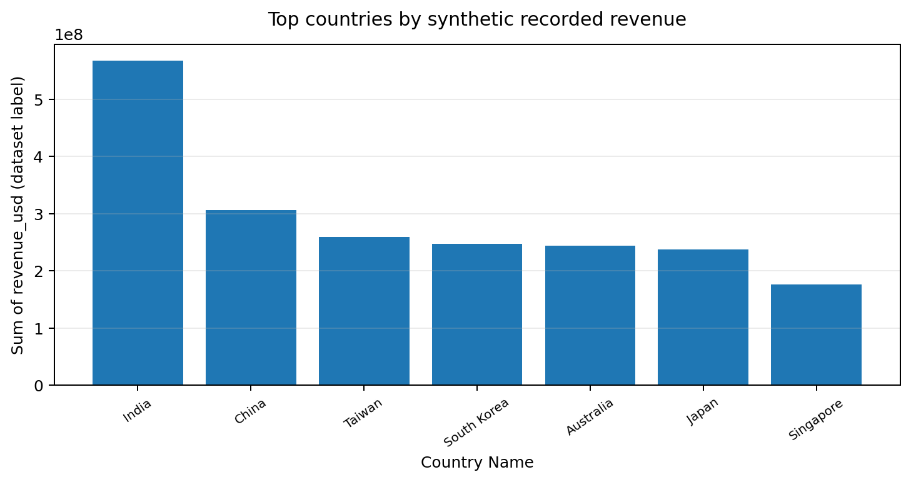
Figure 1. Top countries by synthetic recorded revenue
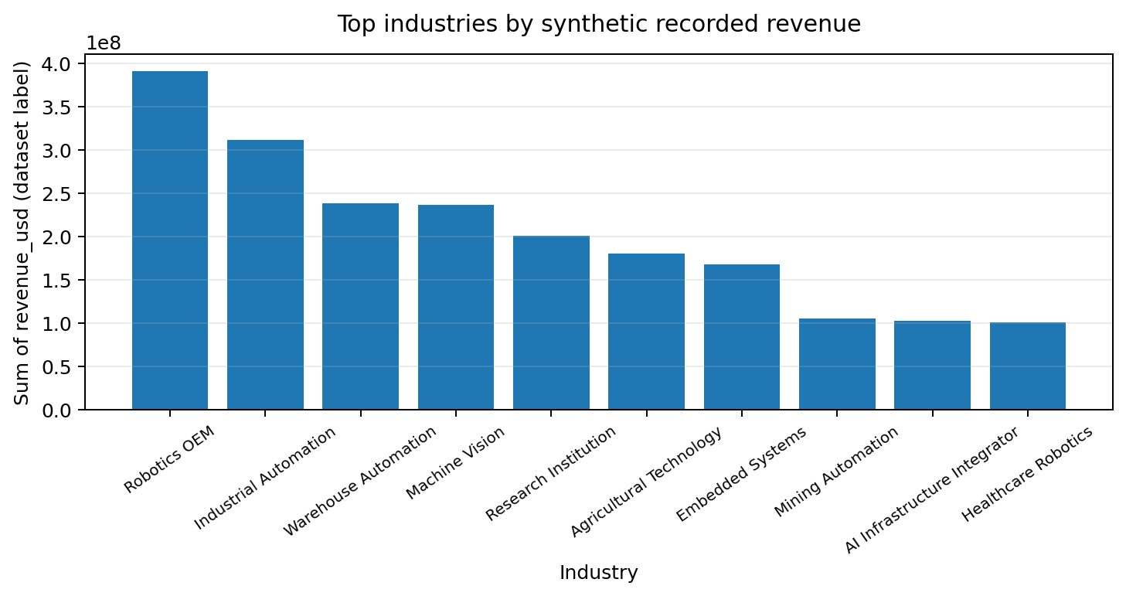
Figure 2. Top industries by synthetic recorded revenue
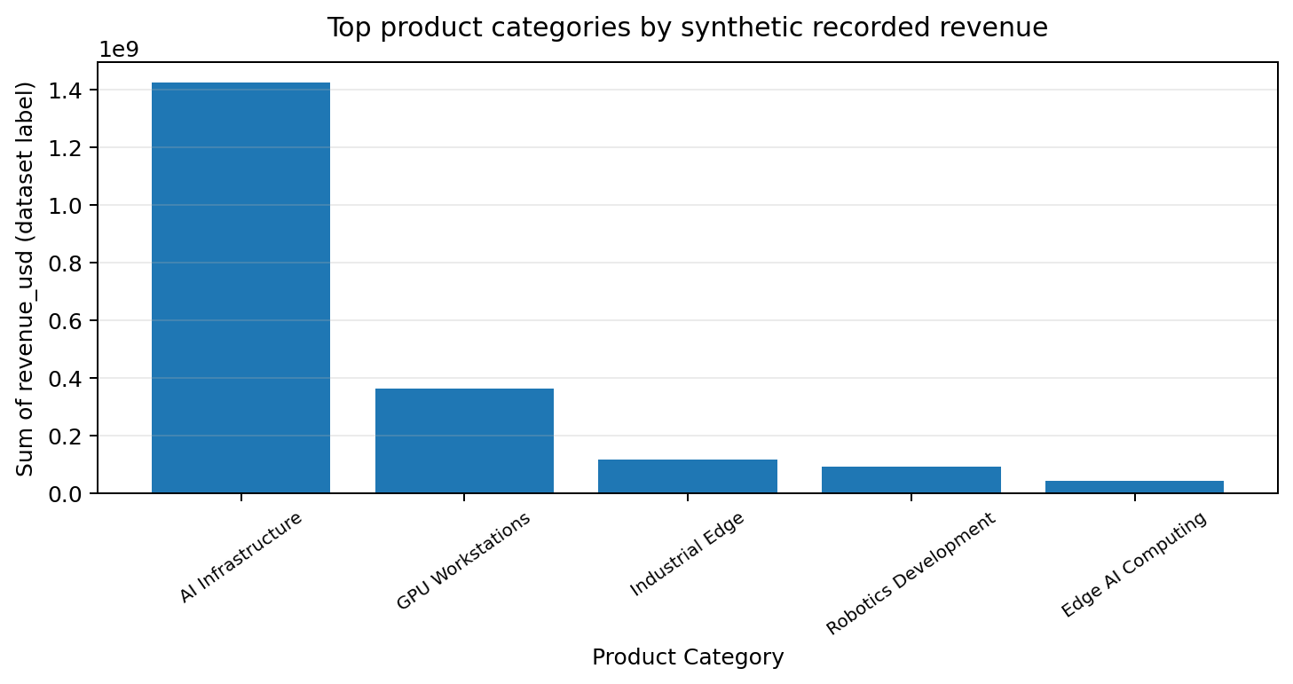
Figure 3. Top product categories by synthetic recorded revenue
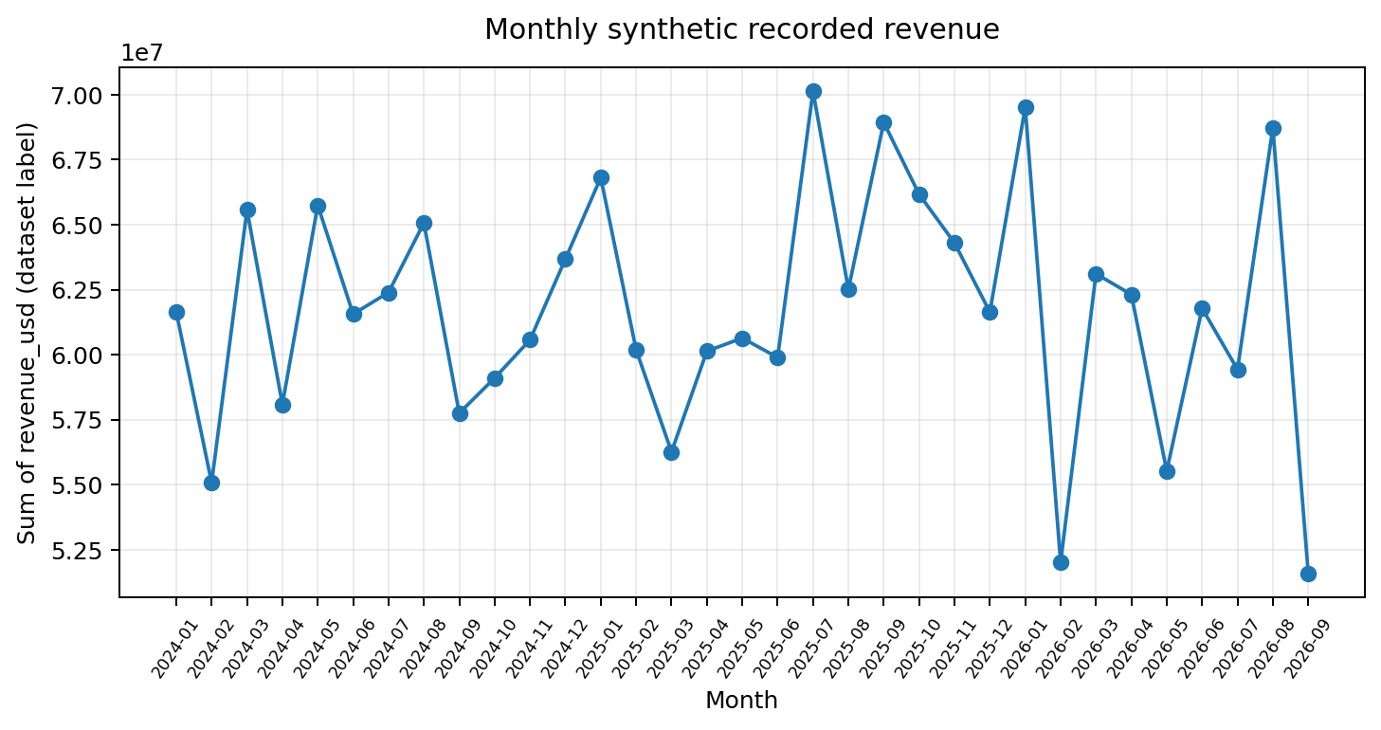
Figure 4. Monthly synthetic recorded revenue
Interpret each chart in terms of ranking, concentration and variation. Do not infer causation from the visual alone. If the same chart is rebuilt in Power BI, verify that filters and measures use the same row inclusion and currency assumptions.

PYTHON ANALYTICS: MARGIN AND QUALITY INSIGHTS

13.1 Estimated gross margin
At aggregate level, the estimated gross margin is computed as total estimated gross profit divided by total revenue. Row-level margin is estimated gross profit divided by revenue for records with non-zero revenue. Row-level percentages can be unstable when revenue is very small, negative or inconsistent.
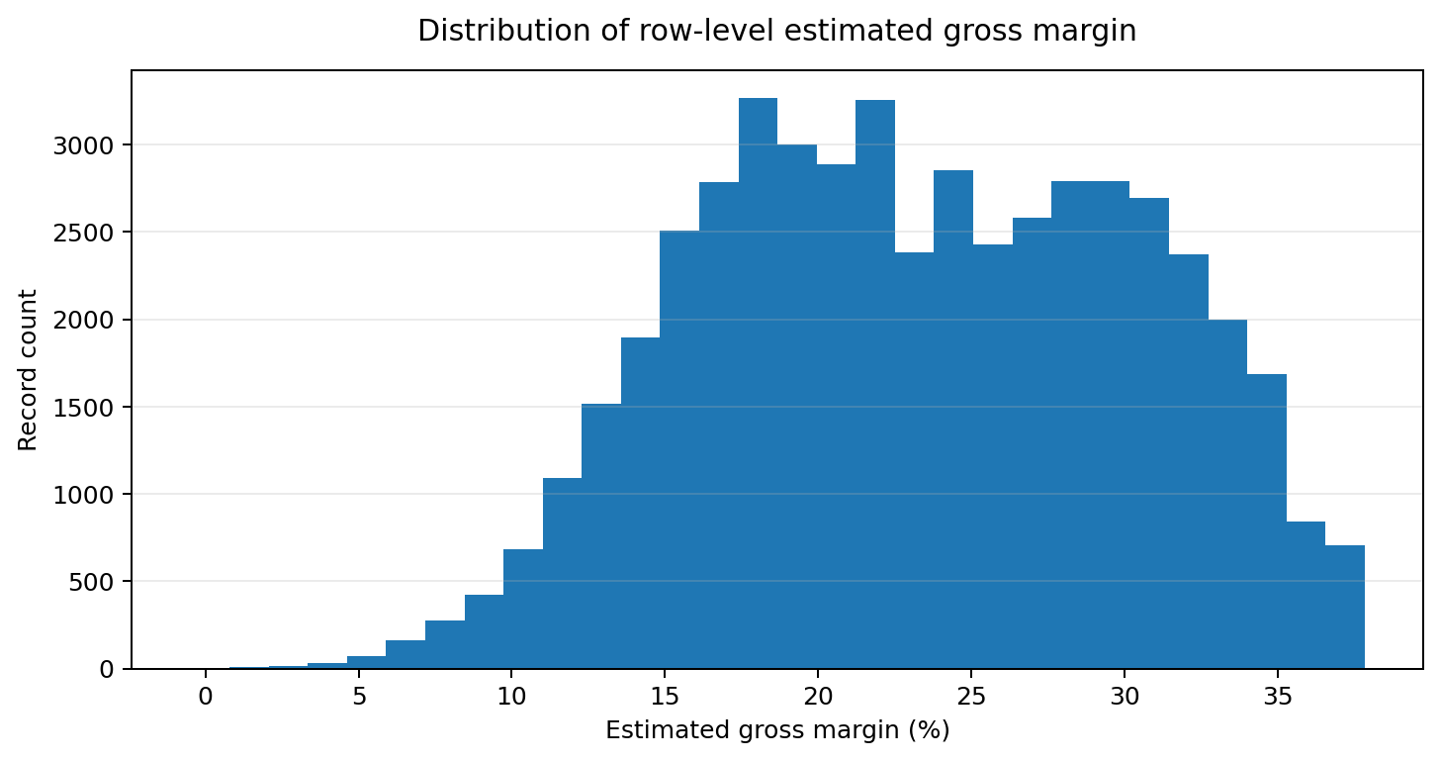
Figure 5. Distribution of row-level estimated gross margin

13.2 Reconciliation
A useful integrity check compares revenue_usd minus estimated_cost_usd with estimated_gross_profit_usd for each row. Differences may arise from rounding, generation logic or data-quality issues. Report the number of exact matches, small rounding differences and larger discrepancies after performing the check in the notebook.

13.3 Avoiding misleading conclusions
Do not describe a high synthetic margin as a viable product margin. Validate product costs, discounts, tax, shipping, currency conversion and recognition rules before using commercial profitability measures. The dataset itself indicates that many company and product details are synthetic or require verification.

DATABRICKS AND APACHE SPARK

14.1 Purpose
Databricks provides a managed environment for Spark-based data engineering and analytics. Apache Spark can process distributed datasets and support transformations such as filtering, type conversion, grouping and aggregation. In this project, Databricks is an implementation stage to demonstrate a repeatable pipeline, not proof that distributed processing was necessary for the current file size.

14.2 Proposed sequence
- Upload the CSV to a workspace-accessible location or Unity Catalog volume.
- Read the raw file with Spark and inspect schema and row count.
- Create a Bronze layer preserving source fields and ingestion metadata.
- Create a Silver layer with explicit date/numeric conversions, standardised labels and quality flags.
- Create a Gold aggregation by month, country, industry, category and channel.
- Compare Gold totals against the Python/PostgreSQL summaries.

14.3 Execution evidence
Include notebook output cells showing schema, row counts, transformation steps and aggregation results. Workspace-specific paths and permissions must be set in your own environment. Do not include the personal invitation or sign-up URL in a public repository.

DELTA LAKE: BRONZE, SILVER AND GOLD

15.1 Delta Lake role
Delta Lake is a table-storage layer for data lakes that supports transactional writes and table history in compatible environments. Its usefulness in this project is the ability to separate raw, cleaned and analytics-ready outputs while preserving a more controlled transformation history.

15.2 Layer design
Layer | Content | Quality rule
Bronze | Raw imported records plus ingestion metadata | Preserve original values; no silent business corrections.
Silver | Typed and standardised records | Document nulls, invalid dates, duplicate flags and category normalisation.
Gold | Aggregated KPI tables | Use explicit groupings and stable metric definitions.

15.3 Example transformation logic
from pyspark.sql import functions as F
raw = spark.read.option('header', True).option('inferSchema', True).csv(input_path)
bronze_path = '/Volumes/<catalog>/<schema>/<volume>/bronze/robotics_market'
raw.write.format('delta').mode('overwrite').save(bronze_path)
bronze = spark.read.format('delta').load(bronze_path)
Replace placeholders with a workspace path permitted by your Databricks configuration. Validate schema inference and explicitly cast dates and financial fields before production-style use. A code template is not evidence that a Delta table has been created; include execution output only after running it.

DATABRICKS TRANSFORMATIONS AND VALIDATION

16.1 Silver transformations
In the Silver layer, trim categorical strings, cast order_date using the correct format, cast financial fields to decimal types and add quality flags for missing identifiers, invalid dates and negative or zero financial values. Preserve the raw fields or maintain a Bronze layer so that cleaning decisions can be traced.

16.2 Gold aggregates
gold_country = (silver.groupBy('country_name')
.agg(F.sum('revenue_usd').alias('synthetic_revenue_total'),
F.sum('estimated_gross_profit_usd').alias('estimated_profit_total')))
gold_month = (silver.withColumn('month', F.date_trunc('month', F.col('order_date')))
.groupBy('month')
.agg(F.sum('revenue_usd').alias('synthetic_revenue_total')))

16.3 Validation
Check that the total number of Bronze records matches the imported source, while Silver record counts are explained by any documented filtering. For Gold totals, reconcile the sum of grouped values to the equivalent base-table sum. Record the actual results, execution date and any exceptions in the final report.

POWER BI DASHBOARD DESIGN

17.1 Dashboard purpose
The dashboard should provide a compact view of the dataset and let a reviewer move from headline measures to geographic, industry, product and time-based detail. It should clearly identify that values are synthetic and that the financial fields require currency-basis validation.

17.2 Recommended KPI cards
- Record Count = count of included transaction rows.
- Synthetic Revenue Total = sum of revenue_usd for the current filter context.
- Estimated Gross Profit Total = sum of estimated_gross_profit_usd.
- Estimated Gross Margin % = estimated gross profit total divided by revenue total, with a safe zero-denominator rule.

17.3 Recommended visuals
- Monthly line chart for synthetic recorded revenue.
- Bar chart for top countries by synthetic recorded revenue.
- Bar chart for industry or product-category totals.
- Sales-channel comparison.
- Table of data-quality or verification-status counts.

17.4 Filters and labels
Suggested slicers include order date, country/region, industry, product category, sales channel and verification status. Add a visible note such as: “Synthetic/illustrative dataset; values are not verified market sales.” Avoid map-based or market-share claims unless country fields and denominators are validated.

POWER BI MEASURES AND INTERPRETATION

17.5 Example DAX measures
Record Count = COUNTROWS('RoboticsMarket')
Synthetic Revenue Total = SUM('RoboticsMarket'[revenue_usd])
Estimated Gross Profit Total = SUM('RoboticsMarket'[estimated_gross_profit_usd])
Estimated Gross Margin % = DIVIDE([Estimated Gross Profit Total], [Synthetic Revenue Total])
Use the actual imported table name and confirm data types in Power BI. Format the margin measure as a percentage. If currency is inconsistent, do not format the mixed sum as if it were a single comparable monetary amount.

17.6 Visual design and alignment
Use a clear hierarchy: title and data caveat at the top; KPI cards in one row; trend chart across the width; category and geography comparisons below; and a small quality/verification panel. Align card edges, use consistent font sizes, keep chart titles concise and ensure all axes and tooltips are labelled. Avoid clutter, unnecessary 3D charts and unexplained abbreviations.
The report contains chart prototypes from Python. Add screenshots of your actual Power BI canvas or publish/export evidence after building the native dashboard. A Python chart or HTML mock-up is not a Power BI .pbix file.

INTEGRATION AND CROSS-TOOL VALIDATION

18.1 Shared definitions
The pipeline is reliable only when PostgreSQL, Python, Spark and Power BI use the same definition of included records, date parsing, null handling and financial measures. Maintain a small metric specification with each KPI's formula, source columns, exclusions and currency assumptions.

18.2 Validation matrix
Check | Python | PostgreSQL | Spark/Delta | Status to record
Input record count | Source CSV row count | COUNT(*) | Bronze count | Fill after execution
Revenue total | sum(revenue_usd) | SUM(revenue_usd) | Gold/base reconciliation | Fill after execution
Profit total | sum(estimated_gross_profit_usd) | SUM(...) | Gold/base reconciliation | Fill after execution
Date coverage | min/max parsed dates | MIN/MAX(order_date) | MIN/MAX(order_date) | Fill after execution
Duplicate IDs | duplicated transaction_id | GROUP BY/HAVING | groupBy/count | Fill after execution

18.3 Common causes of mismatch
Typical causes include parsing dates with different locale assumptions, treating blank strings differently from nulls, casting decimals as floating-point values, filtering invalid rows in only one tool, mixing currency fields and using inconsistent table snapshots. Explain any unresolved differences rather than forcing the numbers to match.

RESULTS AND DISCUSSION

19.1 What the data supports
The file supports descriptive statements about its own structure: 50,000 rows, 35 fields, 0 missing cells and 0 exact duplicate rows. It supports aggregation of the labelled financial fields and comparison across the supplied dimensions. It does not support verified market-size claims because the records are marked synthetic/illustrative.

19.2 How to discuss rankings
Rankings should be presented as “top categories in the supplied dataset” and accompanied by counts as well as totals. A category with a high total may have more records rather than a higher average transaction value. Report record count, total, mean or median, and where relevant margin together to avoid an incomplete interpretation.

19.3 How to discuss trends
Monthly totals should be examined alongside the number of records per month and the completeness of date coverage. A month with fewer records may show a lower total for reasons unrelated to demand. No forecast or causal claim should be made without a suitable time-series design, validation and additional real-world data.

BUSINESS RECOMMENDATIONS

20.1 Data governance
Maintain a source register, versioned raw file, data dictionary and a documented cleaning log. Preserve synthetic and verification flags in downstream tables and dashboards. Require independent verification before a prospect, product capability or commercial figure is used in a real decision.

20.2 Currency and financial controls
Resolve the mismatch between USD-labelled monetary fields and the currency_code dimension. Determine whether financial amounts are already converted to USD or whether the labels are simply part of the synthetic dataset. Until confirmed, avoid cross-currency monetary conclusions. Add currency basis and conversion date to any future real-world dataset.

20.3 Commercial analysis
For a real market-intelligence deployment, combine verified transaction data with approved product catalogues, customer relationship management records, exchange rates, regional market data and clear definitions of gross profit. Distinguish leads from customers and potential technical fit from validated compatibility.

20.4 Dashboard operations
Assign an owner for data refresh, KPI definitions and access control. Add visible freshness dates, a synthetic-data disclaimer where applicable and a process for reporting data-quality issues. Avoid sharing sensitive prospect details or credentials in GitHub.

RISKS, ETHICS AND DATA LIMITATIONS

21.1 Provenance and truthfulness
The dataset contains explicit statements that transactions are synthetic, companies are not real prospects, and website links are placeholders. Therefore, no record should be presented as an actual sale, real customer, verified technology relationship or confirmed market signal.

21.2 Analytical risks
- Currency mismatch may make monetary comparisons invalid.
- Duplicate identifiers may distort transaction counts or uniqueness assumptions.
- Unparsed dates may distort monthly trends.
- Synthetic fit scores can be mistaken for technical validation.
- Placeholder URLs may be mistaken for real company websites.
- Generated category distributions may be mistaken for market demand.

21.3 Ethical reporting
Label all results as synthetic/illustrative, distinguish measured facts from assumptions, and avoid unsupported claims. Do not publish workspace invitation links, passwords, tokens or private data. If the dataset is shared publicly, check the course instructions and any applicable usage permissions first.

CONCLUSION AND FUTURE IMPROVEMENTS

22.1 Conclusion
This project establishes a transparent blueprint for moving a structured robotics-market intelligence file through profiling, SQL storage, Python analytics, Spark/Delta Lake transformation and dashboard reporting. It demonstrates how data definitions, validation checks and clear communication are as important as technical tooling.
The supplied file contains 50,000 rows and 35 fields, with 0.000% of cells missing. Its labelled revenue, cost and profit totals are useful for demonstrating aggregation, but the file's synthetic status prevents interpreting them as verified market results. The most important implementation control is to reconcile the same metrics across tools and document any mismatch.

22.2 Future improvements
- Replace illustrative records with an approved, verified dataset if real market conclusions are required.
- Confirm monetary field currency basis and apply documented exchange-rate conversion where appropriate.
- Create automated data-quality tests for keys, dates, amounts and categorical values.
- Implement incremental ingestion and a governed Delta table if the data volume and use case justify it.
- Add forecast or segmentation methods only after defining a defensible target, sufficient observations and validation strategy.
- Capture genuine execution evidence and complete the native Power BI dashboard before submission.

TEAM CONTRIBUTION AND LEARNING

23.1 Individual contribution
Prepared by: Nikith Pagadala (Roll Number 25024).
Suggested contribution statement—edit to reflect the work actually completed: “I contributed to dataset inspection, field documentation, analytical planning, Python-based profiling and visualisation, SQL query design, dashboard planning, and report preparation. I reviewed the limitations of synthetic data and focused on presenting results transparently.”
Do not submit the suggested statement unchanged unless it accurately reflects your own work. Add teammates and their individual contributions if this is a group project.

23.2 Learning outcomes
- Learned to document data provenance and distinguish synthetic data from verified evidence.
- Practised data-quality profiling, date parsing, missingness and duplicate checks.
- Connected SQL aggregation with Python-based descriptive analysis.
- Designed a Bronze/Silver/Gold processing pattern and reconciliation checks.
- Translated analysis requirements into dashboard KPIs, visuals and slicers.
- Recognised that business interpretation must respect currency, provenance and validation constraints.

REFERENCES AND TECHNICAL DOCUMENTATION
The following official documentation sources are suitable references for the software methods described. Add access dates if required by your faculty's citation style.
- PostgreSQL Documentation — https://www.postgresql.org/docs/
- DBeaver Documentation — https://dbeaver.com/docs/
- pandas Documentation — https://pandas.pydata.org/docs/
- Matplotlib Documentation — https://matplotlib.org/stable/
- Apache Spark Documentation — https://spark.apache.org/docs/latest/
- Databricks Documentation — https://docs.databricks.com/
- Delta Lake Documentation — https://docs.delta.io/
- Microsoft Power BI Documentation — https://learn.microsoft.com/power-bi/
Dataset reference: global_robotics_market_intelligence_master(1).csv, supplied for this project. The file itself labels its transactions and company/prospect records as synthetic or illustrative; no independent external market-data source is established by this file.
Replace or supplement these references with the exact pages and sources you actually consulted. Follow BSM's required citation style if specified.

APPENDIX A: SELECTED DATA DICTIONARY
This compact appendix lists selected fields and their intended use. The companion data_dictionary.csv contains all fields.
Field | Description
transaction_id | Synthetic transaction identifier; intended to distinguish transaction-level records.
order_date | Order date supplied in day-month-year text format; parsed for time-series analysis.
company_id | Synthetic company/prospect identifier.
product_id | Product/SKU identifier.
country_code | Country or market code associated with the record.
industry | Industry classification associated with the transaction or prospect.
quantity | Quantity recorded for the transaction.
unit_price_usd | Unit price field labelled in USD; confirm currency consistency before financial interpretation.
discount_pct | Discount rate represented as a decimal in the supplied sample (for example, 0.0514 = 5.14%).
revenue_usd | Revenue amount labelled in USD; synthetic/illustrative rather than verified market sales.
estimated_cost_usd | Estimated cost amount labelled in USD; synthetic/illustrative.
estimated_gross_profit_usd | Estimated gross profit amount labelled in USD; synthetic/illustrative.
sales_channel | Sales-channel category.
lead_source | Source through which the lead was identified.
data_status | Dataset-level note describing synthetic or illustrative status.
Before using these fields for a real commercial analysis, confirm definitions with the dataset owner and resolve ambiguous or similarly named fields. Preserve the original values to support auditability.

APPENDIX B: SUBMISSION EVIDENCE CHECKLIST
- □ Confirm title page, student details, faculty name and submission date.
- □ Include the original dataset or permitted sample and the complete data dictionary.
- □ Include the PostgreSQL table definition and saved SQL analysis queries.
- □ Capture genuine DBeaver screenshots showing connection, table and query results.
- □ Include the Python notebook (.ipynb), executed outputs and at least three charts.
- □ Include the Databricks notebook/export with actual run outputs and Delta Lake evidence if implemented.
- □ Build the native Power BI dashboard with at least three KPIs, four visuals and useful slicers; include PBIX or screenshots.
- □ Add the GitHub repository URL and ensure README, folders and files are complete.
- □ Reconcile row counts and core totals across CSV, PostgreSQL and Spark.
- □ Check grammar, figure/table numbering, page numbers, alignment and PDF readability.
- □ Remove credentials, invitation URLs, tokens and confidential material.
Final status note: This report is a polished report draft generated from the supplied CSV and computed profiling outputs. It does not substitute for actual execution screenshots, a native .pbix file, a public repository URL or any faculty-specific approvals.

