Project Planning and UX Artefacts

Supermarket Store Web Platform (Laravel MVC)
Authors:
Nikita Smiichyk
Hanna Bokariuk

Module: Server-Side Development
Framework: Laravel (MVC Architecture)

1. Project Concept and Problem Statement

The Supermarket Store Web Platform is a dynamic, data-driven web application designed to support both online shopping and internal supermarket management. The system is developed using the Laravel framework following the Model-View-Controller (MVC) architecture.

Many small and medium-sized supermarkets still rely on manual processes or disconnected tools to manage product data, inventory, and customer orders. This often results in outdated product information, inefficient workflows, and poor visibility of available stock.

The purpose of this project is to develop a structured web platform where customers can browse products and place orders, while administrators can manage product information, categories, and inventory in a secure and organized system.

The platform demonstrates practical server-side development skills including CRUD operations, database management, authentication, validation, and MVC architecture.

2. User Personas

Persona 1: Store Manager
photo

Name: Alex O'Brien
Age: 35
Role: Supermarket Manager
Goals:
- Manage the supermarket product catalog efficiently.
- Add new products when new stock arrives.
- Update product prices and inventory levels.
- Remove products that are no longer available.
Needs:
- A clear dashboard to manage products and categories.
- Easy forms for adding and editing product information.
- Quick access to stock information.
Behaviours:
- Logs into the system daily to monitor products.
- Updates stock levels and product details regularly.
- Reviews product availability to ensure accurate inventory data.
Frustrations:
- Manual inventory management is time-consuming.
- Outdated product information can confuse customers.
- Lack of a centralized system for product management.


Persona 2: Customer

Name: Emma O'Sullivan
Age: 28
Role: Supermarket Customer
Goals:
- Browse available supermarket products online.
- Check prices and product availability before visiting the store.
- Quickly find products using search or categories.
Needs:
- Clear product listings with images and prices.
- Simple navigation through product categories.
- A fast and reliable checkout process.
Behaviours:
- Visits the website occasionally before shopping.
- Searches for specific products using filters or keywords.
- Adds items to the cart and places orders online.
Frustrations:
- Difficulty finding products in large supermarkets.
- Lack of clear price information.
- Limited ability to check product availability in advance.

3. User Flows / Task Journeys

Store Manager Flow
I’ll add diagram later
Login → Access dashboard → View product list → Add new product → Submit form → Product saved → Edit or delete products if necessary.

Steps:
1. The store manager logs into the system using their account credentials.
2. After authentication, the manager accesses the admin dashboard.
3. The manager views the list of existing products.
4. The manager can create a new product by filling in a product form.
5. The product is saved to the database after validation.
6. The manager can later edit product details or remove products when they are no longer available.
Customer Flow
Visit website → Browse products → Select product → View product details → Decide whether to add the product to the cart → Add to cart → Decide whether to continue shopping or proceed to checkout → Confirm order.
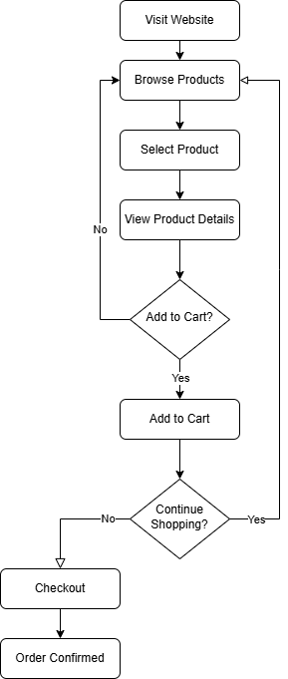
Steps:
1. The customer visits the website homepage.
2. The customer browses the product catalog.
3. The customer selects a product.
4. The customer views detailed information about the product.
5. The customer decides whether to add the product to the cart.
6. If the customer chooses to add the product, the item is added to the cart.
7. The customer then decides whether to continue shopping or proceed to checkout.
8. If the customer continues shopping, they return to browsing products.
9. If the customer proceeds to checkout, the system processes the order.
10. The system confirms the order.

