
Continuous Assessment Cover Sheet
Student Names:  Hanna Bokariuk  Maryna Hordiienko  Nikita Smiichyk | Student Numbers:  D00283065  D00283071  D00283070
Programme: Software Development | Stage: 3 | Complete Student Checklist:  Re-read brief o  References and Bibliography o  Proofread o
Module: Internet of Things
Due Date: 08/11/26 | No. Pages: -
Lecturer’s Names:
Enda Finn, Frank Keenan, Bride Mallon, John Loane
Assignment No. and/or Description/Topic: G-CA2 |  | Mode of Submission:  Softcopy o Hardcopy o
DECLARATION: I declare that:
- This work is entirely my own, and no part of it has been copied from any other person’s words or ideas, except as specifically acknowledged through the use of inverted commas and in-text references;
- No part of this assignment has been written for me by any other person except where such collaboration has been authorised by the lecturer concerned;
- I understand that I am bound by DkIT Academic Integrity Policy. I understand that I may be penalised if I have violated the policy in any way;
- This assignment has not been submitted for any other module at DkIT or any other institution, unless authorised by the relevant Lecturer(s);
- I have read and abided by all of the requirements set down for this assignment.



Signatures …………………………………………….. Date ……08/11/26……

Lecturer’s Comments:

Provisional Mark : Lecturers Signature : Date:
Work submitted late will be subject to penalties in accordance with the DkIT Continuous Assessment Policy

TempSafe

G-CA2 alpha prototype
TempSafe records the temperature inside a prototype controlled drug box. An advanced paramedic can inspect the latest reading and its age, then use the history to investigate an excursion. The bench prototype uses demonstration limits and contains no medicines.

System architecture
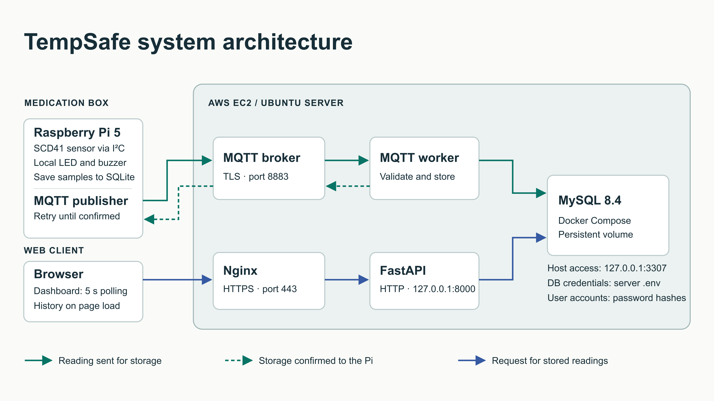
Figure 1. Data paths and trust boundaries. The ingestion worker shown in the project diagram is a logical role. In the integrated design, FastMQTT performs this role inside the FastAPI process.
The Pi queues each sample locally. The broker delivers it to the ingestion handler, which confirms storage after MySQL commits. A separate HTTPS request lets the browser retrieve the same sample. This separation lets the box continue recording when its network connection drops.
Hosted application · tempsafe.app
Project repository · nikitsya/TempSafe

From measurement to storage

Device-to-cloud contract
Each version 1 message carries a sample UUID, box ID, persistent sequence number, profile UUID, clock reliability, observation time, quality and temperature. The Pi subscribes to its acknowledgement channel before publishing. A buffered sample retains its original identifiers and observation time on every attempt.
Publish tempsafe/boxes/TS-01/readings
Subscribe tempsafe/boxes/TS-01/acks
The device and backend use separate broker accounts with opposite permissions on these two topics. The connection to mqtt.tempsafe.app uses port 8883, TLS 1.2 or later, hostname verification, QoS 1 and retain=false. The broker authenticates the publisher. The handler also verifies that the box in the payload matches its topic.

Validation and reliable delivery
Pydantic rejects unexpected fields and malformed payloads. A valid sample requires a temperature between −40 and 80 °C with at most two decimal places. A sensor error carries a null temperature. A reliable clock requires a timezone-aware observation time, normalised to UTC. An unreliable clock requires a null time. MySQL receipt time is assigned by the server.
The handler rejects retained messages and payloads over 4,096 bytes. The storage function checks the box and its profile, then commits the sample in a dedicated SQLAlchemy session. The UUID and the per-box sequence are unique. An identical retry returns the stored row with its original receipt time. Conflicting reuse of either identifier leaves the original row intact.
{"schema_version":1,"sample_id":"2e8a8349-8694-47b7-8abe-284adf85738a",
"status":"stored"}
This application acknowledgement releases the pending SQLite record. A broker PUBACK confirms only broker receipt. If the database fails or the acknowledgement is lost, the device keeps the sample and retries with bounded backoff. A retry after a successful commit produces one row and another acknowledgement.

Subscriber lifecycle
With MQTT_ENABLED=true, FastMQTT connects and subscribes during FastAPI start-up and disconnects on shutdown. Use one Uvicorn worker for the configured MQTT client ID and disable the standalone subscriber when switching over. Leave MQTT disabled for HTTP-only local development.

Storage and interpretation
MySQL 8.4 stores measurements and access metadata on EC2. The device uses SQLite as a local outbox. Separating the stores lets a late upload retain its place in measurement history. Figure 2 shows how the eight tables relate.
Database record | Purpose
boxes / box_access / app_users | Identify the box, map users to their assigned boxes and store password hashes.
threshold_profiles / box_configuration | Keep immutable limits and select one desired profile per box. A composite key ties each selection to its own box.
temperature_samples | Store sample identity, sequence, both timestamps, quality, temperature and the profile used when measuring.
sample_reviews / user_sessions | Provide review-record storage and maintain expiring, revocable sessions. The review workflow is planned.

What the latest reading means
The latest endpoint orders by the highest box sequence. A recent sensor failure therefore remains visible even when an earlier valid temperature exists. The endpoint returns the recorded profile alongside the reading. Changing a box’s desired limits cannot retrospectively reclassify its history.
Demo temperature T | Returned state
T ≤ 0.00 °C or T > 25.00 °C | Alert
24.00 °C ≤ T ≤ 25.00 °C | Warning
0.00 °C < T < 24.00 °C | Normal
Sensor error or missing temperature | Unknown
Freshness is calculated independently at request time. An observation aged 0–90 seconds inclusive is fresh. An older observation is stale. A missing, unreliable or future timestamp yields unknown. For example, a buffered 24.50 °C reading uploaded ten minutes later is Warning and stale. A recent sensor error can be Unknown and fresh.

Changing thresholds
An authorised operator supplies ordered lower, warning and upper limits within the measurement range plus a source note. The service locks the box row, creates a demo profile and selects it in one transaction. Repeating the current settings returns the selected profile. Earlier profiles remain valid for delayed uploads. The setting is a server-side selection. Delivery and acknowledgement of new limits by the Pi are still outstanding.

Database relationships
Figure 2 follows each relationship from parent to child. Each child refers to one parent along that line. The diagram shows selected fields, including the keys that link accounts, boxes and readings.
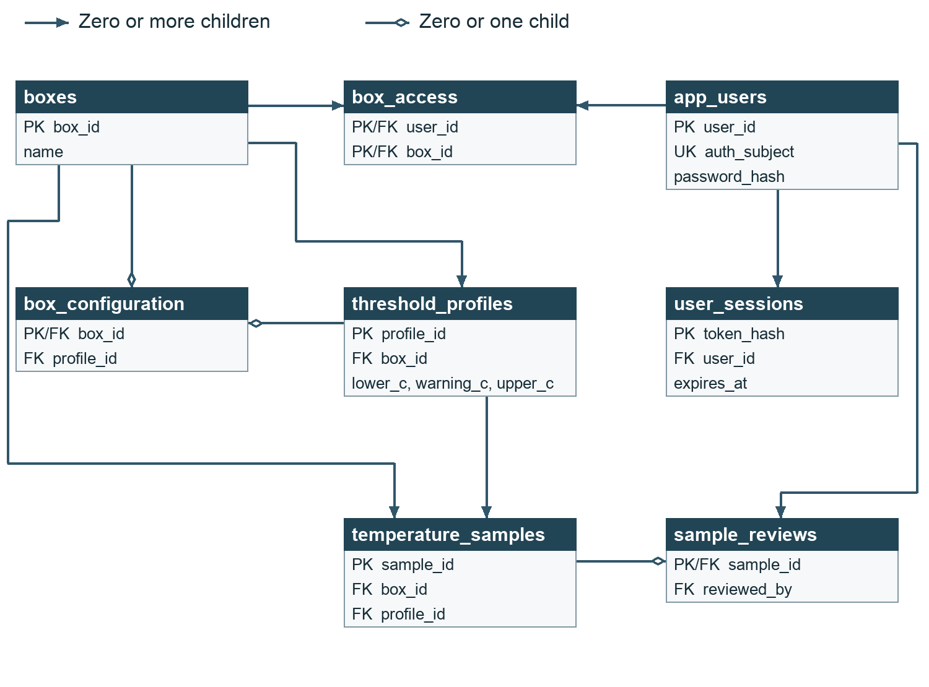
Figure 2. TempSafe MySQL tables and relationships. PK denotes a primary key, FK a foreign key and UK a unique key.

Session ownership
Each session belongs to one account through user_sessions.user_id. The token hash identifies the session and expires_at records its expiry. Deleting an account also deletes its sessions.

Recorded and selected profiles
Both temperature_samples and box_configuration reference a profile through the pair (profile_id, box_id). This keeps profiles within their box and preserves the limits recorded with each sample when the selected profile changes.

Web API and access control
The browser and API share one HTTPS origin. User queries are scoped to assigned boxes. The device uses a distinct credential for HTTP submission and separate MQTT credentials for normal publishing.
Route | Behaviour
POST /api/login · POST /api/logout | Login checks the password and issues an eight-hour host-only Secure, HttpOnly, SameSite=Strict cookie. Logout revokes the session. Both succeed with 204.
GET /api/boxes/{box_id} | Box identity and last recorded contact. A null last_seen_at means contact is unknown.
GET /api/boxes/{box_id}/readings/latest | Latest sample with profile, temperature state and freshness. A known empty box returns 404 with a no-readings detail.
GET /api/boxes/{box_id}/readings | Per-box history by descending sequence. Default 20 records, permitted range 1–100. Empty history returns [].
GET /api/readings · GET /api/readings/{sample_id} | List accessible samples by receipt time, or retrieve one by UUID. Unassigned records are hidden.
POST /api/readings | X-Device-Key must match the configured device and box. Returns 200 for a new reading or identical retry, 404 for an unknown reference, 409 for a conflict and 422 for invalid input.
GET or PUT /api/boxes/{box_id}/configuration | Read or select demo limits. Requires box access and the operator bearer token. GET returns 404 for an absent selection.
GET /api/health | Public application liveness check. MySQL health is checked separately.

Credential boundaries
The login service verifies Argon2id password hashes and stores a SHA-256 digest of each opaque session token. Missing or expired sessions return 401. An authenticated user requesting an unassigned box receives 404. HTTP ingestion rejects an invalid device key with 401 and a valid key for another box with 403. A missing or short operator token disables configuration access with 503.
Provision a test account and its box grant together. Supply separate random secrets of at least 32 characters for device ingestion and operator configuration. Store them server-side. The operator token belongs outside browser code. MQTT broker permissions apply only to MQTT.

AWS deployment and security
Cloudflare resolves tempsafe.app to an AWS EC2 instance running Ubuntu Server 24.04 LTS. Nginx terminates HTTPS and proxies requests to Uvicorn at 127.0.0.1:8000. Systemd manages the API. Docker Compose runs MySQL on the same host, mapping 127.0.0.1:3307 to container port 3306. The persistent mysql_data volume resides on the instance’s EBS storage.

Network and stored data
Boundary | Control and evidence
Public network | Recorded inbound rules allow 80/443 for the website, 8883 for MQTT over TLS and 22 from the operator’s /32. The API listener and database host port bind to loopback.
Web traffic | On 5 November the public site returned 200 for the home page and health check, 308 for the HTTP redirect and 404 for the documentation routes. Nginx sent HSTS, nosniff and frame-denial headers. Certbot successfully simulated renewal of both the website and MQTT certificates.
Database administration | The operator can tunnel to MySQL over SSH. The local application connection does not explicitly configure MySQL TLS. The inspected runtime account had ALL PRIVILEGES on temsafe.*. Separate migration and runtime grants.
At rest | On 5 November the server .env was owned by ubuntu with mode 600. User passwords are hashed. Disk encryption requires evidence from the actual EBS volume. The Pi’s local storage protection belongs in the hardware assessment.
Recovery | The named volume survives container recreation. The 4 November host audit found no scheduled MySQL backup. External snapshots, retention and restoration remain unverified.

Reproducing the deployment
Local setup requires Python 3.11+ and MySQL. Configure a private .env from .env.example, install the project with its dev dependencies and start MySQL with docker compose up -d --wait mysql. Initialise a fresh schema, then apply seed scripts 001 and 002 for TS-01. On an existing database, back up first and apply outstanding migrations, including 003 for configuration and 004 for sessions. Fresh baselines already contain those tables.
On EC2, deploy the integrated revision, install dependencies and load private service settings. Switch to the single-worker subscriber, validate and reload Nginx, then check systemd, container health, external HTTPS and a stored sample. Keep the EC2 instance running through assessment and recheck DNS if its public address changes.

Verification and demonstration

Recorded evidence
Check | Result and scope
End-to-end · 3 November | A real Pi reading of 18.91 °C at 23:02:57 UTC reached History. The publisher received stored acknowledgements. This run used the standalone subscriber.
Broker permissions · 3 November | The operator reported rejection of anonymous access and device attempts to write to the acknowledgement channel or another box’s topic.
EC2 · 4–5 November | A database query succeeded through the application account. On 5 November the standalone subscriber was active and MySQL held 155 samples for TS-01.
Backend regression checks | The threshold configuration report records 128 passing tests at that revision. On 5 November, 31 classification and MQTT worker tests passed on master. The worker tests mock storage. Neither result certifies the integrated deployment.

Live screencast sequence
1. Show Figure 1 and identify where TLS terminates, who can write to each topic and where data persists. Identify each team member’s change with a commit and explain how it affects the demonstration.
2. Start a fresh bench reading. Show its box, sequence and UUID, the returned stored acknowledgement, the matching MySQL row and the same observation on the custom HTTPS domain. Replay the identical message and confirm that the row count for that UUID stays at one.
3. Demonstrate a Warning boundary, a sensor error and a delayed sample. Show observation time, temperature state and freshness separately. Interrupt connectivity, restore it and trace the queued sample to storage.
4. Demonstrate an anonymous read returning 401, an unassigned box returning 404 and a device key used for the wrong box returning 403. Check that the public documentation paths return 404 while health returns 200. Keep cookies, keys, .env contents and passwords out of the recording.

Outstanding proof and next steps
Repeat the live trace using the FastMQTT subscriber and confirm login and authorisation on the hosted revision. Record the EBS encryption setting, reduce database grants, establish an off-server backup and demonstrate a restore. Confirm device contact before interpreting silence as an outage. Web Push and acknowledgement of device configuration still require end-to-end proof.

Hardware and front-end contributions
Replace each italic prompt with your own account of the alpha build. Refer to the same box, sample and time used in the backend demonstration so that the evidence connects across sections.

Hardware | assembly and test
Hardware contributor — Insert the updated Fritzing sketch here. Start from docs/hardware/fritzing/prototype_wiring.fzz. Label the Pi model, power, ground, I²C pins, LED resistor and any buzzer actually fitted. Add a photograph of the final bench assembly and explain any difference from the sketch.
Hardware contributor — Describe the sampling interval, LED and buzzer behaviour you observed. Give one measured temperature and one sensor-disconnection result. Explain how the SQLite queue behaves while offline and show the sample ID used for the retry.
Hardware contributor — Describe who can access the Pi physically and remotely, how SSH and broker credentials are protected and who can read SQLite. State which storage protections you verified. Add your own commit and identify any outstanding hardware limitation.

Front-end | user journey and test
User journey. I traced one journey for Box TS-01. Shannon signs in on the sign-in page, which sends POST /api/login. A correct login opens Current status. The status card shows one word, one number and one time, and the page asks the API for new data every 5 seconds. Details shows the limits and timestamps. History shows the Alerts table, the temperature graph and the reading table.
The screenshots below come from my local build of the same master code with test readings. The hosted build on tempsafe.app is shown live in the screencast.
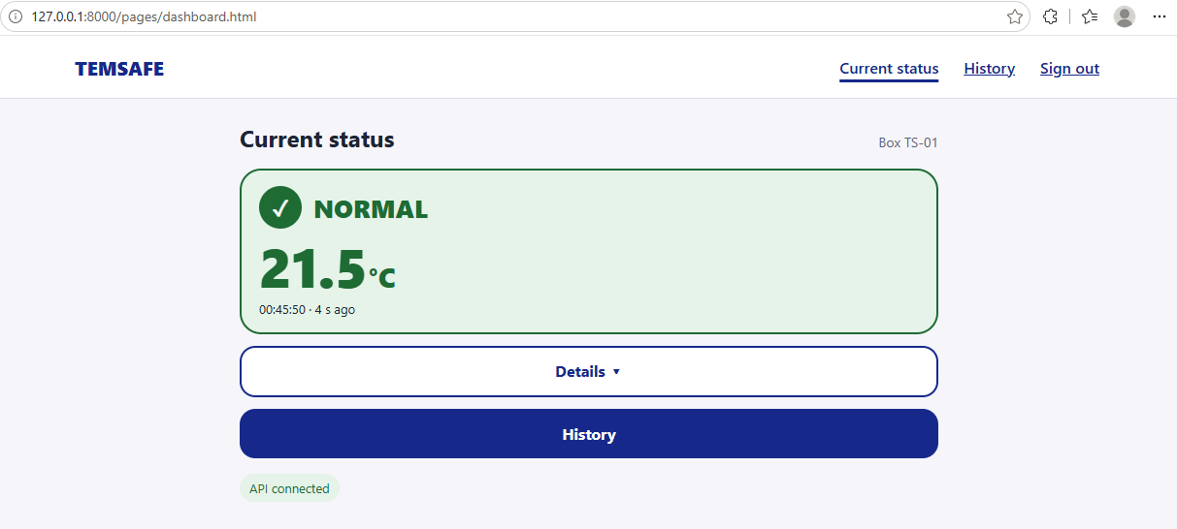
Front-end figure 1. Current status after sign-in. NORMAL, 21.5 °C, updated about 4 seconds after a test reading.
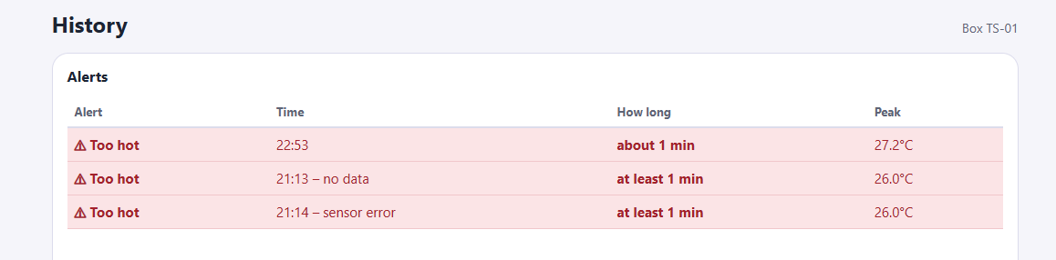
Front-end figure 2. History. Each alert period shows its time, estimated duration and peak temperature.
Expired session or inaccessible box. Every API call checks the session. If the API answers 401, the page returns to sign-in with the message “Please sign in to continue.” Sign out shows “You have signed out.” only after the server answers 204. If sign-out fails, the user stays on the page and sees “We couldn’t confirm that you’ve signed out. Please try again.” If the box is not assigned to the user, the API answers 404 “Box not found” and the dashboard shows “Can’t load temperature”. This message is too general, so I list it as a limitation.
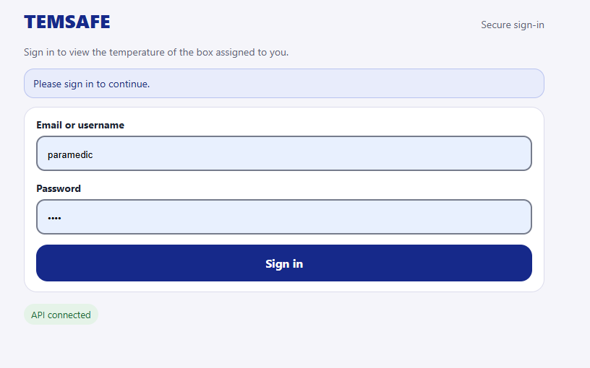
Front-end figure 3. Opening the dashboard without a session returns to sign-in.
Status states. Each state uses an icon, a word and a colour, so status is never shown by colour alone: ✓ NORMAL, ! WARNING (24–25 °C), ✕ ALERT (above 25 °C or at or below 0 °C), ⚠ SENSOR ERROR, ⏱ NO NEW DATA and ⦸ NO CONNECTION. NO NEW DATA appears when the latest reading is older than 90 seconds; the card then says “Temperature unknown” instead of showing an old number as current. A box with no readings shows “No readings yet”. If a refresh fails, the dashboard keeps the last data and shows “Can’t refresh. Showing data from …”; with no data it shows “Can’t load temperature”. Status changes are announced to screen readers, and ALERT uses an assertive live region.
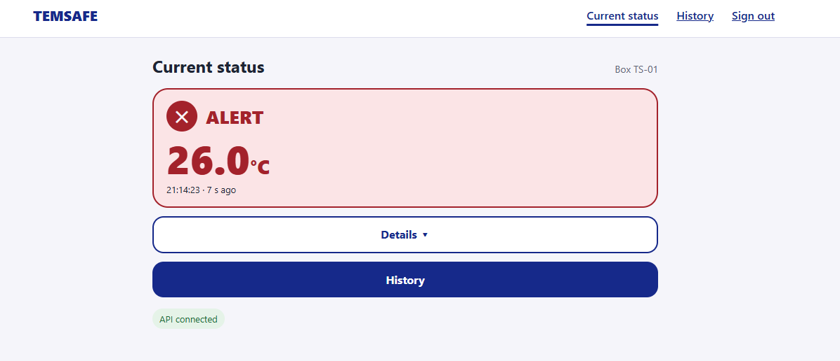
Front-end figure 4. ALERT: icon, word and temperature.
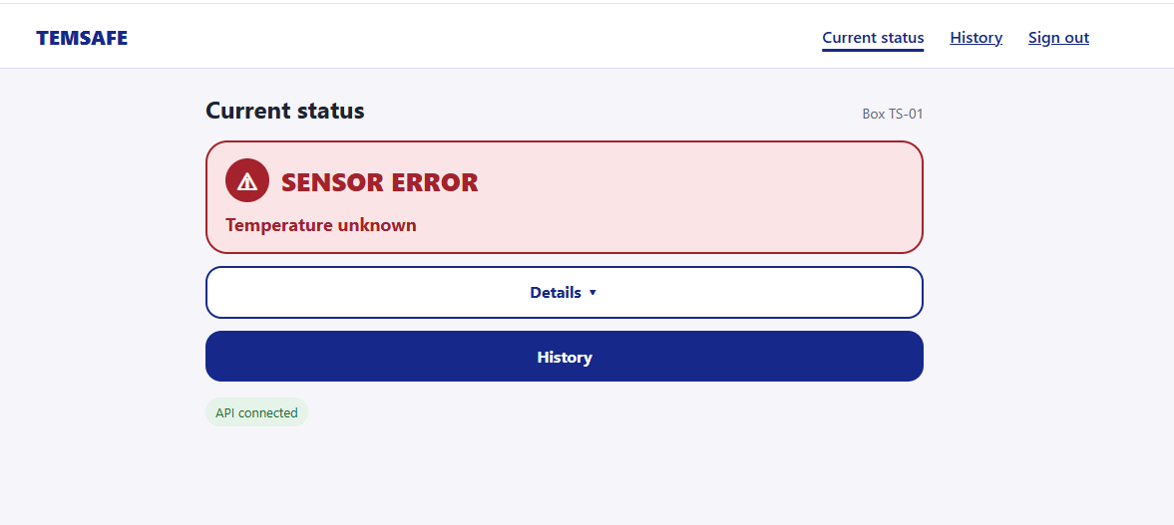
Front-end figure 5. SENSOR ERROR: no temperature is shown.
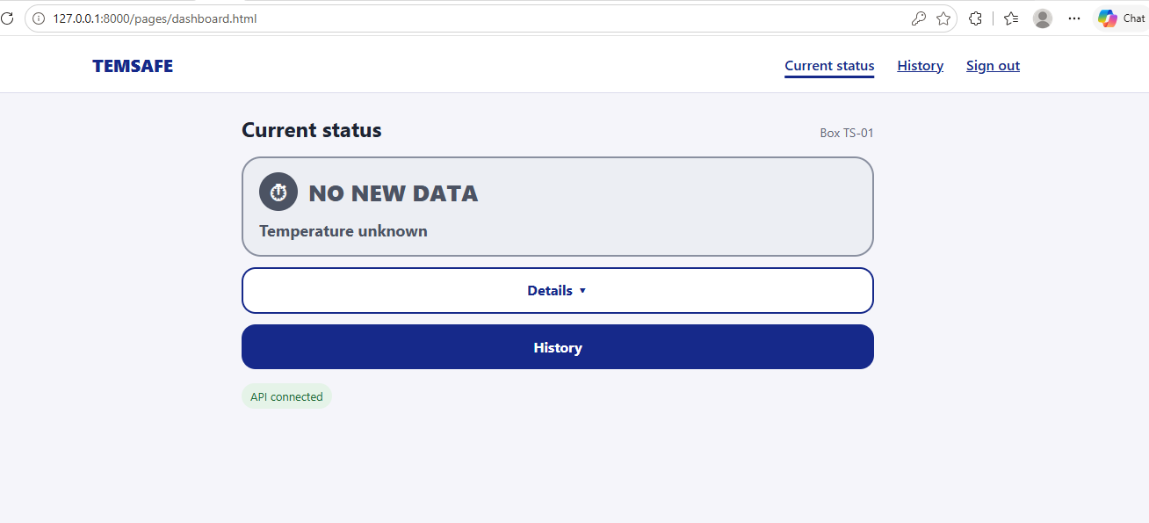
Front-end figure 6. NO NEW DATA: the old number is not shown as current.
Phone. I checked History at phone width. The graph and tables fit the screen without sideways scrolling.
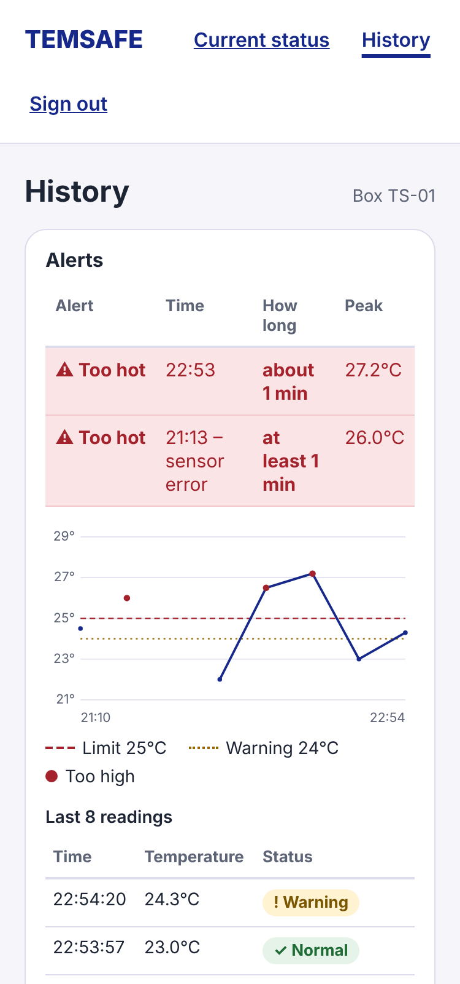
Front-end figure 7. History at phone width.
Accessibility check. axe-core 4.10.2 (WCAG 2.2 A and AA) found no violations on any state of either page. Status, Details, History and Sign out work with the keyboard only, with a visible 3 px focus outline. I fixed two contrast problems: input borders from 1.9:1 to 4.2:1, and the WARNING icon from 2.8:1 to 5.0:1.
Graph, peak and duration. The graph draws the temperature line with the 25 °C limit, the 24 °C warning line and a legend. The Alerts table lists each alert period with its start and end time, estimated duration (“about N min”) and peak temperature. If two readings are more than 90 seconds apart, the line breaks and the duration says “at least N min”, so a gap is never drawn as continuous data. An alert that has not ended says “still going”.
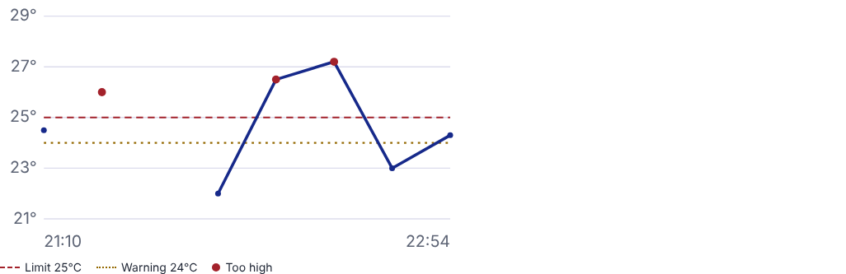
Front-end figure 8. Temperature graph with the 25 °C limit and the 24 °C warning line.
Notifications. On the website I demonstrated the ALERT status card and the screen-reader announcement. Phone push notifications (FR-14) are designed in Figma but not built yet.
My commits. Dashboard connected to the API (c17d1d9), accessible history table (6a6e3b4), simpler status screen and accessibility fixes (c6eb9aa), automatic refresh (0587cf1, d5bf8aa), history graph and alert periods (8be5ebe), and sign-in and sign-out (50bc20b, 3b1294d, 885ae5f; merged in pull request #25).
Observed test result. All 9 local sign-in tests passed, including sign-out when the server is unreachable or returns HTTP 500. A test reading of 21.5 °C changed the dashboard from NO NEW DATA to NORMAL in about 4 seconds without reloading the page.
Remaining limitations. Phone push notifications are not built. History does not show the date of each alert, which was found in usability testing. The “Box not found” case needs its own message. Sign-in on the hosted build still needs to be confirmed.

Contribution evidence
Backend and deployment: nikitsya implemented reading submission and conflict handling (2314f7b), MQTT storage acknowledgements (b6bc87e) and versioned threshold configuration (fe26231).
Starting points for the team accounts: HannaBProjects added device delivery with storage confirmation (08d7b73). Maryna Hordiienko added the history graph and alert periods (8be5ebe). Each contributor should explain their own decisions in the screencast and commit their section.

Evidence and submission handover
The following project records identify the implementation and the evidence behind this report. The links point to the revisions used for the architecture, access controls and deployment guidance.
System architecture diagram and security boundaries
FastMQTT lifecycle and deployment transition
API authorisation, credentials and session migration
Nginx directives and dated server security checks
G-CA2 priorities, including excursion estimates as a Must Have
Device-to-cloud integration record
Database access, grants and backup audit
Threshold configuration and test record

Submission checklist
The G-CA2 Alpha Specification sets the deadline at 23:55 on Sunday 8 November 2026. The team submits one ZIP on Moodle. Its top-level folder follows the iot_gca2_teamname format.
- Complete the CA cover sheet and AI usage cover sheet. Update AI_Chat_Log.md
- Include the source files, final documentation, revised Fritzing sketch and screencast. Remove private environment files, credentials and keys from the archive and recording.
- Place the accessible repository link in the README, share access with the lecturer and commit each contributor’s work and document revisions using clear imperative commit subjects.
- Open the ZIP, check its folder structure, play the screencast and test the custom HTTPS domain. Confirm that the assessed version remains available after submission.

