Getting started with Competitive Programming
Week 8 – Network Flow

Problem: Badges

A badge is created by superimposing two squares. The bottom square should be of blue colour and top square should be of yellow colour. The squares must be rotated in such a way that the projection of the badge displays 8 distinguishable vertices. Please see following image for an example. In the picture, the left-most configuration is permitted while the other two are not.
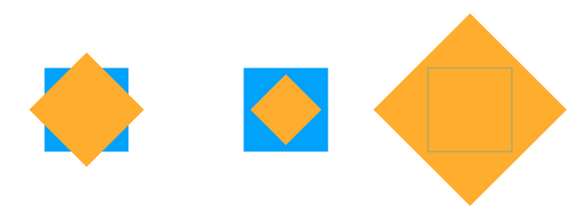
You are given n squares, each of a given color and side length. Determine the maximum number of badges that you can make. Note that each square can be used for at most one badge.
Input Format:
The first line of input file contains integer n. Each of the next n lines contain two space separated integers, c_{i} and d_{i}. c_{i} is the colour number (1 for blue and 2 for yellow) and d_{i} is the length of side of square.
Output Format:
Print the maximum number of badges that can be made.
Constraints:
1 <= n <= 100000
1 <= d_{i} <= 1000
1 <= c_{i} <= 2
Resources:

Try: https://www.spoj.com/problems/MATCHING/

Dinic’s algorithm: https://www.youtube.com/watch?v=M6cm8UeeziI

Dinic’s Implementation: (Java) https://www.youtube.com/watch?v=_SdF4KK_dyM&t=0s

(C++) https://cp-algorithms.com/graph/dinic.html

Sample Input
10
1 3
1 17
2 13
2 13
2 6
1 10
2 8
1 7
1 8
2 8
Sample Output
4

Test case 1

10
2 8
1 15
2 11
1 8
1 2
2 1
1 17
1 6
1 18
2 5
Output: 3

Test case 2

10
1 13
1 12
1 6
2 19
2 19
1 18
1 7
2 10
1 12
2 10
Output: 3

