Food delivery management system

Assignment_4

NUME STUDENT: TRASCULESCU TUDOR
GRUPA: 30424

CUPRINS

1. Assignment objective 3
2. Problem analysis, modeling, scenarios, use cases 4
3. Design 4
4. Implementation 5
5. Results 6
6. Conclusions 7
7. Bibliography 7

Assignment objective
Consider an application for Food Delivery management system for a catering company. The client can order products from the company’s menu. The system should have three types of users that log in using a username and a password: administrator, regular employee, and client. The administrator can:
• Import the initial set of products which will populate the menu from a .csv file.
• Manage the products from the menu: add/delete/modify products and create new products composed of several products from the menu (an example of composed product could be named “daily menu 1” composed of a soup, a steak, a garnish, and a dessert).
• Generate reports about the performed orders considering the following criteria: o time interval of the orders – a report should be generated with the orders performed between a given start hour and a given end hour regardless the date. o the products ordered more than a specified number of times so far. o the clients that have ordered more than a specified number of times so far and the value of the order was higher than a specified amount. o the products ordered within a specified day with the number of times they have been ordered.
The client can:
• Register and use the registered username and password to log in within the system.
• View the list of products from the menu.
• Search for products based on one or multiple criteria such as keyword (e.g., “soup”), rating, number of calories/proteins/fats/sodium/prices.
• Create an order consisting of several products – for each order the date and time will be persisted, and a bill will be generated that will list the ordered products and the total price of the order.
The employee is notified each time a new order is performed by a client so that it can prepare the delivery of the ordered dishes.

Problem analysis, modeling, scenarios, use cases
2.0 Problem analysis
The application should resolve the problem of managing orders of foo. In order to meet these requirements, an initial population of the table which contains the products is taken from the .csv file. The administrator can import the products from the .csv file, he can modify the products and also add new products which can be simple products or products compose from the products which already exist in the products table. The administrator should also generate some reports based on some filters. The client can visualize the products from the table, he can make some orders, and also he can constrain his view on the product table based on some filters like rating, title, sodium, calories, fats and other properties that are listed in the products table. The employee is notified every time a order was made so that it can prepare the delivery of the ordered dishes.
The application should signal to the user if the data which he entered is in wrong format and should guide him to a better understanding of the application after each mistake that the user does. Some alerts will be popped on the screen and will guide the user to learn from his mistakes.
2.1 Model
The way the data is stored inside my application is pretty straight forward, for storing the clients a List of clients is used, for storing the menu items also a simple List of menu items is used. In order to be sure that the same object of Delivery Service is called on every action, in order not to lose all the data inside it when creating a new object, the I chose to use the Singletone Design Pattern. The orders were mapped inside a HashMap which has as key the Order and implicitly the order id, which is unique for each order (I chose the order id as a key in order not to have collisions inside the hash map) and the value is an Array List of menu items, which contain every item that a specific order contain.
2.2 Design
The overall design is simple, the administrator will populate the table with products, he can make changes or remove the items as he prefer, the clients can make orders based on some filters on the properties of each product, and the employee will be notified every time an order was made. After each start of the application the data is retrieved from a serial file and after each end of the application the data is serialized in that file so that it can be further used in the next starting of the application.
2.3 Scenarios
As developers, we can not predict what the user is going to do once the application starts. But we can restrict the output that is displayed based on some assumptions. For example, as long as the input is not in the correct form an alert will be generated and it will guide the user to a better understanding of the program. If the user succeeded to enter the correct form of input, all is left to do is to display the results of the certain operations which were made either by the client or by the administrator.
2.4 Use cases
The use case diagrams are used to make the relations between users and the system visible. These use case diagrams are very useful for a certain number of reasons:
- They offer a general description of the way the system will be used
- They give a general aspect of all the functionalities provided by the application to the user
- They show how the application interacts with one or more users
- They assure the fact that the system will have a correct and expected behave
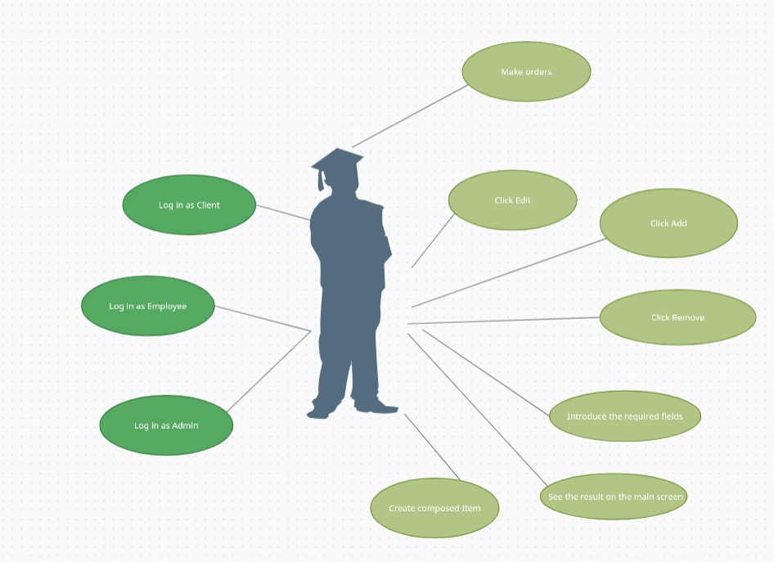

Design
A brief introduction of the overall system design was made in chapter 2.2. Because it is a good practice, in my application I have used many architectural patterns. One of the is Singletone design pattern which allows a global view of the class delivery service, having only one object which will be manipulated by all the other classes and will be notified when to do some needed operations. The approached architectural pattern is the Model View Controller which divides the application into three areas: processing, input and output.
The classes MenuItems, BaseProduct and CompositeProduct use the Composite Design Pattern, BaseProduct and CompositeProduct extending the abstract class MenuItems. CompositeProduct contains a list of menu items which can contain base products or other composite products and each composite product can compute it’s price and all the other properties recursively.
The class EmployeeController implements the Observer Design Pattern. The class will be notified every time an order was made so that it can be added in the table.
The DeliveryService class is using a predefined JCF collections which uses a hashmap data structure. The hashmap key will be generated based on the id of the class Order which is unique and will have associated several MeuItems. Also the DeliveryService class implements the Observable Design Pattern and every time a new order will be places inside the delivery service, it will notify the employee which implements the Observer Design Pattern.
Delivery service also impelements the Design By Contract technique which involves pre conditions, post conditions, invariants and assertions for the most important methods, in order to check the correctness of the inputs and the outputs of each method.
In the Controller package each view is assigned a controller which will manipulate the data in such a way that the user will see the correct output or a message which will guide him to a better understanding of the application. Some important classes inside this package are: the admin controller, the client controller, the employee controller, and the four reports controllers. The AdminController is used for communicating with the DeliveryService and populating the TableView when some certain actions are made by the administrator. Similarly the EmployeeController will be notified from the DeliveryService class each time an order was made and will update the state of the table inside of it. The ClientController will also communicate with the DeliveryService class and will send the reques to make some orders which will be generated inside the delivery service and then processed and put into tables when the employee is notified. The 4 reports controllers will check if the data imported by the user is correct, then will send a request to the delivery service for filtering the results and then the results which were sent by the delivery service will be processed and put inside the TableView of each report controller.

UML diagram:
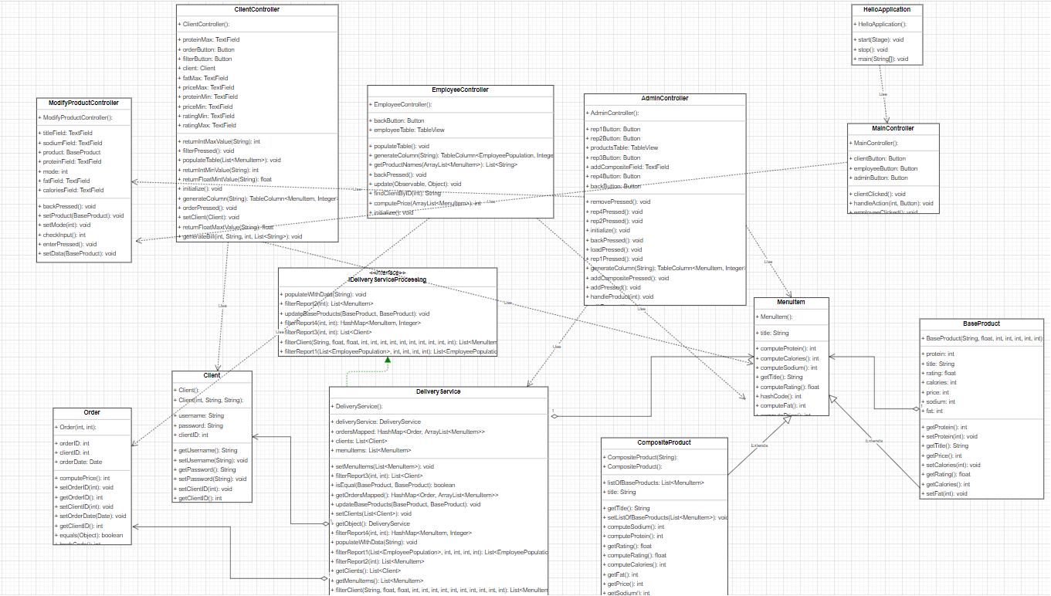
One can observe that the View is completely missing from the UML diagram. That is happening due to the fact that the code is written in JavaFX and my view is in a .fxml format. This cannot be represented in an UML diagram, but the main logic and the use case of the view can also be observed from the previous figure. Also, the class containing the main is missing because it is used only for launching the application and setting the size of the pane seen at the top level by the user.
The package diagram is shown in the next figure:
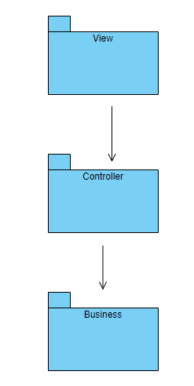

Implementation

- DeliveryService: This class can be found inside the Business package. As the name of the packatge suggests, it’s purpose is to take data from the controller, to manipulate it and transform it in a desired way to be sent back to the Controller package where it will be shown in the tables. This class implements the Observable Design Pattern, which will notify the employee each time a certain order took place and will sent that order to the employee to be further processed. The main logic and data manipulation can be found inside this class methods.
- MenuItems, BaseProduct, CompositeProduct: These classes can be found inside the Business package. The base product and composite products are extending the menu items class. These classes implement the Composite Design Pattern. The main data structures used in the application are based on the menu items class and implicitly on the base product and composite product.
- AdminController: This class can be found inside the Controller package. It’s purpose is to act according to the user’s actions. For example if the Edit button is pressed it should tell the user weather an item was selected and weather that item was a BaseProduct which can be edited or a CompositeProduct which can not be edited. It should pop on the screen some errors and should guide the user to a better understanding of the application.
- EmployeeController: This class implements the Observer Design Pattern and will be notified by the DeliveryService class each time an order took place. Each order will be then put inside a table so that the employee will be able to see it and to prepare the order in time.
- ClientController: This class can be found inside the Controller package. The class will generate the table of products from the DeliveryService and will allow the client to filter the products based on some properties like title, rating, calories and others. The client will also be capable to make orders which will be signaled to the DeliveryService and then the employee will be notified to prepare the order. Also a bill will be generated after each order in a .txt format.
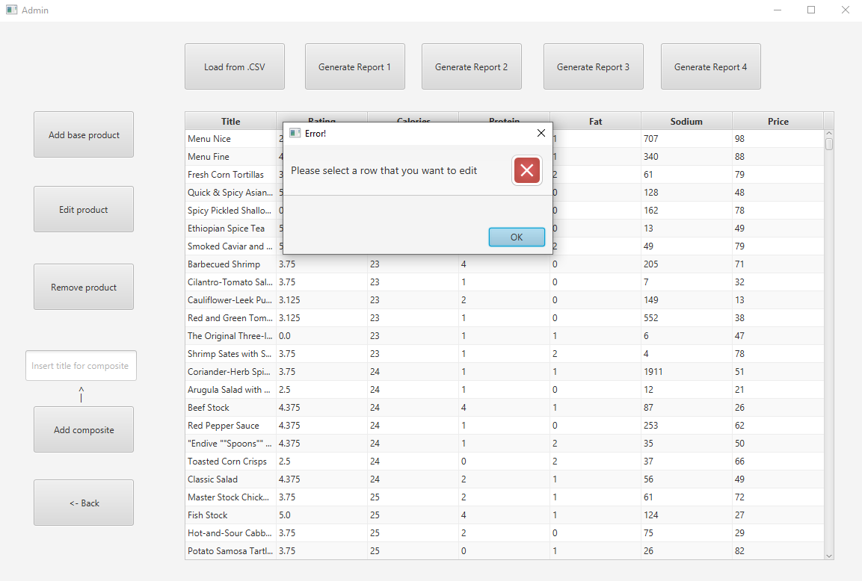

Results
Some results of the application can be seen in the Graphical User Interface for each of the reports, also in a .txt file attached in the repository where the bill was generated after each order. That .txt file will be overwritten each time an order is made so that only the last bill will be displayed. If one wants to see all the orders performed can go to employee’s table where all of them are generated.
Here is an example of output for the bill.txt:
“Order 2: The client: ania ordered: [Fresh Corn Tortillas , Quick & Spicy Asian Pickles , Spicy Pickled Shallots , Ethiopian Spice Tea ], for a total price of: 254” .

Conclusions
After completing the application I feel more comfortable using the Composite, Observable, Observer and Singletone Design Patterns. I learned a lot about streams and filters, this was the first time I have ever used them. Some future developments could be for the client to be able to order the same product more than 1 time in the same order. Also a future development could be for the administrator to be able to edit the composite products, not only the base products which were imported from the .csv file.

Bibliography
- https://stackoverflow.com
- https://app.diagrams.net
- https://dsrl.eu/courses/pt/materials/PT2021-2022_Assignment_4.pdf
- https://dsrl.eu/courses/pt/materials/A4_Support_Presentation.pdf

