Ride Fare Classification



Department of Computer Science and Engineering

University of Moratuwa

Academic Year 2019

W.A.D.N.S. Wijesuriya

199373A

CS5621 - Machine Learning

## Dr. Uthayasanker Thayasivam

## Ride fare classification

Kaggle User Id : nicumwijesuriya

Kaggle Score : 0.95599

Public leader board rank: Not avaialable

Private leader board rank: Not avaialable

Link to the solution : https://www.kaggle.com/submissions/21552762/21552762.raw

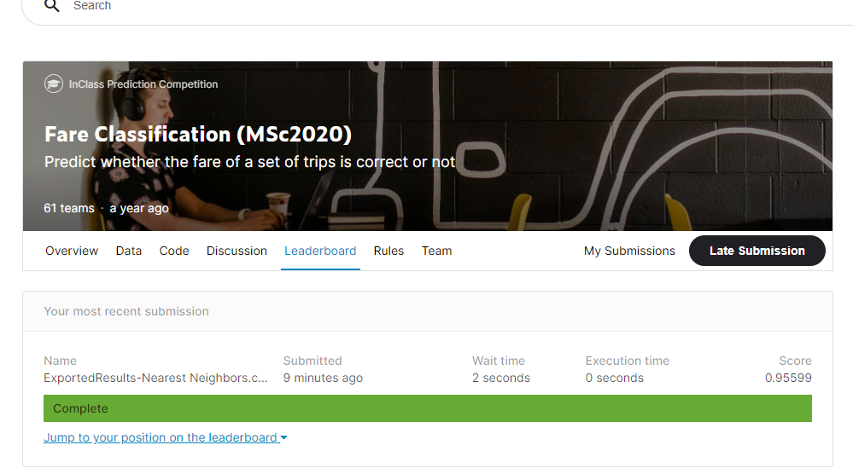

#### Introduction

This solution contains a classifier to classify whether a mentioned fare for a taxi fare is correct or not. Training and test sets were provided by the kaggle competition.

#### Feature engineering

From the given data GPS locations were not useful at all as raw data. So they were transformed using “Harversine formula” to get the distance between the mentioned locations.

Trip start and end times were combined to get the actual time taken to complete the trip. Assuming the system used in the taxi company is correct.

Therefore in this solution feature reduction was used.

If values were not available for any feature, these records were not used in training the classifier.

#### Classification techniques used

In this solution following classifiers were tried :

* Nearest Neighbors
* Linear SVM
* RBF SVM
* Decision Tree
* Random Forest
* Neural Net
* AdaBoost
* Naive Bayes
* QDA

Following are the results for each classifier:

Classifier : Nearest Neighbors

Accuracy : 0.8979191205339615

Precision : 0.914763458401305

Recall : 0.9777680906713164

F1 score : 0.9452170248630425

Classifier : Linear SVM

Accuracy : 0.8994895956026698

Precision : 0.9076

Recall : 0.9891020052310375

F1 score : 0.9465999165623696

Classifier : RBF SVM

Accuracy : 0.8979191205339615

Precision : 0.9010252365930599

Recall : 0.9960767218831735

F1 score : 0.9461697722567288

Classifier : Decision Tree

Accuracy : 0.9057714958775029

Precision : 0.9137792103142627

Recall : 0.988666085440279

F1 score : 0.949748743718593

Classifier : Random Forest

Accuracy : 0.90616411464468

Precision : 0.9085487077534792

Recall : 0.9960767218831735

F1 score : 0.9503015179871076

Classifier : Neural Net

Accuracy : 0.8924224577934825

Precision : 0.9092382495948136

Recall : 0.978204010462075

F1 score : 0.9424611507769843

Classifier : AdaBoost

Accuracy : 0.9002748331370239

Precision : 0.9054054054054054

Recall : 0.993025283347864

F1 score : 0.9471933471933472

Classifier : Naive Bayes

Accuracy : 0.9014526894385552

Precision : 0.9055180627233029

Recall : 0.9943330427201394

F1 score : 0.9478495740702264

Classifier : QDA

Accuracy : 0.894778170396545

Precision : 0.9068273092369478

Recall : 0.984306887532694

F1 score : 0.9439799331103679

#### Sampling techniques used

There was a high imbalance between correct and incorrect labels. Therefore oversampling was used to add more records containing label “incorrect”. Randomly selected “incorrect” labeled records were duplicated in the dataset.

#### Noteworthy observations:

Once difference between actual time and reported time was calculated, for most of the records reported time was greater than actual time calculated from the system. This was observed for records labeled as “correct” as well.

