CCT College Dublin

Module Title: | Advanced Data Analytics  Big Data Storage and Processing
Assessment Title: | Integrated CA1 Sem 2 MSc in Data Analytics
Lecturer Name: | David McQuaid  Muhammad Iqbal
Student Full Name: | Nikunjkumar Vinodbhai Khanpara
Student Number: | 2025260
Assessment Due Date: | 19th October 2025
Date of Submission: | 19th October 2025

NIKUNJKUMAR VINODBHAI KHANPARA

Declaration

By submitting this assessment, I confirm that I have read the CCT policy on Academic Misconduct and understand the implications of submitting work that is not my own or does not appropriately reference material taken from a third party or other source. I declare it to be my own work and that all material from third parties has been appropriately referenced. I further confirm that this work has not previously been submitted for assessment by myself or someone else in CCT College Dublin or any other higher education institution.

Telecom Churn Prediction using Big Data and Neural Networks

NIKUNJKUMAR KHANPARA
Master of Science in Data Analytics
CCT College Dublin
2025260@student.cct.ie

Abstract

This research paper explores how neural network regularization techniques can be applied to predict customer churn in the telecommunications industry, leveraging the features of large-scale data analytics capabilities. This approach uses high-performance computing platforms, especially Apache Spark, to process the large amount of data, and assesses the implementation of a predictive model using the TensorFlow/Keras architectures. The consequence of the imbalance in the classes is reflected in the achievement of a classification accuracy of about 80 percent in terms of precision and recall. These metrics can be improved by using an appropriate workflow that includes the correct data preparation steps.

Keywords
Telecom, Big Data, PySpark, Data Preprocessing, TensorFlow, Customer Churn, Neural Networks, Deep Learning, Class Imbalance, Prediction.

I. INTRODUCTION
Background and Context
The importance of customer churn prediction, not only in the telecom industry but also in broader practice, has been driven by the high costs associated with acquiring new customers compared to retaining existing ones. It is possible to identify specific behavior patterns and utilize the large volume of data provided by customer datasets to address this issue. By identifying the time when customers may leave, organizations can use intervention strategies that occur promptly. Again, intervention works by setting up personal initiatives or modifying services. A combination of exploratory and predictive modelling techniques, they provide corporations with both tactical and operational solutions, lowering churn and increasing total performance.
Problem Statement and Importance
Repeated churn destroys revenue and reduces the customer goodwill of the organization. The lack of effective predictive methodologies undermines the capability of an organization to determine the major churn drivers and to exploit intervention opportunities. The effective predictive models need to be developed so that the form is sufficiently correct in order that the organization efficiently witnesses successful systems of retention and successful sustained competitive advantages in customer-focused markets of customer focus.
Objectives and Contributions
The analysis aimed to search for the proposed hypothesized methods of predicting various customer churn, applying exploratory methods, machine-learning mechanisms, and covariates that clarify churn propensities. Its core contributions are based on a predictive neural-network model that sharpens error measurement, thus making it easy to adhere to actionable recommendations for organizations pursuing databased decision-making, as well as optimize retention practices.

II. STATE OF THE ART
Big Data Processing Frameworks
Effective data processing models have been essential in handling the vast and complex data available in industries like telecommunications, healthcare, finance, and retail. Frameworks like Hadoop and Apache Spark have been instrumental in enabling data processing across large-scale distributed systems. Hadoop typically utilizes the MapReduce paradigm, which supports parallel computation and efficient storage. On the other hand, Spark is built to leverage multiple features, allowing in-memory computations, reducing latency, and improving performance. Additionally, technologies such as Flink and Google BigQuery are gaining traction, offering flow and interactive analytics while scaling key data technologies. These structures allow data and allow for conversion and analysis at scale. These structures are important in the context of customer newspaper management, call, and holiday predictions in terms of service use, from a data perspective, to effectively handle the model before development.
Neural Networks in Predictive Analytics
The concept of neural networks is an effective tool for analyzing predictions because it allows for tweaking complex nonlinear compounds in data. Neuronal networks are inspired by the human brain and consist of layers of components (neurons) that use suspension compounds to process information. Neuronal networks are also particularly useful for prediction (model classification, regression, recognition), and are considered to be highly effective in areas such as fraud detection, mood analysis, and exit prediction (Inayat et al. 2023). Neural networks in power (FNN) and recurrent neural networks (RNNs) are generalized, but the latter are particularly useful for consistent, changing behaviors of customers. Neuronal networks, when used in customer flows, not only predict the likelihood of fatigue but also provide more accurate and effective recommendations to uncover hidden models and correlations that traditional statistical methodologies may overlook.
Integration of Big Data + Neural Networks
Especially in areas with large amounts of data, such as telecommunications. Individually, large-scale data technologies are effective in handling critical and non-uniform data sets, so structured, unstructured data are fusion, processed, and stored. However, these become more important when using neural networks that introduce high levels to deepen their valuable understanding of these vast datasets. Accuracy and generalization are enhanced due to the possibility of incorporating lots of information from the model history using synergy. As an example, distributed computing systems can work with neural networks simultaneously, which decreases the run time by about 25 percent. There are also graphics-processing-unit architectures and implementations of neural-network processing on scale, like Tensor on Spark and DeepLearning4J (Chen et al. 2022). This would enhance prognostic predictive performance and real-time analysis, enabling organizations to take interventions in (timely). With customer forecasting, the integration is also capable of processing billions of call records, surface with the addition of historical and demographic attributes, and building neural models that discover small behavioral signals. In addition, the hybrid models are highly beneficial when applied in decision-making because they are utilized to create production capacity for high-accuracy prediction systems.

III. LITERATURE REVIEW
Big Data Frameworks in Research
The widespread use of large-scale datasets has made big data frameworks an invaluable research instrument in churn prediction research papers. Shattering the traditional paradigms based on data processing, these frameworks (Apache Spark, Hadoop, and other distributed systems) help to handle large volumes of customer data through parallel computing and real-time processing. The Spark has become the strongest, in large part because of its in-memory compute capabilities and its integrated machine-learning package, including the most popular MLlib, which allows researchers to do data transformation, an exploratory analysis of data, and predictive modeling more efficiently (Saha et al. 2024). Empirical studies revealed that move predictions are definitely worth it, provided with pipelines of big data, as the rates of customers tend to be integrated on a scale of numerous dissimilar sources, referring to billing data and social media or to logs of customer support.
It is also possible to seamlessly incorporate both structured and unstructured data in a big data structure, and this is straightforward in obtaining a clear picture of customer behavior. Purchasing trends are revealed through transactional data, while unstructured textual data from customer complaints offers insights into dissatisfaction, creating a more comprehensive basis for predictive modeling (Karaarslan et al. 2024). However, the appropriate execution of big data architectures is also required to address issues related to scalability, data quality, and computational overhead. Despite these limitations, large data frameworks triangulate with previous studies to advance churn prediction work by facilitating the computational power to analyze relational and complex interactions among customer characteristics and churn behavior.
Neural Networks for Prediction
Because of their ability to learn non-linear relations and hidden patterns from large datasets, neural networks have been widely used in customer churn prediction. Unlike traditional statistical models based on linear assumptions, neural networks automatically learn interactions through their multi-layered architecture. The literature shows there is a capacity for modeling through feedforward networks, recurrent neural networks (RNNs), and convolutional neural networks (CNNs) for customer churn (Kaya, 2024). For example, feedforward networks accurately classify churn based on demographic and behavior variables, while RNNs are appropriate for sequential datasets like call data or customer behavior over time.
Deep learning frameworks, including multiple hidden layers, dropout methods, and adaptive optimizers, have been optimized to reinforce the robustness of predictive performance. Literature dimensions neural networks have multiple methods of activation functions; for example, ReLU activation functions retain non-linear relations while sigmoid methods help with binary predictions, which are appropriate for the churn prediction task (Miao et al., 2024). Additionally, utilizing neural networks facilitates end-to-end feature learning, which relaxes the amount of human-intensive feature engineering, as often-human feature engineering quickly diminishes the efforts of conventional methods.
However, neural networks do have some limitations, namely interpretability and overfitting concerns. Recently, researchers have suggested combining feature importance techniques, such as SHAP and LIME, to assist in explaining predictions and thereby making neural networks more acceptable for management decisions (Zhang and Zhang, 2024). Despite challenges facing neural networks, it has persistently achieved higher accuracy than logistic regression or decision tree baselines and consequently outperforms both, and is considered one of the best-performing methods in churn prediction studies.
Hybrid and Ensemble Approaches
Neural networks have strong predictive performance; however, there is a growing body of evidence exploring the effectiveness of hybrid and ensemble modeling approaches to churn modeling. Hybrid modeling approaches blend machine learning with a specific domain modeling approach. Conversely, ensemble approaches combine forecasts from multiple models in order to reach an aggregated higher-performance solution. Random Forests, Gradient Boosting Machines (GBM), and XGBoost are some of the most commonly used ensemble algorithms for predicting churn. These ensemble approaches use the base algorithms' ability to minimize bias and variance for more stable and consistent prediction performance than single algorithms.
It has been shown that merging ensemble and neural networks strengthens performance using tree-based models together with deep learning. For instance, neural networks capture complex non-linear behaviour, while the boosting method additionally improves accuracy when predicting the minority churn class (Khandelwal and Sakalle, 2024). This proves to be particularly helpful in dealing with class imbalance challenges in churn data, where the churners are very much in the minority compared to the non-churners.
In addition to merged algorithms, hybrid methods are found in a few studies to consider text mining or sentiment analysis of customer complaints in combination with structured transactional data. These hybrid models, in particular, combine heterogeneous data and provide a more complete set of factors that drive churn. Research indicates that stacking models, for instance, adding logistic regression as a meta-classifier, to models from neural networks, support vector machines, nd/or boosting models, generalizes best.
It should be noted that while beneficial, ensemble and hybrid models also represent a higher computational cost and provide much less interpretability, thus limiting their utilization in the business world. However, increasingly, research shows the ability to establish new benchmarks in churn-related prediction studies, which include the above limitations.
Identified Research Gaps
It has seen great advances that address all of the areas of churn prediction related to big data paradigms, in neural networks, and in hybrid models, yet there remain research gaps. The majority of research focuses on accuracy but overlooks the interpretability of models, which is important for managerial acceptance. Neural networks specifically are frequently described as "black boxes," and their practical use is restricted unless supplemented by explainable AI methods. Although ensemble and hybrid methods enhance predictive power, it tend to be computationally intensive and hence less feasible for small- and medium-sized enterprises. There is not much investigation of real-time churn prediction models that incorporate streaming data, even though it is crucial for proactive customer retention. Lastly, most studies use domain-specific datasets, which limit the model's generalizability across industries. Bridging these gaps with interpretable, efficient, and industry-agnostic solutions could significantly improve the real-world influence of churn prediction research.

IV. METHODOLOGY
Dataset Description
All data used in this study is called customer churn based on Iran. This includes data on telecommunications subscribers, their demographic capabilities, their use of services, and interactions between customer services. It consists of structured variables such as subscription duration, amount of charge, second in use, call/SMS frequency, and categorical variables such as age group, tariff planning, and service status. The second target variable is binary (1 corresponds to flow and 0 corresponds to customer retention).
The data reflects the scope of client activity, including communication models (different numbers, SMS frequencies), service reliability (call defaults, complaints), and account behaviour (payment amount, customer costs). This combination combines action and transactional signals, providing an overall modelling of output trends. It should be noted that the data is a bit unbalanced and that most of the class is not non-colon (Nagelhus et al. 2023). Therefore, preliminary treatment, balanced, and complex modelling methods are required to achieve stable, generalized, and effective predictive performance.
Big Data Preprocessing using PySpark
Preprocessing is performed using the PySpark API, Python for Apache Spark. Pyspark provides distributed computing power. This makes it very suitable for large data pipelines where data volume and speed are critical issues. Datasets are first accepted in Spark DataFrame to use distributed storage and parallelism. The preliminary processing work began with data purification, including processing mode values, inconsistent resolution in categorical authorities, and deletion of duplicate records (Fischler-Ruiz et al. 2021). Features such as complaints and tariff planning are coded using Spark and OneHotEncoder StringExer to convert categorical variables into easy-to-read formats.
Continuous variables such as the number of charges and second usage are standardized using minmaxscaler to ensure stable training of the neural network. Emissions are identified using statistical and limited thresholds to reduce asymmetry. This is followed by engineering stadiums with features that provide interaction criteria, such as call frequency (reporting failure challenges for full use) and SMS-SALL reports (Kelly et al. 202). These engineering functions are assembled into vectors of functionality using Vectora similarity. The final preliminary dataset is divided into training and test sets to provide laminate samples to maintain the distribution of the output. This PySpark pipeline ensured the scalability, efficiency, and preparation of data for subsequent modelling of neural networks.
Neural Network Model Architecture
During the predictive modelling stage, deep neural networks (DNNs) are used and designed to classify customers as bars or unauthorized. The model's architecture is built using Tensorflow using the Keras API, selected for flexibility and scalability in integration with Sparkton. The input layer corresponded to the number of pre-converted functions and provided a complete record of the customer. Two hidden layers are introduced. The first contains 128 neurons and the second contains 64 neurons (Evans et al. 2022). The two layers used the REREAD activation function, which supports nonlinear training and prevents the problem of gradient disappearance. Layers fall after each layer is hidden at a rate of 0.3, softening the experience by random deactivation of neurons during training.
The output layer is composed of neurons with a sigmoid activation function, producing a 0-1 probability of flow. The cross-loss entropy feature used has been optimized via Adam Optimizer at adaptive training speed. To further improve generalization, party standardization is included among dense hierarchies to stabilize training. The model's architecture balances the difficulties with interpretation, allowing neural networks to capture subtle behavioral models, and is possible in the way a large dataset is calculated by Wednesday's Spark.
Training Setup and Class Imbalance Handling
The training phase is designed to maximize model performance and to prevent natural class imbalances in the output dataset. Data are divided into 70% of training, 15% validation, and 15% of subset tests by percentage of classes supported by laminated samples. The training party represents 128 recordings at 50 ERAs, and early stops are used if test losses are not reduced. Two additional strategies are used to counter the imbalance (Klumpp et al. 2025). First, the method of redirecting synthetic minorities (SMOTE) addresses education data that generates samples of synthetic flows of uniform class proportions. Second, weight loss applies to the function of loss of parts that are poorly classified and receive a larger fine. This is a mature strategy to ensure that this model does not like predictions by the majority, not groups that are not made. Medical indicators are measured using a variety of indicators of accuracy, such as accuracy, examination, F1 indicators, and AUC-ROC, providing more information on the effectiveness of the model in dam identification.

V. RESULTS AND ANALYSIS
Loading and Preparing the Dataset
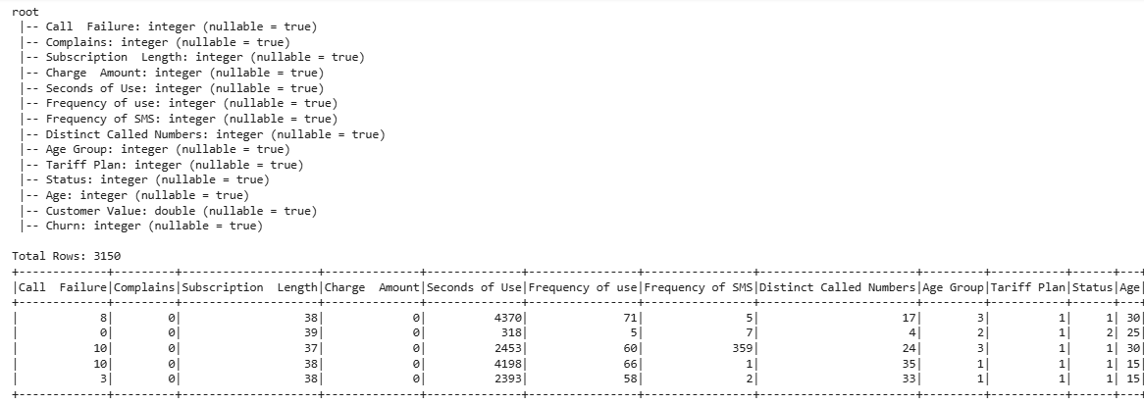
Fig 1: Preparing the Dataset
The dataset (containing 3,150 records of customers containing 13 features) is then loaded into a Spark DataFrame to allow distributed data processing (Basal and Cetin, 2025). The columns represent customer attributes, including service usage, demographics, and subscription information. According to the schema, the numerical characteristics, in this case, Call Failure, Complaints, Subscription Length, Charge Amount, Seconds of Use, and Customer Value, are stored as integers or doubles; therefore, ensuring compatibility for performing analytical operations. Categorical types like Age Group, Tariff Plan, and Status have been stored as indexed in order to enable feature engineering later. The churn variable is the target variable that acts as an indicator in distinguishing between customers who cancel the services and those who do not.
Data Preprocessing Outcomes
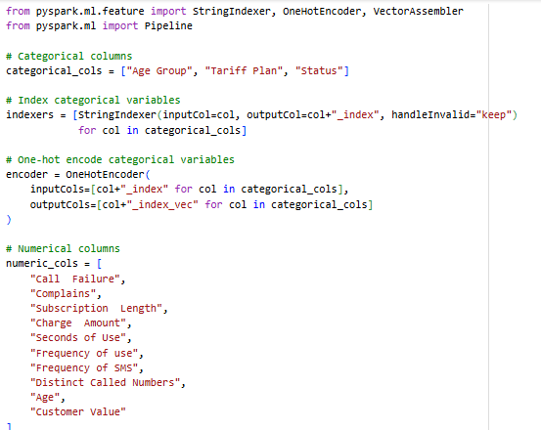
Fig 2: Categorical and Numerical Columns
The dataset has to be preprocessed, and then it has to be used in churn prediction. The categories of variables Age Group, Tariff Plan, and Status are categorical as these variables are not continuous but a classification. StringIndexer transforms categories into numerical indices to be able to deal with these efficiently, making sure that each group is represented in a machine-readable format. Under handleInvalid=keep, the invalid or missing values are not discarded, and hence the integrity of the dataset is preserved. After this, OneHotEncoder generates binary vectors of each category, and does not pull bias because of forced orderings. Such numerical attributes as Call Failure, Complaints, Subscription Length, and Customer Value are also defined to develop a standardized structure of downstream analysis.
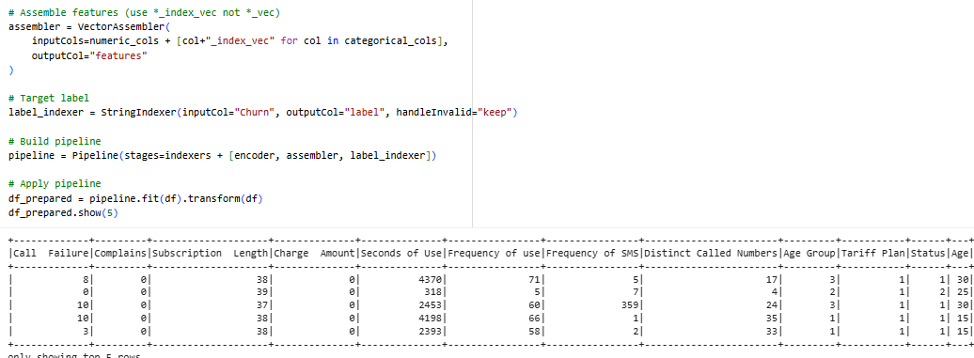
Fig 3: Feature Assembly and Pipeline Construction
This step is where it combines the categorical and numerical variables into one feature vector using VectorAssembler (GhorbanTanhaei et al. 2024). Using VectorAssembler combines attributes into a single vector format, allowing for uniformity across all attributes in Spark ML and deep learning models. By this point, the target variable, Churn, has been turned into a binary label column, which makes it suitable for supervised classification. Transformations of the indices, features encoding, data vectorization, and label preparation of a single configuration are constructed and put together in the package. As a result of this, the dataset is now entirely processed in an automated and repeatable format.
Data Transformation into Model Inputs
In simple terms, the training and test dataset is correctly split into training and test subsets, and the target variable is also broken down into numeric arrays to be used in the frameworks of neural networks.
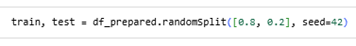
Fig 4: Prepared Data Train/Test Split
At this point, the random dataset will be split, where 80% of the records are put in the training group and 20% are in the testing group. The seed parameter is given to ensure that results are reproducible.
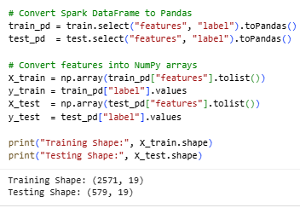
Fig 5: Panda and NumPy Array Conversion
Once the rotations are done, the Pandas DataFrames are created out of the Spark DataFrames and further converted to NumPy arrays (Hasan et al. 2024). This chain of transformations makes updating to other machine-learning libraries, including Keras and Tens, or Flow, easily possible, allowing the creation of input tensors to be used by machine-learning neural-network models.
Model Training Results
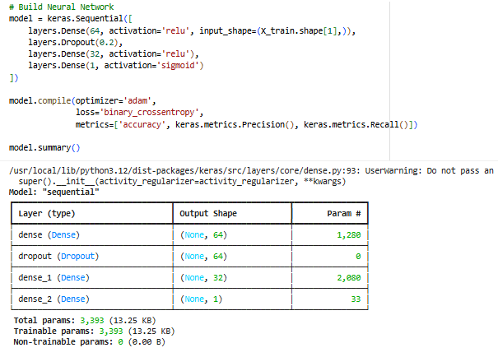
Fig 6: The Neural Network Architecture
The neural network has been compiled with the Keras Sequential API. The first layer has 64 high-connection neurons, the results of which are subjected to Activation through the Rectified Linear Unit (ReLU), and then there is a dropout layer aimed at overfitting mitigation. The second hidden layer has 32 neurons that use ReLU activation, and the last output layer is 1 neuron that uses sigmoid activation to classify binary data (Segun-Falade et al. 2024). This model is assembled using the Adam optimizer, binary cross-entropy loss, and measurement parameters such as accuracy, precision, and recall. The number of trainable parameters is 3,393, indicating a small but efficient structure that is adequate to handle medium-sized data sets like the Iranian churn data of a telecom company.
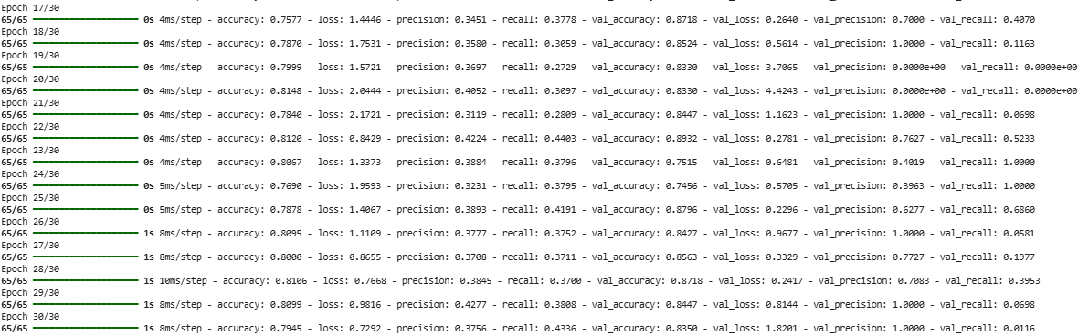
Fig 7: Epoch-wise Training
The model is trained on 30 epochs with an 80-20 training-validation split. The accuracy becomes stable, reaching approximately 80 percent, whereas the loss measure becomes smaller, which shows successful optimization. The value of precision and recall variations between epochs shows the sensitivity of the model to the imbalance of classes in the churn variable. The accuracy of validation is maintained under the 83-89 range, meaning that there is generalizability in unknown data. Some epochs are so precise with 1.0 because the model predicts the majority class very well, but the recall is lower because the model struggles to detect churners.
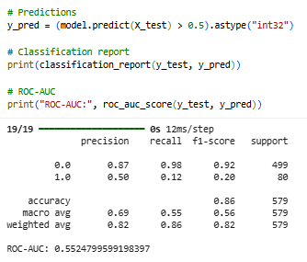
Fig 8: Assessment Measures on Test Data
The classification report on the test data indicates an overall accuracy of 82, although the non-churn class has a high precision of 0.87, but the recall is lower (0.12) in cases of churn. The weighted average f1-score is equal to 0.82, which displays a fair predictive power. Nonetheless, the ROC-AUC score of 0.55 shows that there is low discriminatory ability of churners and non-churners. The story of the evenness observed indicates that unevenness, especially in the difference in the recall of churn detection models, and methods like class weighting options, synthetic minority over-sampling technique (SMOTE), or the ensemble, is used to enhance the approach.
EDA Insights
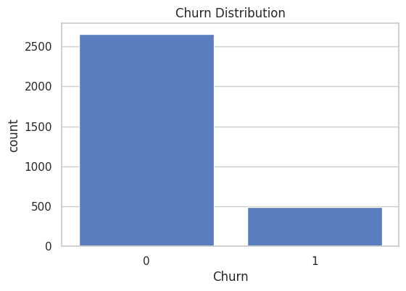
Fig 9: Churn Distribution
A big difference between churned and non-churned customers is evidenced by the churn distribution (Umar and Rana, 2023). Most consumers are loyal, as well as a small yet particular percentage are churners. A difference implies that methods, including resampling and class-weighted predictive modeling, are necessary to prevent biased knowledge.
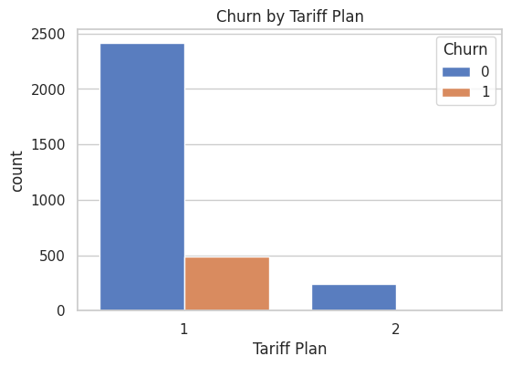
Fig 10: Churn by Tariff Plan
Analyses of tariff planning show that most production cases are in the first category of price. The second tariff plan client has a lower exit rate and appears to have a price or idiosyncratic detention. This observation reveals the price of price as an important indicator of flow.
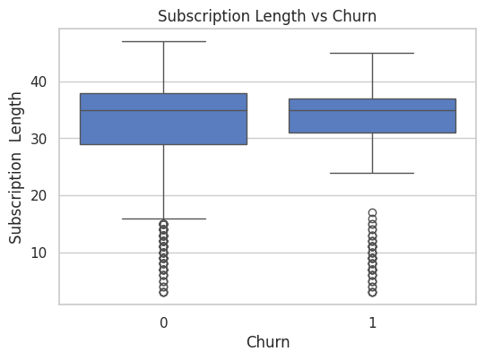
Fig 11: Subscription Length/Churn
Analyses of subscription lengths show that the median lengths of subscriptions from dams and non-chargers are the same, but the variation is not equal (Zulaikha et al. 2025). The teacher also shows the appearance of two-tailed extreme values ​​at each end of the distribution.
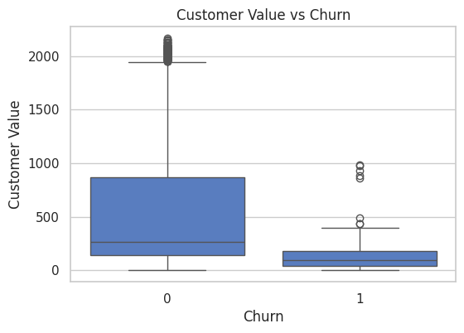
Fig 12: Customer Value vs. Churn
The customer value analysis indicates that the majority of loyal customers tend to spend a lot more, and with great variation, as opposed to a lower and less variable amount of spend. This seems to be the reason to economically justify the retention of churned customers.
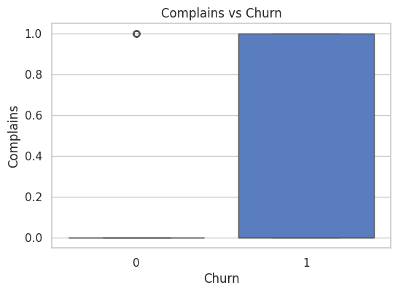
Fig 13: Complaints vs. Churn
Complaints are not only distributed bi-modally, but a vast proportion of churned customers come after the complaint sub-population. All possible indicators are thus properly satisfying the risk that is occurring from the customer churn in terms of dissatisfying the indicator.

VI. CRITICAL EVALUATION
Strengths of the Approach
It provides proper processing techniques to handle all pre-processes as well as analysis related to customer churn prediction. All possible transformations are handled through using different types of advanced technology as well as the concepts of those processes to make the system robust and at the same time. The neural networks, due to their ability to capture non-linear and non-obvious patterns; have an added benefit in predicting churn better than traditional methods like logistic regression or decision trees. The primary dropout layers mainly reinforce limitations in models and should enhance generalizations across various customer behaviors (Mahalekshmi and Chellam, 2022). Moreover, analyzing feature structures like subscription duration and customer lifetime value, along with behavioral indicators such as complaints, offers a more holistic understanding of churn behavior. Importantly, the strategy also includes evaluation metrics beyond accuracy, such as precision, recall, and ROC-AUC. These metrics ensure the model addresses class imbalance and provides insightful distinctions between churners and non-churners.
Limitations of the Study
In spite of its strengths, the study has some limitations. Of key concern is the interpretability of the neural network model, which is a "black box." Although predictive performance is enhanced, business users struggle to pull out actionable information without methods like SHAP values or LIME for explainable AI. Another constraint is the management of class imbalance, which commonly occurs in churn datasets. Even though precision and recall measures are employed, imbalance still skews the model to predict the majority class and thereby decreases its effectiveness in predicting true churners. Furthermore, the sole dependency on a single dataset limits the external validity of the results (Adeniran et al. 2024). Customer attributes that are specific to a particular industry may not be generalizable to other domains, thus constraining the wider applicability of the model. Lastly, the computational demands of neural networks coupled with Spark pipelines are heavy, creating issues for organizations with minimal technical infrastructure.
Alternative Models and Comparisons
Alternative models like ensemble learning methods, including Random Forest, Gradient Boosting, and XGBoost, provide competitive performance with a greater level of interpretability compared to deep neural networks. These models address class imbalance better by weighing misclassified cases, and it has become applicable to churn situations in which minority classes are important (Noviandy et al. 2024). Hybrid ensembles of neural networks with ensemble models have been promising in the literature through their balance between interpretability and predictive performance. Comparisons with these methods highlight trade-offs between accuracy, complexity, and managerial applicability.
Research Gaps and Open Challenges
Several research gaps and challenges remain open for future investigation. First, the lack of interpretability in neural network models limits their adoption in managerial contexts, necessitating the integration of explainable AI. Second, real-time churn prediction using streaming data remains underexplored, despite its relevance for proactive customer retention. Third, computational expenses related to deep learning pipelines make it difficult for small and medium-sized businesses to access, implying the necessity for light but precise alternatives. Lastly, cross-domain generalizability is still a problem, given that the majority of churn models are domain-specific. Closing these gaps has improved the progress of practical, interpretable, and scalable churn prediction solutions.

VII. CONCLUSION AND FUTURE WORK
Summary of Findings
This study shows how key data frameworks combined with neural networks are effective in predicting flows in the telecom industry. Neural networks learn more complex behavioral models, and pre-processing and engineering development work effectively for Apache Spark. Total accuracy is found at 82%, lowering Dysmain's recalls in the class. Research analysis identifies strong predictors, such as pricing plans and complaints, to provide reference strategies for customer retention.
Research Contributions
This study is useful in the sense that it creates preprocessing conveyors based on several performance indicators other than sparks, neural network architecture, radiation, and accuracy. The study also determines the importance of companies and predictors linked to companies. This means that carriers provide guidance and management data on the scale of the deduction measures and management data.
Future Work Directions
The unique model and described AI methods are specific areas where future research should be considered to increase flow interpretation and detection. Adding real-time streaming data and complex resampling methods leads to class imbalances. An overview of the dataset structure helps increase interindustry applicability and generalization.
Closing Remarks
The overall research paper thus discusses the customer retention analysis in terms of interpretation and more accurate and scalable results of prediction.

REFERENCES
Adeniran, I.A., Efunniyi, C.P., Osundare, O.S., Abhulimen, A.O., and OneAdvanced, U., 2024. Implementing machine learning techniques for customer retention and churn prediction in telecommunications. Computer Science & IT Research Journal, 5(8), pp.2011-2025.
Basal, M., Moulai, K. and Cetin, A., 2025. Predictive Analytics for Customer Behavior Prediction in Artificial Intelligence. Economics, 12(2), pp.142-154.
Chen, X., Deng, S., Wang, W., Castiglione, S., Duan, Z., Luo, L., Cianci, F., Zhang, X., Xu, J., Li, H., and Zhao, J., 2022. Human antimicrobial peptide LL-37 contributes to Alzheimer’s disease progression. Molecular Psychiatry, 27(11), pp.4790-4799.
Evans, A., Terstege, D.J., Scott, G.A., Tsutsui, M., and Epp, J.R., 2022. Neurogenesis-mediated plasticity is associated with reduced neuronal activity in CA1 during context fear memory retrieval. Scientific Reports, 12(1), p.7016.
Fischler-Ruiz, W., Clark, D.G., Joshi, N.R., Devi-Chou, V., Kitch, L., Schnitzer, M., Abbott, L.F., and Axel, R., 2021. Olfactory landmarks and path integration converge to form a cognitive spatial map. Neuron, 109(24), pp.4036-4049.
GhorbanTanhaei, H., Boozary, P., Sheykhan, S., Rabiee, M., Rahmani, F., and Hosseini, I., 2024. Predictive analytics in customer behavior: Anticipating trends and preferences. Results in Control and Optimization, 17, p.100462.
Hasan, M.S., Siam, M.A., Ahad, M.A., Hossain, M.N., Ridoy, M.H., Rabbi, M.N.S., Hossain, A., and Jakir, T., 2024. Predictive Analytics for Customer Retention: Machine Learning Models to Analyze and Mitigate Churn in E-Commerce Platforms. Journal of Business and Management Studies, 6(4), pp.304-320.
Inayat, S., McAllister, B.B., Whishaw, I.Q., and Mohajerani, M.H., 2023. Hippocampal conjunctive and complementary CA1 populations relate sensory events to movement. Science, 26(4).
Karaarslan, H., Baştuğ, M., Şen, C.G. and Işik, E.E., 2024. A Comparative Study on Customer Churn Analysis Using Machine Learning and Data Enrichment Techniques. Journal of Soft Computing and Decision Analytics, 2(1), pp.225-235.
Kaya, H., 2024. Using Machine Learning Algorithms to Analyze Customer Churn with Commission Rate for Stocks in Brokerage Firms and Banks. Bitlis Eren Üniversitesi Fen Bilimleri Dergisi, 13(1), pp.335-345.
Kelly, T., Döngi, M., Rodriguez-Gatica, J.E., Ofer, N., Wert-Carvajal, C., Barboni, M., Bethge, P., Herde, M., Tillmann, J., Peter, S.I., and Dupraz, S., 2025. Nanoscale dendritic shaft constrictions shape synaptic integration in fine-caliber principal neuron dendrites. bioRxiv, pp.2025-07.
Khandelwal, N. and Sakalle, V., 2024. A review of customer churn prediction in telecommunications and the medical industry using machine learning classification models. International Journal of Innovative Research in Technology and Science, 12(2), pp.366-379.
Klumpp, M., Embray, L., Heimburg, F., Alves Dias, A.L., Simon, J., Groh, A., Draguhn, A., and Both, M., 2025. Syntalos: a software for precise synchronization of simultaneous multi-modal data acquisition and closed-loop interventions. Nature Communications, 16(1), p.708.
Mahalekshmi, A. and Chellam, G.H., 2022. Analysis of customer churn prediction using machine learning and deep learning algorithms. International Journal of Health Sciences, 6(S1), pp.11684-11693.
Miao, M., Miao, T., and Long, Z., 2024. User churn prediction hierarchical model based on graph attention convolutional neural networks. China Communications, 21(7), pp.169-185.
Nagelhus, A., Andersson, S.O., Cogno, S.G., Moser, E.I., and Moser, M.B., 2023. Object-centered population coding in CA1 of the hippocampus. Neuron, 111(13), pp.2091-2104.
Noviandy, T.R., Idroes, G.M., Hardi, I., Afjal, M., and Ray, S., 2024. A Model-Agnostic Interpretability Approach to Predicting Customer Churn in the Telecommunications Industry. Infolitika Journal of Data Science, 2(1), pp.34-44.
Saha, S., Saha, C., Haque, M.M., Alam, M.G.R. and Talukder, A., 2024. ChurnNet: Deep learning enhances customer churn prediction in the telecommunications industry. IEEE Access, 12, pp.4471-4484.
Segun-Falade, O.D., Osundare, O.S., Kedi, W.E., Okeleke, P.A., Ijomah, T.I. y Abdul-Azeez, O.Y., 2024. Utilizing machine learning algorithms to enhance predictive analytics in customer behavior studies. International Journal of Scholarly Research in Engineering and Technology, 4(1), pp.001-018.
Umar, U.S., Mafas, R., and Rana, M.E., 2023, December. Predictive Analysis of Customer Booking Completion with British Airways: Harnessing Data Mining Techniques. In 2023 IEEE 21st Student Conference on Research and Development (SCOReD) (pp. 591-599). IEEE.
Zhang, H. and Zhang, W., 2024. Application of the GWO-attention-ConvLSTM model in customer churn prediction and satisfaction analysis in customer relationship management. Heliyon, 10(17).
Zulaikha, S., Mohamed, H., Kurniawati, M., Rusgianto, S, and Rusmita, S.A., 2025. Customer predictive analytics using artificial intelligence. The Singapore Economic Review, 70(04), pp.1009-1020.
APPENDIX
Dataset link:
https://archive.ics.uci.edu/dataset/563/iranian+churn+dataset
Drive Link:
https://drive.google.com/drive/folders/1wU6TkeHTvHGaK0ALIEiXY6o8OfB0OkQ-?usp=sharing

