Satellite Dataset Analysis Report

Based on UCS Satellite Database

Generated by: Your Name

Date: 2025-08-30

# Executive Summary

This report provides an analysis of the UCS Satellite Database. Key insights include:  
- The top countries operating satellites.  
- Yearly launch trends.  
- Orbit classifications and distribution.  
- Statistics on satellite mass, lifetime, and power.

# Dataset Overview

Total records: 7562

Total columns: 18

Key columns include satellite name, operator, purpose, orbit class, launch date, and mass.

## Missing Values (Top 10)

power_watts: 7334 missing

expected_lifetime_yrs: 2112 missing

apogee_km: 1377 missing

perigee_km: 1352 missing

launch_mass_kg: 1079 missing

type_of_orbit: 653 missing

period_minutes: 59 missing

inclination_degrees: 6 missing

launch_year: 5 missing

date_of_launch: 5 missing

# Top Countries by Number of Satellites

|  |  |
| --- | --- |
| Country | Number of Satellites |
| USA | 5165 |
| United Kingdom | 651 |
| China | 617 |
| Russia | 181 |
| Japan | 87 |
| ESA | 63 |
| Multinational | 63 |
| Canada | 60 |
| India | 59 |
| Luxembourg | 57 |

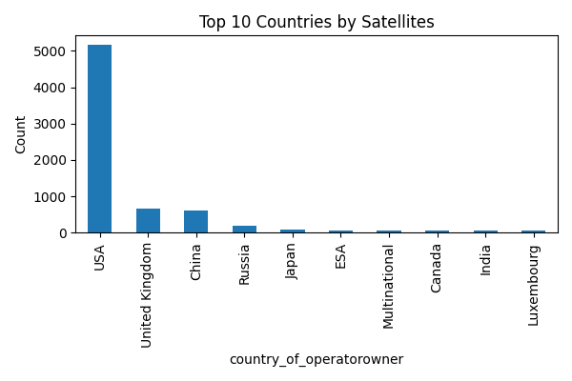

# Launch Trends Over Time

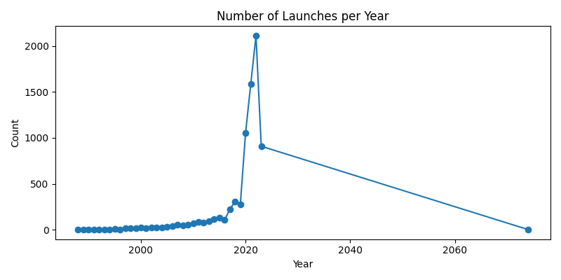

# Orbit Distribution

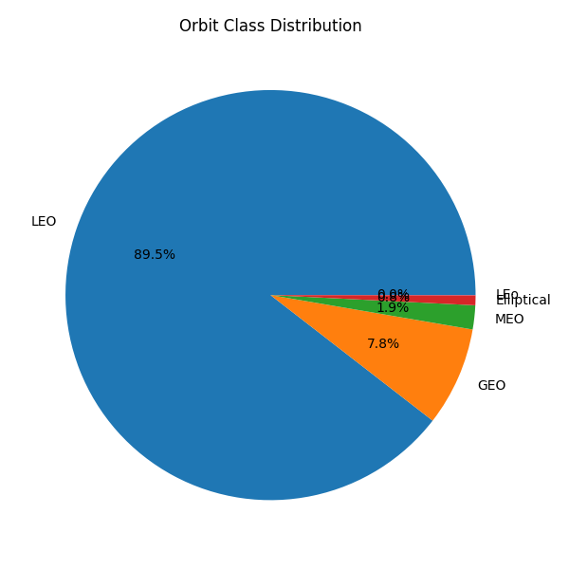

# Satellite Mass & Lifetime Statistics

|  |  |  |
| --- | --- | --- |
| Stat | launch_mass_kg | expected_lifetime_yrs |
| count | 6483.00 | 5450.00 |
| mean | 225.14 | 5.35 |
| std | 157.63 | 3.42 |
| min | 1.00 | 0.25 |
| 25% | 148.00 | 4.00 |
| 50% | 260.00 | 4.00 |
| 75% | 260.00 | 5.00 |
| max | 980.00 | 30.00 |