**1. Introduction**

The Skill Set Assessment System is a network based standalone application designed to evaluate the various skill sets of the employees' of the company. The admin has the right to add, delete or modify details about employees', examinations, questions and feedback. The examination will be conducted in a controlled environment. The employees’ have to login with their Employee IDs’ and the passwords provided by the company. The software provides the employees with tutorials and test guidelines making it user friendly. A feedback form is provided at the end which takes the employees' input regarding their experience of using the tool and seeks for suggestions for improving the same.

The Skill Set Assessment System is being developed using C# (pronounced as C Sharp) in .NET Framework. The backend being used is SQL Express where all the database tables for the Skill Set Assessment System will be stored. The GUI is designed using Windows Forms, while ADO.NET is being used for connecting forms to the databases.

* 1. **Objective**

To build a network based standalone application that tests the skills of the employees of the company in various fields. The employees are evaluated based on their performances in the various tests they give.

* 1. **Problem Statement**

Skills Assessment Set System is used primarily to evaluate the skills of the employees of the company. In this there will be two users: Admin and Employee. While working with the Skill Set Assessment System, the user has to first login either as an employee or an admin.

The Employee uses this system to give a test which will assess his/her skills. After an Employee has logged in, he has an option of either taking a tutorial for the test or skipping it. The tutorial is used to help the employees get familiarized with the user interface. If the Employee wishes to skip the tutorial, he can do so. After the tutorial, the Employee will be given a few instructions and then the test will start. The test will contain numerous questions of various types including fill in the blank, match the following, and multiple choice type questions which may either be text based or image based. The test will be timed and a timer will be set at the top of the screen. The Employee will be able to bookmark questions for future reference. At the end of the tests, the employees will have to answer some feedback questions. The result of the test will be available to the employee after the submission of the test. On the basis of the test, his skills will be assessed.

The Admin uses this system for a variety of functions including adding and altering employee details, exam details, exam-type, feedback questions and question papers. The Admin can add new employees or alter any information related to the employees. He also creates a question bank and keeps adding or altering questions if necessary. He also has to schedule the exam. The Admin sets the paper for that exam stating the number of questions from the various sections. He can access the detailed report of the test which he can use to assess the skills of the employees.

The Admin is responsible for evaluating the answers of the feedback questions. He has the sole rights to add another employee and differentiate whether he is a trainee or an admin.

* 1. **Methodology Used**

We are using the Object Oriented approach for the implementation of this project using the MVC (Model View Controller) architecture. We have used the MVC architecture as it brings modularity to the project making it easier to detect and remove errors and also to add new modules.

## 2. LITERATURE SURVEY

In the literary survey that we conducted, we went through the following systems analyzing their features, thus helping us to understand the requirements of an examination system better.

**Online Exam for Acelentia Consulting**

The Online Exam for Acelentia Consulting [10]is a website using which institutes can register and host online exams. They just have to register on the site and enter the exam details and the lists of the students which can appear in the exam. Students can give exam without the need of going to any physical destination. They can view the result at the same time. Thus the purpose of the site is to provide a system that saves the efforts and time of both the institutes and the students.

The website will allow access only to authorized users with specific roles (Administrator- maintains the website, Institutes-Register to conduct the exams, Students-Give the exams online). The major functions that the system provides includes facility for institutes to register to conduct a online test, Institutes can enter the number of questions, positive and negative marking, questions, options, answers, the list of eligible students, login for student using which he/she can give the tests, mark for review option, stop for a while option.

**Online Examination System at DLW training Centre**

The website at DLW training centre[11]will allow access only to authorized users with specific roles (Administrator- maintains the website, Institutes-Register to conduct the exams, Students-Give the exams online). The website provides facility for institutes to register to conduct an online test, Institutes can enter the number of questions, positive, negative marks, questions and answers and the list of eligible students, Students can login and give the tests. Since the DBMS being used is MS Access 2000, which is not a very popular DBMS, it will not be able to store a very huge number of records. Due to limited features of DBMS being used performance tuning features will not be applied to the queries and thus the system may become slow with the increase in number of records being stored.

**Online Examination System for Tilak Maharashtra University**

This system for Tilak Maharashtra University [12] was launched basically to conduct long distance education. The System has been developed as a website. The website has been developed as a common Internet-based portal for students, admission office, examination office, Study center Authority, Examination supervisors, Examiners/Moderators etc. Basically the two users of this system are the center head (The head of a particular center) and the exam supervisor. The center head is required to register him/her on the website. The menus common to both the users after login are Change Password, Edit My Profile, Edit My Identification and Sign Out. The Center head has additional functionalities like Authorize Exam Session, Terminate Exam Session and the Exam Supervisor’s additional features include View Student List, Print Admission Form and Start Exam Session.

**Online Examination**

**International School of Informatics and Management**

This Web Application for International School of Informatics and Management [13] provides facility to conduct online Examination worldwide. It saves time as it allows number of students to give the exam at a time and displays the results as the test gets over, so no need to wait for the result. It is automatically generated by the server. Administrator has a privilege to create, modify and delete the test papers and its particular questions. User can register, login and give the test with his specific id, and can see the results as well. In this, the user needs a web-based system, which will remove all the above-mentioned problems that, the user is facing. The user wants a web-based system, which will reduce the bulk of paperwork, provide ease of work, flexibility, fast record finding, modifying, adding, removing and generating the reports. They assumed that the user has complete knowledge of the system that means user is not a naïve user. Any data entered by him/her will be valid.

As far as the usability is concerned, the links were provided for each form. The user is facilitated to view and make entries in the forms. Validations were provided in each field to avoid inconsistent or invalid entry in the databases. Some forms consist of Hyper Links, which provide further details. Reports screen containing text boxes and drop down lists, so that reports can be produced.

From the security perspective, application will allow only valid users to access the system. Access to any application resource will depend upon user’s designation. There are two types of users namely Administrator and Student. Security is based upon the individual user ID and Password. User interface is only in English i.e. no other language option is available. User can login only with his assigned username and password i.e. no guest facility is available.

Skill Set Assessment System has most of the above mentioned functionalities in it. It has two types of users which have authenticated access to the tool. Also the result is system generated and spontaneous. But unlike all the above mentioned Online Examination Systems (except the one for International School of Informatics and Management), Skill Set Assessment Tool is a software based system and not a website. However the upper hand our system has that it can be run both as standalone application as well as an online application. As the Skill Set Assessment System is being developed for Hexaware Technologies Ltd., the requirements are accordingly framed. As the examination will be conducted in a controlled environment, the chances of cheating are reduced to a great extent.

We are using SQL Express as our backend which overcomes the problems of MS Access that were faced by Online System developed at DLW training center. The additional features that we are planning to implement in our system which aren’t present in many of the existing systems are multimedia support and disabling of background application while using the Skill Set Assessment System. There is also a feature to configure the number of attempts permitted for each exam.

# 3. Requirement Analysis

* 1. SRS Document

# 3.1.1 Introduction

## 3.1.1.1 Purpose

This document gives detailed functional and non-functional requirements for implementing the SKILL SET ASSESSMENT SYSTEM. The purpose of this document is that the requirements mentioned in it should be utilized by software developer to implement the system.

## 3.1.1.2 Document Conventions

The SRS document has been drafted according to the IEEE format.

## 3.1.1.3 Intended Audience

The intended audiences of this document are programmers who are contributing to the designing of the assessment system & the end users who will use the system.

## 3.1.1.4 References

IEEE format 830 1998 template www.wikipedia.org/wiki/Software_requirement_specification.

# 3.1.2 Overall Description

## 3.1.2.1 Product Perspective

The application is a software product integrated with the LMS of Hexaware Technologies Ltd.

## 3.1.2.2 Product Functions

Skill Set Assessment System provides the following functions:

To the **Employee**:

|  |  |
| --- | --- |
| 1 | Login to the system using the Employee ID and password provided by Hexaware Technologies Ltd. |
| 2 | Perform the tests in the controlled environment. |
| 3 | Bookmark questions for further reference. |
| 4 | Fill the feedback form. |

To the **Administrator**:

|  |  |
| --- | --- |
| 1 | Login to the system through the Employee ID and password provided by Hexaware Technologies Ltd. as an Admin. |
| 2 | Schedule the test. |
| 3 | Modify the employee database. |
| 4 | Set the paper by selecting random questions from different categories. |
| 5 | View detailed reports of the results. |
| 6 | Update the question bank. |

## 3.1.2.3 User Classes and Characteristics

There are two types of user classes:

**Employee**

The trainee can login to the system in the controlled environment using his Employee ID and password provided by the company. He can go through the tutorials to get acquainted with the tool. He can bookmark questions during the test for further reference. After the test he can view his score. Later he can fill the feedback form to help improve the system.

**Admin**

The admin can access his own page by logging in with the Employee ID and password. He can schedule tests, inform the employees about the same through mail. He can add, and delete employees from the database. He also has an option of bulk upload and bulk delete. He can view detailed reports about the results. He sets the paper by specifying the number of questions of different sections, formats and marks. He can upload and delete questions from the question bank.

## 3.1.2.4 Operating Environment

The application uses Network operating system provided by the LMS of the Hexaware Technologies Ltd.

## 3.1.2.5 User Environment

The Users are expected to have Windows Operating System.

## 3.1.2.6 Design and Implementation Constraints

* RAM requirement of minimum 256 Mb.
* Windows Operating System

# External Interface Requirements

## 3.1.3.1 User Interfaces

**Employee Interface**: The user interface at the employee end is basically a Windows Form Application through which he can login, appear for the tests and view results.

**Admin Interface**: The Admin uses this interface to login as well as manage the various databases and also to set up a paper.

## 3.1.3.2 Hardware Interfaces

* 1024x768 or higher resolution screen.
* Integration with the LMS of Hexaware Technologies Ltd.

## 3.1.3.3 Software Interfaces

* Windows XP Operating System or above.
* SQL Express.
* Adobe Flash Player
* Adobe Photoshop

## 3.1.3.4 Communication protocols and Interfaces

## The Skill Set Assessment System is a Network based standalone application using the client server model for communication. The communication interface is a Windows Form Application through which the admins and the employees can login using their respective usernames and passwords. The user interface consists of many GUI elements such as text-boxes, dropdown menus, radio buttons, check-boxes etc., making it user friendly.

# System Features

# Use Case Names

# Use Case: UC 1.0 Admin

|  |  |
| --- | --- |
| **Use Case Name** | **UC 1.0.1 Login** |
| **Trigger** | The user opens the Skill Set Assessment System. |
| **Basic Path** | * The user enters the Employee ID and password,selects the Admin radio button and then clicks on login. |
| **Post-condition** | The user is logged in and can access the available functionalities. |
| **Alternate flow** | The user has entered data incorrectly. |

|  |  |
| --- | --- |
| **Use Case Name** | **UC 1.0.2 Add Exam Type** |
| **Trigger** | The user navigates to Exam Type and then chooses Add Exam Typeoption and clicks on Next. |
| **Precondition** | The user must have logged in as admin. |
| **Basic Path** | * The user navigates to Exam Type and chooses Add Exam. * He enters the Subject, Level and the Number of Attempts permitted and clicks on the add button. |
| **Post-condition** | The changes are recorded in the database and then a message box showing “Exam Type Successfully added” is displayed. |
| **Alternate flow** | The user is not logged in as admin. |
| **Use Case Name** | **UC 1.0.3 Add Question** |
| **Trigger** | The user navigates to Questions and chooses Add Question. |
| **Precondition** | The user must have logged in as admin. |
| **Basic Path** | * The user navigates to Questions and chooses Add Question. * The user enters the exam type, question, options, solution, marks, format and the section and clicks on the add button. |
| **Post-condition** | The changes are recorded in the database and a message box showing “Question Successfully added” is displayed. |
| **Alternate flow** | The user is not logged in as admin. |

|  |  |
| --- | --- |
| **Use Case Name** | **UC 1.0.4 Add Employee.** |
| **Trigger** | The user navigates to Employee and chooses Add Employee.. |
| **Precondition** | The user must have logged in as admin. |
| **Basic Path** | * The user navigates to Employee and chooses Add Employee.. * The user enters the Employee ID, Name of the Employee, Birth date, Title of Courtesy, Hire date, Address, City, Region, Postal Code, Country and Mobile number of the Employee to be added. * The user clicks on the add button |
| **Post-condition** | The changes are recorded in the database and a message box showing “Employee Successfully added” is displayed. |
| **Alternate flow** | The user is not logged in as admin. |

|  |  |
| --- | --- |
| **Use Case Name** | **UC 1.0.5 Alter Employee** |
| **Trigger** | The user navigates to Employees and then chooses Alter Employees. |
| **Precondition** | The user must have logged in as admin and entry of the employee whose information is to be altered should be already present in the database. |
| **Basic Path** | * The user navigates to Employees and then choosesAlter Employees. * The user has to choose whether to update or delete and employee. * If he chooses to delete an employee, he will enter his Employee ID. * If he chooses update, the user changes one or more of the fields of the Employee, Employee ID, Name of the Employee, Birthdate, Title of Courtesy, Hire date, Address, City, Region, Postal Code, Country and/or Mobile number, to be updated |
| **Post-condition** | The changes are recorded in the database and a message box showing “Employee Update Successful” or “Employee Deleted” is displayed |
| **Alternate flow** | The user is not logged in as admin. |

|  |  |
| --- | --- |
| **Use Case Name** | **UC 1.0.6 Add FeedBackQuestions** |
| **Trigger** | The user navigates to Feedback Questions and chooses Add Feedback Question. |
| **Precondition** | The user must have logged in as admin. |
| **Basic Path** | * The user navigates to Feedback Questions and chooses Add Feedback Question. * The user enters the Feedback questions and clicks on Add. |
| **Post-condition** | The changes are recorded in the database and a message box showing “Employee Update Successful” is displayed. |
| **Alternate flow** | The user is not logged in as admin. |

|  |  |
| --- | --- |
| **Use Case Name** | **UC 1.0.7 Add Exam** |
| **Trigger** | The user navigates to Exam and chooses Add Exam. |
| **Precondition** | The user must have logged in as admin. |
| **Basic Path** | * The user navigates to Exam and chooses Add Exam * The user enters the Exam Type, Date, Time and the Number of Applicants for that examination. * The user clicks on the Add button. |
| **Post-condition** | The changes are recorded in the database and then a message box showing “Exam Successfully added” is displayed. |
| **Alternate flow** | The user is not logged in as admin. |

|  |  |
| --- | --- |
| **Use Case Name** | **UC 1.0.8 Alter Feedback Questions** |
| **Trigger** | The user navigates to Feedback Questions and chooses Alter Feedback Question. |
| **Precondition** | The user must have logged in admin and there must be a correspondingfeedback questions previously added. |
| **Basic Path** | * The user navigates to Feedback Questions and chooses Alter Feedback Question. * The user has two options, whether to update or delete the feedback questions. * If the user chooses to update a question, an existing question will be modified. The user clicks on the update button. * If the user chooses to delete a question, he will enter the Question ID and that corresponding question will be deleted. |
| **Post-condition** | The changes are recorded to the database and a message box showing “Feedback Question Update Successful” or "Deleted Question" is displayed. |
| **Alternate flow** | The user is not logged in as admin. |

|  |  |
| --- | --- |
| **Use Case Name** | **UC 1.0.9 Alter Exam** |
| **Trigger** | The user navigates to Exam and chooses Alter Exam. |
| **Precondition** | The user must have logged in as administrator and the Exam whose details are to be altered must be already present in the database. |
| **Basic Path** | * The user navigates to Exam and chooses Alter Exam. * The user will have to choose whether to update exam type or delete exam type. * The user clicks on Update Examination Button. The user can modify one or more than one fields. (Exam Type, date, time, number of applicants, highest score, lowest score and the average score.) * The user clicks Delete Examination Button. The user can delete any Exam Type. |
| **Post-condition** | The changes are recorded in the database and then a message box showing “Exam Successfully Updated” or “Exam Successfully Deleted” is displayed. |
| **Alternate flow** | The user is not logged in as admin. |

**Use Case: UC 2.0 Trainee**

|  |  |
| --- | --- |
| **Use Case Name** | **UC 2.0.1 Login** |
| **Trigger** | The user opens the Skill Set Assessment System. |
| **Basic Path** | * The user enters the Employee ID and password and selects the Employee radio button and then clicks on submit. |
| **Post-condition** | The user is logged in and can access functionalities available to Employee. |
| **Alternate flow** | The user has entered data incorrectly. |

|  |  |
| --- | --- |
| **Use Case Name** | **UC 2.0.2 Take Tutorial** |
| **Trigger** | The user clicks on the Take Tutorial button. |
| **Precondition** | The user must have logged in as Employee. |
| **Basic Path** | * The user clicks on the Take Tutorial button. * The user goes through the tutorials for the examination. * The user then clicks on the next button. |
| **Post-condition** | The page containing the instructions for the exam opens up. |
| **Alternate flow** | The user can skip the tutorial by clicking on the Skip Tutorial button and go directly to the instruction page. |

|  |  |
| --- | --- |
| **Use Case Name** | **UC 2.0.3 Give Test** |
| **Trigger** | The user clicks the Start Test button. |
| **Precondition** | The user must have logged in as Employee and should have gone through the instructions for the test. |
| **Basic Path** | * The user clicks on Start Test. He can mark answers, bookmark questions, view bookmarks, and scroll though questions in the stipulated test time. |
| **Post-condition** | The result of the test is displayed. |

|  |  |
| --- | --- |
| **Use Case Name** | **UC 2.0.4 Bookmark Question** |
| **Trigger** | The user clicks on the Bookmark Question button. |
| **Precondition** | The user must have logged in as Employee and must have started with the test. |
| **Basic Path** | * The user clicks on the Bookmark Question button for later reference to the question. * The user can review these questions once the test is done. |
| **Post-condition** | The user cansee the question in Bookmarks. |
| **Alternate flow** | The test is not started. |

|  |  |
| --- | --- |
| **Use Case Name** | **UC 2.0.5 Give Feedback** |
| **Trigger** | The user clicks the next button after having submitted the test. |
| **Precondition** | The user must have logged in as Employee and must have submitted the test. |
| **Basic Path** | * After submitting the paper, the user clicks the next button. * The user then answers the feedback questions. * The user clicks on the next button. |
| **Post-condition** | The Feedback answers are stored in the database. |
| **Alternate flow** | The user can click the next button without answering the questions. |

* + 1. **Other Nonfunctional Requirements**

## 3.1.5.1 Performance Requirements

The PCs used must be at least Pentium 4 machines so that they can give optimum performance of the product.

## 3.1.5.2 Safety Requirements

If for some reason the application gets closed accidentally or with any malicious intent in between a test, a new test can be started for the employee. As the questions for every test is selected in a random manner from the database, the integrity of the test is maintained.

## 3.1.5.3 Security Requirements

The user should be either an employee or the assigned admin of the Hexaware Technologies Ltd. They should login with the unique username provided to them by the company.

## 3.1.5.4 Software Quality Attributes

**Confidentiality**: - This application provides confidentiality by allowing only registered administrators to access the database.

**Maintainability**: - The cost of maintenance is very low. The modules are easily manageable because of the MVC architecture.

**Scalability**: - This application is highly scalable. It is easy to add new features to the application and also add different service related information to the database because of the MVC architecture.

**Usability**: - The application has an interface which is user friendly and anyone can use the application easily.

* 1. **UseCase Diagram**

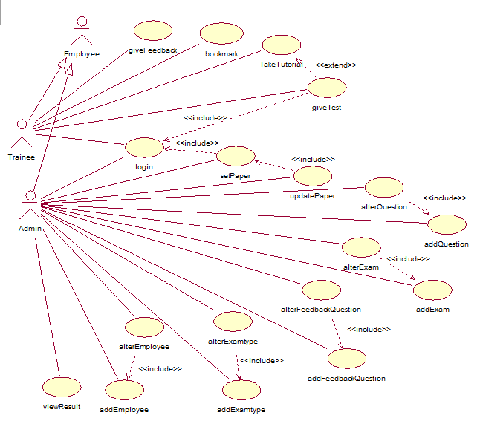

* 1. **Business Flow Diagram**

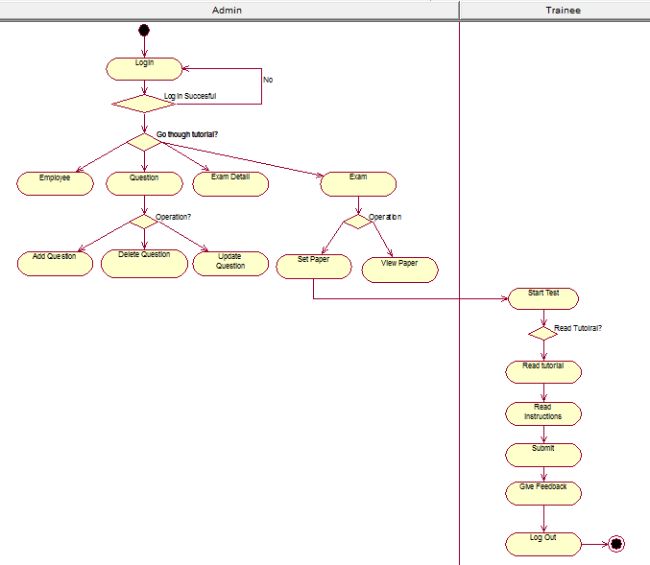

* 1. **Activity Diagram for giveTest**

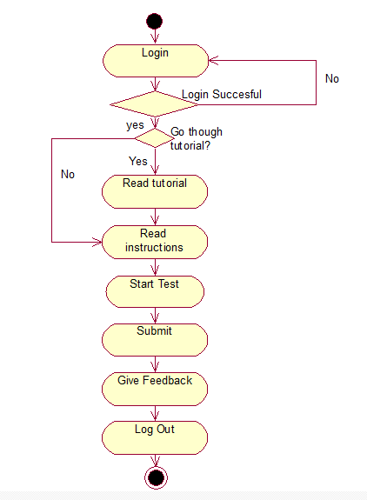

**4. Design**

**4.1Class Diagram**

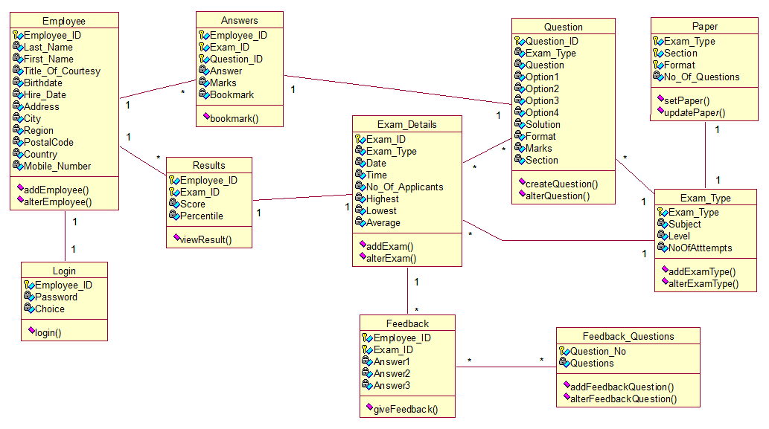

**4.2 Database Schema**

**Employee**

|  |  |  |  |  |
| --- | --- | --- | --- | --- |
| **Sr. No.** | **Attribute** | **Data Type** | **Constraint** | **Domain** |
| 1 | Employee_ID | Varchar | Primary Key | ET001. |
| 2 | Last_Name | Varchar | Not Null | A valid String. |
| 3 | First_Name | Varchar | Not Null | A valid String. |
| 4 | Title_Of_Courtesy | Varchar | Not Null | {Mr,Mrs, Ms,Dr,Shri} |
| 5 | Birthdate | Date | Not Null | **--------** |
| 6 | Hire_Date | Date | Not Null | **---------** |
| 7 | Address | Varchar | Not Null | **---------** |
| 8 | City | Varchar | Not Null | **---------** |
| 9 | Region | Varchar | Not Null | **---------** |
| 10 | Postal_Code | Integer | Not Null | **---------** |
| 11 | Country | Varchar | Not Null | **---------** |
| 12 | Mobile_Number | Integer. | Unique Key | **---------** |
| 13 | Password | Varchar | Unique Key |  |
| 14 | Type | Integer | Not Null | {1,2} |

**Answers**

|  |  |  |  |  |
| --- | --- | --- | --- | --- |
| **Sr. No.** | **Attribute** | **Data Type** | **Constraint** | **Domain** |
| 1 | Employee_ID | Varchar | Primary Key | E001 |
| 2 | Exam_ID | Varchar | Primary Key ,Foreign Key references Exam_Details(Exam_ID) | ED001 |
| 3 | Question_ID | Varchar | Primary Key, Foreign Key references Question(Question_ID) | Q001 |
| 4 | Answer | Varchar | Not Null | **---------** |
| 5 | Marks | Integer | Not Null | {0,1,2,3,4,5} |

**Exam_Details**

|  |  |  |  |  |
| --- | --- | --- | --- | --- |
| **Sr. No.** | **Attribute** | **Data Type** | **Constraint** | **Domain** |
| 1 | Exam_ID | Varchar | Primary Key | ED001 |
| 2 | Exam_Type | Varchar | Not Null | ET001 |
| 3 | Date | Date | Not Null | **---------** |
| 4 | Time | Time | Not Null | **---------** |
| 5 | No_Of_Applicants | Integer | Not Null | **---------** |
| 6 | Highest | Integer | Not Null | {0,1,2,.. ,100} |
| 7 | Lowest | Integer | Not Null | {0,1,2,.. ,100} |
| 8 | Average | Float | Not Null | {0,1,2,.. ,100} |

**Exam_Type**

|  |  |  |  |  |
| --- | --- | --- | --- | --- |
| **Sr. No.** | **Attribute** | **Data Type** | **Constraint** | **Domain** |
| 1 | Exam_Type | Varchar | Primary Key | ET001 |
| 2 | Subject | Varchar | Not Null | **---------** |
| 3 | Level | Varchar | Not Null | **---------** |
| 4 | No_Of_Attempts | Integer | Not Null | {0,1,2,3,4,5} |

**Question**

|  |  |  |  |  |
| --- | --- | --- | --- | --- |
| **Sr. No.** | **Attribute** | **Data Type** | **Constraint** | **Domain** |
| 1 | Question_ID | Varchar | Primary Key | Q001 |
| 2 | Exam_Type | Varchar | Foreign Key references Exam_Type(Exam_Type) | ET001 |
| 3 | Format | Varchar | Not Null | **---------** |
| 4 | Question | Varchar | Not Null | **---------** |
| 5 | Option1 | Varchar | Not Null | **---------** |
| 6 | Option2 | Varchar | Not Null | **---------** |
| 7 | Option3 | Varchar | Not Null | **---------** |
| 8 | Option4 | Varchar | Not Null | **---------** |
| 9 | Solution | Varchar | Not Null | **---------** |
| 10 | Format | Varchar | Not Null | **---------** |
| 11 | Marks | Integer | Not Null | {0,1,2,3,4,5} |
| 12 | Section | Varchar | Not Null | **---------** |

**Results**

|  |  |  |  |  |
| --- | --- | --- | --- | --- |
| **Sr. No.** | **Attribute** | **Data Type** | **Constraint** | **Domain** |
| 1 | Employee_ID | Varchar | Primary Key, Foreign Key references Employee (Employee_ID) | E001 |
| 2 | Exam_ID | Varchar | Primary Key, Foreign Key references Exam_Details (Exam_ID) | ED001 |
| 3 | Score | Varchar | Not Null | {0,1,2,..,100} |
| 4 | Percentile | Integer | Not Null | {0,1,2,. ,100} |

**Feedback**

|  |  |  |  |  |
| --- | --- | --- | --- | --- |
| **Sr. No.** | **Attribute** | **Data Type** | **Constraint** | **Domain** |
| 1 | Employee_ID | Varchar | Primary Key, Foreign Key references Employee (Employee_ID) | E001 |
| 2 | Exam_ID | Varchar | Primary Key, Foreign Key references Exam_Details (Exam_ID) | ED001 |
| 3 | Answer1 | Varchar | Not Null | **---------** |
| 4 | Answer2 | Varchar | Not Null | **---------** |
| 5 | Answer3 | Varchar | Not Null | **---------** |

**Login**

|  |  |  |  |  |
| --- | --- | --- | --- | --- |
| **Sr. No.** | **Attribute** | **Data Type** | **Constraint** | **Domain** |
| 1 | Employee_ID | Varchar | Primary Key, Foreign Key references Employee (Employee_ID) | E001 |
| 2 | Password | Varchar | Primary Key | **---------** |
| 3 | Choice | Character | Not Null | {a,e} |

**Paper**

|  |  |  |  |  |
| --- | --- | --- | --- | --- |
| **Sr. No.** | **Attribute** | **Data Type** | **Constraint** | **Domain** |
| 1 | Exam_Type | Varchar | Primary Key, Foreign Key references Exam_Type (Exam_Type) | ET001 |
| 2 | Section | Varchar | Primary Key | **---------** |
| 3 | Format | Varchar | Not Null | **---------** |
| 4 | No_Of_Questions | Integer | Not Null | {0,1,2,.. , 30} |
| 5 | Bookmark | Boolean | Not Null | {True, False} |

**Feedback_Questions**

|  |  |  |  |  |
| --- | --- | --- | --- | --- |
| **Sr. No.** | **Attribute** | **Data Type** | **Constraint** | **Domain** |
| 1 | Question_No | Number | Primary Key | {0,1,2,3 } |
| 2 | Question | Varchar | Not Null | **---------** |

**4.3 User Interface Design**

**4.3.1 System Block Diagram**

The architecture followed is MVC architecture. Here views, business logic layer, data access layer are segregated. Views consist of the user interface made up of forms. Business Logic Layer consists of the implementation of business logic used in the system. All the validations are carried out in this layer. Data access layer which stands between the business logic layer and data access layer is used to extract data from the database. Instead of passing a huge parameter list for method calls, objects of Entities are used. This simplifies the entire communication between the layers.

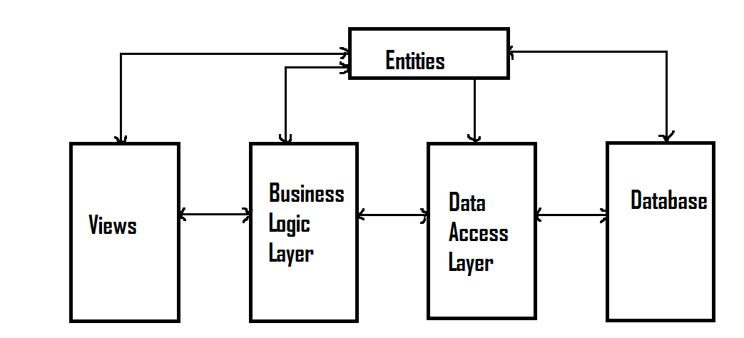

**5. Implementation**

**5.1 Module Description**

**5.1.1 Registration Module:**

This module lets the employees register themselves to the tool. To register, the employee clicks on the register link on the home page. Then a page opens where the employees fill in various fields present. Once an employee gets registered, he/she can give various examinations to which he/she is enrolled for.

**5.1.2 Login Module:**

This module restricts the access of the system only to the authorized users. The user (admin or employee) enter the UserID and the password and selects the type (admin or employee) and clicks on the login button. If the information entered is right, the user gets logged in and can use the system or else the user will have to enter the details once again.

**5.1.3 Admin Management Module:**

The admin management module consists of all the functionalities provided to the admin. The various sub-modules under this module are:

**5.1.3.1 Question Module:**

This module lets the admin manage the database which has all the questions for the examinations stored. This module allows the admin to carry out three operations: Add a question, Update an existing question, and Delete a question from the database.

The question ID is automatically generated by the system and is displayed when the admin clicks on the add employee menu and the corresponding form loads. The admin has to enter the questions and the various options and along with it the subject and section, and format and has to specify the correct answer and the marks to be allocated to that question.

For updating an existing question from the database, the admin has to click on the update question option from the menu. The admin then selects the question from the combobox and clicks on the select button. Then all the details of the question are displayed in a form and the admin changes the fields to be changed and clicks on the update button. Validations are carried out again for all the fields and an error box specifying the faulty entry is displayed in case of an error.

For deleting a question, the admin has to select the delete question option from the menu and selects the question ID of the question to be deleted from the combobox and clicks on the delete button.

**5.1.3.2 Exam Type Module:**

An Exam Type basically declares the various subjects and their difficulty levels for which the test will be conducted (For e.g. Java Level-1). Thus this module lets the admin manage the various exam types, wherein he can add an exam type, update information of an existing exam type or delete an exam type.

For adding an exam type, the admin has to click on the add exam type option from the menu bar. The ID for the new exam type is automatically generated by the system and displayed when the form is loaded. The admin enters the various fields shown in the form and clicks on the add button. Validations are carried out for all the fields and a message box is displayed in case of a failure in validation and the names of the faulty fields are displayed in it.

For updating the details of an existing exam type, the admin has to click on the update exam type option from the menu bar. The admin then selects the exam type which has to be updated from the combobox and clicks on the select button. Then a form consisting of information regarding the exam type is displayed. The admin then makes changes to the fields that are to be changed and clicks on the update button. Validations are carried out for all the fields and a message box is displayed in case of a failure in validation and the names of the faulty fields are displayed in it.

To delete an exam type, the admin has to click on the delete exam type option from the menu bar. Then the admin selects the exam type to be deleted from the combobox and clicks on the delete button.

**5.1.3.3 Exam Details Module:**

This module lets the admin manage the exam details, like the day of examination, the timing etc. The admin can schedule new examinations by using the add exam details option from the Exam Details option from the menu bar. He will be displayed a form with the automatically generated Exam Details ID displayed when the form opens. The admin fills up the various fields and then presses onto the add button. Validation is carried out for all the fields and an error box is displayed in case of an error, specifying the field in which the error has occurred.

To update a particular exam detail, the admin selects the update sub menu from the Exam Detail Menu Item from the menu bar. A form is displayed consisting of a combo box using which the admin selects the exam to be updated and presses on the okay button. Then the admin makes changes to the appropriate fields and clicks on the update button and the update is done.

To delete a particular exam detail, the admin selects the delete sub menu from the Exam Detail Menu Item from the menu bar. A form is displayed consisting of a combo box using which the admin selects the exam to be deleted and presses on the delete button.

**5.1.3.4 Applicants Module:**

This module lets the admin manage the applicants, giving him the option to add/delete an applicant to/from a particular examination. The admin can enroll a particular employee for an examination by selecting the add applicant option from the manage applicants sub item from the Exam Details Menu Item from the menu bar. Then the admin enters the Employee ID and the Exam ID of the examination to which he wants to add the employee to. Then he presses on the add button and thus enrolls the employee to a particular examination.

To delete an employee from a particular examination, the admin first clicks on the delete applicant option from the manage applicants sub item from the Exam Details Menu Item from the menu bar. Then a form loads with a single combobox with entries showing the employee ID and the Exam ID of the examination to which that employee is enrolled to. The admin selects the appropriate entry and clicks on the delete button.

**5.1.3.5 Paper Module:**

This module concerns the management of the question papers for various examinations and lets the admin add, modify, delete and view question papers. To add a paper, the admin selects the Exam Type of the examination and then for various sections, selects the various types of questions and the number of questions of the types to set the paper. The total number of questions selected and the total marks for the test will be displayed at the top of the form. Once the admin is done selecting the questions, he clicks on the add button.

To update a question paper, the admin selects the appropriate entry from the combobox and then makes the necessary changes and clicks on the update button.

To delete a question paper, the admin selects the PaperID of the paper from the combobox and clicks on the delete button.

To view a certain question paper, the admin selects the PaperID from the combobox and then clicks on the view button. Then a form displaying the number of questions for various formats, ExamID and the PaperID is shown.

**5.1.3.6 Feedback Questions Module:**

This module lets the admin add and update the feedback questions. The Feedback form is displayed after the completion of test by an employee and which has a few question regarding the tool and the employees are asked to rate the tool based on their experience.

Now, to add a feedback question, the admin selects the add sub menu from the Feedback Questions menu item from the menu bar. Then a form is displayed with an automatically generated question ID and a text box where the admin enters the question which he wants to be displayed on the feedback form and clicks on the add button.

To modify a question, the admin selects the update sub menu from the Feedback Questions menu item from the menu bar. Then a form containing a combobox is displayed and the admin selects the appropriate entry from the combobox and clicks on the update select button. Then a form with the question is displayed and the admin makes the necessary changes to the question and clicks on the update button.

**5.1.3.7 Results Module:**

This module allows the admin to view the results of the employees who had enrolled for a particular examination. The admin selects the View Result menu from the Exam Details menu item from the menu bar. Then a form will be displayed with a combobox to select the ExamID of the examination of which the admin wants to view the result. Then the admin selects the appropriate entry and clicks on the view button. Then a form will be displayed showing the results of all the employees who had given the test along with their percentages and the highest, lowest and the average scores for that particular examination.

**5.1.4 Employee Management Module:**

The employee management module is basically concerned with the employees who are enrolled for a scheduled test(s). After having logged in the as employees, a form will be displayed showing the employee name, the time and the name of the examination. Then the employee will have an option to either go through the tutorials or skip them. The tutorials will help the user get acquainted with the tool. Then the instruction page will be displayed which will give the employee an overview of the examination process, with the help of snapshots. The employee will be briefed about the various types of questions, the navigation tools and the various other facilities provided by the tool. When an employee when skips the tutorials, the instruction page will be displayed directly. After having gone through the instructions, the employee can start the test. As soon as the employee starts with the examination, the countdown timer starts ticking. During the examination, the employee can move from one question to another using the navigation buttons (previous and next) or by clicking on the question number in the bookmark box. The employee can bookmark questions for later review and can remove the bookmark by clicking on the checkbox in the bookmark box. Once the employee is done with the examination, he/she can submit the test. In case the employee runs out of time, the test will get submitted automatically and the test will be closed. However, any unchecked bookmark will not have any effect on the score as it is only for self-reference. Once the test is submitted, the employee’s score and percentage will be displayed. Then a feedback form will be displayed asking questions regarding the experience of the tool. Then the thank you screen is displayed and the employee logs out of the tool.

1. **Testing**

Development of Test Cases and Methods

Testing Methods

Software Testing is a critical element of software quality assurance and represents the ultimate review of specifications, design and code generation.

Software testing is a process used to help identify the correctness, completeness, security and quality of developed and complete software. With that in mind, testing can never completely establish the correctness of arbitrary computer software. In computability theory, a field of computer science, an elegant mathematical proof concludes that it is impossible to solve the halting problem, the question of whether an arbitrary computer program will enter an infinite loop or halt and produce output. In other words, testing is criticism or comparison, which is comparing the actual value with the expected one.

The learning objectives of testing are:

1. To find uncovered errors based on requirements.
2. Ensure the products are bug free before shipment/release.
3. Quality is ensured.

**TEST CASES :**

|  |  |  |  |  |  |  |
| --- | --- | --- | --- | --- | --- | --- |
| Step No. | Step Case | Pre- Requisites | Test Data | Expected Output | Actual Output | Remarks |
| 1 | Login. | The user must be an employee of Hexaware Technologies Ltd. | The user (admin) enters the correct username, correct password and selects the employee radio button. | A message box with the message “wrong info” is shown. | A message box with the message “wrong info” is shown. | Pass |
| 2 | Login. | The user must be an employee of Hexaware Technologies Ltd. | The user (admin) enters the correct username, correct password and selects the admin radio button. | A message box with the message “wrong info” is shown. | A message box with the message “wrong info” is shown. | Pass |
| 3 | Login. | The user must be an employee of Hexaware Technologies Ltd. | The user (employee) enters the incorrect username and correct password and selects the employee radio button. | A message box with the message “wrong info” is shown. | A message box with the message “wrong info” is shown. | Pass |
| 4 | Login. | The user must be an employee of Hexaware Technologies Ltd. | The user (employee) enters the correct username, correct password and selects the employee radio button. | The user gets logged in to the tool. | The user gets logged in to the tool. | Pass |
| 5 | To add an employee. | The user should be logged into the tool as an admin. | The user enters all the details except for City and Mobile Number. | A message box with the message “Enter proper details for  1. City, 2.Mobile Number” is shown. | A message box with the message “Enter proper details for  1. Mobile Number” is shown. | Pass |
| 6 | To add an employee. | The user should be logged into the tool as an admin. | The user enters all the details properly. | The employee gets added to the database successfully. | The employee gets added to the database successfully. | Pass |
| 7 | To update details of an employee. | The user should be logged into the tool as an admin and the employee details should exist in the database. | The user makes updates to certain fields of a particular employee leaving one of the fields, say Pin Code, empty. | A message box with the message “Enter proper details for  1. Pin Code” is shown. | A message box with the message “Enter proper details for  1. Pin Code” is shown. | Pass |
| 8 | To update details of an employee. | The user should be logged into the tool as an admin and the employee details should exist in the database. | The user makes updates to certain fields of a particular employee making sure all the fields are filled. | The changes are updated successfully to the database and a message box with the message “Update Successful” is shown. | The changes are updated successfully to the database and a message box with the message “Update Successful” is shown. | Pass |
| 9 | To delete entry of an employee from the database. | The user should be logged into the tool as an admin and the employee details should exist in the database. | The user selects the employee ID of the employee from the combobox and clicks on the delete button. | The entry of the employee is deleted from the database and a message box with the message “Successfully Deleted” is shown. | The entry of the employee is deleted from the database and a message box with the message “Successfully Deleted” is shown. | Pass |
| 10 | To add a MCQ (Single Answer)  Question to the database. | The user should be logged into the tool as an admin. | The user selects the type of question to be added and adds the question and fills all the fields correctly. | The question is added successfully to the database and a message box with the message “Question successfully added” is shown. | The question is added successfully to the database and a message box with the message “Question successfully added” is shown. | Pass |
| 11 | To add a MCQ (Multiple Answers)  Question to the database. | The user should be logged into the tool as an admin. | The user selects the type of question to be added and adds the question and fills all the fields correctly. | The question is added successfully to the database and a message box with the message “Question successfully added” is shown. | The question is added successfully to the database and a message box with the message “Question successfully added” is shown. |  |
| 12 | To add a Match The Column  Question to the database. | The user should be logged into the tool as an admin. | The user selects the type of question to be added and adds the question and fills all the fields correctly. | The question is added successfully to the database and a message box with the message “Question successfully added” is shown. | The question is added successfully to the database and a message box with the message “Question successfully added” is shown. | Pass |
| 13 | To add an Exam Type to the database. | The user should be logged into the tool as an admin. | The user enters all the details properly and leaves the subject field blank. | A message box with the message “Enter proper details for  1. Subject” is shown. | A message box with the message “Enter proper details for  1. Subject” is shown. | Pass |
| 14 | To add an Exam Type to the database. | The user should be logged into the tool as an admin. | The user enters all the details properly. | The Exam Type gets added successfully to the database and a message box with the message “Exam Type added successfully” is shown. | The Exam Type gets added successfully to the database and a message box with the message “Exam Type added successfully” is shown. | Pass |
| 15 | To update an existing Exam Type in the database. | The user should be logged into the tool as an admin and the exam type should exist in the database. | The user makes updates to certain fields of a particular Exam Type making sure all the fields are filled. | The changes are updated successfully to the database and a message box with the message “Update Successful” is shown. | The changes are updated successfully to the database and a message box with the message “Update Successful” is shown. | Pass |
| 16 | To delete an existing Exam Type from the database. | The user should be logged into the tool as an admin and the exam type should exist in the database. | The user selects the Exam Type from the combobox and clicks on the delete button. | The entry of the Exam Type is deleted from the database and a message box with the message “Successfully Deleted” is shown. | The entry of the Exam Type is deleted from the database and a message box with the message “Successfully Deleted” is shown. | Pass |
| 17 | To add Exam Details of a particular examination to the database. | The user should be logged into the tool as an admin. | The user enters all the details properly. | The Exam Details of the particular examination is added to the database. | The Exam Details of the particular examination is added to the database. | Pass |
| 18 | To add Exam Details of a particular examination to the database. | The user should be logged into the tool as an admin. | The user enters all the details properly and leaves the Number of Applicants Field blank. | A message box with the message “Enter proper details for  1. No. Of Applicants” is shown. | A message box with the message “Enter proper details for  1. No. Of Applicants” is shown. | Pass |
| 19 | To update an existing Exam Details of a particular examination in the database | The user should be logged into the tool as an admin and the Exam Detail should exist in the database. | The user makes updates to certain fields of a particular Exam Detail making sure all the fields are filled. | The changes are updated successfully to the database and a message box with the message “Update Successful” is shown. | The changes are updated successfully to the database and a message box with the message “Update Successful” is shown. | Pass |
| 20 | To delete an existing Exam Details of a particular examination from the database. | The user should be logged into the tool as an admin and the Exam Detail should exist in the database. | The user selects the Exam Detail from the combobox and clicks on the delete button. | The entry of the Exam Detail is deleted from the database and a message box with the message “Successfully Deleted” is shown. | The entry of the Exam Detail is deleted from the database and a message box with the message “Successfully Deleted” is shown. | Pass |
| 21 | To add an applicant to a particular examination. | The user should be logged into the tool as an admin and the Employee Detail should exist in the database. | The user selects the EmployeeID and ExamID from the comboboxes and clicks on the add button. | The Applicant is successfully added for the particular examination and the entry is added to the database. | The Applicant is successfully added for the particular examination and the entry is added to the database. | Pass |
| 22 | To delete an applicant’s entry from a particular examination. | The user should be logged into the tool as an admin and the Employee Detail should exist in the database and the employee must be enrolled for at least one examination. | The user selects the EmployeeID of the employee and the ExamID of the exam from which the employee is to be removed and clicks on the delete button. | The entry of the employee is deleted from an examination in the database and a message box with the message “Successfully Deleted” is shown. | The entry of the employee is deleted from an examination in the database and a message box with the message “Successfully Deleted” is shown. | Pass |

1. Results and Analysis

The project is implemented to fulfill the requirement of the company. Hexaware Technologies Ltd. provides all the basic functionalities of admin management & employee management. The user interface of the application is quite easy to use and the tutorials for the employees make it easier for them to get acquainted with the User Interface. The tool also provides following features:

1. Randomization: The questions for the papers are generated randomly and thus the chances of cheating are reduced as the probability of two people getting the same paper is significantly diminished.
2. Data Back-up: The application allows you to keep a back-up copy of significant data.
3. User Management: You can set the necessary user-level permissions depending upon the designation of the user. For example, Admin, Staff, etc.
4. Bulk Upload: The tool allows the admin to upload questions in bulk to the database using the bulk upload option.

**i/18 Conclusions and Future Scope**

The Skill Set Assessment System fulfills the requirements and needs of Hexaware Technologies Ltd. It provides the basic functionalities required for an examination software.

The tool has three basic modules:

1. Registration Module: This module lets the employee register himself to use the tool for giving various tests.
2. Admin Module: This module gives the admin various functionalities like addition, updates and deletion of questions, examinations, etc.
3. Employee Module: This module lets the employee give examinations.

Thus the tool covers the various aspects for all the mentioned modules as per the requirements of the company. The tool has been incorporated with various components which make the overall conduction of examinations starting from the scratch, like setting papers, to giving the examinations very user friendly.

The future scope of the project could be improvement of multimedia implementation by bringing in video based questions for the examination, and also improvisation of short answer questions.

**9. References**

[1] Microsoft Development Network (MSDN), http://msdn.microsoft.com/

[2] CpmScheduling, <http://www.cpmscheduling.com>

[3] Object Oriented Software Engineering (Roger Freeman)

[4]Tutorialspoint, http://www.tutorialspoint.com

[5] UML-diagrams, [http://www.uml-diagrams.org](http://www.uml-diagrams.org/activity-diagrams-examples.html)

[6]<http://yuml.me/diagram/scruffy/class/draw>

[7] Developer, <http://www.developer.com>

[8] Professional C# 4.0 and .NET (Chrsitian Nagel)

[9]Murach’s ADO.NET 3.5 (Joel Murach)

[10]<http://www.ibm.com/developerworks/rational/library/2802.html>

[11]Acelentia,http://www.acelentia.com

[12]DLW Training Center, http://dlwveteranscenter.org

[13]Tilak Maharashtra University, <http://www.tmv.edu.in/>

[14]International School of Informatics and Management, <http://www.iisjaipur.org>