

**International Institute of Information Technology, Bangalore**

**CSE 731: Software Testing**

|  |  |
| --- | --- |
| **Rishabh Teli** | **MT2023061** |
| **Nikita Gupta** | **MT2023132** |

**Project Work: Mutation Testing**

Link to [Source Code](https://github.com/rishabh0014/software_testing)

Mutation Testing

Mutation testing is a type of software testing where the system introduces small changes (mutations) to the code to verify if the existing test suite can detect these changes. If a test fails when the code is mutated, it’s considered effective.

Overview

Tests are essential for verifying the correctness of a software system’s implementation. However, their creation raises a fundamental question: how can we ensure that the tests themselves are correct and adequately cover the requirements that drove the implementation? This challenge reflects the broader philosophical problem of "Quis custodiet ipsos custodes?" or "Who will guard the guards?"

Mutation testing addresses this issue by introducing small changes, or "mutants," into the code. These mutants simulate bugs, and a well-designed test suite should be able to detect them. If a test suite fails to identify a mutant, it typically indicates a gap in the test suite's ability to catch the types of faults represented by the mutant. However, there are exceptions. Some mutants may represent valid changes that do not introduce faults—for instance, modifications to "dead code" that are never executed.

To achieve effective mutation testing, a large number of mutants are often introduced, resulting in the compilation and execution of numerous program variants. This process can be resource-intensive, historically limiting the practicality of mutation testing. However, the rise of object-oriented programming languages and the widespread adoption of unit testing frameworks have led to the development of mutation testing tools capable of efficiently targeting specific portions of an application. These advancements have made mutation testing a more feasible and valuable method in modern software development.

Implementation

We have implemented mutation testing across various algorithms within our project. Mutation testing is a highly effective technique for evaluating the robustness of a test suite. It works by introducing small changes (mutations) to the source code and verifying whether the test suite can successfully detect these alterations, simulating potential bugs.

For this purpose, we utilized the **PIT (Pitest)** framework, a widely recognized mutation testing tool for Java. PIT streamlines the process by automating the generation and analysis of code mutations, providing insights into test suite effectiveness and identifying areas for improvement.

Our project consists of over **1,000 lines of code**, encompassing multiple algorithms and functionalities. By applying mutation testing, we aimed to ensure that our test suite not only covers the codebase thoroughly but also reliably detects subtle faults, thereby enhancing the overall quality and resilience of the application.

**Test Case Strategy**

Our test case strategy adopted a comprehensive approach to mutation testing, emphasizing the robustness and reliability of the project's algorithms. The focus was on systematically targeting a diverse set of potential code alterations, including mutations in conditionals, arithmetic operations, and return values.

**Objectives:**

1. **Detection and Resolution of 'KILLED' Mutations**  
   The primary goal was to identify and address mutations categorized as *'KILLED.'* These represent successfully detected and resolved code changes, ensuring the stability and correctness of the underlying algorithms.
2. **Improving Coverage for 'SURVIVED' Mutations**  
   Mutations classified as *'SURVIVED'* indicated weaknesses in the current test suite's coverage. These areas were prioritized for enhanced test case development to better detect subtle faults and ensure more comprehensive protection against potential defects.
3. **Eliminating 'NO_COVERAGE' Gaps**  
   Addressing sections of the codebase marked as *'NO_COVERAGE'* was integral to our strategy. By filling these gaps, we aimed to ensure thorough and consistent evaluation of the entire codebase, leaving no potential issue unexamined.

**Approach:**

* **Iterative Refinement:**  
  The test suite underwent continuous refinement to adapt to newly introduced code changes. This iterative process ensured that the testing framework evolved alongside the project, maintaining alignment with its growing complexity.
* **Focus on Algorithm Reliability:**  
  By targeting critical code areas and introducing diverse mutations, the strategy aimed to solidify the algorithms' resilience against unforeseen issues, ensuring long-term stability and performance.

This approach enabled a robust mutation testing framework, minimizing undetected faults and enhancing the overall quality of the project's codebase.

**Tools Used**

**1. IntelliJ IDEA for Java**

IntelliJ IDEA is a renowned integrated development environment (IDE) tailored for Java development. It is celebrated for its:

* **Robust Features**: Includes intelligent code completion, in-depth analysis, and error detection.
* **User-Friendly Interface**: Offers an intuitive and customizable workspace for developers.
* **Plugin Support**: Provides access to a vast library of plugins, enabling integration with various tools and frameworks.

These features make IntelliJ IDEA a productivity powerhouse for efficient coding, debugging, and testing, ensuring high-quality development workflows.

**2. PIT Mutation Testing Tool**

PIT is a powerful and easy-to-use mutation testing tool designed for Java applications. It operates by introducing small code modifications (mutations) to evaluate the efficiency of the test suite in identifying these changes. Key benefits include:

* **Automation**: Automatically generates mutated versions of the source code.
* **Insightful Analysis**: Measures the effectiveness of the existing test suite by detecting undetected mutants.
* **Seamless Integration**: PIT can be easily integrated into development workflows using plugins like **PITclipse** for Eclipse or **Maven** for build management.

For more information, visit [PIT Mutation Testing Tool Official Website](https://pitest.org/).

These tools collectively streamline development and testing processes, ensuring comprehensive validation and high code quality.

**Mutators in PIT**

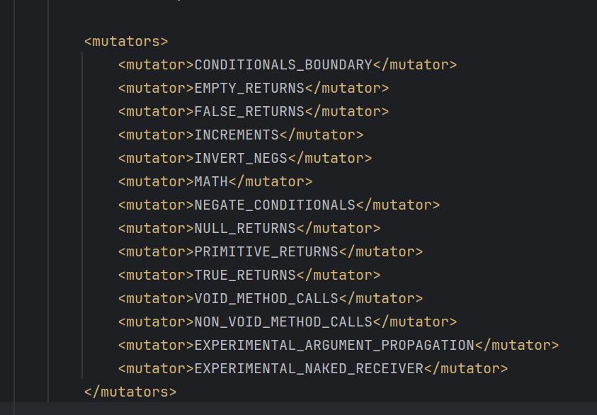

Each **mutator** represents a type of change (mutation) that PIT can introduce to your code during testing. Here's what the specific mutators in your configuration mean:

1. **CONDITIONALS_BOUNDARY**: Modifies conditional statements like > to >=.
2. **EMPTY_RETURNS**: Replaces return statements in void methods with empty returns.
3. **FALSE_RETURNS**: Forces methods to always return false.
4. **INCREMENTS**: Modifies increments/decrements, e.g., i++ to i--.
5. **INVERT_NEGS**: Inverts negative numbers to positive.
6. **MATH**: Changes basic mathematical operations, like + to -.
7. **NEGATE_CONDITIONALS**: Negates conditionals, turning if (x) into if (!x).
8. **NULL_RETURNS**: Forces methods to return null.
9. **PRIMITIVE_RETURNS**: Changes return values of primitive data types.
10. **TRUE_RETURNS**: Forces methods to always return true.
11. **VOID_METHOD_CALLS**: Removes calls to void methods.
12. **NON_VOID_METHOD_CALLS**: Removes calls to methods that return a value.
13. **EXPERIMENTAL_ARGUMENT_PROPAGATION**: Modifies how arguments are passed to methods.
14. **EXPERIMENTAL_NAKED_RECEIVER**: Experiments with replacing method receivers in a context-sensitive way.

In PIT (Pitest), **mutators** represent the types of changes that can be introduced into the code during mutation testing. These mutators allow developers to test the effectiveness of their test suites by simulating different kinds of code alterations. PIT provides three primary predefined sets of mutators: **ALL**, **DEFAULTS**, and **STRONGER**.

**1. ALL Mutators**

* **Description**:  
  The ALL configuration includes every mutator that PIT provides. This means that every possible mutation type will be applied to the code. While comprehensive, this can lead to a significant increase in processing time and may generate mutations that are not always relevant to your project.
* **Use Case**:  
  Use the ALL mutators when you need the most exhaustive mutation testing, such as when performing a full audit of test suite effectiveness for a critical or legacy system.
* **Example in Configuration**:

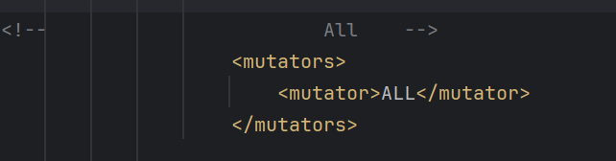

**2. DEFAULTS Mutators**

* **Description**:  
  The DEFAULTS configuration includes a carefully curated subset of mutators that strike a balance between thoroughness and performance. These mutators are chosen to represent the most common code changes that could occur in real-world scenarios, making it suitable for most use cases.
* **Includes**:
  + **CONDITIONALS_BOUNDARY**: Changes conditionals (e.g., < to <=).
  + **INCREMENTS**: Modifies increment and decrement operators (e.g., i++ to i--).
  + **RETURN_VALS**: Alters return values.
  + **VOID_METHOD_CALLS**: Removes calls to void methods.
  + **MATH**: Modifies mathematical operations (e.g., + to -).
  + **NEGATE_CONDITIONALS**: Negates boolean conditions.
* **Use Case**:  
  Suitable for most projects where mutation testing needs to focus on key areas without introducing unnecessary overhead.
* **Example in Configuration**:

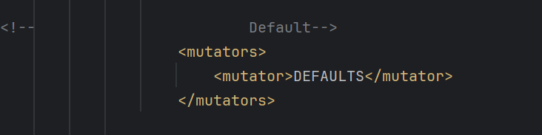

**3. STRONGER Mutators**

* **Description**:  
  The STRONGER configuration includes a stricter set of mutators for advanced testing. This set not only contains the **DEFAULTS** mutators but also introduces additional mutation types to challenge the robustness of the test suite further.
* **Includes**:
  + All **DEFAULTS** mutators.
  + Additional experimental or less common mutators, such as those affecting argument propagation and deeper logical operations.
* **Use Case**:  
  Ideal for teams aiming for highly resilient test suites, such as those developing critical software systems where faults are unacceptable.
* **Example in Configuration**:

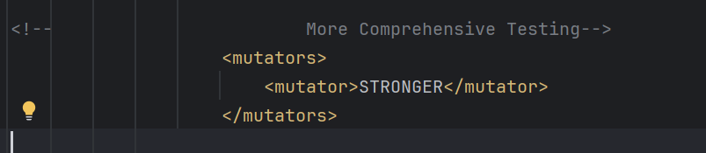

**Key Considerations**

* **Performance**:
  + Using **ALL** mutators will significantly increase testing time and may introduce irrelevant mutations.
  + **DEFAULTS** is generally the most balanced option in terms of performance and relevance.
  + **STRONGER** may also require additional computational resources but provides more robust testing.
* **Relevance**:  
  Consider the project's requirements when choosing a set of mutators. For most teams, **DEFAULTS** is sufficient, while **STRONGER** and **ALL** are better suited for in-depth testing of mission-critical systems.

**Why Configure Mutators?**

Customizing mutators allows developers to target specific types of logic in their code that they suspect might be prone to errors. Using relevant mutators ensures the mutation testing process aligns with your project's needs and helps improve your test suite effectively.

In our case, the configuration specifies a comprehensive set of mutators, including some experimental ones, for thorough mutation testing of the specified classes.

Run PIT runner

It can be run directly from the command-line:

mvn test-compile org.pitest:pitest-maven:mutationCoverage

this command will create mutants and run the mutation testing on the codebase, the resultant report will be generated in the target folder as an HTML document.

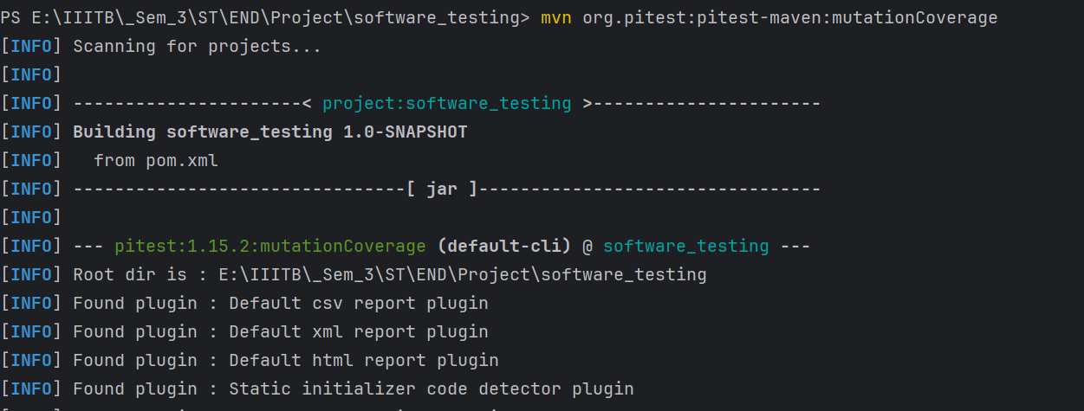

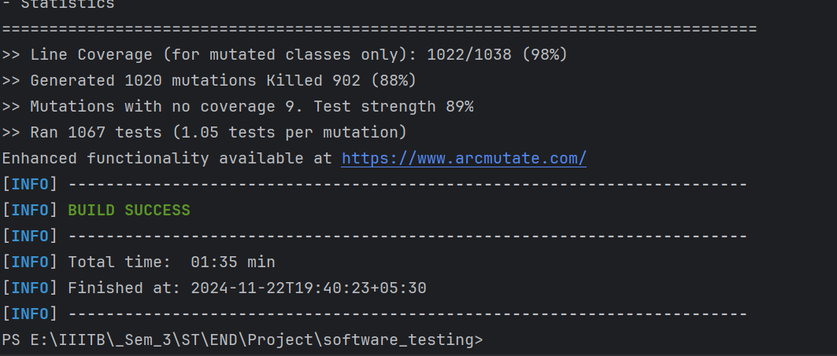

View the generated reports

After the execution is complete, we can find the HTML report in the target/pit-reports directory. Open the index.html file in a browser to view the detailed mutation testing report.

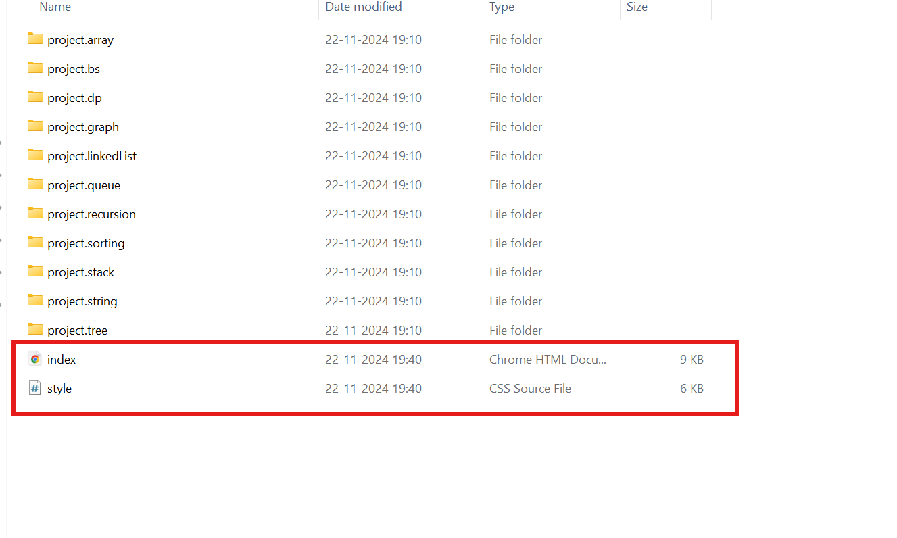

PIT Test Coverage Report

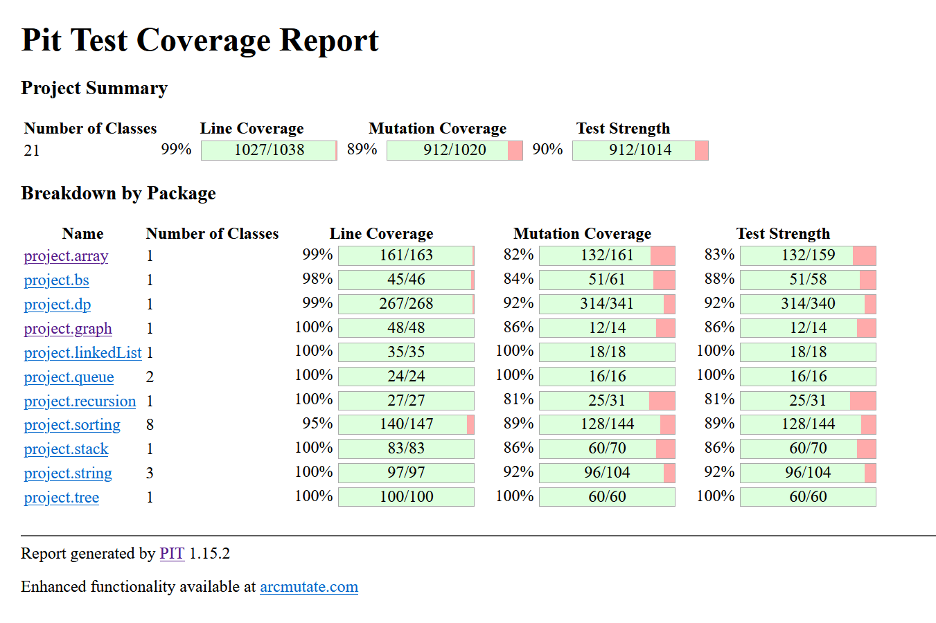

These are the statistics from the IntelliJ Plugin called Statistic. It’s a third party plugin that can be installed through IntelliJ

