Game Design Document

Fill up the following document

1. Write the title of your project.

Alien Hunter

1. What is the goal of the game?

Reach the safehouse whilst collecting coins and running from aliens.

1. Write a brief story of your game.

There is an alien apocalypse. The pc is a human running from the aliens trying to find a safehouse. He/She can also collect coins on their way to increase their score.

1. Which are the playing characters of this game?

* Playing characters are the ones who respond to the user based on the input from the user.
* Cars, monkeys, dinos, wizards, etc., are the playing characters in the game.

|  |  |  |
| --- | --- | --- |
| Number | Character Name | What can this character do? |
| 1 | Human | Run and collect coins |
| 2 |  |  |
| 3 |  |  |
| 4 |  |  |
| 5 |  |  |
| 6 |  |  |
| 7 |  |  |
| 8 |  |  |

1. Which are the Non-Playing Characters of this game?

* Non-Playing characters are the ones that don't have an action or behavior when the user interacts with the game.
* Hurdles, stones, bananas, coins, etc., are non-playing characters in the game.

|  |  |  |
| --- | --- | --- |
| Number | Character Name | What can this character do? |
| 1 | Alien | Catch the human |
| 2 | Coins | Increase the score of the human |
| 3 |  |  |
| 4 |  |  |
| 5 |  |  |
| 6 |  |  |
| 7 |  |  |
| 8 |  |  |

Draw your imagination of this game. What does this game look like?

* Draw the game either on your computer or on paper.
* Add images of the game scenes to show each of the playing and non-playing characters at least once.

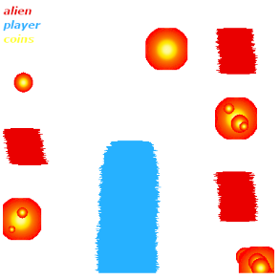

How do you plan to make your game engaging?

The number of aliens trying to catch the human increases as the player keeps running. The coins increase the score which motivates the player.