**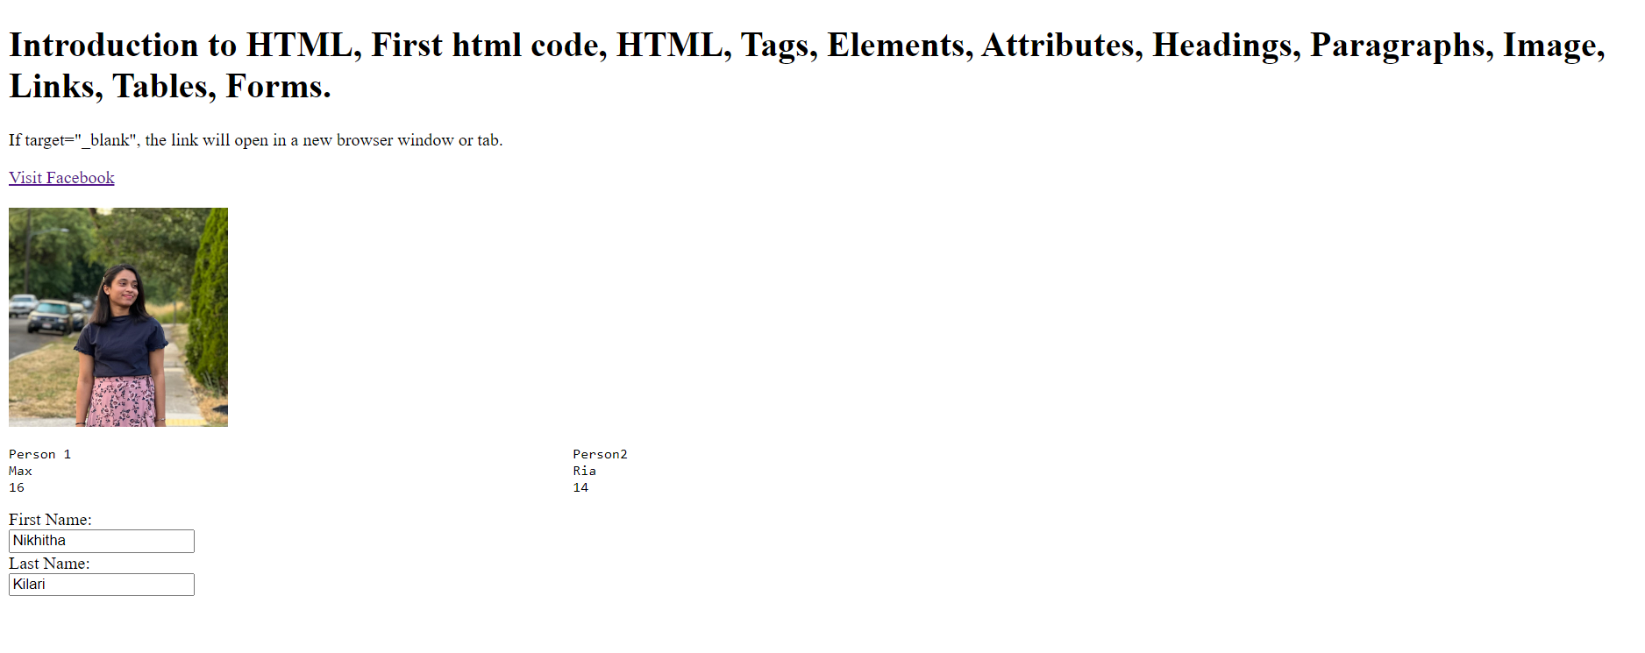Nikhitha Kilari  
CS360 Lab Assignment-01  
  
Task 1 Screenshot:  
  
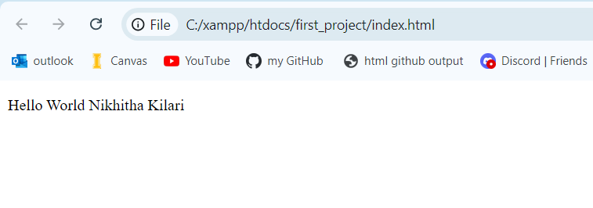  
  
Task 2 Screenshot:**