**RegistrationSystem Output Screenshots**

**Registration Page:**

**

**

**Unsuccessful Login:**

Insert New User Page:**

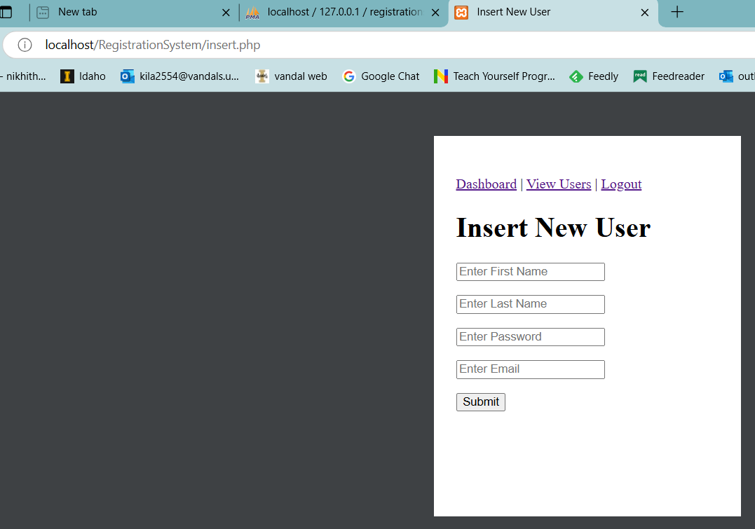

**View Inserted users Page:**

