Audit System Specification Document

# Graphical User Interfaces and Examples of Use

## Administrative Panel

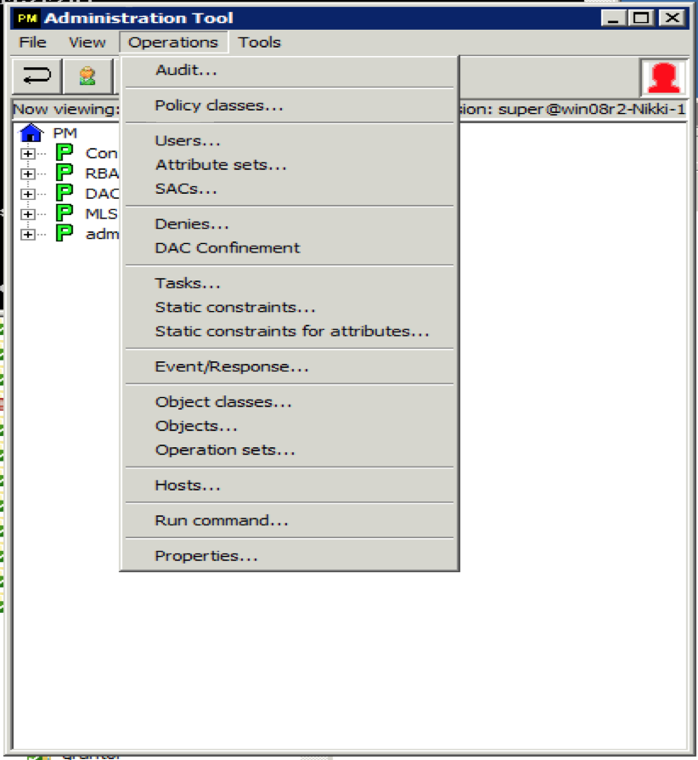

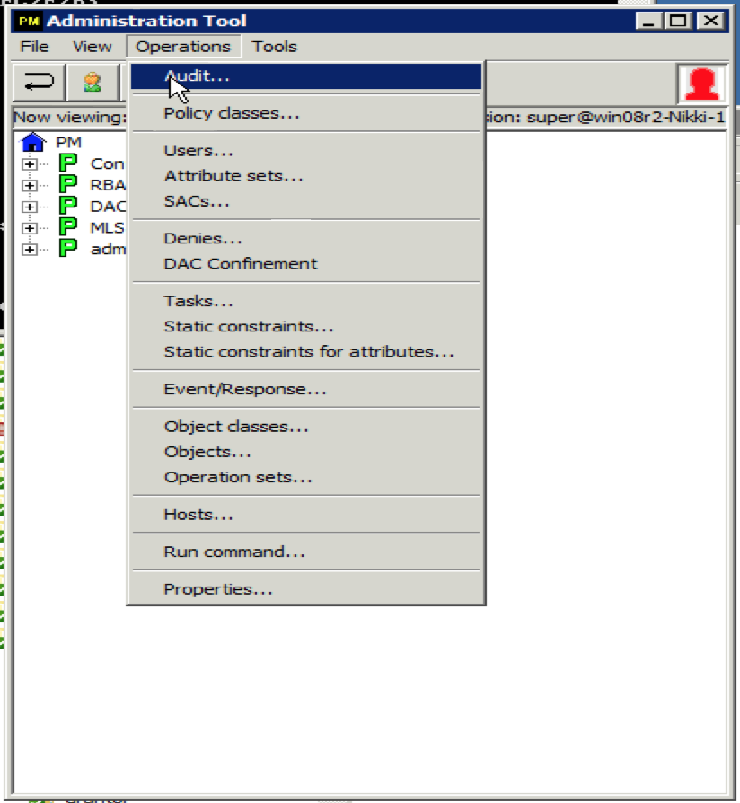

## Audit GUI

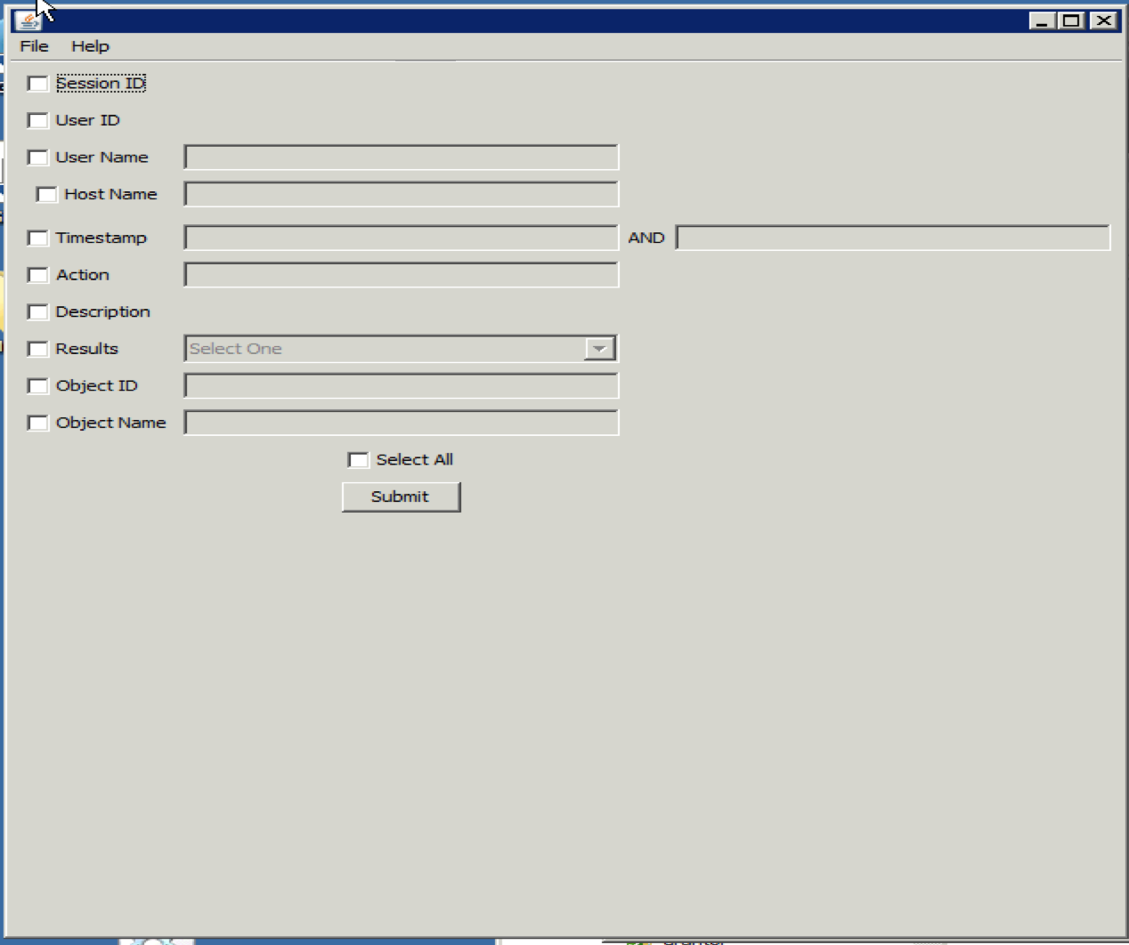

# Use Cases Scenarios

## Use Case 1: Getting the Audit GUI to show up

Since only administrators can see audit reports this scenario will assume that the administrator has already logged into the administration tool.



Figure Admin panel with dropdown menu showing the Audit option highlighted

After selecting the Audit… menu item a new screen will pop-up. This is called the Audit Panel shown in Fig. 2.



Figure Audit Panel

As seen above there are many options an administrator can choose. Each checkbox option allows the administrator to choose which columns they want displayed in the Audit Report. If the row has a text field then that column can be filtered further. The text field will only be enabled if the checkbox in the same row is selected. Below in Figure 3 it is shown how the text fields will look when they are enabled.

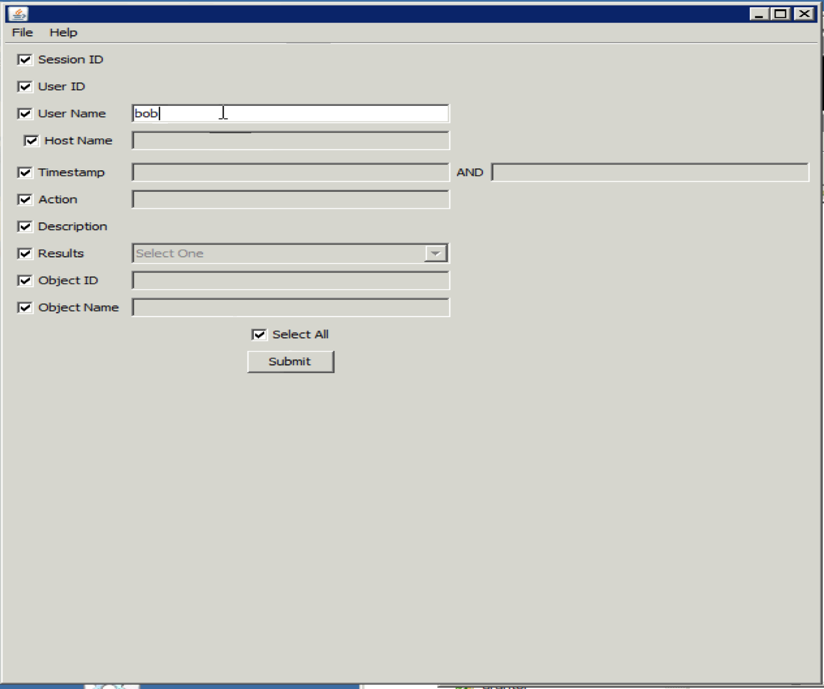

Figure Text Field Enabled