The Policy Machine
User Guide

Serban I. Gavrila

Created December 8, 2006
Updated January 3, 2007
Table of Contents

1 Introduction 5
1.1 Policy Machine Overview 5
2 Architecture 9
2.1 Overview 9
2.2 PM Components 9
2.2.1 Policy Server/Engine 9
2.2.2 PM Data Repository 10
2.2.3 PM Administrative Tool 10
2.2.4 PM User Environment Simulator 11
3 Starting the Policy Machine 13
3.1 Starting the Policy Machine Server 13
3.2 Starting the PM Administrative Tool 13
3.3 Starting the User Environment Simulator 13
4 Managing the PM Entities 15
4.1 The PM Graph 15
4.2 Graph Navigation 17
4.3 The Initial Graph 18
4.4 PM Entities 20
4.4.1 Policies 20
4.4.2 User attributes 21
4.4.3 Users 23
4.4.4 Object attributes 24
4.4.5 Objects 26
4.4.6 Operation sets 28
4.5 Defining Hosts 30
4.6 Importing/Exporting the PM State 31
4.6.1 Overview 31
4.6.2 Command Syntax 32
4.6.3 Example 35
4.7 Defining Subject Attribute Constraints 35
4.8 Defining Dynamic Constraints 38
5 Permissions 41
5.1 PM Entities 41
5.2 Setting ordinary permissions on PM objects 42
5.3 Updating ordinary permissions on PM objects 43
5.3.1 Deleting some permissions 43
5.3.2 Adding some permissions 44
5.3.3 Deleting the entire operation set 45
5.4 Setting administrative permissions on PM entities 45
6 Event-Response Relations 48
6.1 Overview 48
6.2 Writing, Compiling, and Enabling EVER Scripts 48
6.3 The EVER Lexical Elements 49
6.4 The EVER Syntax 49
6.5 An Example of EVER Script 54
6.6 A Translation Schema for the EVER Language 55
6.7 Functions in the EVER Language 59
object_new() 60
oattr_with_name_of_active_attr(policy pol) 60
oattr_of_user_choice(policy pol) 60
oattr_of_default_user() 60
oattr_home_of_default_user() 60
user_default() 60
prop_home_of_new_user() 61
uattr_name_of_new_user() 61
prop_name_of_new_user() 61
user_new() 61
uattr_name_of_user(user u) 61
prop_name_of_user(user u) 61
pol_discr() 62
pol_id() 62
pol_with_prop(property p) 62
oattr_home_of_new_user() 62
oattr_home_of_user(user u) 62
obj_rep_of_home_of_new_user() 62
obj_rep_of_home_of_user(user u) 62
oattr_rep_of_home_of_new_user() 63
oattr_rep_of_home_of_user(user u) 63
oattr_rep_of_discr_users() 63
uattr_discr_users() 63
oattr_of_default_obj() 63
uattr_lowest_level() 63
oattr_direct_asc_of_and_containing(oattr oa₁, oattr oa₂) 64
uattr_direct_ascs_of_uattr (uattr ua) 64
uattr_direct_ascs_of_uattr_except(uattr ua₁, uattr ua₂) 64
uattr_active_in_default_session_and_in_uattr(uattr ua) 64
prop_discr_users() 64
obj_rep_of_discr_users() 64
7 Using the User Environment Simulator 65
7.1 Overview 65
7.2 Sessions and subjects 66
7.2.1 Configuring a session 68
7.2.2 Changing user password 69
7.2.3 Customizing the LOS view 69
7.2.4 Running the PM applications 69
8 Configuring Access Control Policies 80
8.1 Discretionary Access Control (DAC) Policies 80
8.1.1 Overview 80
8.1.2 Creating a DAC Policy 80
8.1.3 Creating Users under a DAC Policy 81
8.1.4 An EVER Script for Creating Users under DAC Policies 82
8.1.5 Creating Objects Under a DAC Policy 83
8.2 Multi-Level Security (MLS) Policies 87
8.2.1 Creating a MLS Policy Class 87
8.2.2 Creating Users Under MLS Policies 89
8.2.3 Creating Objects Under MLS Policies 89
8.2.4 Categories and MLS policies 89
8.2.5 Alternate MLS Configuration 91
8.3 Identity-Based Access Control (IBAC) Policies 91
8.3.1 Creating an IBAC Policy Class 91
8.3.2 Creating Users under an IBAC Policy 92
8.4 Confinement Policies 92
8.4.1 Confinement under DAC policies 92
8.4.2 Confinement under RBAC policies 94
8.5 History-based Policies 95

1 Introduction
The Policy Machine (PM) is an attribute-based access control mechanism whose core features are the ability to configure and enforce arbitrary attribute-based access control policies and the ability to protect resources under multiple instances of these policies [1]. This guide describes NIST’s implementation of the Policy Machine from the user’s perspective.

1.1 Policy Machine Overview
Like probably every access control model, the PM is defined in terms of authorized users, subjects, operations, and objects. The authorized users are humans, each one mapped to a unique user identifier, typically established at user account creation time. An authorized user – hereafter simply referred to as a user – obtains access to the PM system by presenting his/her credentials, typically the user identifier and a password, and establishing a PM session. The user must submit requests to access system resources through a subject, which is a process that runs within the session on behalf of the user. An access request consists of one or more operations (e.g., read) and an object (e.g., a text file). In PM, the objects are names (with global meaning) given to system entities that must be protected and perhaps shared under one or more policies.

Note that we distinguish between a user request and a process request. In addition to issuing the user request to the system, a process may maliciously or by system error issue requests that are independent of, and perhaps unknown to the process user.

As any access control mechanism, the PM includes a set of permissions and a reference mediation function. For simplicity, the permissions may be imagined as triples (user, operation, object), indicating that the user is potentially able to perform the operation on that object’s content. Although the permissions are defined in terms of users, the reference mediation function controls access in terms of subjects. Ultimately, a subject request (operation, object) is granted by the reference mediation function if and only if there exists a permission (user, operation, object), where the user is the subject’s user.
In the PM, the permissions are not individually managed, but instead they are derived from a set of policy-specific user and object attributes.

A user attribute expresses some user properties, thereby defining the set of users that possess that property. In this regard, a user attribute is a user container. In the PM, one can define user attributes and assign users to them. In addition, one can assign a user attribute ua₁ to another user attribute ua₂, with the meaning that ua₂’s properties are included among ua₁’s properties. Consequently, ua₁’s users are included among ua₂’s users. Indeed, if a user is a ua₁ (i.e., if he/she possesses ua₁’s properties), then he/she must also be a ua₂ (because then he/she possesses ua₂’s properties). As an example, let’s consider the user attributes Doctor and Intern and denote the assignment relation by “”. Intuitively there may be an assignment Doctor  Intern, because a Doctor has all the properties/capabilities of an Intern. A Doctor “smith”, i.e., a user “smith” assigned to the attribute Doctor, smith  Doctor, will also be an Intern, i.e., will have all the properties/capabilities of an Intern.

Similarly, an object attribute expresses some object properties, thereby defining the set of objects that possess that property. In this regard, an object attribute is an object container. In the PM, one can define object attributes and assign objects to them. In addition, one can assign an object attribute oa₁ to another object attribute oa₂, with the meaning that oa₂’s properties are included among oa₁’s properties. Consequently, oa₁’s objects are included among oa₂’s objects. Note that an object (name) is considered to be an object attribute, with the object itself as its sole member. The assignment relation between object attributes is also denoted by “”.

In order to define the capabilities of a user associated with one of the user’s attributes, or, equivalently, the access control entries of an object associated with one of the object’s attribute, in the PM one assigns a user attribute ua to an operation set, and further assigns that operation set to an object attribute oa. Through this double assignment, a user possessing the attribute ua has potential access defined by the operation set to the objects possessing the attribute oa. The assignment relation between user attributes and operation sets, and between operation sets and object attributes is also denoted by “”. As an example, consider the assignments: Intern  {read} “Medical Records” and Doctor  {write} “Medical Records”, where Intern and Doctor are the previously mentioned user attributes, and “Medical Records” is an object attribute including all objects that happen to be medical records. If smith  Doctor  Intern and jones  Intern are valid assignments in the PM, and mrec1 is a medical record, i.e., mrec1  “Medical Records”, then smith can potentially read and write mrec1, while jones can potentially read mrec1.

The PM has the ability to configure different policy instances. In this aspect, each user attribute and object attribute may pertain to one or more policies. In PM, the instantiated policies are identified by names, and an attribute pertains to a policy by way of another assignment relation, also denoted by “”. For example, we may assume that all user and object attributes used before in examples pertain to a role-based access control policy called “rbac”. Figure 1 illustrates the corresponding assignment relations.

The reference mediation function, which grants or rejects the subject request to access a resource, takes into consideration the subject’s active attributes at the moment of invocation. The subject’s active attributes at a given moment are a subset of the attributes authorized for the subject’s user. In Figure 1, the user smith is authorized to both attributes Doctor and Intern, while user jones is only authorized to attribute Intern. However, a process running on behalf of user smith may have {Doctor, Intern}, or {Doctor}, or {Intern}, or the empty set as the set of active attributes. Similarly, a process running on behalf of user jones may have {Intern}, or the empty set, as the set of active attributes. A number of constraints can and sometimes must be placed on the attributes that may be activated for a subject, known as “subject attribute constraints” or SAC. For example, a valid constraint may be that the attributes Teller and Supervisor cannot be active in the same time, meaning that a user cannot function in the same time as a teller and as a supervisor, even though the user might be authorized to both attributes.

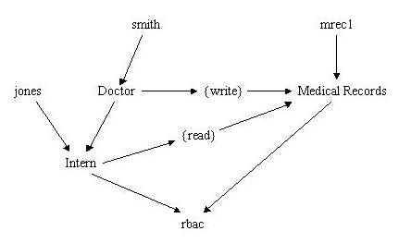
Figure 1. Example of assignments in the Policy Machine

Initially, a subject is created with an empty set of active attributes. When a user submits an access request through the subject, the policy machine calculates and automatically activates a minimum subject attribute set that fits the user’s access request. Subsequent user access requests issued through the same subject may activate additional attributes as long as the current set of active attributes does not violate a SAC constraint. The reference mediation function grants the subject’s request on behalf of the user if and only if the subject’s active attributes possess the capabilities required to satisfy the request. For example, using the diagram of Figure 1, and assuming that one of smith’s processes has the active attribute set {Intern}, smith would be able to read object mrec1, but not to write it. If the process’s active attribute set is {Doctor}, then smith would be able to write mrec1’s content, but not to read it.
When multiple policy instances are present, things get a little more complicated. The PM grants a process the request to access an object if and only if it is able to grant the request to access that object in each policy instance that object pertains to. As an example, let’s consider Figure 2, which illustrates two policies, our old acquaintance rbac, and an identity-based access control policy with the name “ibac”. Under ibac, the user smith has an attribute “Dr. Smith” representing his identity. In the same time, the object “mrec1” is among Dr. Smith’s patients, which is illustrated by mrec1’s assignment to an object attribute “Dr. Smith Patients” pertaining to the ibac policy. Further, user attribute “Dr. Smith” is assigned read and write rights on the object attribute “Dr. Smith Patients”.
To be able to read object mrec1, a process running on behalf of user smith should have active at least the attributes {Intern, Dr. Smith}. No process running on behalf of user jones would be able to read mrec1, because it couldn’t activate the attribute Dr. Smith.
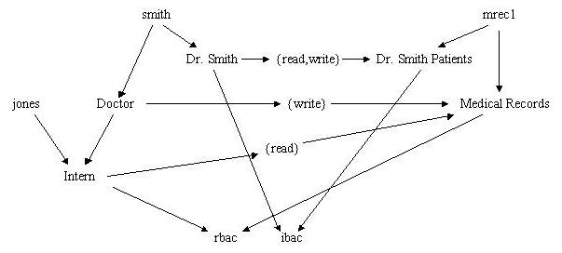
Figure 2. Multiple policies example

2 Architecture

2.1 Overview
The reference implementation of the Policy Machine is a three-tier application (viz. Fig. 1) running on MS Windows 2000 and 2003 Servers. The application logic layer consists of a policy server (also called the policy engine) running on a dedicated MS Windows 2000/2003 Server. The data layer consists of a data repository and its access mechanism. PM uses the MS Active Directory as data repository and its LDAP server as the mechanism to store/retrieve PM data to/from the repository. The presentation layer consists of instances of the Administrative Tool, which provides graphical interfaces for PM data management, and User Environment Simulators, which manage user sessions/processes and provide graphical interfaces for user interaction with the PM system.
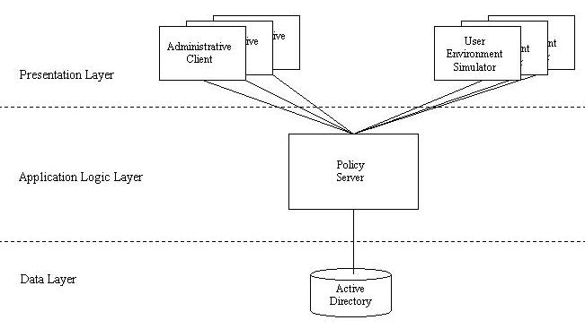
Figure 3. Policy Machine Architecture

2.2 PM Components

2.2.1 Policy Server/Engine
The policy server/engine is the core of the Policy Machine, and manages all PM data (e.g., users, user attributes, policy classes, etc.) and relations (e.g., various “assignment” relations, etc.). The PM data and relations are located in the MS Active Directory (AD), and the engine uses the LDAP server in order to store/retrieve its data to/from the AD.
The engine acts like a server for the presentation layer components, in the sense that it provides services through a set of engine commands. An administrative client may request administrative services, like “create a new user”, “create a new user attribute”, “assign a user attribute to another user attribute”, etc. A session simulator may request session services, like “create session”, “get process’ permissions on object x”, etc.

2.2.2 PM Data Repository
The Policy Machine data repository stores the PM data and relations defined in [1]. PM uses MS Active Directory as actual repository support, and the LDAP server as access mechanism.
In order to support the PM data and relations, we added new Active Directory class and attribute definitions to the original Windows 2000/2003 AD schema. An example will help understand how the PM data and relations defined in [1] can be represented through the new AD classes and attributes. A PM user attribute ua, according to [1], has a unique id and a name, it may have users or user attributes assigned to it, and it may be assigned to user attributes or to operation sets or to policy classes. In the AD schema, such a user attribute is described by a new AD class pmClassUserAttribute, which has the mandatory AD attributes pmId (containing ua’s unique id), pmName (ua’s name), pmDescription (a description), pmOtherInfo (other possible info), and the optional multi-valued AD attributes pmFromUser (containing the id of a user assigned to ua), pmFromAttr (the id of a user attribute assigned to ua), pmToAttr (the id of a user attribute to which ua is assigned), pmToPolicy (the id of a policy class to which ua is assigned), pmToConnector (the id of the connector node, if ua is assigned to it), pmToOpSet (the id of an operation set to which ua is assigned).
The accompanying “PM Installation Guide” details the procedure for augmenting the AD schema. Appendix 1 details the AD new classes and attributes.
The AD objects representing the PM data and relations (e.g., a PM user attribute, which is an AD object of class pmClassUserAttribute) are stored in specialized containers located in the AD hierarchy. Appendix 2 details the object containers.

2.2.3 PM Administrative Tool
Multiple instances of the Administrative Tool can run on the same machine or on different machines in the PM system. The Administrative Tool has a graphical interface that allows the administrator to manage the PM data and relations, like creating a new user attribute, or assigning an object attribute to another object attribute. The administrator’s actions on the client GUI are translated into a sequence of PM engine commands that are sent to the PM engine. The engine interprets the commands and eventually returns an answer to the administrative client.
The default GUI of the administrative tool is a graph as defined in [1] restricted to users, user attributes, policy classes, and the connector as nodes, and their assignments as arcs. The administrator can navigate through the graph by clicking on any of its nodes. The selected node will be displayed next together with a few “levels” of nodes upward and downward from it. That’s only one of the four possible views of the policy machine graph. The other three that can be selected by the administrator are: the object view, which displays the objects, objects attributes, policy classes, and the connector as nodes and their assignments as arcs; the capabilities view, which displays the user attributes and their assigned capabilities (operations on object attributes); and the access control entries view, which displays the object attributes and their assigned access control entries (user attributes with operations).

2.2.4 PM User Environment Simulator
The Policy Machine controls access to resources on a number of hosts in the enterprise. A User Environment Simulator is intended to simulate the functionality of an operating system designed to cooperate with the Policy Machine. An instance of UES runs on every host controlled by PM. It manages the user sessions, user processes, and enforces the PM’s access control policies. Figure 4 illustrates the architecture of a UES.

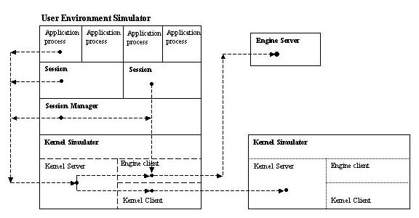
Figure 4. User Environment Simulator Architecture
A user registered with the PM may log on any simulator by using its name and password registered with the PM. The simulator opens a session for the user, in which the user is presented with a display of his/her “logical object system” (LOS). The user LOS contains the objects and their attributes that the user is authorized to access. The virtual objects represent resources located anywhere (i.e., on any host) in the system.
The user may try to access a resource by invoking an application that processes the resource. For example, the user might right-click an object representing a file and then invoke a text editor on that file from a popup menu. The simulator has to intercept the user request for editing the file, translate it into a set of requested operations (in the above example probably {File read, File write}), and ask the PM engine to grant the process in which the editor is running the permission to execute those operations on the virtual object representing the file. The engine tries to activate those user attributes that grant the process the requested permissions. If some permission is granted, the engine returns that permission to the simulator together with supplementary information about the resource, for example its location in the system (host and path).
Let’s assume that the user request was granted with read-only permission. The editor process issues system calls to the simulator in order to read/save the file contents from/to its location. In processing these system calls, the simulator examines the permissions granted earlier by the engine, and denies or grants the process’ request. For example, assuming that only the read permission was granted to the user request, the editor’s call to save the file (to its original location) would be rejected. In processing the “read” system call, the simulator may have to call another UES to obtain the requested data if the resource is located on another host.
Note that for simplicity reasons, attribute activation is performed per session. This means that all processes (subjects) running in a session share the same set of active attributes. Also, note that the active attribute set of a session starts as the empty set and never decreases.

3 Starting the Policy Machine

3.1 Starting the Policy Machine Server
Install the Policy Machine Server on a computer running Windows 2000 or 2003 Server, as detailed in the “Policy Machine Installation Guide”. Log on the server as Administrator. To start the PM engine (server), use the MS-DOS command (everything on one line, or use a batch file that contains the command):

java -cp E:\PolicyMachine\PMServer\server.jar
-Djavax.net.ssl.keyStore=E:\PolicyMachine\Keystores\serverKeystore
-Djavax.net.ssl.keyStorePassword=aaaaaa
-Djavax.net.ssl.trustStore=E:\PolicyMachine\Keystores\serverTruststore
pmserver.PmEngine

We assumed that the server.jar file is stored in E:\PolicyMachine\PMServer\ directory, and that the server’s key store is E:\PolicyMachine\Keystores\serverKeystore, while the server’s trust store is E:\PolicyMachine\Keystores\serverTruststore. You need to update the command line according to your particular setup. Also, instead of the key store password “aaaaaa” use the password you set up when you created the key store.

3.2 Starting the PM Administrative Tool
Install the Policy Machine Administrative Tool on a computer running Windows 2000 or XP, as detailed in the “Policy Machine Installation Guide”. Right after the PM engine/server installation, there is only one user registered with the PM, with the name “super” and password “super”. Log as any user on the computer on which you want to run the Admin Tool and run the following command in a MS-DOS command window:

java –cp E:\PolicyMachine\PMAdmin\admin.jar
-Djavax.net.ssl.keyStore=E:\PolicyMachine\Keystores\superKeystore
-Djavax.net.ssl.keyStorePassword=aaaaaa
-Djavax.net.ssl.trustStore=E:\PolicyMachine\Keystores\superTruststore
pmadmin.PmAdmin -enginehost musial -engineport 8080 –debug

Note that you need to update the command with the correct locations and names of the admin.jar file, the key and trust store of the “super” user, the key store password, and the PM engine host (“musial” in the above example). The key store “superKeystore” should contain the private key and public key certificate of the “super” user. The trust store superTruststore should contain the root certificate of the certification authority (CA) that issued the super’s certificate.
The tool will ask you to present the password of the PM user “super”, which is set to “super” in the shipped PM version. Change the super password by using the tool’s “Operations/Change password…” menu.

3.3 Starting the User Environment Simulator
Install the User Environment Simulator on a computer running Windows 2000 or XP. Log on as administrator and run the following command in a MS-DOS command window:

java –cp E:\PolicyMachine\PMAdmin\simulator.jar
-Djavax.net.ssl.keyStore=E:\PolicyMachine\Keystores\xaraxKeystore
-Djavax.net.ssl.keyStorePassword=aaaaaa
-Djavax.net.ssl.trustStore=E:\PolicyMachine\Keystores\xaraxTruststore
pmuser.KernelSimulator -enginehost musial -engineport 8080
-simport 8081 -debug

In the above command, xaraxKeystore should contain the private key and public key certificate of the computer running UES. Also, xaraxTruststore should contain the root certificate of the certification authority that issued the computer’s certificate. Note that you need to update the command with your correct locations and names of the simulator.jar, the key store and trust store, the key store password, and the PM engine host (“musial” in the above example).

First time UES runs on a target host, you must select the session manager’s “Manager/Configure…” menu and set up the locations of the two PM applications, the Administrative Tool (admin.jar) and the RTF editor (editor.jar).

Now the PM users may log on the UES by using the Manager/Login menu of the session manager. Note that the PM is shipped with only one PM user, “super” (with the password “super”), which designated the super administrator. The super administrator must use the Admin Tool in order to create and register other PM users.

4 Managing the PM Entities

4.1 The PM Graph
The PM graph is a directed graph without cycles, whose nodes represent users and user attributes, objects and object attributes, operation sets, and policies. The graph arcs represent the assignment relations “”. As we already know, possible assignments are between a user and a user attribute, between two user attributes, between an object and an object attribute, between two object attributes, between a user attribute and a policy, between an object attribute and a policy, between a user attribute and an operation set, and between an operation set and an object attribute.
To have the graph always connected, we add a “connector” node, called PM, with all policies assigned to it. The connector node also serves as a “sink” for various unused users, user attributes, objects, object attributes, and operation sets.
Figure 5 below illustrates a PM graph that could correspond to the diagram of Figure 2. Note that the gray double ellipses represent users, the gray ellipses represent user attributes, the blue ellipses represent objects attributes, with the blue double ellipses also being objects, the “house” symbols represent policies, the rectangles represent operation sets, and the octagon represents the connector node. Remember that an object is also an object attribute that uses the object name.
In practice, the Admin Tool displays the graph containing the connector node, the policies, user attributes and users separately from the graph containing the connector node, the policies, and the object attributes – see Figure 6. It is also possible to display the operation sets and the attributes assigned to them separately – see Figure 7.

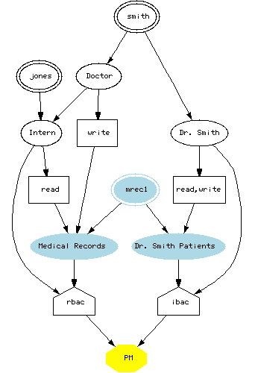
Figure 5. A PM Graph

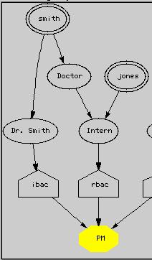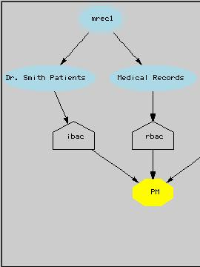
Figure 6. User-side and object-side presentations of the PM graph

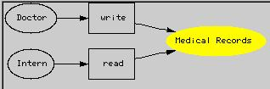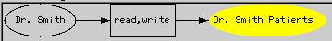
Figure 7. Permissions presentation

4.2 Graph Navigation
No matter what kind of graph the AT displays, the navigation method through its nodes is the same and very intuitive. One of the displayed nodes is the “selected” node, and is marked by the yellow color. Initially (right after launch), the connector node PM is the selected node, as it happens in Figure 5. When the user moves the mouse cursor (usually an arrow) over one of the graph nodes, the cursor changes to the “hand” form. By left clicking on that node, the node becomes the next “selected” node, and a number of nodes – better said a number of tiers - above and below it are displayed. The number of tiers displayed can be increased or decreased by using the menus View/More tiers, View/Fewer tiers.

The user can switch between different views of the PM graph by using the menus View/User attributes graph, View/Object attributes graph, View/Capabilities graph, View/ACEs graph.

4.3 The Initial Graph
Initially, the PM contains very few entities, namely:
- The connector node PM.
- A policy called “admin”.
- A user attribute called “superAdmin”, assigned to the policy “admin”.
- A user called “super”, which represents the super administrator, assigned to the user attribute “superAdmin”.
- An object (and object attribute) called “everything”, that represents the entire PM database, assigned to the policy “admin”.
- An operation set called “all ops”, containing all operations possible on PM database. The user attribute “superAdmin” is assigned to “all ops”, and “all ops” is assigned to the object attribute “everything”.
As a consequence, a process running on behalf of the “super” user has access to the entire PM database, from the moment the engine activates the “superAdmin” attribute. Figure 8 illustrates the initial PM graph restricted to users and user attributes, but also displays the superAdmin being assigned to the “all ops” operation set assigned to the “everything” object attribute. Figure 9 illustrate the initial PM graph restricted to objects and object attributes.

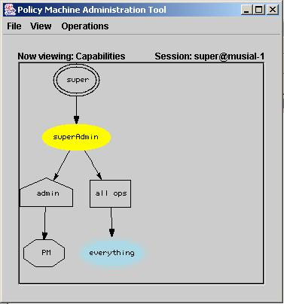
Figure 8. Initial PM graph - users, user attributes, and capabilities

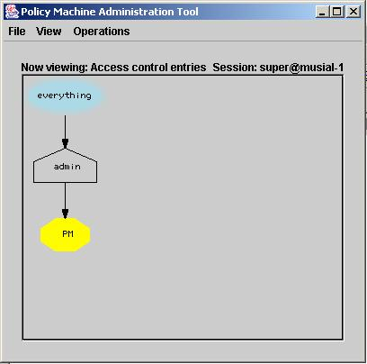
Figure 9. Initial PM graph - objects and object attributes

4.4 PM Entities

4.4.1 Policies

Creating a new policy

Each policy in the PM is assigned to the connector node, PM. To create a new policy, either right-click on the connector node and select the pop-up menu “Add policy class…”, or directly select the menu “Operations/Policy classes…”. Figure 10 displays the window where you can enter the new policy’s attributes. Note that the only required information about the policy is its name, which must be unique among the policy names. Optionally, you may enter a description and other information about the policy, as well as various properties, like “type=identity” in the Figure 10. These properties could be used to identify the policy in PM scripts without using the policy name. You may add/edit/remove properties to/from the list by using the Add/Edit/Remove buttons. Only when you click the “Add policy” button, the PM engine creates the policy with all its attributes as displayed on the interface and assigns it to the connector node.

Adding/Editing/Removing the properties of a policy

You may add/edit/remove properties of an existing policy. Just right-click on the policy in the PM graph and select the pop-up menu “Edit”. Use the buttons Add, Edit, or Remove to update the policy’s properties. Be aware that each GUI update is reflected right away in the PM database. To date, the other attributes (name, description, other information) of a policy cannot be updated.

Deleting a policy

Before deleting a policy, you have to delete all assignments to it. In order to delete the policy, just right-click on the policy node, then select the pop-up menu “Delete node”.

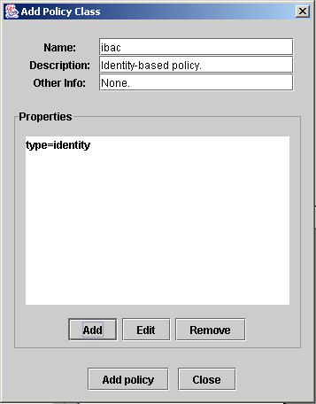
Figure 10. Creating a policy

4.4.2 User attributes
To display, create, or delete user attributes you need to select the graph presentation “View/Users/Attributes with capabilities” or “View/Users/Attributes”.

Creating a new user attribute

To create a user attribute, first you have to select its place in the PM graph, by indicating a “base node”, which can be the connector node or a policy or a user attribute or a user. The new user attribute will be assigned to the base node (i.e., the user attribute becomes a direct ascendant of the base node), except when the base node is a user. In the latter case, the user will be assigned to the new user attribute and the new user attribute will also be assigned to the connector node.
Right-click on the desired base node and select the pop-up menu “Add user attribute…”. A window pops up allowing you to define the new user attribute (see Figure 11). Note that the only required information about the new user attribute is its name, which must be unique among the user attribute names. Optionally, you may enter a description and other information about the attribute, as well as various properties, like “nameof=smith” in the Figure 11. These properties could be used to identify the attribute in PM scripts without using the actual attribute name. You may add/edit/remove properties to/from the list by using the Add/Edit/Remove buttons. Only when you click the “Add attribute” button, the PM engine creates the user attribute with all its properties as displayed on the interface and assigns it to the base node.
Note that a user attribute created as an ascendant of the connector node is useless. To be useful in PM, it needs to be assigned (either directly or indirectly – through other user attributes) to a policy.

Adding/Editing/Removing the properties of a user attribute

You may add/edit/remove properties of an existing user attribute. Just right-click on the user attribute in the PM graph and select the pop-up menu “Edit”. Use the buttons Add, Edit, or Remove to update the attribute’s properties. Be aware that each GUI update is reflected right away in the PM database. To date, the other elements (name, description, other information) of a user attribute cannot be updated.

Deleting a user attribute

Before deleting a user attribute, you have to delete all assignments to it. In order to delete the attribute, just right-click on the attribute node, then select the pop-up menu “Delete node”.

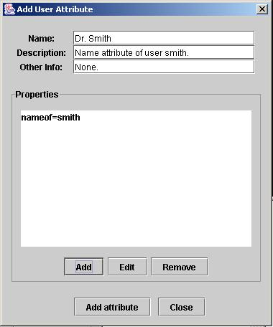
Figure 11. Creating a user attribute

4.4.3 Users
To display, create, or delete users you need to select the graph presentation “View/Users/ Attributes” or “View/Users/Attributes with capabilities”.

Creating a new user

To create a new user, first you have to select its place in the PM graph, by indicating a “base node”, which can be the connector node or a user attribute. The new user will be assigned to the base node (i.e., the user becomes a direct ascendant of the base node)
Right-click on the desired base node and select the pop-up menu “Add user…”. A window pops up allowing you to define the new user (see Figure 12). Note that the only required information about the new user is his/her logon name and full name, which must be unique. Optionally, you may enter a description and other information about the user, as well as the user’s initial password. By default, the initial password is the empty string.
A user created as an ascendant of the connector node is useless. To be useful in PM, it needs to be assigned to a user attribute.

Deleting a user

To delete a user you may either use the “Delete” button on the interface of Figure 12 after you select the user to be deleted from the user list, or you may right-click the user node in the PM graph and select the “Delete node” menu.

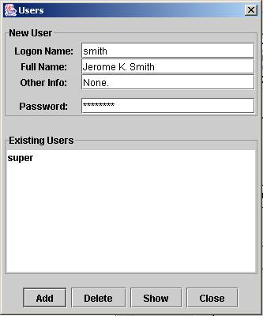
Figure 12. Creating a new user

4.4.4 Object attributes
To display, create, or delete object attributes you need to select the graph presentation “View/Objects/Attributes” or “View/Objects/Attributes with ACEs”.

Creating a new object attribute

To create an object attribute, first you have to select its place in the PM graph, by indicating a “base node”, which can be the connector node or a policy or another object attribute. The new object attribute will be assigned to the base node (i.e., the object attribute becomes a direct ascendant of the base node).
Right-click on the desired base node and select the pop-up menu “Add object attribute…”. A window pops up allowing you to define the new object attribute (see Figure 13). Note that the only required information about the new object attribute is its name, which must be unique among the object attribute names. Optionally, you may enter a description and other information about the attribute, as well as various properties. These properties could be used to identify the attribute in PM scripts without using the actual attribute name. You may add/edit/remove properties to/from the list by using the Add/Edit/Remove buttons. Only when you click the “Add attribute” button, the PM engine creates the object attribute with all its properties as displayed on the interface and assigns it to the base node.
Note that an object attribute created as an ascendant of the connector node is useless. To be useful in PM, it needs to be assigned (either directly or indirectly – through other object attributes) to a policy.

Adding/Editing/Removing the properties of an object attribute

You may add/edit/remove properties of an existing object attribute. Just right-click on the object attribute in the PM graph and select the pop-up menu “Edit”. Use the buttons Add, Edit, or Remove to update the attribute’s properties. Be aware that each GUI update is reflected right away in the PM database. To date, the other elements (name, description, other information) of an object attribute cannot be updated.

Deleting an object attribute

Before deleting an object attribute, you have to delete all assignments to it. In order to delete the attribute, just right-click on the attribute node, then select the pop-up menu “Delete node”.

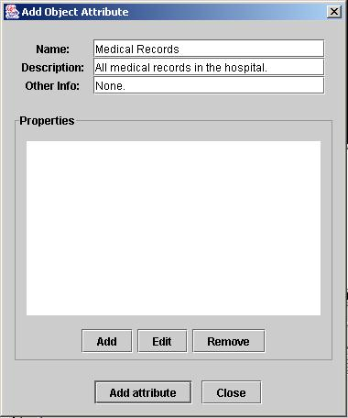
Figure 13. Creating an object attribute

4.4.5 Objects
This section describes how to create or delete objects using the Admin Tool. It is also possible to create/delete objects programmatically, using specialized PM APIs in applications.

To display, create, or delete objects using the Admin Tool you need to select the graph presentation “View/Objects/attributes” or “View/Objects/attribute with ACEs”.

Creating an object

To create a new object, first you have to select its place in the PM graph, by indicating a “base node”, which can be the connector node or a policy or an object attribute. The new object will be assigned to the base node (i.e., the object becomes a direct ascendant of the base node).
Right-click on the desired base node and select the pop-up menu “Add object…”. A window pops up allowing you to define the new object (see Figure 14). Another way is to directly select the menu “Objects…”, in which case the default base node is the connector node.
The name of the new object must be unique. Optionally, you may enter a description and other information about the object.
Each object must have a class. There are a few predefined object classes, namely: File, Directory, User, User attribute, Object, Object attribute, Operation set, Policy, and Connector. The user may define additional object classes. You need to select the object class from the drop-down list titled “Class:”. For objects of class “File” or “Directory”, you have to specify the host name and the absolute path of the file or directory this object will represent. For objects that represent PM entities, for example an object of class “User attribute”, you have to select the entity name from the right-side list titled “PM Entities:”. You may want the new object to represent not only the selected entity, but also all its ascendants. In this case, check the checkbox titled “Include Ascendants”.
Click on the “Add” button to create the object. Note that the Admin Tool automatically creates an object attribute – represented as a blue double ellipse - with the same name as the object, as direct ascendant of the base node. This new object attribute and the new object are said to be associated.
An object created as an ascendant of the connector node is useless. To be useful in PM, the object needs to be assigned (either directly or indirectly – through other object attributes) to a policy.

Deleting an object

To delete an object, use the same interface, select the object in the bottom table, and click on the “Delete” button. The object will be deleted together with the associated object attribute.

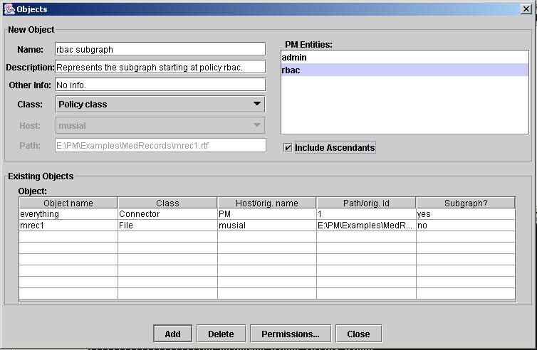
Figure 14. Adding a new object

4.4.6 Operation sets
An operation set usually has one or more user attributes assigned to it and is assigned to one or more object attributes.

To display, create, or delete operation sets in the Admin Tool you need to use the PM graph presentation that either displays the user attributes with capabilities or object attributes with their access control entries, by selecting one of the menus View/Users/Attributes with Capabilities” or “View/Objects/Attributes with ACEs”.

To display the operation sets a user attribute is assigned to, just click on that user attribute. To display the operation sets assigned to an object attribute, just click on that object attribute.

Another way to display the operation sets a user attribute is assigned to, or the operation sets assigned to an object attribute is to right-click the user attribute or the object attribute and to select the pop-up menu “View permissions”.

To create a new operation set and assign an existing user attribute to it, right-click on that user attribute and select the pop-up menu “Add operation set…”. To create a new operation set and assign it to an existing object attribute, right-click on that object attribute and select the pop-up menu “Add operation set…”. You may also create an operation set assigned to the connector node by right-clicking the connector node and select the pop-up menu “Add operation set…”. Another way is to directly select the menu Operations/Operation sets…”.

The GUI that pops up is displayed in Figure 15. You have to enter a unique name for the new operation set. Optionally, you may enter a description and other information about the operation set. To add operations to the operation set, select an object class, and then add operations pertaining to that class. Repeat the operation for another object class if needed.

The same interface can be used to edit the contents of the operation set, or to delete the operation set.

Sometimes you may want to assign an existing operation set to an object attribute. First display the operation set, by clicking a user attribute or an object attribute or the connector node, whichever is assigned to the operation set or whomever the operation set is assigned to (be sure you’re using the appropriate presentation of the graph). Then right-click the operation set. Select the pop-up menu “Mark node”. Switch to the View/ Objects/Attributes with ACEs” presentation (if you’re not already in it), then right-click the desired object attribute and select the pop-up menu “Assign marked node”.

Now perform similar operations in order to assign a user attribute to an existing operation set. Right-click on the user attribute. Select the pop-up menu “Mark node”. Switch to the View/ Objects/Attributes with ACEs” presentation, then right-click the operation set and select the pop-up menu “Assign marked node”. Another, simpler way, is described in the section “Granting permissions”.

To delete an operation set, you have to delete all its assignments from any user attribute or to any object attribute. First, display the operation set and its assignments.

To delete the assignment of an operation set to an object attribute, right-click the operation set and select the pop-up menu “Mark node”. Then right-click on the object attribute and select the pop-up menu “Delete assignment”.

To delete the assignment of a user attribute to an operation set, right-click on the user attribute and select the pop-up menu “Mark node”. Then right-click on the operation set and select the pop-up menu “Delete assignment”.

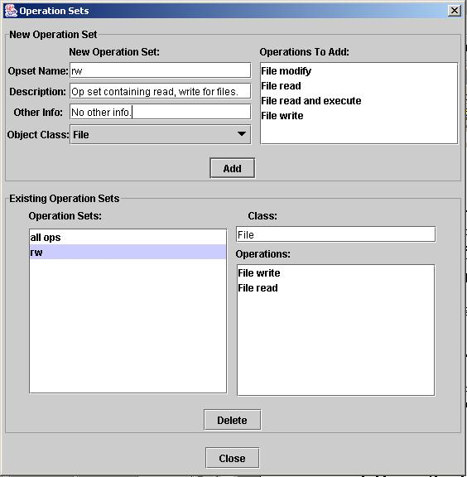
Figure 15. Adding an operation set

4.5 Defining Hosts
You may activate the interface for adding new computer hosts (also called target systems) to the PM system by selecting the menu “Hosts…”. The only information required is the host’s name or IP address, whether the host is a primary domain controller or not, and the path of the host’s repository for PM-protected file system objects.
To date, only file system objects can be protected by PM policies, as well as the PM entities themselves. The PM objects are just names that designate the physical files. The PM objects are logically organized in virtual containers. Together, the PM objects and containers form the PM virtual object system (VOS). The physical files that correspond to PM objects can reside on any host controlled by the PM. Their location is transparent for the user and only the PM engine needs to know it. The PM engine must have some rules of allocating space for the physical files. To date, we use a very simple rule. For an application running on a certain host, the PM system creates a physical file corresponding to a new PM object on that host, in a reserved area called the PM repository for that host, and where only the kernel (simulator) of that host has access. The administrator must identify this area by its complete path when he/she adds the host to the PM system.

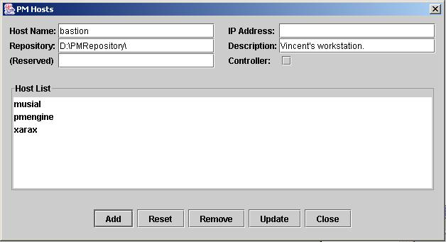
Figure 16. Adding a new host

4.6 Importing/Exporting the PM State

4.6.1 Overview
The PM state comprises all PM entities and their assignment relations, and also any SAC or dynamic (deny) constraints. It is possible to export the PM state to a file and later to import it back. When exporting the state, the AT does not export the elements of the initial state (i.e., the connector node, the admin policy, the superAdmin user attribute, the super user, etc.), because they are automatically rebuilt. When importing the state, it is important to note that the engine will try to add the state elements defined by the state file to the current engine state.

A state file is a text file. Each line of text is either a comment that starts with the ‘#’ character, or a PM administrative command. Thus, it is possible to write a state file from scratch, and import it. The order of the commands in the state file is important, because you have to create the state elements before you refer to them. For example, to create the elements pc, ua1, ua2, ua3 and assignments ua1  ua2pc, ua1 ua3pc, you need to include the commands in this order (this is not the only valid order):

Add policy pc
Add user attribute ua3 to policy pc
Add user attribute ua2 to policy pc
Add user attribute ua1 to user attribute ua3
Assign user attribute ua1 to user attribute ua2

The rest of this section contains a short description of the command syntax and a small example.

4.6.2 Command Syntax
Each command must be written on a single line. No spaces are allowed within the command, unless they are part of the entity names. A line that starts with ‘#’ is considered a comment and ignored.

add|a|<uattr name>|c|PM
This command creates a user attribute of name <uattr name> as a direct ascendant of the connector node.

add|a|<uattr name>|p|<pol name>
This command creates a user attribute of name <uattr name> as a direct ascendant of the policy <pol name>.

add|a|<uattr name>|a|<uattr2 name>
This command creates a user attribute of name <uattr name> as a direct ascendant of the user attribute <uattr2 name>.

add|a|<uattr name>|u|<user name>
This command creates a user attribute of name <uattr name> as a direct descendant of the user <user name>.

add|a|<uattr name>|as|<attr set name>
This command adds the user attribute of name <uattr name> to the attribute set of name <attr set name>.

add|u|<user name>|c|PM
This command creates a user of name <user name> as a direct ascendant of the connector node PM.

add|u|<user name>|a|<uattr name>
This command creates a user of name <user name> as a direct ascendant of the user attribute <uattr name>.

add|p|<pol name>|c|PM
This command creates a policy class of name <pol name> as a direct ascendant of the connector node.

add|s|<opset name>|oc|<obj class>|a|<uattr name>
This command creates an operation set of name <opset name> and assigns the user attribute <uattr name> to it. The object class is currently ignored, but must be present.

add|s|<opset name>|oc|<obj class>|b|<oattr name>
This command creates an operation set of name <opset name> and assigns it to the object attribute <oattr name>. The object class is currently ignored, but must be present.

add|s|<opset name>|oc|<obj class>|c|PM
This command creates an operation set of name <opset name> and assigns it to the connector node.

add|op|<operation>|s|<opset name>
This command adds an operation <operation> to an operation set <opset name>.

add|op|<operation>|oc|<obj class>
This command adds an operation <operation> to an object class <obj class>.

add|op|<operation>|deny|<deny name>
This command adds an operation <operation> to a deny constraint of name <deny name>.

add|oc|<obj class>
Creates a new object class of name <obj class>.

add|b|<oattr name>|<c>|PM
This command creates an object attribute <oattr name> as a direct ascendant of the connector node
.
add|b|<oattr name>|<p>|<pol name>
This command creates an object attribute <oattr name> as a direct ascendant of the policy <pol name>.

add|b|<oattr name>|<b>|<oattr2 name>
This command creates an object attribute <oattr name> as a direct ascendant of the object attribute <oattr2 name>.

add|b|<oattr name>|<deny>|<deny name>
This command adds the object attribute <oattr name> to the list of containers of the deny constraint <deny name>.

add|cb|<oattr name>|<deny>|<deny name>
This command adds the complement of the object attribute <oattr name> to the list of containers of the deny constraint <deny name>.

add|ob|<obj name>|<obj class>|<inh>|<host or orig name>|<path or ignored>|<base node type>|<base node name>
This command creates an object <obj name> of class <obj class>. <obj class> can be File, Directory, User, User attribute, Object, Object attribute, Policy class, Connector, Operation set, or a custom class name. <inh> can be “yes” or “no”.
For an object of class File or Directory, <inh> is ignored but must be present. <host or orig name> contains the name of the host where the corresponding physical file system object resides. <path or ignored> is the complete path of the corresponding physical file system object.
For an object of another class, the object represents the PM data and relations pertaining to an existing PM entity of that class, or to that PM entity and all its ascendants in the PM graph. Such an object is created for the purpose of setting up administrative permissions on that entity or its ascendants. <inh> specifies whether the new object represents only the PM entity (“no”) or the entire sub-graph that comprises the entity and all its ascendants (“yes”). <host or orig name> contains the original name of the PM entity this new object represents (the entity type can be retrieved from the <obj class>). <path or ignored> is ignored, but must be present.
A new object attribute with the same name as the new object is also created (the associated object attribute), and is assigned to the so-called base node, which is specified by <base node type> and <base node name>. The <base node type> can be c for the connector node (with the name PM), p for a policy, or b for an object attribute.

add|prop|<property>|<entity type>|<entity name>
This command adds a property <property> to the existing entity <entity name> of type <entity type>. <entity type> can be p, a, or b for policy, user attribute, or object attribute. The property has the format “name=value”, for example, “usersof=identity”.

add|as|<attr set name>
This command creates an empty attribute set of name <attr set name>.

add|a|<uattr name>|as|<attr set name>
This command adds a user attribute <uattr name> to the attribute set <attr set name>.

add|sa|<sac name>
This command creates an empty subject attribute constraint with the name <sac name>.

add|as|<attr set name>|sa|<sac name>
This command adds an attribute set <attr set name> to a subject attribute constraint <sac name>.

add|app|<at path>|<editor path>|<wkf path>|h|<host>
This command sets the paths of the three PM application jar files – the Admin Tool, the RTF Editor, and the Workflow application – for the host <host>. The session uses these paths to launch the applications. Include the paths in double quotes if they contain spaces.

add|ks|<user key store>|<user trust store>|h|<host>|u|<user>
This command sets the paths of the key and trust stores of a specific user <user> on a specific host <host>. The PM uses the certificates and keys to establish SSL communications between the components like the Admin Tool and the engine. Include the paths in double quotes if they contain spaces.

add|deny|<deny name>|<deny type>|<user or attr>|<user or attr name>|
<is intersection>
This command creates an empty (without operations or containers) deny constraint of name <deny name> and type <deny type>. The type can be “user id” or “intra session” or “across sessions”. <user or attr> can be either u or a, and specifies that <user or attr name> is either a user or a user attribute name. <is intersection> is either “yes’ or “no”. If yes, the deny constraint uses the intersection of the containers, otherwise it uses their union.
To add operations to the deny constraint, use the command
add|op|<operation>|deny|<deny name>
To add a container to the list of containers, use the command
add|b|<oattr name>|<deny>|<deny name>
To add the complement of a container to the list of containers, use the command
add|cb|<oattr name>|<deny>|<deny name>

asg|<ent1 type>|<ent1 name>|<ent2 type>|<ent2 name>
This command assigns the entity <ent1 name> of type <ent1 type> to the entity <ent2 name> of type <ent2 type>. <ent1 type> is s for operation set, a for user attribute, u for user, b for object attribute. <ent2 type> is p for policy class, a for user attribute, b for object attribute, s for operation set.

4.6.3 Example
As an example, let’s write the command lines that will instruct the engine to build the PM graph corresponding to the diagram of Figure 1:

add|p|rbac|c|PM
add|a|Intern|p|rbac
add|b|Medical Records|p|rbac
add|u|jones|a|Intern
add|a|Doctor|a|Intern
add|s|IrMR|oc|File|a|Intern
add|op|File read|s|IrMR
add|ob|mrec1|File|no|musial|E:\PM\Examples\MedRecords\mrec1.rtf|b|Medical Records
add|s|DwMR|oc|File|b|Medical Records
add|op|File write|s|DwMR
asg|s|IrMR|b|Medical Records
add|u|smith|a|Doctor
asg|a|Doctor|s|DwMR

4.7 Defining Subject Attribute Constraints
The subject attribute constraints (SAC) are constraints placed on the attributes that may be activated for a subject. For example, in a multi-level security policy where the clearance levels are low, medium, and high, assume that a user is cleared for the high clearance level. This means that he/she can run processes at any level. But a process running on his behalf cannot run at level low and medium (for example) in the same time. In PM terms, even though the user is authorized to all three attributes low, medium, and high, only one of them can be active for a process at one time.

A SAC constraint consists of a set of disjoint sets of user attributes and a predicate which is satisfied if the active attribute set of any subject has common elements with at most one set of user attributes specified in the constraint. For the example above, the SAC constraint should be {{low}, {medium}, {high}}.

To define a SAC constraint using the Admin Tool, first you have to define the user attribute sets that occur in the constraint. The menu “Operations/Attribute sets…” invokes the interface that can be used to define attribute sets (viz. Figure 17).

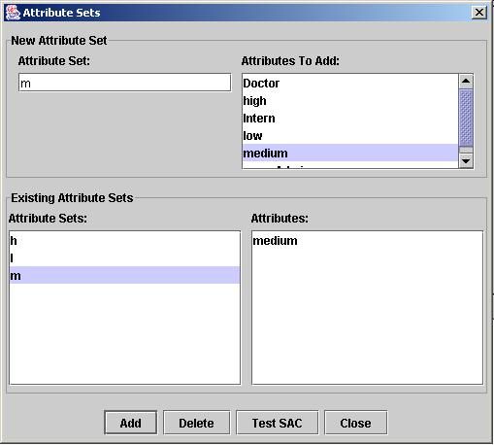
Figure 17. Defining attribute sets

Choose a name for an attribute set, for example m, then select a user attribute from the upper right list and click the Add button. If you need to add more attributes to the attribute set, select another attribute in the upper right list and click the Add button. If you want to delete an attribute from an attribute set, select the attribute set in the lower left list, select the attribute you want to delete in the lower right list, and click the Delete button. If you select only the attribute set and click the Delete button, the entire attribute set will be deleted.

Assuming that we defined the needed attribute sets, we can start building the SAC constraints. Note that PM accepts two types of SAC constraints: intra-session and across sessions. Before explaining them, remember that all subjects executing in a user session have the same set of active attributes, so we can refer to them as the session’s active attributes. An intra-session SAC requires that the set of active attributes of any session have common attributes with at most one of the attribute sets of the SAC. An across-session SAC requires that the union of active attributes of all sessions of a user have common attributes with at most one of the attributes sets of the SAC

Click on the Operations/SAC to invoke the SAC editor (viz., Figure 18). Choose a name for the SAC constraint, for example lmh. Select the type of SAC constraint, wither intra-session or across sessions, typically intra-session. Select an attribute set from the upper right, for example l, and click the Add button. A constraint lmh containing the attribute set l will be created. If you need to add more attribute sets to the constraint, select another attribute set in the upper right list and click the Add button. If you want to delete an attribute set from a constraint, select the constraint in the lower left list, select the attribute set you want to delete in the lower right list, and click the Delete button. If you select only the constraint and click the Delete button, the entire constraint will be deleted.
You can repeat the process to define new constraints.

After you define a constraint, the engine will start right away to consider it when computing the sets of attributes that must be activated in order to satisfy the user’s requests.

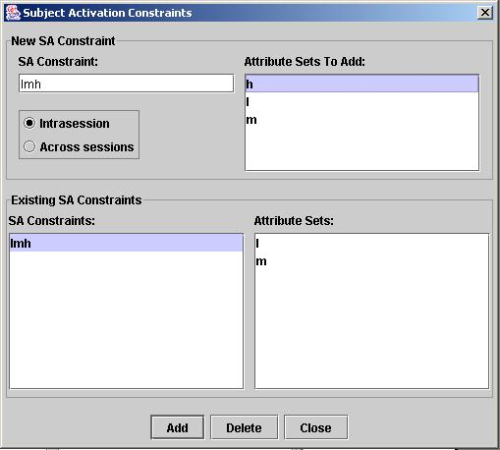
Figure 18. Defining Subject Attribute Constraints

4.8 Defining Dynamic Constraints
Currently the PM engine implements only deny constraints as dynamic constraints. A deny constraint specifies permissions that will be denied to a subject during reference mediation, even though the subject’s active attributes would grant those permissions to that subject. We implement three types of deny constraints.

The first type of deny constraints is based on the subject’s user id and formally is a tuple (<user id>, <operation set>, <container set>, <is intersection>), where <user id> is a user id, <operation set> is a set of operations, <container set> is a set of object attributes, and <is intersection> is a Boolean specifying whether the deny constraint should use the intersection or union of the object containers specified in the <container set>. It specifies that a subject be denied the operations in <operation set> on all objects contained in the union or intersection of the containers specified in the <container set>, provided the subject’s user has the <user id>.

The second type of denies is based on the subject user’s active attributes in the current session, and formally is a tuple (<user attribute>, <operation set>, <container set>, <is intersection>). It specifies that the subject be denied the operations in <operation set> on all objects contained in the union or intersection of the containers specified in the <container set>, provided the <user attribute> is active for the subject’s user in the subject’s session.

The third type of denies is similar to the second type, except that the <user attribute> may be active in any open session of the subject’s user.

To build a deny constraint, invoke the Deny Constraint Editor by selecting the menu “Operations/Denies…” (viz. Figure 19). First, select the type of deny from the radio buttons, for example “Attribute-based across sessions”. Then enter a name for the constraint, for example “deny doctor”. Select the user attribute, for example Doctor, from the top right list. Now you can click the Add button to add the new deny constraint as is (without operations or containers), or you can select an operation and/or a container and click the Add button afterwards. After you add the new deny constraint, you may add other operations and containers to it. Be careful to have the desired constraint selected in the lower left list before adding other operations and/or containers. In Figure 19, we added two operations, File read and File write, and one container, Archive, to the constraint named “deny doctor”. As explained above, this constraint denies any subject the permission to read/write objects in Archive if the subject’s user is active as a Doctor in any session.

Let’s assume, for example, that we want to deny any subject the permission to read/write objects in Archive1 or Archive2, if the subject has the Doctor attribute active (in its session). You need to define a deny constraint of the type “Attribute-based intra-session” for the Doctor attribute, and add the two containers Archive1, Archive2 without checking the box “Intersection”.

Let’s assume now that we want to deny any subject the permission to read/write objects that belong to Archive1 and Archive2, if the subject has the Doctor attribute active (in its session). You need to define a deny constraint of the type “Attribute-based intra-session” for the Doctor attribute with the box “Intersection” checked.

Let’s assume now that we want to deny any subject the permission to read/write objects that belong to Archive1 but not to Archive2, if the subject has the Doctor attribute active (in its session). You need to define a deny constraint of the type “Attribute-based intra-session” for the Doctor attribute with the box “Intersection” checked. Add the container Archive1 as usual, then add the container Archive2 with the box “!Container’s complement” checked.

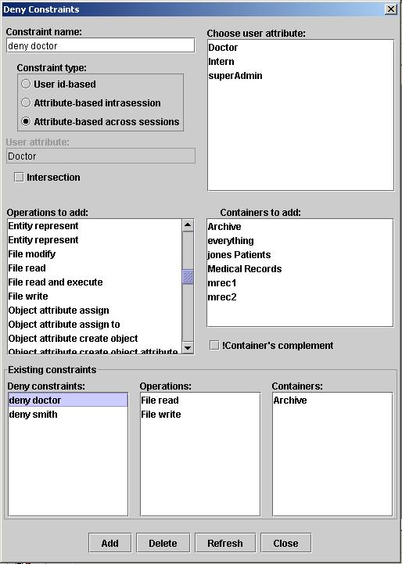
Figure 19. Defining deny constraints

If you need to delete an operation and/or a container from a constraint, select the deny constraint, select the operation and/or the container from the bottom lists, and click the Delete button. If you select only the deny constraint and click on the Delete button, the entire constraint will be deleted.

5 Permissions

5.1 PM Entities
PM uses quite a few type or classes of PM entities. The primary classes of PM entities are: users, user attributes, objects, object attributes, policies, connectors, operation sets. Secondary entity classes include SAC relations, deny relations, event/response relations, etc.

The entities of primary classes together with the various assignment relations define a directed graph that is called the PM graph, which has the entities as nodes, and the assignments as arcs.

All PM entities, not only the objects, need to be protected from unauthorized access. As any access control mechanism, PM uses permissions to specify who has access to what information, but stores them as triples of the form user attribute  operation set  object attribute.

Let o be an object, s a subject running on behalf of user u, and op an operation. The subject s is authorized to perform the operation op on the object o if and only if for each policy p such that o belongs to p, there exists a user attribute ua of user u within policy p and active for subject s, an object attribute oa of object o within policy p, and an operations set ops that contains operation op, such that ua  ops  oa.

For example, in the diagram of Figure 20, user u is authorized to perform operation op₁, but not op₂ or op₃, on object o, which belongs to both policies p₁ and p₂. A subject running on behalf of user u must have both attributes ua₁ and ua₂ activated in order to perform operation op₁ on object o.

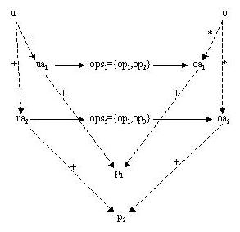
Figure 20. User u is authorized to perform op1, but not op2 or op3, on object o

5.2 Setting ordinary permissions on PM objects
Assume that we have a user attribute Doctor and an object container (attribute) “Med Records” within the RBAC policy, and we want to grant Doctor read/write permissions on the objects included in “Med Records”.

Method 1 – Step by step. We start by building an operation set containing the operations “File read”, “File write”, and assigned to the “Med Records” object attribute. Then we assign the attribute Doctor to the new operation set.
- Start the Admin tool as super administrator and switch to “Objects/Attributes with ACEs” view.
- Right-click on the “Med Records” object attribute and select the “Add operation set…” menu. The operation set editor window pops up. Enter a name for the new operation set, for example “doctor rw”, select “File” in the Object class drop-down list, then select “File read” in the upper right operation list (named “Operations to add”) and click the Add button. Select “File write” in the operation list and click the Add button. Close the operation set editor. Select the “Med Records” object attribute to see the new operation set assigned to it.
- Switch to the “Users/Attributes with capabilities” view. Right-click the user attribute Doctor and select “Mark node”.
- Switch to the “Objects/Attributes with ACEs” view and select the “Med Records” attribute to display the operation set “doctor rw”. Right-click on the operation set “doctor rw” and select “Assign marked node”.

Method 2 – automatic.
- Start the Admin tool as super administrator and switch to “Objects/Attributes with ACEs” view.
- Right-click on the “Med Records” object attribute and select the “Set permissions on…” menu. The permission editor window (viz. Figure) pops up.
- In the user attribute list select the Doctor attribute (the grantee). In the “All permissions” list select “File read”, then “File write”.
- Click on the Set button. A new operation set containing “File read” and “File write” will be created and assigned between Doctor and “Med Records”.

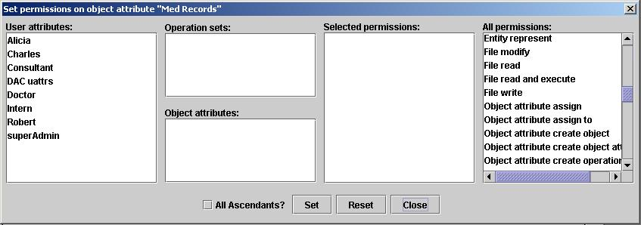
Figure 21. The permission editor main window

5.3 Updating ordinary permissions on PM objects

5.3.1 Deleting some permissions
Assume that we have the assignment Doctor  doctor rw  Med Records, where “doctor rw” is the operation set {File read, File write}, and we want to update it so that “doctor rw” contains only “File read”.

Method 1.
- Run the Admin Tool as super administrator and display the operation set “doctor rw”. For example, you can switch to the “Objects/Attributes with ACEs” view and click on the “Med Records”, or switch to the “Users/Attributes with capabilities” and click on the Doctor.
- Stay with the mouse on “doctor rw” a few seconds. The operation set editor window will pop up, with “doctor rw” selected and both operations displayed. Select the unwanted one, “File write”, and click the “Delete” button.

Method 2.
- Run the Admin Tool as super administrator, switch to the “Objects/Attributes with ACEs” view, and right-click on the “Med Records”. Select the “Set permissions on…” menu. The permission editor window pops up.
- Click on Doctor in the “User attributes” list. The operation set name “doctor rw” appears in the “Operation sets” list. Click on it. All the object attributes to which “doctor rw” is assigned (in our case only “Med Records”) will appear in the “Object attributes” list, and the operations contained in “doctor rw” (i.e., File read and File write) will appear in the “Selected operations” list. See Figure.
- Click on the “File write” operation in the “Selected operations” list. It will disappear from the list. Then click on the “Set” button.

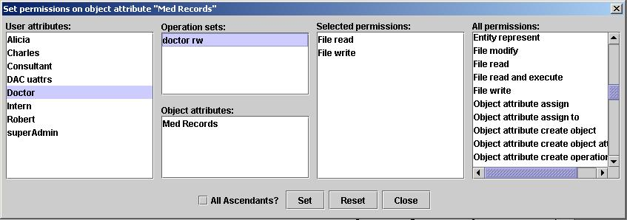
Figure 22. Updating permissions

5.3.2 Adding some permissions
Assume that we have the assignment Doctor  doctor rw  Med Records, where “doctor rw” is the operation set {File read}, and we want to add the operation “File read” to it.

Method 1.
- Run the Admin Tool as super administrator and display the operation set “doctor rw”. For example, you can switch to the “Objects/Attributes with ACEs” view and click on the “Med Records”, or switch to the “Users/Attributes with capabilities” and click on the Doctor.
- Stay with the mouse on “doctor rw” a few seconds. The operation set editor window will pop up, with “doctor rw” selected and the operation “File read” displayed. Add the operation “File write” by selecting it in the upper operation list and clicking on the Add button.

Method 2.
- Run the Admin Tool as super administrator, switch to the “Objects/Attributes with ACEs” view, and right-click on the “Med Records”. Select the “Set permissions on…” menu. The permission editor window pops up.
- Click on Doctor in the “User attributes” list. The operation set name “doctor rw” appears in the “Operation sets” list. Click on it. All the object attributes to which “doctor rw” is assigned (in our case only “Med Records”) will appear in the “Object attributes” list, and the operation contained in “doctor rw” (i.e., File read) will appear in the “Selected operations” list.
- Click on the “File write” operation in the “All operations” list. It will appear in the “Selected operations” list. Then click on the “Set” button.

5.3.3 Deleting the entire operation set
An operation set can be deleted only if it is not assigned to any object attribute and no user attribute is assigned to it. Consequently, first delete its assignments. The operation set will be assigned to the connector node. Right-click on it and select the menu “Delete node”.

5.4 Setting administrative permissions on PM entities
Sometimes we need to set up administrative permissions on PM entities, for example, grant a user (through his/her attributes) the permission to create objects in a certain object container, or the permission to assign users to a certain user attribute. In the case of administrative permissions, the object on which the user attribute is authorized to operate is a subset of the PM data and relations stored in the PM database. For uniformity, we use a PM object to represent this subset, and we use the same mechanism as for ordinary permissions to set up the administrative permissions on this representative object considered as an object attribute.
In other words, to set up some administrative permissions on an entity e, first create an object “e rep” that represents (the data and relations of) e, then set up the desired permissions on “e rep” (actually on the object attribute “e rep” that is associated with the object “e rep”).
Sometimes, we want to grant some administrative permissions not just on a single PM entity, but on all PM entities included in a sub-graph of the PM graph. For example, assume that the user bob has the object attribute “bob home” as his home container in an identity-based access control policy. This means that bob should be able to perform the usual administrative operations on his home and everything inside it. In this case, the sub-graph on which bob should have access is the PM sub-graph that starts with “bob home” and contains all its ascendants. At this time, the PM engine only accepts sub-graphs of two kinds: comprising only one entity, or comprising the entity and all its ascendants.

Assume that we have a user bob with the name attribute Robert within a discretionary access policy called DAC. The DAC policy also contains bob’s home, an object attribute called “bob home”. Further assume that we want to grant bob the permission to create objects, create object attributes, make assignments between object attributes, etc., anywhere in his home.

Method 1 – Step by step. We start by building an object that represents bob’s home and all its ascendants within the DAC policy. It will be called “bob home rep”. The engine will also create an object attribute with the same name “bob home rep”. Then we will create an operation set containing the desired administrative operations, and assign it to the “bob home rep” object attribute. Then we assign the attribute Robert to the new operation set.
- Start the Admin tool as super administrator and switch to “Objects/Attributes with ACEs” view.
- Right-click on the “DAC” policy and select the “Add object…” menu. The object editor window pops up (Figure ). Enter the name “bob home rep” for the new object, select “Object attribute” in the Class drop-down list, then select “bob home” in the upper right PM Entities list. Check the checkbox “Include Ascendants” and click the Add button. The new object and the associated object attribute “bob home rep” will be both created.
- Right-click on the “bob home rep” object attribute and select the “Add operation set…” menu. The operation set editor window pops up. Enter a name for the new operation set, for example “bob admin”. Select “Object attribute” in the Object class drop-down list, then select the desired administrative operations from the upper right operation list (named “Operations to add”) one by one and click the Add button. Repeat this for operations pertaining to other object classes, as desired. Finally, close the operation set editor. Select the “bob home rep” object attribute in the graph display to see the new operation set assigned to it.
- Switch to the “Users/Attributes with capabilities” view. Right-click the user attribute Robert and select “Mark node”.
- Switch to the “Objects/Attributes with ACEs” view and select the “bob home rep” attribute to display the operation set “bob admin”. Right-click on the operation set “bob admin” and select “Assign marked node”.
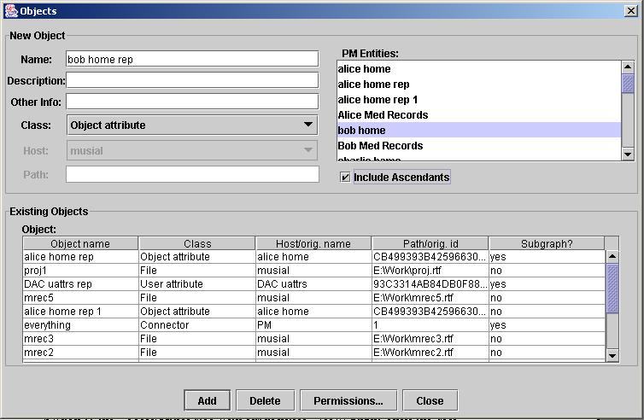
Figure 23. Creating an object that represents a PM sub-graph
Method 2 – automatic.
- Start the Admin tool as super administrator and switch to “Objects/Attributes with ACEs” view.
- Right-click on the “bob home” object attribute and select the “Set permissions on…” menu. The permission editor window (viz. Figure) pops up.
- In the user attribute list select the Robert attribute (the grantee). Select the desired administrative operations from the “All permissions” list.
- Check the checkbox “All Ascendants”.
- Click on the Set button. A new window appears asking you to select a container for the new object/object attribute representing “bob home” that will be created. The container can be a policy class (select it from the left side list), or an object attribute (select it from the right side list). In this case, select the policy DAC as a container for “bob home rep”. Click the OK button, then close the permissions editor. The engine will automatically create the “bob home rep” object and object attribute within the DAC policy. It will also create an operation set with the selected admin operations, and will assign it between Robert and “bob home rep”. Note that the operation set will have an randomly generated name. The representative object will be named “bob home rep” in general. If such an object or object attribute already exists, the engine will try to create an object “bob home rep 1”, etc.

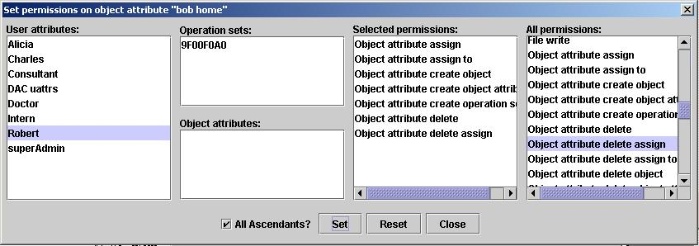
Figure 24. Automatic granting of administrative permissions

6 Event-Response Relations

6.1 Overview
The event/response relations define a set of conditions and methods under which policy state data is dynamically obligated to change. An event/response relation consists of an event pattern and a response. The event pattern typically includes pre-specified conditions pertaining to a subject’s successful execution of an operation on an object. Condition parameters may include the subject’s user, the subject’s attributes, the operation that was executed, the attributes of the object on which the operation was executed. The response is a sequence of administrative commands. Whenever the PM engine detects an event that matches an event pattern, it executes the associated response.
To date, we implement the following types of events: “Object create”, “Object destroy”, “Object read”, “Object write”, “User create”.
We designed a language called EVER for specifying the event response relations. An EVER program, called script, needs to be compiled to an intermediary code before being interpreted by the PM engine. The compiled scripts are stored in the PM database. The administrator needs to indicate the compiled script, if any, to be interpreted. We say that the script currently interpreted by the engine is enabled. At most one script can be enabled at any moment.
Section 5.2 describes the interface that can be used to write, compile, enable, and disable an EVER script. Section 5.3 provides a formal description of the EVER language syntax. Section 5.4

6.2 Writing, Compiling, and Enabling EVER Scripts
One can compose an EVER script using any text editor (e.g., Notepad), then saving it to a file without formatting characters (except new lines and line feeds). An alternative is to use the PM EVER editor, activated by selecting the menu “Operations/ Event/Response…” in the Admin Tool.

A script source stored in a text file can be loaded in the EVER editor by using the “File/Open…” or “File/Insert…” menus of the editor. The script source in the EVER editor can be saved to a text file by using the “File/Save” or “File/Save As…” menus of the editor.

To compile a script, first load the script source into the EVER editor (or write directly in the editor), then select the “Operations/Compile” menu of the editor. The editor will display an error or success message. If the compilation is successful, the script name will appear in the list of successfully compiled scripts. This list is displayed whenever you select the “Operation/Manage scripts…/” menu of the editor. You may select a (compiled) script from the list and enable it, or delete it, or display its source, or disable the currently enabled script.

6.3 The EVER Lexical Elements
The lexical elements of the EVER language are: the keywords (reserved), names, labels, and separators.

The EVER keywords are: active, all, and, any, as, ascendants, assign, assignment, attribute, base, choice, class, complement, create, delete, deny, do, each, exists, grant, if, in, intersection, intrasession, like, name, new, not, object, of, on, operation, operations, performs, policy, property, representing, rule, rules, script, then, to, user, when, with.

The EVER names are strings of letters, decimal digits and the underscore character, possibly enclosed in quotes. A name may also contain spaces provided the name is enclosed in quotes. For example, “John Smith” and 5A3f are valid names.

The labels are strings of letters or decimal digits (a label is a name, and is distinguished from a name by its context).

The EVER separators are the left and right parentheses, the comma, and the colon.

6.4 The EVER Syntax
In this section we present a context-free grammar for the EVER language in the Extended Backus-Naur Form (EBNF). The square brackets enclose optional elements, and the curly brackets enclose elements that can occur zero or more times.

Note that two or more grammar productions may have the same right-hand side because they may translate differently during semantic analysis and code generation.

A script consists of a script header and a sequence of zero or more rules (event/response relations). The header specifies the script name.

<script> ::= <script header> <rules>
<script header> ::= script script_name
<rules> ::= {<rule>}

A rule is composed of an event pattern introduced by the keyword when, and a response introduced by the keyword do, and may be labeled. Any time an event occurs, the engine starts with the first rule in the script and tries to match the event against the rule pattern. If it matches, the engine executes the actions specified in the rule’s response. After that, the engine tries the next rule in the script, and so on until it exhausts all rules.

<rule> ::= [label :] when <event pattern> do <response>

The event pattern specifies an event, such as an operation performed on an object by a subject running on behalf of a user, which has (active) attributes in some policy classes. The event pattern contains a user specification, a policy class specification, an operation specification, and an object specification. In order to apply an event-response rule, the event being processed (the current event) must match all four specifications of the rule’s event pattern.

<event pattern> ::= <user spec> <pc spec> <op spec> <obj spec>

The user specification is optional. If it is omitted, then any event matches it. If present, it specifies a user with a specific name, or any user, or any user from a set of users and/or user attributes. An attribute may be prefixed with the modifier “active”, meaning that the attribute must be active for the user to match.

<user spec> ::= [<user> | <any user>]
<user> ::= [user] user_name
<any user> ::= any [user] [of <user or attr set>]
<user or attr set> ::= <user or attr> {, <user or attr>}
<user or attr> ::= <user> | <uattr>
<uattr> ::= [active] attribute attribute_name

The policy class specification is optional. If present, it can specify a certain policy class by name, any policy class, any policy class from a set, all policy classes, or all policy classes from a set. The current event matches the policy class specification if the user is contained in or has an active attribute in the specified policy classes (depending on the absence or presence of the keyword active). If the policy class is omitted, any event matches it. If only the keyword active is present, the current event matches the policy class specification if the user has an active attribute in some policy class.

<pc spec> ::= [active] [in <pc subspec>]
<pc subspec> ::= <pc> | <any pc> | <each pc>
<pc> ::= [policy] pc_name
<any pc> ::= any [policy] [of <pc set>]
<each pc> ::= each [policy] [of <pc set>]
<pc set> ::= <pc> {, <pc>}

The operation specification is mandatory and specifies the event operation by its name, or as any operation, or as any operation from a set.

<op spec> ::= performs <op subspec>
<op subspec> ::= <op> | <any op>
<op> ::= [operation] op_name
<any op> ::= any [operation] [of <op set>]
<op set> ::= <op> {, <op>}

The object specification is optional. If present, it can specify an object by its name, an object class by its name prefixed by the keyword class, any object, or any object from a set of objects, object attributes (i.e., objects contained in those object attributes), or classes (i.e., objects of those classes).

<obj spec> ::= [on <obj subspec> <container subspec>]
<obj subspec> ::= <obj> | <any obj>
<obj> ::= [object] obj_name
<any obj> ::= any [object]

<container subspec> ::= [of <obj or attr or class set>]
<obj or attr or class set> ::= <obj or attr or class> {, <obj or attr or class>}
<obj or attr or class> ::= <obj as container> | <oattr> | <class>
<obj as container> ::= [object] obj_name
<class> ::= class class_name
<oattr> ::= attribute attribute_name

The response specifies a sequence of conditional actions to be performed by the PM engine whenever the engine processes an event that matches the corresponding event pattern. The optional condition specifies the existence or nonexistence of a PM entity.

<response> ::= {<conditional action>}
<conditional action> ::= [if <condition> then] <action>
<condition> ::= [not] <cond entity> exists
<cond entity> ::= user [attribute] <name or function call> |
object [attribute] <name or function call> |
policy <name or function call>

To date, only the following action types are defined: assign, grant, create, deny, and delete actions.

<action> ::= <assign action> |
<grant action> |
<create action> |
<deny action> |
<delete action>

An assign action is introduced by the keyword assign and specifies the two operands of the assignment operation.

<assign action> ::= assign <assign what> <assign to>

The entity to be assigned can be a user, a user attribute, an object, or an object attribute:

<assign what> ::= <user or obj prefix> [attribute] <name or function call>
<user or obj prefix> ::= user | object

The specification of the entities to which the object is to be assigned is optional. If it is missing, then the object or object attribute must be assigned directly to each policy class that contains a user attribute that has an operation set assigned to the object. If present, it either specifies the containers this object must be assigned to, or specifies (by using the keywords like or as) an object or object attribute from which the assignments can be copied. A container name can be specified explicitly or as the result of a function call. The EVER functions are evaluated at run time before each use.

<assign to> ::= [<assign like> | <assign as> | <assign to containers>]

<assign like> ::= like <model entity>
<assign as> ::= as <model entity>
<model entity> ::= <user or obj prefix> [attribute] <name or function call>

<assign to containers> ::= to <container set>
<container set> ::= <container> {, <container>}
<container> ::= <base container> | <policy container> | <attr container>
<base container> ::= base
<policy container> ::= policy <name or function call>
<attr container> ::= <attr prefix> <name or function call>
<attr prefix> ::= user attribute | object attribute

<name or function call> ::= name <arg part>
<arg part> ::= [ ( <arg list> ) ]
<arg list> ::= <name or function call> {, <name or function call>}

A grant action is introduced by the keyword grant and specifies the three operands of the grant operation: the user attributes, the granted operations, and the objects/object attributes on which the operations are granted.

<grant action> ::= grant <grant to> <grant what> <grant on>

The <grant to> clause specifies the user attributes that receive the granted operations. A user attribute can be specified explicitly or as the result of a function call.

<grant to> ::= <uattr spec> {, <uattr spec>}
<uattr spec> ::= [[user] attribute] <name or function call>

The <grant what> clause specifies the operations granted:

<grant what> ::= <op prefix> <granted op set>
<op prefix> ::= operation | operations
<granted op set> ::= op_name {, op_name}

The <grant on> clause is optional. If omitted, the object specified in the event pattern of the rule is the targeted one. Otherwise, the <grant on> clause specifies a list of objects or object attributes similar to the <assign what> clause.

<grant on> ::= [on [object] [attribute] <name or function call>]

A “create” action is introduced by the keyword create and specifies the entity to be created, the entity that is to be represented by it, the properties, and the containers where the new entity will be created.

<create action> ::= create <create what> <representing what> <with properties>
<create where>

The <create what> clause specifies the entity to create, which can be a user, a user attribute, an object, an object attribute, or a policy class.

<create what> ::= <user or obj prefix> [attribute] <name or function call> |
policy <name or function call>

The <representing what> clause is optional and specifies the PM entity to be represented by the new entity. It could be the base node (the connector), or a policy class, or a user or user attribute, or an object or object attribute, alone or together with all its ascendants.

<representing what> ::= [representing <represented entity> [and ascendants]]
<represented entity> ::= base |
policy <name or function call> |
user [attribute] <name or function call> |
object [attribute] <name or function call>

The <with properties> clause is optional and specifies a list of properties of the entity to be created. It can be applied only to user attributes, object attributes, and policy classes.

<with properties> ::= [with property <property set>]
<property set> ::= <name or function call> {, <name or function call>}

The <create where> clause specifies the container where the new entity is to be created.

<create where> ::= in <container>

A deny action is introduced by the keyword deny and specifies the three operands and the type of the deny operation.

<deny action> ::= deny <deny to> <deny what> <deny on>

The <deny to> clause specifies the user or user attribute that is denied the operations specified by <deny what>. If the operand is a user, then the deny operation is user-based. If the operand is a user attribute, then the deny operation is attribute-based. If the operand is a user attribute followed by the keyword intrasession, then the deny will be effective if the user attribute is active within current session. Otherwise, the deny will be effective if the user attribute is active in any open session.

<deny to> ::= user [attribute] <name or function call> [intrasession]

The <deny what> clause specifies the operations denied:

<deny what> ::= <op prefix> <denied op set>
<op prefix> ::= operation | operations
<denied op set> ::= op_name {, op_name}

The <deny on> clause specifies a list of objects or object attributes on which the denied operations apply. A list member can be prefixed by the keyword complement, meaning the complement of that member as a container. The list is normally interpreted as the union of its members. If prefixed by the keywords intersection of, then it is interpreted as the intersection of its members.

<deny on> ::= [on [intersection of] <obj container set>
<obj container set> ::= <obj container> {, <obj container>}
<obj container> ::= [complement of] [object] [attribute] <name or function call>

A delete action is introduced by the keyword delete. To date, the following subtypes of delete actions are defined: delete assignment relations, delete deny relations, delete EVER rules from a script.

<delete action> ::= delete <delete subaction>
<delete subaction> ::= <delete assignment subaction> |
<delete deny subaction> |
<delete rules subaction>

<delete assignment subaction> ::= assignment of <assign what> <assign to containers>

<delete deny subaction> ::= deny <deny to> <deny what> <deny on>

<delete rules subaction> ::= <rule prefix> <label set>
<rule prefix> ::= rule | rules
<label set> ::= label {, label}

6.5 An Example of EVER Script
Following is a short script that illustrate some features of the EVER language. It contains only one rule that applies whenever some user successfully performs a “create user” operation, which triggers an event “User create”. The rule has several create, assign, and grant actions.

script demo

if any user performs "User create"
then
// create user attribute uattr_name_of_new_user()
create user attribute uattr_name_of_user(user_new())
// with property prop_name_of_new_user()
with property prop_name_of_user(user_new())
in policy pol_discr()

assign user user_new() to user attribute uattr_name_of_new_user()

// assign user attribute uattr_name_of_new_user() to policy pol_id()
assign user attribute uattr_name_of_new_user() to
policy pol_with_prop("type=identity")

assign user attribute uattr_name_of_new_user() to
user attribute uattr_discr_users()

create object attribute oattr_home_of_new_user()
// create object attribute oattr_home_of_user(user_new())
with property prop_home_of_new_user()
// with property prop_home_of_user(user_new())
in policy pol_discr()

create object obj_rep_of_home_of_new_user()
// create object obj_rep_of_home_of_user(user_new())
representing object attribute oattr_home_of_new_user()
and ascendants
in policy pol_discr()

grant uattr_name_of_new_user() operations "File read", "File write"
on object attribute oattr_home_of_new_user()

grant uattr_name_of_new_user() operations
"Object attribute create object",
"Object attribute create object attribute",
"Object attribute create operation set",
"Object attribute assign",
"Object attribute assign to",
"Operation set assign to",
"Operation set assign",
"Entity represent"
on object attribute oattr_rep_of_home_of_new_user()

grant uattr_name_of_new_user() operations
"User attribute assign to operation set"
on object attribute oattr_rep_of_discr_users()

6.6 A Translation Schema for the EVER Language
This section provides a translation schema based on the grammar presented in the previous section. The schema looks almost like the grammar, but the productions contain semantic operators that perform semantic analysis and generate code.

<script> ::= <script header> <rules>
<script header> ::= script script_name semopScript
<rules> ::= {<rule>}

<rule> ::= semopRuleInit [label : semopSetLabel] when <event pattern>
do <response> semopRuleFinal

<event pattern> ::= <user spec> <pc spec> <op spec> <obj spec>

<user spec> ::= [<user> | <any user>]
<user> ::= [user] user_name semopAUser
<any user> ::= any [user] [of <user or attr set>]
<user or attr set> ::= <user or attr> {, <user or attr>}
<user or attr> ::= <user> | <uattr>
<uattr> ::= attribute attribute_name semopAUattr |
active attribute attribute_name semopAnActiveUattr

<pc spec> ::= semopPcSpecInit [active] [in <pc subspec>]
<pc subspec> ::= <pc> | <any pc> | <each pc>
<pc> ::= [policy] pc_name semopAPc
<any pc> ::= any [policy] [of <pc set>]
<each pc> ::= each semopEachPc [policy] [of <pc set>]
<pc set> ::= <pc> {, <pc>}

<op spec> ::= performs <op subspec>
<op subspec> ::= <op> | <any op>
<op> ::= [operation] op_name semopAnOp
<any op> ::= any [operation] [of <op set>]
<op set> ::= <op> {, <op>}

<obj spec> ::= [on <obj subspec> <container subspec>]
<obj subspec> ::= <obj> | <any obj>
<obj> ::= [object] obj_name semopObj
<any obj> ::= any [object]

<container subspec> ::= [of <obj or attr or class set>]
<obj or attr or class set> ::= <obj or attr or class> {, <obj or attr or class>}
<obj or attr or class> ::= <obj as cont> | <oattr> | <class>
<obj as cont> ::= [object] obj_name semopObjAsCont
<class> ::= class class_name semopAClass
<oattr> ::= attribute attribute_name semopAnOattr

<response> ::= {<conditional action>}
<conditional action> ::= semopCondActionInit [if semopCondInit <condition> then]
<action> semopCondActionFinal
<condition> ::= [not semopSetCondNegated] <cond entity> exists semopSetCondExist
<cond entity> ::= <cond entity type> semopCondEntityInit <name or function call>
semopCondEntityFinal
<cond entity type> ::= user semopSetTypeUser [attribute semopUpdateType] |
object semopSetTypeObject [attribute semopUpdateType] |
policy semopSetTypePolicy

<action> ::= <assign action> |
<grant action> |
<create action> |
<deny action> |
<delete action>

<assign action> ::= assign semopSetActionAssign semopSetTypeUattr <assign what>
<assign to>

<assign what> ::= <user or obj prefix> [attribute semopUpdateType]
semopAssignWhatInit <name or function call> semopAssignWhatFinal
<user or obj prefix> ::= user semopSetTypeUser | object semopSetTypeObject

<assign to> ::= [<assign like> | <assign as> | <assign to containers>]

<assign like> ::= like <model entity>
<assign as> ::= as <model entity>
<model entity> ::= <user or obj prefix> [attribute semopUpdateType]
semopModelEntityInit <name or function call> semopModelEntityFinal

<assign to containers> ::= to semopAdjustTypeForContainer <container set>
<container set> ::= <container> {, <container>}
<container> ::= <base container> | <policy container> | <attr container>
<base container> ::= base semopSetTypeBase
<policy container> ::= policy semopSetTypePolicy
semopPolicyContInit <name or function call> semopPolicyContFinal
<attr container> ::= <attr prefix>
semopAttrContInit <name or function call> semopAttrContFinal
<attr prefix> ::= user semopSetTypeUser attribute semopUpdateType |
object semopSetTypeObject attribute semopUpdateType

<name or function call> ::= name semopNameOrFunctionCallInit <arg part>
<arg part> ::= [ (semopArgPartInit <arg list> ) semopArgPartFinal ]
<arg list> ::= semopSetTypeUnknown <name or function call> {, semopSetTypeUnknown
<name or function call>}

<grant action> ::= grant semopSetActionGrant <grant to> <grant what> <grant on>

<grant to> ::= <uattr spec> {, <uattr spec>}

<uattr spec> ::= [[user] attribute] semopSetTypeUattr
semopUattrSpecInit <name or function call> semopUattrSpecFinal

<grant what> ::= <op prefix> <granted op set>
<op prefix> ::= operation | operations
<granted op set> ::= op_name semopGrantedOp {, op_name semopGrantedOp}

<grant on> ::= [on semopSetTypeOattr [object semopUpdateType] [attribute semopUpdateType]
semopGrantOnInit <name or function call> semopGrantOnFinal]

<create action> ::= create semopSetActionCreate <create what> <representing what>
<with properties> <create where>

<create what> ::= <create what type>
semopCreateWhatInit <name or function call> semopCreateWhatFinal

<create what type> ::= user semopSetTypeUser [attribute semopUpdateType] |
object semopSetTypeObject [attribute semopUpdateType] |
policy semopSetTypePolicy

<representing what> ::= [representing <represented entity>
[and ascendants semopSetAndAscs]]
<represented entity> ::=
base semopSetTypeBase semopReprBase |
policy semopSetTypePolicy
semopReprEntityInit <name or function call> semopReprEntityFinal |
user semopSetTypeUser [attribute semopUpdateType]
semopReprEntityInit <name or function call> semopReprEntityFinal |
object semopSetTypeObject [attribute semopUpdateType]
semopReprEntityInit <name or function call> semopReprEntityFinal

<with properties> ::= [with property <property set>]
<property set> ::= semopSetTypeUnknown semopPropSetInit <name or function call>
semopPropSetFinal {, semopPropSetInit <name or function call>
semopPropSetFinal }

<create where> ::= in <create container>

<create container> ::=
base semopSetTypeBase semopCreateContBase |
policy semopSetTypePolicy semopCreateContInit
<name or function call> semopCreateContFinal |
user attribute semopSetTypeUattr semopCreateContInit
<name or function call> semopCreateContFinal |
object attribute semopSetTypeOattr semopCreateContInit
<name or function call> semopCreateContFinal

<deny action> ::= deny semopSetActionDeny <deny to> <deny what> <deny on>
<deny to> ::= user semopSetTypeUser [attribute semopUpdateType]
semopDenyToInit <name or function call>
[intrasession semopSetIntraAttrDeny] semopDenyToInit

<deny what> ::= <op prefix> <denied op set>
<op prefix> ::= operation | operations
<denied op set> ::= op_name semopDeniedOp {, op_name semopDeniedOp }

<deny on> ::= on [intersection semopSetIntersectionDeny of] <obj container set>
<obj container set> ::= <obj container> {, <obj container>}
<obj container> ::= semopSetTypeOattr [complement semopSetIsComplement of]
[object semopUpdateType]
[attribute semopUpdateType]
semopObjContainerInit <name or function call> semopObjContainerFinal
semopSetIsNotComplement

<delete action> ::= delete <delete subaction>
<delete subaction> ::= <delete assignment subaction> |
<delete deny subaction> |
<delete rules subaction>

<delete assignment subaction> ::= assignment semopSetActionDeassign of
semopSetTypeUattr <assign what>
<assign to containers>

<delete deny subaction> ::= deny semopSetActionDeleteDeny <deny to>
<deny what> <deny on>

<delete rules subaction> ::= <rule prefix> semopSetActionDeleteRule <label set>
<rule prefix> ::= rule | rules
<label set> ::= label semopARule {, label semopARule }

6.7 Functions in the EVER Language
All the EVER functions return an object of Java class ActOperand (action operand). One of the fields of an ActOperand is a string named error. If error is null, then the operand is valid. Otherwise, the operand is invalid, and error contains the error condition. In the following descriptions, the functions are identified by their names and a numeric id. The functions’ signatures are stored in the active directory, where the function id serves as the function’s common name.

object_new()
Description: Returns an operand containing the name of the new object just created. The event must be “Object create”. Otherwise, the function returns an invalid operand.

Parameters: none.

oattr_with_name_of_active_attr(policy pol)
Description: Returns an object attribute with the same name as a user attribute that is active for the current session in the policy class that is the only argument of this function. (The current session is part of the event context). The function tries every active attribute in the policy class, and stops when it finds an object attribute with the same name as an active attribute. If there are no active attributes in the policy class, or if no object attribute exists with the same name as an active attribute, the function returns an invalid operand.

Parameters: pol is the policy class where the engine looks for the session’s active attributes.

oattr_of_user_choice(policy pol)
Description: Returns the name of an object attribute that was selected by the user within the policy class that is the only argument of this function. The object attribute is extracted from the event context (ctx1), which should contain a list of object attributes separated by commas. If there are multiple object attributes selected by the user within the same policy class, the function returns the first one. If there are no object attributes selected by the user in the policy class, the function return a null operand.

Parameters: pol is the policy class that must contain the object attribute selected by the user.

oattr_of_default_user()
Description: Returns the name of the object attribute with the property “owner=<user>”, where <user> is the user of the process that triggered the event. If no such object attribute exists, it returns a null operand.

Parameters: none.

oattr_home_of_default_user()
Description: Returns an operand containing the object attribute with the property “homeof=<user>”, where <user> is the user of the current session.

Parameters: none.

user_default()
Description: Returns an operand containing the user of the current session.

Parameters: none.

prop_home_of_new_user()
Description: Returns the property “homeof=<user>”, where <user> is the new user created. The current event must be “Create user”, the event object must be the user, and the object class must be “User”. Otherwise, the function returns an invalid operand.

Parameters: none.

uattr_name_of_new_user()
Description: Returns an operand containing a user attribute with the full name of the new user. It is valid only for “User create” events. Sometimes, such a user attribute is not created when the user is created. Then this function returns null.

Parameters: none.

prop_name_of_new_user()
Description: Returns the property “nameof=<user>”, where <user> is the logon name of the new user created. The current event must be “Create user”, the event object must be the user, and the object class must be “User”. Otherwise, the function returns an invalid operand.

Parameters: none.

user_new()
Description: Returns an operand containing the new user logon name. The event name must be “User create”, the event object must be the user, and the object class must be “User”. Otherwise, the function returns an invalid operand.

Parameters: none.

uattr_name_of_user(user u)
Description: Returns an operand containing a user attribute that has as name the full name of the user passed as argument.

Parameters: The user whose name attribute is returned by the function.

prop_name_of_user(user u)
Description: Returns the property “nameof=u” as an operand.

Parameters: A user whose name is used in the returned property.

pol_discr()
Description: Returns an operand representing the policy with the property “type=discretionary”, if such a policy exists. Otherwise, it returns an invalid operand.

Parameters: None.

pol_id()
Description: Returns an operand representing the policy with the property “type=identity”, if such a policy exists. Otherwise, it returns an invalid operand.

Parameters: None.

pol_with_prop(property p)
Description: Returns an operand representing the policy with the property p, if such a policy exists. Otherwise, it returns an invalid operand.

Parameters: The property that characterizes the policy.

oattr_home_of_new_user()
Description: Returns an operand containing an object attribute, which is the home container of the new user. Its name is “<user> home”, where <user> is the new user. The event must be a “User create” event.

Parameters: None.

oattr_home_of_user(user u)
Description: Returns an operand containing an object attribute, which is the home container of the user passed as argument. Its name is “u home”.

Parameters: The user u.

obj_rep_of_home_of_new_user()
Description: Returns an operand containing an object that represents the home container of the new user, as well as all its ascendants. Its name is “<user> home rep”, where <user> is the new user. The event must be a “User create” event.

Parameters: None.

obj_rep_of_home_of_user(user u)
Description: Returns an operand containing an object that represents the home container of the user passed as argument. Its name is “u home rep”.

Parameters: The user u.

oattr_rep_of_home_of_new_user()
Description: Same as obj_rep_of_home_of_new_user(), but it returns the associated object attribute.

Parameters: None.

oattr_rep_of_home_of_user(user u)
Description: Same as obj_rep_of_home_of_user(), but it returns the associated object attribute.

Parameters: The user u.

oattr_rep_of_discr_users()
Description: When the administrator creates a discretionary policy class <dac> (with the property type=discretionary), he/she must also create a user attribute “<dac> users” with the property “usersof=discretionary”. The administrator must also create an object “<dac> users rep” that represents the user attribute “<dac> users” and all its ascendants. This function returns the object attribute associated to the object “<dac> users rep”.

Parameters: None.

uattr_discr_users()
Description: When the administrator creates a discretionary policy class <dac> (with the property type=discretionary), he/she must also create a user attribute with the property “usersof=discretionary”, that acts as a container for the name attributes of the DAC users. The function returns that user attribute.

Parameters: None.

oattr_of_default_obj()
Description: Returns the object attribute associated with the default object, i.e., the event’s object.

Parameters: None.

uattr_lowest_level()
Description: Returns the user attribute with the lowest classification level in a MLS policy. The policy is found by looking for the property “type=mls”, and the lowest level attribute is extracted from the policy’s property “levels=l1,l2,…”.

Parameters: None.

oattr_direct_asc_of_and_containing(oattr oa₁, oattr oa₂)
Description: Returns the object attribute that is a direct ascendant of the first argument and that contains the second argument. It is assumed that only one such object attribute exists. More precisely, the function determines the object attribute oa with the property: oa₂ * oa  oa₁.

Parameters: The object attributes oa₁, oa₂.

uattr_direct_ascs_of_uattr (uattr ua)
Description: Returns all user attributes that are direct ascendants of the user attribute passed as argument.

Parameters: A user attribute whose direct ascendants this function will return.

uattr_direct_ascs_of_uattr_except(uattr ua₁, uattr ua₂)
Description: Returns all user attributes that are direct ascendants of the user attribute passed as first argument, except the user attribute passed as the second argument.

Parameters:
ua₁: the user attribute whose ascendants will be returned.
ua₂: the user attribute excepted from the result.

uattr_active_in_default_session_and_in_uattr(uattr ua)
Description: Returns the user attribute that is active in the session that triggered the event and that is contained in the user attribute passed as the only argument.

Parameters:
ua: the user attribute containing the active attribute.

prop_discr_users()
Description: Returns the property “usersof=discretionary”, which characterizes the user attribute that serves as container of all DAC users’ name attributes.

Parameters: None.

obj_rep_of_discr_users()
Description: Returns the object that represents the user attribute that serves as container of all DAC users’ name attributes. The function returns a null id if the representative object does not exist, but the object name is correct and can be used to create the object.

Parameters: None.

7 Using the User Environment Simulator

7.1 Overview
The User Environment Simulator is intended to simulate the functionality of an operating system designed to cooperate with the Policy Machine. An instance of UES must run on every host controlled by PM. UES manages the user sessions and processes, and enforces the access control policies configured in the PM. After launching the UES, a very simple interface pops up, illustrated in Figure 25.

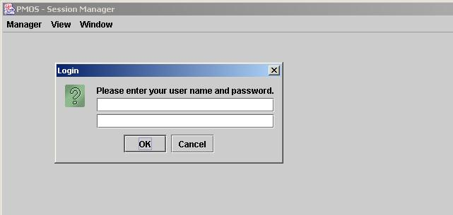
Figure 25. The UES main window with the login dialog

UES provides a set of APIs that can be used by sessions or applications running on the UES to interact with the PM engine. For example, there are APIs that can be used to open/close a user session, to open an object for reading or writing, to read or write the contents of an object, etc. These APIs are the equivalent of the system calls in traditional operating systems. On a UES, we simulate the separation between the user space and the kernel space by having the applications communicate with the kernel through sockets.

We provide three PM-aware applications with the UES. One of them is the Administrative Tool, whose use was explained in previous sections. The other two are a simple Rich Text Format (RTF) editor, and a simple Workflow application. We also provide the RTF editor with an embedded Trojan horse. They are shipped as jar files, called admin.jar, editor.jar, thEditor.jar, and wkf.jar respectively. Installing the applications is very simple: just copy the jar files to your desired locations, then use the UES menu “Manager/Configure…” to tell UES those locations, as Figure 26 illustrates.

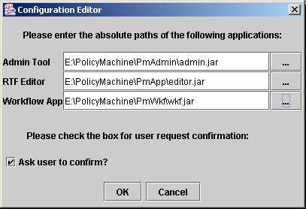
Figure 26. Installing the PM-aware applications.

The applications can be launched in two ways: explicitly, by using a session menu like “Launch RTF Editor”, or implicitly, by requesting the UES to open an object with the proper type. To date, the UES determines the object type by looking at the extension of the name used for the file that stores the object content. The RTF editor objects use the .rtf extension. The Workflow application objects use the .wkf extension.

7.2 Sessions and subjects
A user registered with the PM may log on any simulator by using his/her name and password registered with the PM (viz. Figure 25).

As a result of a successful login, the simulator opens a session for the user, in which the user is presented with his/her “logical object system” (LOS) (viz. Figure 27). The user’s LOS contains the objects and their attributes the user is authorized to access. One can navigate through the LOS using the same method as in the case of the Administrative Tool.

You can open multiple sessions on the same or different simulators/hosts, as the same user or as different users. Note that a session is opened with an empty set of active attributes. All processes that run in the same session share the same set of active attributes. As the session user/processes issue access requests, the engine will augment the set of active attributes, trying to satisfy those requests. Augmentation is limited by the subject attribute constraints.
One can examine the session’s active attribute set by launching the administrative tool and selecting the menu View/Sessions, then selecting the session to examine (viz. Figure 28).

Using the session menu you can customize the LOS view, change your password, execute engine commands, run a PM-aware application, or configure the session.
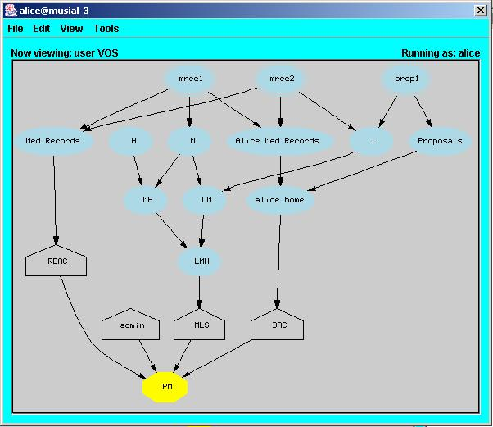
Figure 27. User view - The logical object system displayed in a session

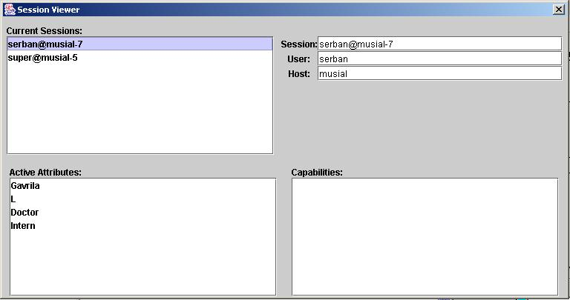
Figure 28. Active attributes of a session

7.2.1 Configuring a session
As we said, we simulate the context switch between user space and kernel space by socket communication between the user application and the kernel simulator. The communication uses SSL sockets. Hence, both the user and the UES need private keys and public key certificates. They should be generated when the PM user entity is created, and the Installation Manual explains how to do it. To date, PM assumes that the keys and certificates are stored in Java key stores of the “jks” type.

The session user needs to specify the Java key store where his/her private key and certificate reside, as well as the trust store that contains the root certificate of the Certification authority that issued the UES kernel certificate. This information should be valid for all subsequent sessions, and can be set up by clicking the session’s “Tools/Configure…” menu. One needs to enter the paths of the key and trust stores in the available fields, as in Figure 29.

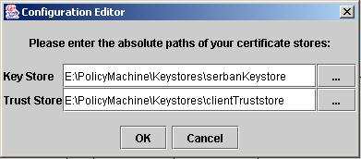
Figure 29. Configuring the user's key and trust stores

7.2.2 Changing user password

7.2.3 Customizing the LOS view
Right after a successful login, the user session displays “a user presentation” of the LOS, i.e., the objects the user could be allowed to process (read/write) as well as their containers. The user can change it to an “administrative presentation” of the LOS (viz., Figure 30), i.e., the objects, containers, user and user attributes on which the user is authorized to perform administrative operations, like assignment of a user to a user attribute, etc. Use the “View/Admin view” and “View/User view” to switch between the two views.

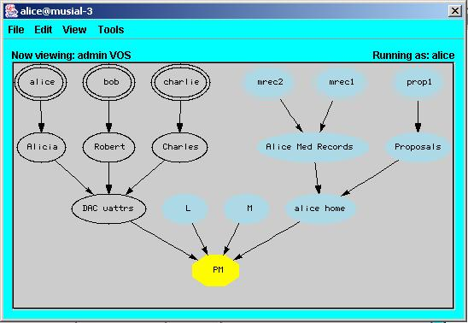
Figure 30. Administrator view

7.2.4 Running the PM applications
If you right-click on a LOS object, from the popup menu you can select the Open item, which tries to run the application that corresponds to the type of the object contents.

7.2.4.1 Running the RTF Editor
To create and edit a new RTF object, open a session and select the menu Tools/Run RTF Editor. After inserting text, save the object using the editor’s “File/Save As” menu, which makes a container selection window to pop up. You can navigate through the displayed objects and containers in the usual way. You need to select one or more containers (i.e., object attributes) where the new object will be inserted by right clicking on the desired object attributes. You also need to choose a unique name for the new object. Then press the OK button. Figure 31 illustrates the selection of two containers, “MedRecord” and “Gavrila Patients” for the new object named mrec12.

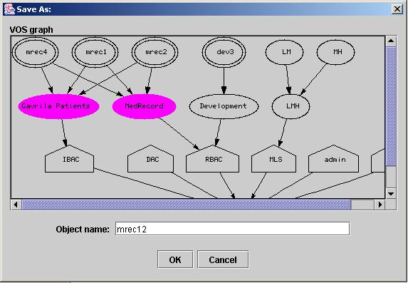
Figure 31. Selecting the containers and name of the new object

If an RTF object already exists in your LOS, you may try to open it in the RTF editor by right-clicking the object in your session’s LOS display and select Open from the popup menu. When you finish editing the contents, save the file by choosing either the File/Save or File/Save As menu.

7.2.4.2 Running the Administrative Tool
You can run the Admin Tool from your session by selecting the menu Tools/Run Admin Tool. The Admin Tool will run on behalf of the session’s user. If you are not logged in as “super”, your administrative rights will be very limited, unless the super granted you some special rights.

7.2.4.3 Running the Workflow application
Before running the Workflow Application, the administrator needs to define the following PM entities and relations:

- Two policy classes, an RBAC policy, and an IBAC policy.
- In the RBAC policy, define the roles (user attributes) Secretary and OU Officer.

- Define the users alice, bob, charlie, and dave, each assigned to his/her name attribute in IBAC. All name attributes are assigned to a user attribute “IBAC users”.
- User alice is also assigned to the Secretary role in RBAC. Figure 32 shows the user side of the PM graph.
- In RBAC, define the object containers (attributes) Forms and Archive.
- In the IBAC policy, define the following object containers (attributes): PopForms, “alice witems”, “bob witems”, “charlie witems”, “dave witems”.

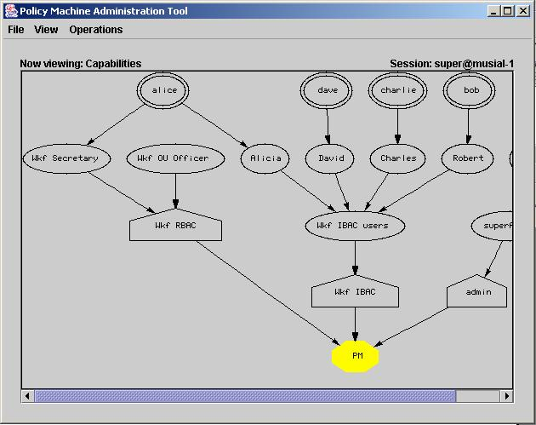
Figure 32. User side of the Workflow PM graph

The Forms container might contain forms for various purposes, like leave, purchase order, etc. To date, it contains only one form, a purchase order form poForm. The content of the poForm object is stored in a file poform.wkf as a textual representation of a purchase order graphical interface. Only the Secretary role can read forms from the Forms container.

The Archive container contains completed and approved forms. Only the OU Officer role can read objects from the Archive container.
PopForms is to be used by any user that fills out a form to store the completed (“populated”) form. Consequently, “IBAC users” has the permissions to create/write objects in PopForms.

The “alice witems” and similar containers are used to temporarily hold the corresponding user’s work items, i.e., purchase orders that need to be signed by that user. The user has the permissions to read/write objects in his/her work items container.

In addition to the permissions specified above, the Secretary should also be granted the privilege of adding event-response scripts to the PM engine.

Figure 33 shows the object side of the PM graph.

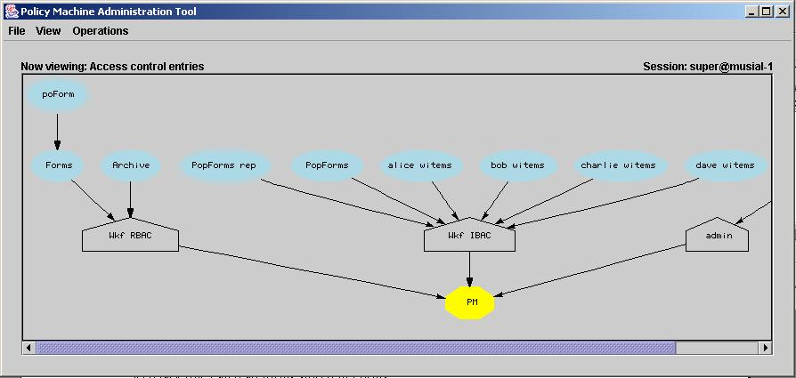
Figure 33. Object side of the Workflow PM graph

We are ready now to run the Workflow application.

The Secretary – alice – logs on. Her LOS shows the object poForm in the Forms container (viz. Figure 34).
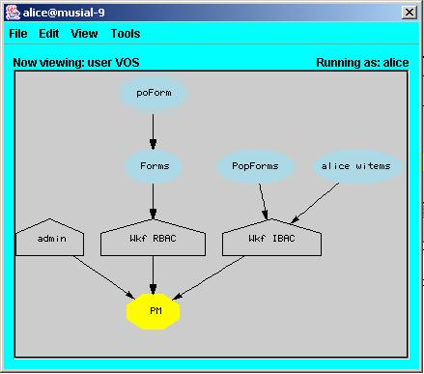
Figure 34. Secretary (alice) 's VOS
By opening the poForm object in her session, she launches the Workflow application (based on the .wkf type of the physical file corresponding to poForm). The Workflow application interprets the content of the .wkf file (Figure 35) and displays an empty purchase order form (Figure 36).
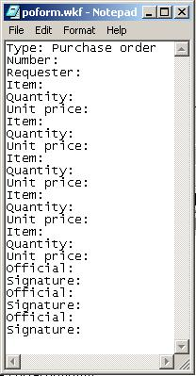
Figure 35. The text representation of an empty purchase order

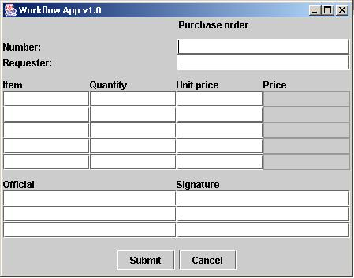
Figure 36. The graphic presentation of an empty purchase order
Alice fills out the purchase order number, the requester, the items to be purchased (name, quantity, unit price), and the routing slip – the users that need to sign the purchase order, in the order they need to sign it, as in Figure 37. Then she hits the “Submit” button. The workflow application generates and submits the event-response script shown in Figure 38 to the PM engine. Then, the application creates and writes an object with the name “po1” of the purchase order in the PopForms container. The corresponding text file is shown in Figure 39.

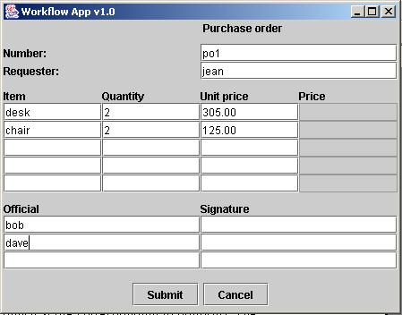
Figure 37. Completing the purchase order

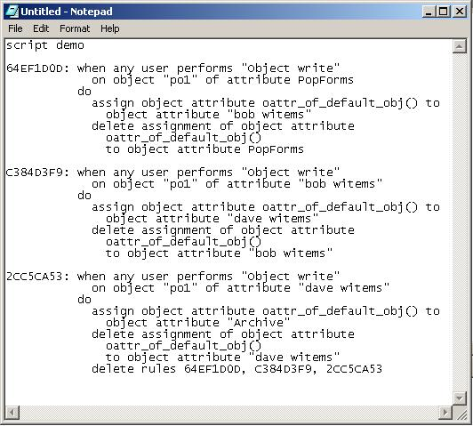
Figure 38. The event-response script generated by the workflow application

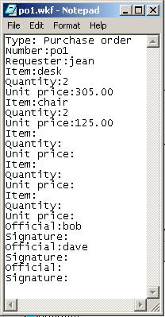
Figure 39. The text representation of the completed purchase order

Writing the object po1 into the PopForms container is an event that matches the pattern of the first rule in the event-response script. Consequently, the object po1 is moved from PopForms into the work items container of the first signer on the routing slip, which happens to be “bob witems”. If bob is logged on, he will see the object po1 popping up on his VOS (Figure 40).

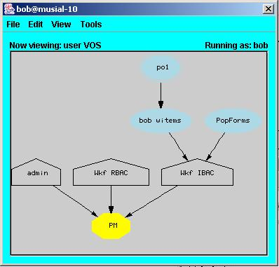
Figure 40. Object po1 shows up in bob’s work items

By opening the po1 object in his session, bob launches the Workflow application (based on the .wkf type of the physical file corresponding to po1). The Workflow application interprets the .wkf file and displays the corresponding purchase order (Figure 41). Bob signs it and hits the “Submit” button. The workflow application writes the signed purchase order back into “bob witems”. This event triggers execution of the second rule in the event-response script, which moves the signed-by-bob purchase order from “bob witems” to the second signer’s work items container, “dave witems”. The process repeats itself, with the purchase order popping up on dave’s VOS, dave opening it, signing, and submitting to the workflow application. Finally, the script moves the purchase order to the Archive container, and deletes all rules of the event-response script.

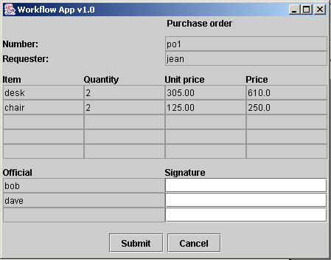
Figure 41. The purchase order graphic presentation as bob's work item

8 Configuring Access Control Policies

8.1 Discretionary Access Control (DAC) Policies

8.1.1 Overview
In classic Discretionary Access Control (DAC), there is the notion of owner of an object, who is usually its creator. In some DAC variants, the ownership of an object can change. Anyway, the main characteristic of DAC is that the object owner has discretionary authority over who can access that object.
The owner can also delegate his discretionary power to other users. There are many variants of DAC policy regarding how this delegation works and how access is revoked.
For example, a strict DAC policy requires that the owner is the only one who can grant access to an object, and ownership cannot be transferred. A liberal DAC policy allows the owner to delegate discretionary authority for granting access to an object to other users, using either one level grant or multilevel grant. Access to an object can be revoked either by anyone with the right to revoke access to that object, or only by the grantor of the access.

Under a discretionary policy as currently implemented in PM, a new user receives discretionary power over objects within a special container called his/her home and having the name “<user> home”, where <user> is the logon name of the new user. The new user’s home is created within the discretionary policy class as a response to the event “User create” triggered by the new user creation. The new user cannot be directly assigned permissions in PM (only user attributes are assigned permissions). Because of that the new user creation also triggers the creation of a user attribute representing the name of the new user, and whose only member is the new user. The new user attribute has the property “nameof=<user>” and the name “<user full name>”, where <user full name> is the user’s full name.

As a response to the event “User create”, the PM engine also creates two objects in the discretionary policy class. One object represents the new user’s home object attribute and all its ascendants, and has the name “<user> home sub-graph”. This object will be used to set administrative permissions on the new user’s home sub-graph. The other object represents a container of user attributes and/or users to whom the new user should be able to grant permissions on objects in his/her home. Its name is “<discretionary policy> user attributes”, where <discretionary policy> is the name of the discretionary policy class.

8.1.2 Creating a DAC Policy

Required Permissions
Creation of any policy class (in the connector node) requires the permission “Connector create policy class” on the connector node. Any user having this permission on the connector can create a discretionary policy class.

Properties
In PM, a discretionary policy class must have certain properties that identify it as a discretionary policy. At this time, there is only one such property, namely “type=discretionary”. The policy name is arbitrary.

Other Elements
The administrator is required to create two more entities assigned to the discretionary policy class.

The first entity is a user attribute with the name “<dac> uattrs”, where <dac> is the name of the discretionary policy class. This attribute must have the property “usersof=discretionary”. It will be used as a collection of user attributes and users that can be granted permissions on objects residing in a user’s home by that user. (The administrator can include selected users (thru their attributes) in this collection).

The second entity is an object with the name “<dac> uattrs rep”, which represents the sub-graph consisting of the user attribute “<dac> uattrs” and all its ascendants. Assume user “dave” wants to grant some user attribute “ua” included in “<dac> uattrs” permissions on objects in his home. In order to grant those permissions, dave himself needs the permission “User attribute assign to operation set” on “ua”, and this should happen for every ua included in “<dac> uattrs”. The simplest way to achieve that is to grant “dave” (through one of his user attributes) that permission on the entire sub-graph consisting of “<dac> uattrs” and its ascendants, i.e., on the object “<dac> uattrs rep”.

8.1.3 Creating Users under a DAC Policy
In general, the administrator creates a user within a specified PM container by using a simple interface provided by the Admin Tool.

The administrator may be any user with the required permissions on the container. The container may be a user attribute or the connector node. To create a user assigned to a user attribute “ua”, one needs the permission “User attribute create user” on “ua” (actually on an object that represents the user attribute “ua”). To create a user assigned to the connector node, one needs the permission “Connector create user” on the connector (actually on an object that represents the connector).

The engine simply creates a user entity and assigns it to the specified container. If a discretionary or MLS, etc., policy is enabled, the engine needs to perform additional tasks. They are defined in EVER scripts as responses to the event “User create” triggered by the user’s successful creation. The rest of this section describes the additional actions in the presence of a discretionary policy class. Let assume that the discretionary policy class is <dac>, the logon name of the newly created user is <u>, and his/her full name is <u name>.

Step 1. Create a user attribute “<u name>” with the property “nameof=<u>” and assign <u>  “<u name>”  <dac>.

If an identity-based policy class (i.e., one with the property “type=identity”) <ibac> exists, create a user attribute “<u name>” if not already present, and assign <u>  “<u name>”  <ibac>.

Step 2. Create an object attribute “<u> home” with the property “homeof=<u>” and assign “<u> home”  <dac>.

Step 3. Create an object “<u> home rep” and assign “<u> home rep”  <dac>.

Step 4. Create the operation set “<u> c1” = {“Object attribute create operation set”, “Operation set assign to”, “Object attribute assign operation set to”, “Object attribute create object attribute”, “Object attribute assign”, “Object attribute assign to”, “Object attribute delete assignment”, “Object attribute delete assignment to”} and assign “<u name>”  “<u> c1”  “<u> home rep”. This assignment allows user <u> to perform some administration limited to “<u> home” and its ascendants, i.e., to create containers and objects within the home, move objects among containers within the home, grant permissions on objects within his/her home.

Step 5. Create the operation set “<u> rw” = {read, write} and assign “<u name>”  “<u> rw”  “<u> home”. This assignment allows user u to read and write objects anywhere in his/her home.

Step 6. Create the operation set “<u> c2” = {“User attribute assign to operation set”} and assign “<u name>”  “<u> c2”  “<dac> uattrs rep”. This assignment allows user <u> to assign the ascendants of “<dac> uattrs” to operation sets on which <u> has the permission “Operation set assign to”. According to step 4, all operation sets in his/her home have this property, i.e., they may be assigned to users included in “<dac> uattrs”.

8.1.4 An EVER Script for Creating Users under DAC Policies
The following fragment of EVER script may be used to direct the PM engine to perform the previous steps in response to the user creation event.

if any user performs “User create” then

// create user attribute uattr_name_of_new_user()
create user attribute uattr_name_of_user(user_new())
// with property prop_name_of_new_user()
with property prop_name_of_user(user_new())
in policy pol_discr()

assign user user_new() to user attribute uattr_name_of_new_user()

// assign user attribute uattr_name_of_new_user() to policy pol_id()
assign user attribute uattr_name_of_new_user() to
policy pol_with_prop("type=discretionary")

create object attribute oattr_home_of_new_user()
// create object attribute oattr_home_of_user(user_new())
with property prop_home_of_new_user()
// with property prop_home_of_user(user_new())
in policy pol_discr()

create object obj_rep_of_home_of_new_user()
// create object obj_rep_of_home_of_user(user_new())
representing object attribute oattr_home_of_new_user()
and ascendants
in policy pol_discr()

grant uattr_name_of_new_user() operations ...
on object attribute oattr_home_of_new_user()

grant uattr_name_of_new_user() operations ...
on object attribute oattr_rep_of_home_of_new_user()

grant uattr_name_of_new_user() operations ...
on object attribute oattr_rep_of_discr_users()

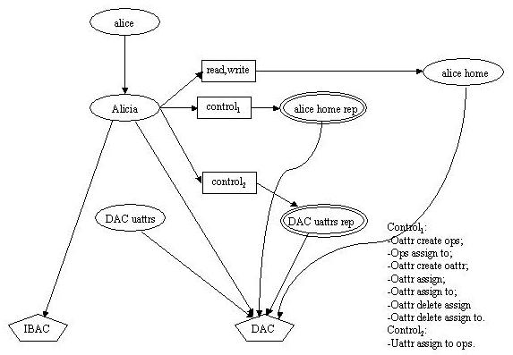
Figure 42. Containers and permissions in a DAC policy

8.1.5 Creating Objects Under a DAC Policy
First, we make a few helpful observations about the steps and permissions needed to grant a user attribute some permissions to an object (attribute) under a DAC policy.

1. Assuming that <oattr> is in “<u> home”, <uattr> is in “<dac> uattrs”, and <opset> does not yet exist, to set up the assignment <uattr>  <opset>  <oattr> the user <u> needs to:
- create <opset> assigned to <oattr> (requires permission “Object attribute create operation set” on <oattr>);
- assign <uattr> to <opset> (requires permissions “User attribute assign operation set” on <uattr>, and “Operation set assign to” on <opset>).
2. Assuming that <oattr> is in “<u> home”, <uattr> is in “<dac> uattrs”, and <opset> is assigned to <oattr>, to set up the assignment <uattr>  <opset>  <oattr> the user <u> needs to:
- assign <uattr> to <opset> (requires permissions “User attribute assign operation set” on <uattr>, and “Operation set assign to” on <opset>).
3. Assuming that <oattr₁> is in “<u> home” and <oattr₂> does not yet exist, to set up the assignment <oattr₂>  <oattr₁> the user <u> needs to:
- create <oattr₂> in <oattr₁> (requires permission “Object attribute create object attribute” on <oattr₁>).
4. Assuming that oattr₁ and oattr₂ are in “<u> home”, to set up the assignment <oattr₂>  <oattr₁> the user <u> needs to:
- assign <oattr₂> to <oattr₁> (requires permission “Object attribute assign” on <oattr₂> and “Object attribute assign to” on <oattr₁>).

Assume that the administrator creates users alice (full name Alicia), bob (full name Robert), and Charlie (full name Charles) under the PM DAC policy. Consequently, alice has a home container “alice home”, represented by the object “alice home rep” (viz. Figure 42). Similar entities exist for the other two users. Also, alice is assigned to the user attribute Alicia, which is assigned to “DAC uattrs” in turn. Similar attributes and assignments are created for bob and charlie.

Notice that alice has the permissions “Object attribute create object attribute” on “alice home rep”, so she may create an object attribute Proposals anywhere in her home.

Now we discuss several scenarios of alice granting bob permissions on objects in her container, Proposals.

Alice grants Bob read and write permissions on objects in her container Proposals

Step 1. Alice creates opset1 = {read, write} assigned to Proposals.

Permissions needed:
- “Object attribute create operation set” on Proposals. Alice has it on any object attribute in her home.

Step 2. Alice assigns Robert  opset1.

Permissions needed:
- “User attribute assign to operation set” on Robert. Alice has it on all “DAC users”.
- “Operation set assign to” on opset1. Alice has it on any operation set in her home, hence on opset1.

Alice lets Bob assign Proposals to his home

Step 1. Alice creates the object “Proposals rep”, which represents the “Proposals” object attribute, directly in her home.

Permissions needed:
- “Object attribute create object” on her home. Alice has it on any object attribute in her home.
- “Entity represent” on Proposals. Alice has it on any entity in her home.

Step 2. Alice creates opset2 = {“Object attribute assign”} assigned to “Proposals rep”.

Permissions needed:
- “Object attribute create operation set” on “Proposals rep”. Alice has it on any object attribute in her home.

Step3. Alice assigns Robert  opset2.

Permissions needed:
- “User attribute assign to operation set” on Robert. Alice has it on all “DAC uattrs”.
- “Operation set assign to” on opset2. Alice has it on any operation set in her home, hence on opset2.

Step 4. Bob assigns Proposals to his home, Proposals  “bob home”.

Permissions needed:
- “Object attribute assign” on Proposals. Alice just granted bob (Robert) this permission on “Proposals rep” in steps 2, 3 above.
- “Object attribute assign to” on Bob’s home. Bob has it on any object attribute in his home.

Note. Bob needs to perform the assignment in step 4 by using a tool that displays the object attribute “Proposals”, like the Admin Tool. His session does not, because there is no direct operation assignment from Bob to it.

Once Proposals is assigned to Bob’s home, Bob can perform all operations on its contents, including granting access to other users.

Alice grants Bob administrative rights (without grant) on Proposals

Step 1. Alice creates the object “Proposals rep”, which represents the “Proposals” object attribute, directly in her home.

Permissions needed:
- “Object attribute create object” on her home. Alice has it on any object attribute in her home.
- “Entity represent” on Proposals. Alice has it on any entity in her home.

Step 2. Alice creates opset3 = {some permissions} and assigns it to “Proposals rep”.

Permissions needed:
- “Object attribute create operation set” on “Proposals rep”. Alice has it on any object attribute in her home.

Step3. Alice assigns Robert  opset3.

Permissions needed:
- “User attribute assign to operation set” on Robert. Alice has it on all “DAC uattrs”.
- “Operation set assign to” on opset3. Alice has it on any operation set in her home, hence on opset3.

Now Bob has “some permissions” on Proposals. There is no way Bob can grant other users these or other permissions on Proposals.

Alice grants Bob the grant permission on Proposals

Step 1. Alice creates the object “Proposals rep”, which represents the “Proposals” object attribute, directly in her home.

Permissions needed:
- “Object attribute create object” on her home. Alice has it on any object attribute in her home.
- “Entity represent” on Proposals. Alice has it on any entity in her home.

Step 2. Alice creates opset4 = {Entity represent, some permissions} and assigns it to “Proposals rep”.

Permissions needed:
- “Object attribute create operation set” on “Proposals rep”. Alice has it on any object attribute in her home.

Step3. Alice assigns Robert  opset4.

Permissions needed:
- “User attribute assign to operation set” on Robert. Alice has it on all “DAC uattrs”.
- “Operation set assign to” on opset4. Alice has it on any operation set in her home, hence on opset3.

Now Bob has “some permissions” on Proposals.

Step 4. Bob creates the object “Bob’s Proposals rep”, which represents the “Proposals” object attribute, directly in his home.

Permissions needed:
- “Object attribute create object” on his home. Bob has it on any object attribute in his home.
- “Entity represent” on Proposals. Bob has it from opset4.

Step 5. Bob creates opset5 = {bob’s some permissions} and assigns it to “Bob’s Proposals rep”.

Permissions needed:
- “Object attribute create operation set” on “Bob’s Proposals rep”. Bob has it on any object attribute in his home.

Step6. Bob assigns Charles  opset5.

Permissions needed:
- “User attribute assign to operation set” on Charles. Bob has it on all “DAC uattrs”.
- “Operation set assign to” on opset5. Bob has it on any operation set in his home, hence on opset5.

Now charlie has “bob’s some permissions” on Proposals.

Note. Bob can use steps 4, 5, 6 above to grant he or other users more permissions than he received from Alice.

8.2 Multi-Level Security (MLS) Policies

8.2.1 Creating a MLS Policy Class

Required Permissions

Creation of any policy class (in the connector node) requires the permission “Connector create policy class” on the connector node. Any user having this permission on the connector can create an MLS policy class.

Properties

In PM, an MLS policy class must have certain properties that identify it as an MLS policy, and specify the policy’s clearance levels and their order relation.
The property “type=mls” identifies the policy as MLS. The policy name remains arbitrary.
The property “levels=<l₁>,<l₂>,…,<l_{n}>” specifies the policy’s clearance levels and their order from low to high. <l_{i}> is the level’s name, which is used as a user attribute as well as an object attribute.

Other Elements

Let’s denote by <mls> the MLS policy class. The administrator must establish the following user attributes and assignments:

<l_{n}>  …  <l₁>  <mls>

In addition, a SAC constraint ({l₁},…,{l_{n}}) must be established.

Assuming that n = 3, the administrator must establish the following object attributes and assignments:

<l₁><l₁l₂>, <l₂>  <l₁l₂>, <l₂>  <l₂l₃>, <l₃>  <l₂l₃>, <l₁l₂>  <l₁l₂l₃>, <l₂l₃>  <l₁l₂l₃>.

The administrator must establish the following permission assignments:

<l₁> {read}  <l₁>
<l₁> {write}  <l₁l₂l₃>
<l₂> {read}  <l₁l₂>
<l₂> {write}  <l₂l₃>
<l₃> {read}  <l₁l₂l₃>
<l₃> {write}  <l₃>

For each level l_{i}, the administrator must create an object <l_{i} rep> that represents the object attribute <l_{i}>, an operation set <l_{i} Perms> = {Object attribute create object, Object attribute assign to}, and establish the assignment <l_{i}>  <l_{i} Perms>  <l_{i} rep>, which gives a process at level li the right to create/assign objects in/to the container <l_{i}>.

What About Existing Users?

What should happen with the existing users when an MLS policy gets created?
Approach 1. Leave the existing users outside the MLS policy.
Approach 2. Assign the existing users to the lowest clearance level of the MLS policy.

What About Existing Objects?

What should happen to existing objects when an MLS policy gets created?
Approach 1. Leave the existing objects outside the MLS policy.
Approach 2. Assign the existing objects to the lowest MLS level. This approach must be coordinated with a similar move regarding the existing users; otherwise they will not be able to access the objects.

8.2.2 Creating Users Under MLS Policies
If an MLS policy exists, the newly created user must be assigned to one of the MLS policy’s clearance levels, which thus becomes the user’s maximum clearance level.
This administrator may specify the level as the new user’s base node (i.e., he/she right-clicks on a level and selects the “Create user…” menu). If the administrator does not specify a level (i.e., the base node is not a clearance level), the engine should assign the new user to the lowest clearance level. The following EVER script could be used to enforce this approach:

script mls_user_creation
when any user performs "User create"
then assign user user_new() to user attribute uattr_lowest_level()

8.2.3 Creating Objects Under MLS Policies
This section describes object creation under an MLS policy.

Case 1. Assume that the subject’s user (in our implementation, the session) has no active clearance level, but is assigned to one of the MLS levels, which specifies the user’s maximum clearance level. In this case, the application must assign the new object to a MLS level up to and including the user’s maximum clearance level. The level for the new object should be selected by the user and passed to the engine in the createObject() API. The engine should check the subject’s permission to create an object in each of the containers specified in createObject(). As the subject does not have the permission to create the object in the specified MLS container because the corresponding user attribute is not active, the engine would activate the corresponding attribute (if the user is authorized for that level).

Case 2. Assume that the subject’s user (actually the session) has an active clearance level. In this case, the only MLS container where the new object could be created is the container corresponding to the user’s active clearance level.

Case 3. Assume that the subject’s user is not assigned to any MLS levels. Note that this assumption is not realistic, because under MLS policies every user is assigned to a MLS level. In this case, the process will not be allowed to create or assign the object to an MLS container.

8.2.4 Categories and MLS policies
Suppose that we need to define categories in addition to the security levels of a MLS policy. As an example, let the basic categories be A and B. Then the derived categories are , {A}, {B}, {A, B}. The administrator must define the permissions so that a subject S can read an object O if and only if S dominates O, and S can write O if and only if O dominates S, where the “dominates” definition is as follows:

(level₁, category₁) dominates (level₂, category₂)  level₂  level₁ and category₂  category_{1.}

(where the relation  is the order relation defined on the MLS levels).
The administrator can configure the PM to simulate levels with categories, as follows:

- Configure the PM to simulate the MLS levels, e.g., L  M  H.
- Add a new policy class “Category”.
- Add the user attributes A, B, AB in the policy class Category.
- Add the object attributes A, B, AB in the policy class Category.
- Grant the following permissions:

A  {read, write}  A
A  {write}  AB
B  {read, write}  B
B  {write}  AB
AB  {read, write}  AB
AB  {read}  A
AB  {read}  B

- Create users and assign them to desired levels and categories, for example:

Alice  H
Alice  A
Bob  H
Bob  AB

- Create objects and assign them to desired levels and categories, for example:

o1  M
o1  A
o2  M
o2  B
o3  M
o3  AB
o4  M
o5  L

Now experiment accessing those objects as Alice or Bob.

8.2.5 Alternate MLS Configuration
This section shows how to use deny relations to configure MLS policies, in which not all objects under the PM control need to be included in the configuration. Also, subject activation constraint need not be imposed. Assume that U (unclassified), C (confidential), and S (secret) are the three MLS clearance levels as well as security labels, and let the administrator create the user and object attribute and assignments shown in Figure 43.

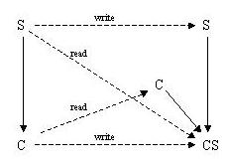
Figure 43. Alternate MLS configuration
The administrator must also create the attribute-based deny relations:

Deny(S, {write}, S);
Deny(C, {write}, CS).

First deny specifies that subjects with the Secret attribute active can write objects only to the Secret container. The second deny specifies that subjects with the Confidential attribute can write objects only to the Secret or Confidential containers. There is no need for SAC to constrain the set of active attribute to either S or C.

8.3 Identity-Based Access Control (IBAC) Policies

8.3.1 Creating an IBAC Policy Class

Required Permissions

Creation of any policy class (in the connector node) requires the permission “Connector create policy class” on the connector node. Any user having this permission on the connector can create an IBAC policy class.

Properties

In PM, an IBAC policy class must have certain properties that identify it as an IBAC policy, and specify the policy’s clearance levels and their order relation.
The property “type=identity” identifies the policy as IBAC. The policy name remains arbitrary.

8.3.2 Creating Users under an IBAC Policy
In general, the administrator creates a user within a specified PM container by using a simple interface provided by the Admin Tool.

The administrator may be any user with the required permissions on the container. The container may be a user attribute or the connector node. To create a user assigned to a user attribute “ua”, one needs the permission “User attribute create user” on “ua” (actually on an object that represents the user attribute “ua”). To create a user assigned to the connector node, one needs the permission “Connector create user” on the connector (actually on an object that represents the connector).

The engine simply creates a user entity and assigns it to the specified container.

If an identity-based policy is enabled, the engine needs to perform additional tasks. They are defined in EVER scripts as responses to the event “User create” triggered by the user’s successful creation. The rest of this section describes the additional actions in the presence of an identity-based policy class. Let assume that the identity-based policy class is <ibac>, the logon name of the newly created user is <u>, and his/her full name is <u name>.

Step 1. Create a user attribute “<u name>” with the property “nameof=<u>” and assign <u>  “<u name>”  <ibac>.

The following script fragment specifies the creation and assignment of the <u name> attribute

// create user attribute uattr_name_of_new_user()
create user attribute uattr_name_of_user(user_new())
// with property prop_name_of_new_user()
with property prop_name_of_user(user_new())
in policy pol_with_prop(“type=identity”)

8.4 Confinement Policies

8.4.1 Confinement under DAC policies
We assume that a DAC policy is enabled, in which alice and bob are users with Alicia and respectively Robert as name attributes. Assume that user alice has some objects in her home that are sensitive, in the sense that she accepts to let other users to read and even modify them, but she doesn’t want the other users to save the sensitive objects in other containers (for example, she doesn’t want bob to save any of her sensitive objects in his home). Let “Sensitive” be the container with sensitive objects, contained in alice’s home.

The technique used to confine sensitive objects to certain containers is as follows: we make the engine to activate a specific attribute in a specific policy class in order for a user to access a sensitive object. This specific attribute is linked to a deny relation that denies subjects with that attribute the permission to save objects anywhere outside the sensitive container. The deny relation has the form <specific attribute, {create object, write}, not(sensitive container)>.

The rest of this section describes an implementation of this technique.

First, the administrator needs to:

- Create a new policy class “Confinement” and a user attribute “Conf attr” in the new policy class. “Conf attr” will contain the users that are allowed to access Alice’s sensitive objects.
- Assign the container “Sensitive” to the Confinement policy class. Consequently, to access objects in “Sensitive”, a user needs to have active attributes in both policy classes DAC and Confinement.
- Create the object “Conf attr rep” that represents “Conf attr” in the DAC policy class.
- Create the object “Sensitive rep” that represents “Sensitive” in the Confinement policy class.
- Set the permissions “Conf attr”  {Object read, Object write}  “Sensitive”.
- Set the permissions “Conf attr”  {Object attribute create object}  “Sensitive rep”.
- Set the permissions “Alicia”  {User attribute assign to}  “Conf attr rep”. Note that both Alicia and “Conf attr rep” are in DAC only, so this assignment allows alice to assign something to “Conf attr”.
- Modify the rule for user creation under DAC to set the permission <User name attribute>  {User assign}  <DAC user names attributes> (in addition to “User attribute assign to operation set”. In our example, this permission is “Alicia”  {User assign}  “DAC names”, and in combination with the preceding permission allows user alice to assign another user to “Conf attr”.
- Create an attribute-based inter-sessions deny constraint <”Conf attr”, “Object attribute create object”, not “Sensitive”>, with the meaning that a user active in “Conf attr” in any session (not just the current one) cannot “Save As” an object anywhere except to the “Sensitive” container.
- Create an attribute-based Deny constraint <”Conf attr”, “Object write”, not “Sensitive”>, with the meaning that a user active in “Conf attr” cannot write the content of an object anywhere except to the “Sensitive” container.
- Assign “alice”  “Conf attr” (viz. Figure 44).

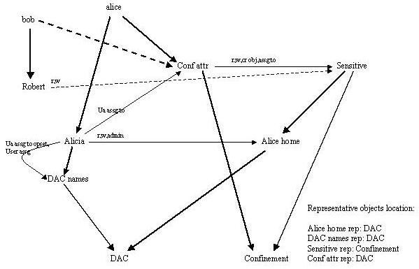
Figure 44. DAC confinement

Now Alice can log on and create objects in the “Sensitive” container.
To grant Bob read/write access to “Sensitive” with the saving of sensitive objects confined to “Sensitive”, Alice just needs to grant bob’s name attribute (i.e., Robert) the permissions {read, write} on “Sensitive” and to assign bob  “Conf attr”.

Now, if Bob logs on, he can create an object and save it in his home. He can also read and write any object in “Sensitive” by having the engine activate his name attribute and the “Conf attr” attribute. But he cannot save (a copy of) that object in his home, because users active in “Conf attr” can create objects only in “Sensitive”, according to the above-mentioned deny constraints.

8.4.2 Confinement under RBAC policies
Let’s assume that a RBAC policy is enabled. We also assume that a DAC policy is enabled, but only for the purpose of easy building of a user account and home container.

Assume that the contents of the “Med Records” container is sensitive, we want to allow Interns to read it and Doctors to write it, but we do not want either to copy such contents in other containers.

The technique used to confine sensitive objects’ saving to certain containers is as follows: in order for a user to access a sensitive object, make the engine activate a specific attribute in a specific policy class for that user. When the user tries to “Save As” the sensitive object, his/her being active in that specific attribute triggers a permission denial of the form <specific attribute, create object, not specific container>, where “specific container” is the container for sensitive objects.

The rest of this section describes an implementation of this technique.

First, the administrator needs to:

- Create a new policy class “Confinement” and a user attribute “Med Records Auth” in Confinement. “Med Record Auth” will contain the users that are allowed to access the medical records in “Med Records”.
- Assign “Med Records”  “Confinement”.
- Create the object “Med Records conf rep” that represents “Med Records” in the Confinement policy class.
- Assign “Med Records Auth”  {read, write}  “Med Records”.
- Assign “Med Records Auth”  {object attribute create object}  “Med Records conf rep”.
- Create an attribute-based Deny constraint <”Med Record Auth”, “Object attribute create object”, not “Med Records conf rep”>, or <”Med Record Auth”, “Object attribute create object”, not “Med Records rep”> (or both), with the meaning that a user active in “Med Records Auth” cannot save an object anywhere except in “Med Records”.
- Enable the EVER script for creating users under DAC policies, create user Alice, and assign Alice  Doctors and Alice  “Med Records Auth”.

Let Alice log on and create an object in her home. She will be able to save a copy of it in her home. Now, let her open a medical record in “Med Records”. She is able to save a copy of it in “Med Records”, but not in her home. Actually, because she got the active attribute “Med Record Auth”, she will not be able to save anything anywhere, except to “Med Records” (in her current session).

8.5 History-based Policies
For examples of configuring history-based policies, see section 7.2.4.3, “Running the Workflow application”.

The attributes, users, objects, operation sets, policy classes and the assignment relations define a graph, which may be not always connected. To make it connected, we add a “connector node” to the graph and some default assignments.

