**Checkpoint Report**

Nikhilesh Sigatapu  
Advised by Adam Finkelstein

**Progress to Date**

So far, I have done the following:

* Set up Oculus Rift hardware
* Download, compile Oculus SDK code with sample programs
* Read Oculus API documentation
* Write a test Oculus program that shows a simple room
* Write a point cloud viewer that supports viewing through the Oculus Rift with full positional and rotational tracking (supports point cloud data of the format from <http://homes.cs.washington.edu/~kevinlai/datasets.html> and has been tested with the urban scenes on that page). A video can be found at <https://www.youtube.com/watch?v=R9XcvrQ-9Mo> and a screenshot below:  
  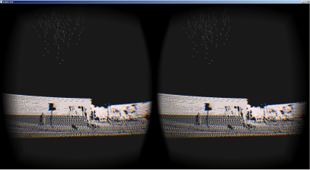

The project source code and documentation (such as this file and the proposal presentation) are available on GitHub with full development history.

Readings: “Kintinuous: Spatially Extended KinectFusion” by T. Whelan, M. Kaess, M.F. Fallon, H. Johannsson, J.J. Leonard and J.B. McDonald; Oculus Developer Guide; Oculus User Guide; "AR-Rift" by William Steptoe

**Current Difficulties**

I am currently waiting on shipment of a new desktop computer that should speed up development considerably due to increased computing resources. The expected time of arrival is in the next week. My old computer didn’t have a USB 3.0 port which was required to get the Intel depth camera working. I haven’t faced any blocking technical issues so far – most trouble with the APIs etc. was quickly resolved through searching online or experimentation.

**Next Steps**

One key next step would be to figure out the concrete project plan and goals – so far I’ve been going based on the proposal presentation which isn’t very in-depth. This should help direct development in the coming weeks. Another would be to get the depth camera up and running with its API etc., and then work on a test program to feed data from the camera into the point cloud viewer described above.