**1. Set Up Development Environment**

* **Install Node.js and npm**
* Download and install VScode

**2. Create a New Next.js Project**

npx create-next-app@latest trademark-search in the terminal.

**3. Set Up Tailwind CSS for Styling**

npm install -D tailwindcss postcss autoprefixer

npx tailwindcss init -p

**Configure Tailwind file**

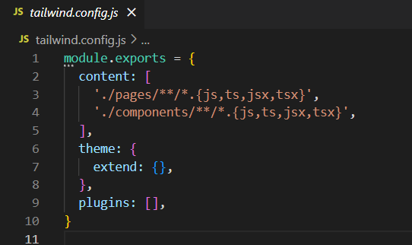

**4. Create the Main Components**

Break down the UI into components: SearchBar, Filter, StatusIndicator, and a Results component.

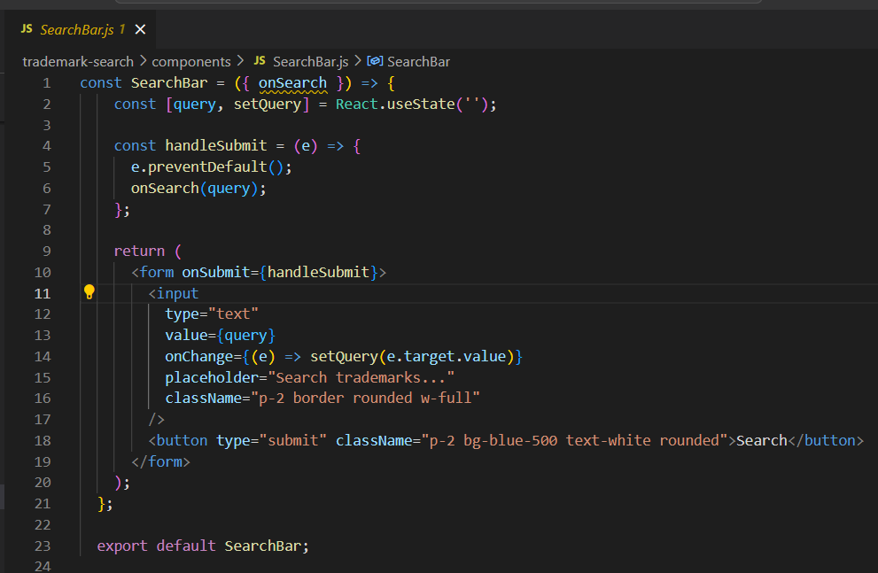

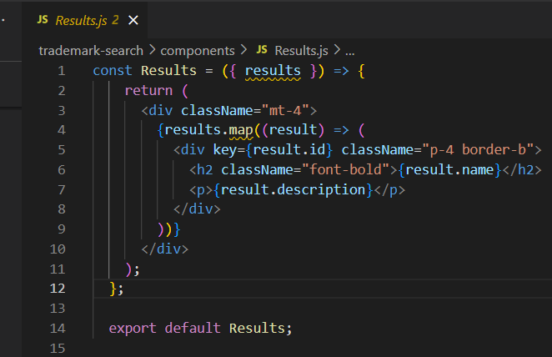

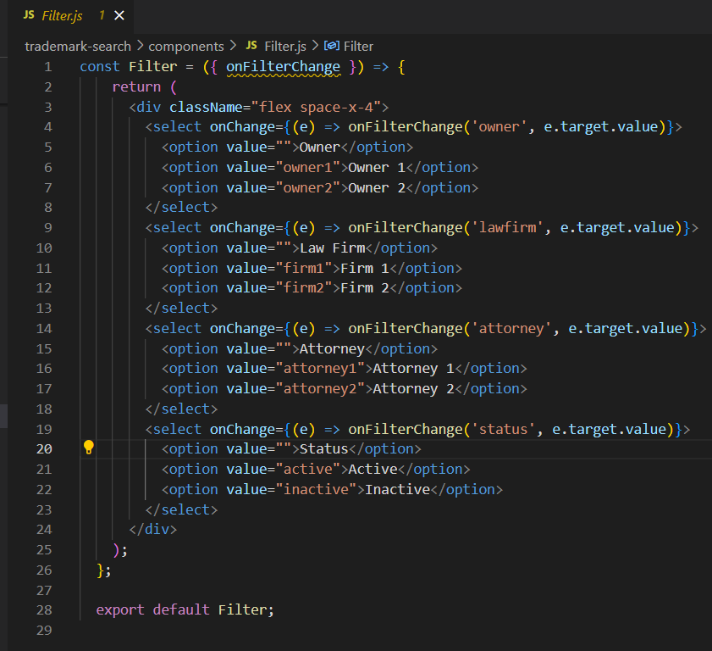

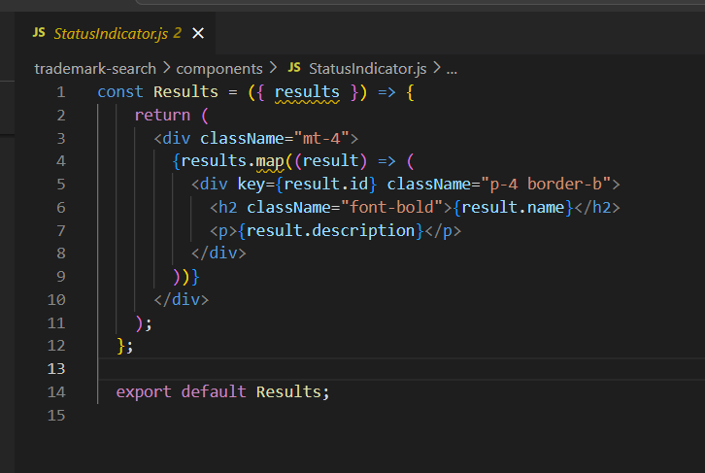

**5. Connect Components in Your Page**

Open pages/index.js and import the components created

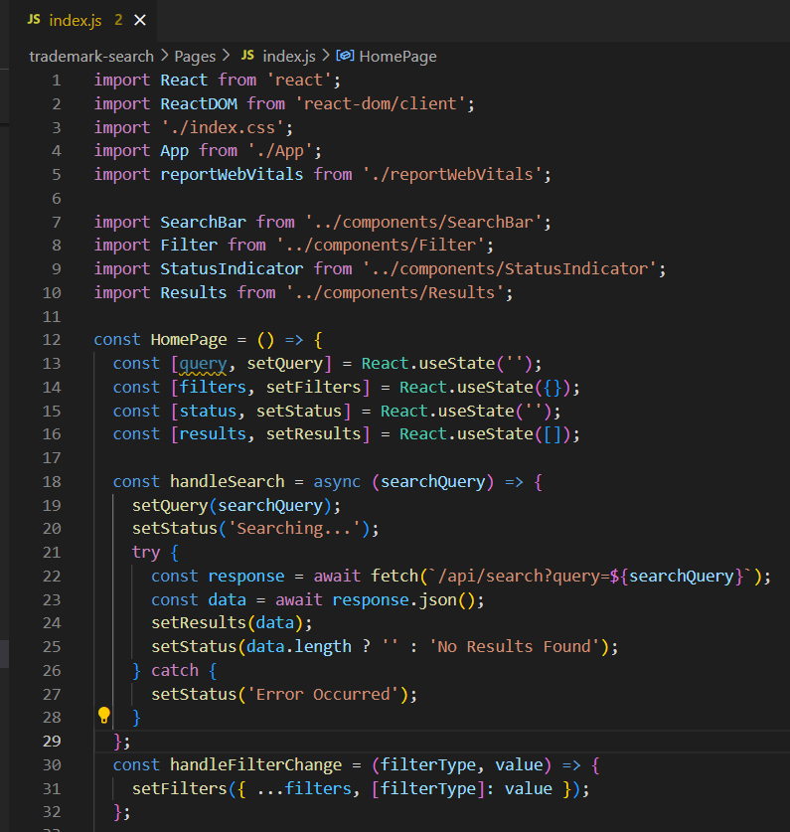

**6. Implement the API**

Create a new folder called pages/api , create a file called search.js

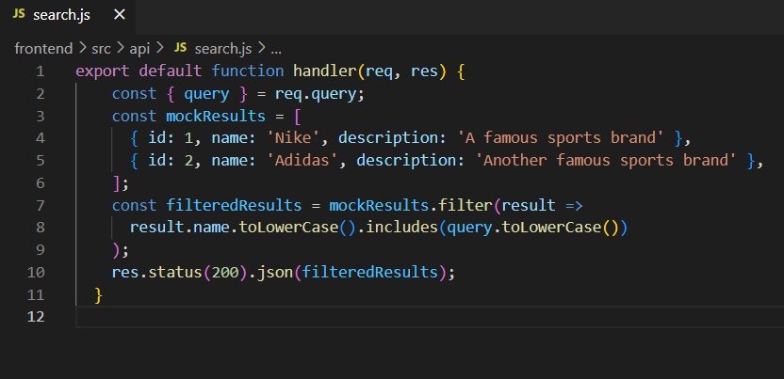

**7. Test Your Application**

Run the project by typing “ npm run dev “ and open browser and go to http://localhost:3000

