**IOT BASED AIR QUALITY AND WEATHER MONITORING SYSTEM  
(BT-ECE-802)**  
Thesis  
Submitted in partial fulfilment of the requirements for the award of degree of  
  
BACHELOR OF TECHNOLOGY  
  
By  
  
[Your Name]  
(Registration No: ____________)  
  
Under the supervision of:  
  
Dr. Sanjeev Kumar Metya  
Assistant Professor  
Department of Electronics and Communication Engineering

DEPARTMENT OF ELECTRONICS & COMMUNICATION ENGINEERING

**National Institute of Technology**  
 (Established by Ministry of Human Resource Development, Govt. of India)   
Jote, District: Papumpare, Arunachal Pradesh 791123

**ABSTRACT**

This project implements a multi-sensor IoT device for real-time monitoring of air and water quality using an ESP32 microcontroller. The system integrates various sensors to measure water parameters (such as pH, dissolved oxygen, turbidity, and total dissolved solids) and air parameters (including carbon dioxide, particulate matter, temperature, humidity, TVOCs, and formaldehyde). These readings are processed using the ESP32, displayed locally on a Nextion touch display, and transmitted to the cloud via Wi-Fi.

The data is sent to AWS IoT Core, where it is stored and visualized using Amazon Timestream and Grafana dashboards, providing a powerful remote monitoring system. All components are tested and validated to ensure reliability and accuracy. Real-time data visualization helps users monitor pollution trends and environmental conditions.

This low-cost, scalable system demonstrates the potential of IoT in environmental monitoring and can be further expanded into a distributed sensor network for smart cities, agriculture, or water management systems.

Key Words: IoT; ESP32; Air Quality; Water Monitoring; Sensors; AWS IoT; Cloud Dashboard; Environmental Monitoring

**ACKNOWLEDGEMENT**

Wetake this opportunity to express our heartfelt gratitude and sincere thanks to our project supervisor, Dr. Sanjeev kumar metya, Assistant Professor, Department of Electronics and Communication Engineering, National Institute of Technology Arunachal Pradesh, for his constant guidance, valuable suggestions, and encouragement throughout the duration of this project.

We are also thankful to the faculty members and technical staff of the Department of Electronics and Communication Engineering for their timely support and insightful feedback.

We would also like to acknowledge my project teammates and peers for their constructive discussions and moral support. Lastly, We express my deepest gratitude to my family for their unwavering motivation and encouragement, without which this work would not have been possible.

**CHAPTER 1: INTRODUCTION**

**1.1 Background**

Air and water pollution continue to be serious threats to public health and the environment. According to the World Health Organization (WHO), millions of premature deaths annually are linked to poor air quality. Simultaneously, many people in remote or rural areas lack access to real-time water quality monitoring tools. With increasing concerns over environmental sustainability, the demand for intelligent, cost-effective, and remote environmental monitoring systems has grown.

**1.2 Objectives**

This project aims to develop a smart IoT-based system capable of monitoring multiple air and water quality parameters using a suite of sensors. The device should be portable, low-cost, energy-efficient, and capable of real-time data transmission and visualization via a cloud platform.

Specific objectives include:

* Designing an IoT device using ESP32 and various sensors.
* Monitoring parameters like temperature, humidity, PM1.0, PM2.5, PM10, CO₂, TVOC, CH₂O, pH, turbidity, TDS, and dissolved oxygen.
* Displaying data locally using a Nextion HMI touchscreen.
* Transmitting data to AWS IoT Core and visualizing it using Grafana dashboards.
* Testing and validating the device in real-world environments.

**CHAPTER 2: LITERATURE REVIEW**

The concept of smart environmental monitoring using IoT has gained attention over the past decade. Researchers have developed air monitoring systems with low-cost sensors such as NDIR-based CO₂ modules and laser-based PM sensors. Similarly, water quality monitoring systems using analog and digital sensors for pH, turbidity, and DO have been successfully implemented.

Previous works primarily focused on either air or water monitoring, but few have combined both in a single device. Our system integrates both domains and provides real-time visualization with cloud storage, making it a more comprehensive approach.

Studies also reveal that while low-cost sensors lack the precision of industrial devices, with proper calibration and filtering techniques, they offer reliable data suitable for academic and public use.

**CHAPTER 3: SYSTEM ARCHITECTURE**

The system architecture consists of three major segments:

* Sensor Unit: Includes air and water quality sensors.
* Processing and Communication Unit: The ESP32 microcontroller collects data, processes it, and transmits it to the cloud.
* Visualization Unit: Composed of a local Nextion display and an AWS-based web dashboard.

The ESP32 is chosen due to its built-in Wi-Fi and Bluetooth capabilities. It connects to AWS IoT Core using secure MQTT protocol. Data is routed to Amazon Timestream for time-series storage and visualized using Grafana dashboards.

**CHAPTER 4: HARDWARE AND SOFTWARE COMPONENTS**

**4.1 Hardware Components**

* 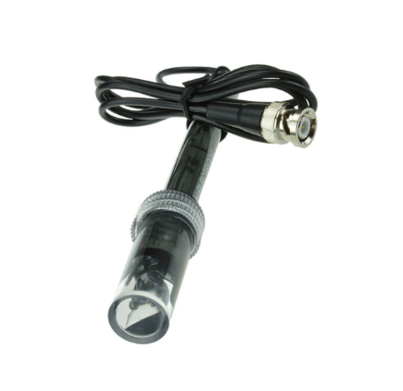**Electrode Probe for Liquid ph. Value Detection Sensor**

PH range: 0-14 PH

Temperature range: 0-60℃

Zero-point: 7 ± 0.5PH

Alkali Error: 0.2PH

Theoretical Percentage Slope: ≧98.5%

Internal Resistance: ≦250MΩ

Response Time: ≦1min

* **DS18B20 Water Proof Temperature Probe – Black (1m)**

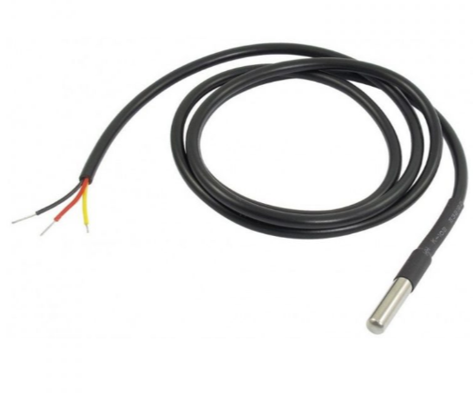

A probe by new original installation import DS18B20 temperature sensor chip.

Chip each pin use heat shrinkable tube to prevent short circuit, internal sealing glue, waterproof, moisture proof.

Stainless steel tube encapsulation waterproof moisture proof prevent rust.

Stainless steel shell (6 * 45 mm), lead length 100 cm (shielding wire) use stability.

Without the external components, the unique single bus;

* 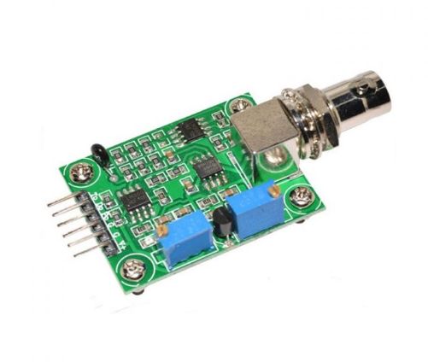**Liquid ph Value Detection Sensor for Arduino**

Heating voltage: 5±0.2V

Working current: 5-10ma

The detection concentration range: PH0-14

The detection range of temperature: 0-60 centigrade

The response time: ≤ 5S

Stability time: ≤ 60S

Power consumption: ≤ 0.5W

* **Dissolved Oxygen Level Sensor for Arduino**

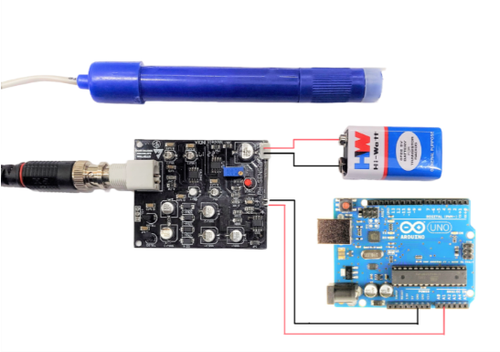

Dissolved Oxygen Level Sensor for Arduino by Graylogix is widely used for measuring dissolved oxygen in water. It’s compatible with Arduino, ESP8266, ESP32, STM32 microcontrollers, and Raspberry Pi. Applications include aquaculture, environmental monitoring, and natural science. In a word it serves the purpose of measuring dissolved oxygen in water to reflect water quality.

Calculating Dissolved Oxygen Levels:Expressed in milligrams per liter (mg/L) or parts per million (ppm), given that dissolved oxygen concentration levels are interchangeable, with 1 mg/L equaling 1 ppm. The Dissolved Oxygen Level Sensor kit includes a signal converter board with a BNC connector, especially directly connectable to the Galvanic Probe. This signal converter board amplifies the minor voltage difference eventually to a readable signal detectable by Arduino. With plug-and-play functionality, coupled with the signal converter board ensures good compatibility.

To protect the sensitive and fragile oxygen-permeable membrane in the membrane cap, for that reason it is crucial to cover the sensor tip. Also Avoid fingernails and other sharp objects to prevent damage. This sensor can seamlessly integrate into any control or likewise detecting system.

* 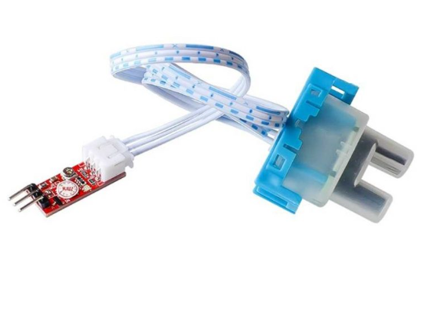**Turbidity Sensor with Module**

Operating Voltage: 5VDC.

Current: 30ma (MAX).

Operating temperature: -30 ° C to 80 ° C.

Compatible with Arduino, Raspberry Pi, AVR, PIC, etc.

Measuring Range: 0 ~ 1000 NTU.

Compatible with Arduino, Raspberry Pi, AVR, PIC, etc.

Measures turbidity of water in rivers.

Detects and verifies water quality.

Digital and analog output;

Able to detect particles that are suspended in water.

Trimpot for sensitivity adjustment.

Ideal monitoring of water turbidity in rivers, streams, lakes, water boxes, catchment and research sites, laboratories, tanks with liquids and etc.

Comes with a module and jumpers

* 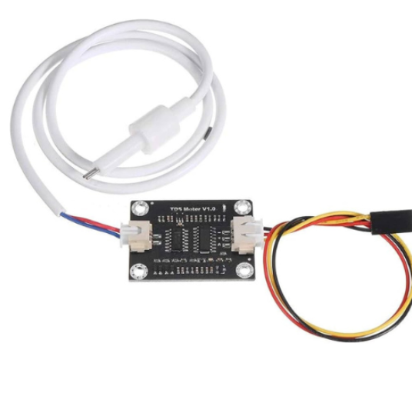**Analog TDS Sensor Module for Arduino and Microcontroller**

Wide voltage operation: 3.3~5.5V

0~2.3V analog signal output, compatible with 5V, 3.3V two control systems

The excitation source is an AC signal, effectively preventing probe polarization

Waterproof probe for long-term immersion in water

Wide voltage operation: 3.3~5.5V

0~2.3V analog signal output, compatible with 5V, 3.3V two control systems

The excitation source is an AC signal, effectively preventing probe polarization.

Waterproof probe for long-term immersion in water

Arduino compatible, easy to connect, plug and play, no soldering required.

* **MH-Z19 Infrared CO2 Sensor Module for CO2 monitor**

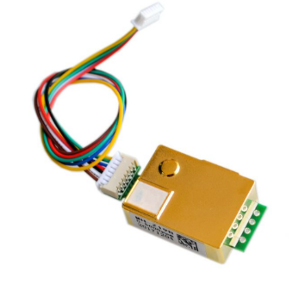

Operating voltage: 3.6 V ~ 5.5V DC

Average current: < 18 ma

High sensitivity, high resolution.

Low energy consumption.

Output mode: UART and PWM wave.

Temperature compensation, excellent linear output.

Good stability and long lifespan.

Anti-interference of water vapor.

This is MH-Z19 Infrared CO2 Sensor Module for CO2 monitor. The MH-Z19 NDIR infrared gas module is a common type, small size sensor, using non-dispersive infrared (NDIR) principle to detect the existence of CO 2 in the air, with good selectivity, non-oxygen dependent and long life.

The built-in temperature sensor can do temperature compensation; it has digital output an analog voltage output. It is developed by the tight integration of mature infrared absorbing gas detection technology, precision optical circuit design, and superior circuit design.

MH-Z19 NDIR infrared gas module is widely used in the HVAC refrigeration and indoor air quality monitoring.

High sensitivity, high resolution.

Low energy consumption.

Output mode: UART and PWM wave.

Temperature compensation, excellent linear output.

Good stability.

Long lifespan.

Anti-interference of water vapor.

No poisoning.

* 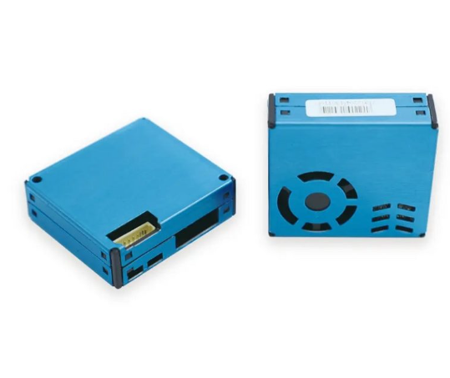**MPM10-BS memsfrontier Laser PM sensor (Air inlet and outlet are on the front, 8 pin)**

Particulate matter detection category: PM1.0, PM2.5, PM10.

8-pin design for advanced connectivity and data output.

The specified particle size range of particulate matter is 0.3 to 10 micrometers (μm).

Focuses on PM2.5 and PM10 particles.

Measures concentrations from 0 to 1000 micrograms per cubic meter (μg/m³).

±15μg/m³ or ±15% reading under standard conditions (25±2℃, 50%±10%RH).

Efficient power-on settling time of less than 10 seconds.

Mean free error time: ≥5 Years

* 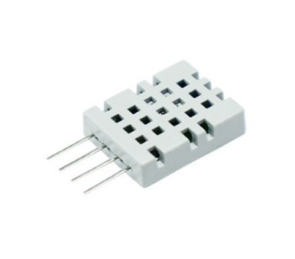**ASAIR TVOC Sensor Model AGS02MA**

AGS02MA is a MEMS TVOC gas sensor with a calibrated digital signal output. It uses dedicated digital module acquisition technology and gas sensing technology to ensure high reliability and excellent long-term stability. This MEMS gas sensor features low power consumption, high sensitivity, fast response, high reliability and stability, low cost, and a simple drive circuit.

Features:

Low cost, good long-term stability and excellent quality

Super-fast response, high sensitivity, fast response and recovery time.

Long service life

Long signal transmission distance

Digital signal output, accurate calibration

Sensor category MEMS semiconductor metal oxide compound sensor

Output unit ppb or ug/m ³

* 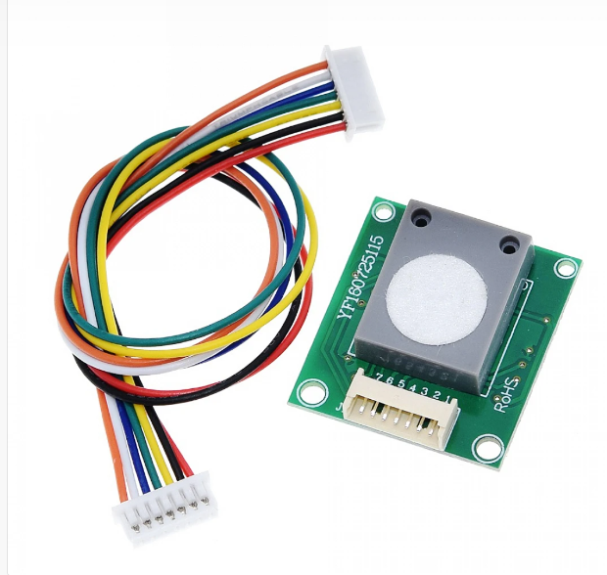**ZE08 CH2O Formaldehyde Gas Sensor Module**

ZE08-CH2O utilizes the electrochemical principle to detect CH2O in the air which makes the module with high selectivity and stability. It has a built-in temperature sensor to make temperature compensation. It has the digital output and analog voltage output at the same time.

Features:

Model: ZE-08 CH2O

High sensitivity and resolution.

Low power consumption.

Good stability, excellent ability of anti-interference, and excellent Linear output

Application: It has some applications such as portable detector, air-quality monitor, air cleaner, air renewal system, air conditioner, and smart home.

* 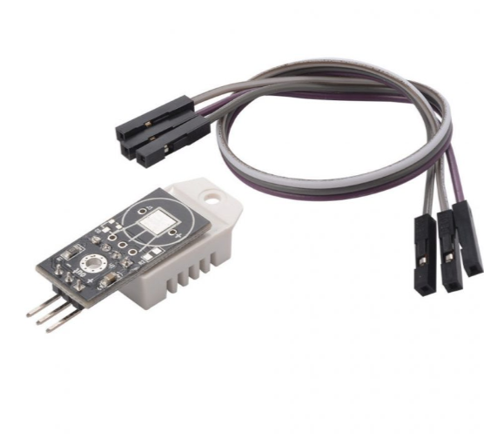**DHT22 Digital Temperature and Humidity Sensor Module AM2302**

Measuring range: temperature -40-80 ℃; humidity 0; 99.9%RH

Measurement accuracy (25℃): temperature: + 0.5; humidity: + 2%RH (10; 90%RH)

Resolution: temperature: 0.1 ℃, humidity: 0.1%RH

Attenuation value: temperature: <1℃ / year; humidity: < 1%RH/ years

High precision

Capacitive type

Full range temperature compensated

Relative humidity and temperature measurement

Calibrated digital signal

Outstanding long-term stability

High precision

Capacitive type

Full range temperature compensated

Relative humidity and temperature measurement

Calibrated digital signal

Outstanding long-term stability

Extra components not needed

Long transmission distance

Low power consumption

4 pins packaged and fully interchangeable

* 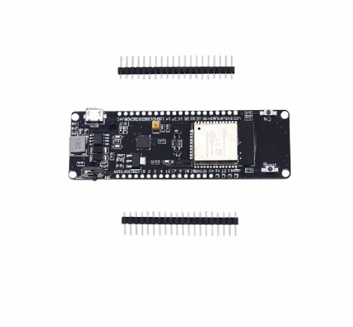**Wemqs wifi and Bluetooth Battery ESP32 Development Board With 18650 Lithium Battery Shiel**

Operating Voltage: 2.2 to 3.6VDC

Ultra-low power consumption

32 GPIO: ADC(16), SPI(2), I2C(1), UART(1), PWM(32), SDIO(50 mhz)

520 KB SRAM, 16 MB Flash, 1A output

Overcharge protection

Over-discharge protection

Full ESP32 pins break out

91.18mm x 29mm x 18.6mm (L x W x H)

This is Wemqs wifi and Bluetooth Battery ESP32 Development Board With 18650 Lithium

Features:

High performance-price ratio

Small volume, easily embedded to other products

Strong function with support LWIP protocol, Freertos

Supporting three modes: AP, STA, and AP+STA

Supporting Lua program, easily to develop

18650 charging system integrated.

Ultra-low power consumption

Indicate LED inside(Green means full& Red means charging)

Charging and working could be at the same time.

1 Switch could control the power.

1 extra LED could be programmed(Connected with GPIO16[D0])

0.5A charging current

1A output

Overcharge protection

Over-discharge protection

Full ESP32 pins break out

* **Nextion Enhanced NX3224K024 2.4” HMI Touch Display**

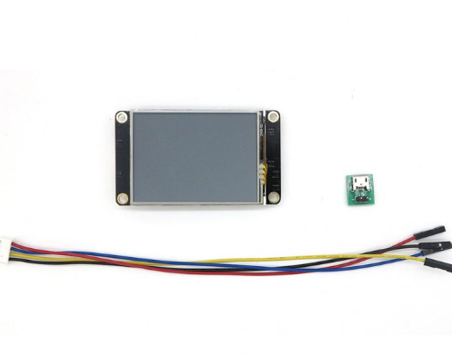Operating Voltage (VDC):4.75 ~ 7  
Max. Operating Current (ma):90  
Display Layout Size (L x W x H) mm:74.4 × 42.72 × 5.8

Features:

Supports built-in RTC

Supports GPIO

SD Card interface: support max 32G Micro TF/SD card (FAT32 file format)

Flash data storage space: 16MB

EEPROM: 1024 bytes

RAM: 3584 bytes

Instruction buffer: 1024 bytes

Color: 65K (65536) colors

Resolution: 320×240 pixel

Adjustable Brightness: 0~180 nit – the interval of adjustment is 1%

**4.2 Software Stack**

* Arduino IDE for firmware development
* MQTT Protocol for data communication
* AWS IoT Core for cloud communication
* Amazon Timestream for data storage
* Grafana for visualization
* Nextion Editor for GUI development

**CHAPTER 5: CIRCUIT DESIGN AND SYSTEM INTEGRATION**

Each sensor is connected to the ESP32 via digital or analog I/O pins. Power is supplied through a 5V rail, managed by the battery shield.

* Analog sensors (pH, turbidity, DO, TDS) are connected to the ESP32's ADC pins.
* Digital sensors (DHT22, DS18B20, TVOC) use GPIO pins.
* Serial devices (Nextion, CO₂, PM sensor) use UART communication.

The entire setup is housed in a waterproof, rugged enclosure with separate chambers for air and water probes. The display is mounted on the front panel.

**CHAPTER 6: DATA COLLECTION AND TESTING PROCEDURE**

**6.1 Calibration**

* pH Probe: Calibrated using pH 4, 7, and 10 buffer solutions.
* DO Sensor: Calibrated using saturated DO values based on water temperature.
* CO₂ Sensor: Auto-calibrated in fresh air (~400 ppm baseline).

**6.2 Testing Setup**

The device was tested for 24 hours in both indoor and outdoor conditions. Water probes were immersed in standard tap water and monitored continuously.

**6.3 Data Logging**

Data was sent every 60 seconds to AWS IoT Core, then logged into Amazon Timestream and visualized via Grafana. Real-time readings were also displayed on the Nextion screen.

**CHAPTER 7: RESULTS AND ANALYSIS**

Sample readings collected:

|  |  |  |
| --- | --- | --- |
| Parameter | Value | Unit |
| pH | 7.2 | - |
| Dissolved Oxygen | 7.5 | mg/L |
| Turbidity | 12 | NTU |
| TDS | 320 | ppm |
| CO₂ | 420 | ppm |
| PM2.5 | 40 | µg/m³ |
| PM10 | 75 | µg/m³ |
| TVOC | 250 | ppb |
| Formaldehyde (CH₂O) | 60 | ppb |
| Temperature | 25 | °C |
| Humidity | 52 | % |

Graphical Analysis:

* PM2.5 levels exceeded WHO guidelines (~25 µg/m³).
* Water pH and DO levels were within normal range.
* Time-series graphs showed stability and consistent performance.

**CHAPTER 8: COST ANALYSIS**

|  |  |
| --- | --- |
| Component | Cost (INR) |
| ESP32 Dev Board + Battery Shield | 500 |
| pH Sensor | 700 |
| DO Sensor | 1500 |
| Turbidity Sensor | 300 |
| TDS Sensor | 100 |
| CO₂ Sensor (MH-Z19) | 1200 |
| PM Sensor (MPM10-BS) | 1500 |
| TVOC Sensor (AGS02MA) | 400 |
| CH₂O Sensor (ZE08) | 2000 |
| DHT22 Sensor | 150 |
| DS18B20 Sensor | 50 |
| Nextion Display | 2000 |
| Miscellaneous | 300 |
| Total | 15,700 |

**CHAPTER 9: CHALLENGES FACED**

* Sensor Calibration: Frequent recalibration was needed for pH and DO sensors.
* Power Consumption: The system drained power quickly; a larger battery is recommended.
* Environmental Factors: Humidity and dust affected air sensor performance.
* Cloud Connectivity: Required stable Wi-Fi and re-authentication logic.

**CHAPTER 10: FUTURE SCOPE**

* Integration with LoRaWAN for long-range rural monitoring.
* Addition of rainfall and water level sensors.
* Development of a mobile app.
* Use of machine learning for predictive analytics.
* Deployment as a smart city node.

**CHAPTER 11: CONCLUSION**

The developed system successfully achieved real-time, multi-parameter environmental monitoring using low-cost sensors and cloud integration. It demonstrates the practical utility of IoT in solving environmental challenges and provides a strong foundation for further innovation in smart monitoring systems.

**REFERENCES**

1. Shahid, S., et al., “Innovations in Air Quality Monitoring: Sensors, IoT and Future Research”, *Sensors*, 2024.
2. Tadeo, S., et al., “Low-Cost Water Quality Sensors for IoT: A Systematic Review”, *Sensors*, 2023.
3. World Health Organization, “WHO Global Air Quality Guidelines”, WHO Press, 2021.
4. AWS Documentation, “AWS IoT Core Developer Guide”, Amazon, 2023.
5. Nextion Editor Guide, Nextion Official Docs, 2022.