St Pats Nursery Programme – Mentor Summary
Our Purpose
The St Pats Nursery Programme introduces children aged 4–6 to Gaelic Games in a fun, safe and engaging environment that builds confidence, movement skills, enjoyment of sport, and a lifelong connection with St Pats.
Our guiding principle is simple:
Children play sport because it is fun.
Everything we do should reflect that.

Our Coaching Philosophy
The Nursery focuses on developing Physical Literacy — helping children learn how to move confidently and competently so that they can enjoy a lifelong involvement in Sports.
This means building:
- Physical Competence – movement skills and sporting skills
- Confidence & Motivation – helping children feel capable and enjoy participation
- Knowledge & Understanding – creating positive habits around activity and sport
The objective is:
“As many as we can, for as long as we can.”

What We Coach
The Nursery sits within the GAA Foundation 1 (F1) Player Pathway, with an emphasis on fundamental movement and early game skills.
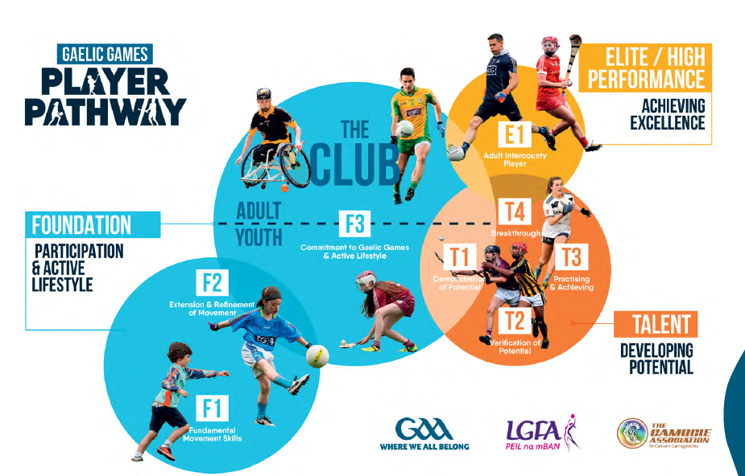

Core Skill Areas

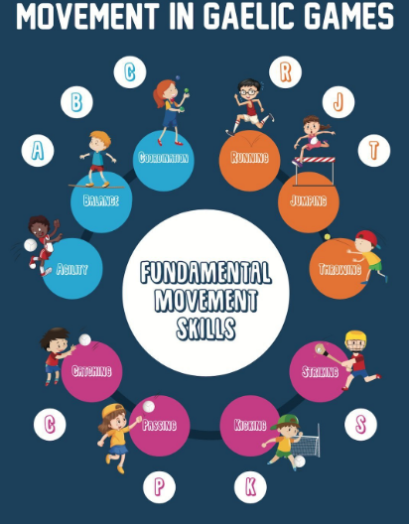

The aim is to create children who are:
- confident movers
- enthusiastic participants

Understanding 4–6 Year Olds
Children in this age group:
- have short attention spans
- are still learning cooperation
- often focus only on the ball
- respond best to games, races and fun challenges
- learn through demonstration, repetition and encouragement
Coaching should therefore be:
- active
- simple
- energetic
- positive
- game-based

The St Pats Coaching Approach
All nursery mentors should follow our coaching model:
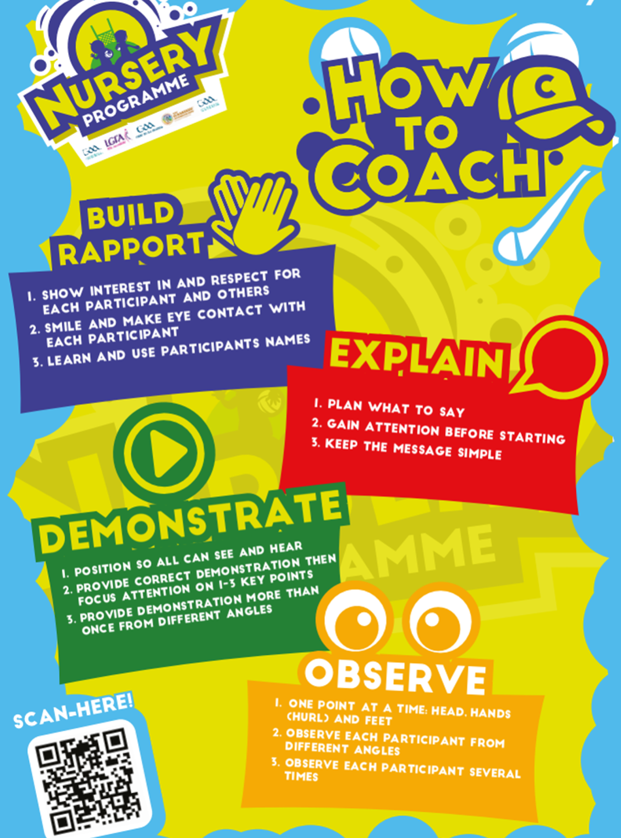

Mentor Expectations
All mentors are expected to:
- Complete Garda Vetting
- Complete GAA Child Safeguarding
- Support a safe, inclusive environment
- Follow the coaching plan
- Help with set-up and clean-up
- Encourage effort, fun and participation for every child

Nursery Rules We Reinforce
Children should learn to:
- Be on time
- Respect equipment
- Give their best effort
- Be kind to others
- Encourage teammates
- Play fairly
- Have fun

Final Reminder
At nursery level, we are not coaching winning teams — we are developing happy, confident children who love Gaelic Games.
Fun first. Movement & Skills second, Development always.

