 **GEETANJALI COLLAGE**

**OF COMPUTER SCIENCE & COMMERCE(BBA)**

**(Saurashtra University)**

**Project Report**

**On**

**In Partial fulfillment of the 2nd semester PGDCA Project in PHP**

**Project Title**

**Car Rental**

**Developed By**

**Haresh Kanzariya**

**Project Guide**

**Prof.Pranav Trivedi**

**College Certificate**

**Acknowledgement**

* **I am happy to submit my idea of “Car Rentals “in Saurashtra University, Rajkot for PGDCA degree in computer branch.**
* **I also grateful to Prof. Brijesh Shah Head of the Department and all the faculty members of the Department of Computer Science for their kind support throughout this journey.**
* **I take the privilege to acknowledge the elite authors of numerous books and papers and blogs which we have referred during progress of this.**
* **I also say the big thank you to my parents for such a support and without them I can do nothing not in just project but also in life. Thankful to my family for their support.**
* **The feeling of gratefulness to any one's help directly arises from the bottom of heart. A small but an important and timely help can prove to be a milestone in one's life.**
* **Very thankful to almighty of all of "God" to give me such a best persons and all the thing he provides before I need and I always feel that without him I are nothing.**

**Perfact**

* **I feel immensely delighted to present this 'Car Rental ' project. In this project I have tried to give all the important and appropriate things about the project.**
* **In this project, I have endeavoured to make this project attractive and easy to understand. Each and every topic of the project is well-explained in detail which will enhance the depth of the learning experience. I have also include pictures and diagram related to the topic which gives better understanding of project.**
* **I thankful to my project guide, who gave me moral support and guided me to complete the project on time. He also suggested me how to deal with the topics regarding this project. While doing this project I came to know many know and interesting things.**
* **It is sincerely hoped that this project is immensely helpful to me. I have given all the information in this project by consulting books and useful resources.**

**INDEX**

**Contents**

Project profile ………………………………………………………...…………..1

System Requirement Specification ………………………...…………..2

Development ………………………………………………………...…………..4

Project profile ………………………………………………………...…………..1

Project profile ………………………………………………………...…………..1

Project profile ………………………………………………………...…………..1

Project profile ………………………………………………………...…………..1

Project profile ………………………………………………………...…………..1

Project profile ………………………………………………………...…………..1

Project profile ………………………………………………………...…………..1

Project profile ………………………………………………………...…………..1

Project profile ………………………………………………………...…………..1

Project profile ………………………………………………………...…………..1

**Project Profile**

* **Project Title : Car Rental**
* **Development Software : Visual Studio Code**
* **Front End : HTML ,CSS,BOOTSTRAP**
* **Backend : PHP,MYSQL**
* **Academic Year : 2023-2024**
* **Developed By : Haresh Kanzariya**
* **Submitted To : Geetanjali Collage**
* **Documentation Tool : Ms Word**
* **Operating System : Windows**
* **Language : PHP**

**System Requirement Specification (SRS)**

**(For development of project)**

To implement this project, following system hardware and network required.

* **Hardware Requirements :**

|  |  |
| --- | --- |
| **Operating System** | Windows 7,8,8.1,10 |
| **CPU/Processor** | X86-64 processor(64-bit with intel core 2 duo, Core i3, Core i5, Core i7, or Xeon processor) |
| **Ram** | 8 GB |
| **Hard Disk** | 1 TB |

* **Software Requirements :**

|  |  |
| --- | --- |
| **Server type** | Unix-Windows based |
| **Services Required** | Windows-Operating System Backend Tool(DataBase) |
| **Tool** | Visual Studio Code and bootstarp |
| **Language** | PHP |
| **Framework** | Bootstrap framework(v 4.5) |

* **Network Requirements :**

|  |  |
| --- | --- |
| **Network** | Internet Connection |
| **Bandwith** | Upload speed & Download speed of server |

**Development**

* **Coding Standards:**

Everycompany follows a different coding standers based on their best practice. Coding Standards is required because their may be many developers working on different modules so if they will start inventing their own standers then source will become very unmanageable and it will become difficult to maintain that source code in future .

**About The Tools(Tools & Technology used)**

**PHP:**

* PHP is an acronym for "PHP: Hypertext Preprocessor"
* PHP is a widely-used, open source scripting language
* PHP scripts are executed on the server
* PHP is free to download and use
* PHP files can contain text, HTML, CSS, JavaScript, and PHP code
* PHP code is executed on the server, and the result is returned to the browser as plain HTML
* PHP files have extension ".php"
* PHP can generate dynamic page content
* PHP can create, open, read, write, delete, and close files on the server
* PHP can collect form data
* PHP can send and receive cookies
* PHP can add, delete, modify data in your database
* PHP can be used to control user-access
* PHP can encrypt dat

**Visual Studio Code:**

* Visual Studio Code (also called VS Code) is like the mini version of Visual Studio. It is an open-source and lightweight text editor available on Windows, Mac, and Linux.
* VS Code comes with built-in support for JavaScript, TypeScript and Node JS, but you can use it to code in any language you want. All you need to do is download the relevant extensions.
* Its features let the user modify the editor as per the usage, which means the user is able to download the libraries from the internet and integrate it with the code as per his requirements.

**Bootstrap Framework:**

* Bootstrap is a free, open source Front-end development framework for creation of websites web apps.
* It is design to enable development responsive mobile-first Websites, Bootstrap provides a collection of syntax for template designs.
* As a Framework, Bootstrap includes the basics for responsive web development, so developer only need to insert the code into a pre-defined grid system.
* Web developer using bootstrap can build web sites much faster without spending time worrying about commands and functions.

**Microsoft Word:**

* To make the documentation we have used Microsoft word.
* It has features like formatting data, pictures, tables, charts, mailings, etc.

**Use case Diagram**

**Sign Up**

**Login**

**Booking**

**Contact us**

**Data Flow Diagram**

**Register (New user)**

**((**

**Contact us**

**Log Out**

**Update images Images**

**Add Images**

**Images**

**Home pages**

**Delete Images**

**Login**

**Data Dictioary**

* **Registration**

|  |  |  |
| --- | --- | --- |
| **Column Name** | **Data Type** | **Constraints** |
| **Id** | **INTEGER(5)** | **Primary key(AI)** |
| **Name** | **VARCHAR(100)** | **-** |
| **Gender** | **VARCHAR(50)** | **-** |
| **Email** | **VARCHAR(100)** | **-** |
| **Password** | **VARCHAR(50)** | **-** |
| **Contact** | **VARCHAR(10)** | **-** |
| **City** | **VARCHAR(50)** | **-** |

* **ADMIN LOGIN:**

|  |  |  |
| --- | --- | --- |
| **Column Name** | **Data Type** | **Constraints** |
| **Id** | **INTEGER(5)** | **Primary key(AI)** |
| **Username** | **VARCHAR(50)** | **-** |
| **Password** | **VARCHAR(50)** | **-** |

* **CONTACT :**

|  |  |  |
| --- | --- | --- |
| **Column Name** | **Data Type** | **Constraints** |
| **Id** | **INTEGER(5)** | **Primary key(AI)** |
| **Name** | **VARCHAR(100)** | **-** |
| **Email** | **VARCHAR(100)** | **-** |
| **Subject** | **VARCHAR(100)** | **-** |
| **Massage** | **VARCHAR(50)** | **-** |

* **Image:**

|  |  |  |
| --- | --- | --- |
| **Column Name** | **Data Type** | **Constraints** |
| **Id** | **INTEGER(5)** | **Primary key(AI)** |
| |  | | --- | |  |   **Uploadfile** | **VARCHAR(100)** | **-** |
| |  | | --- | | **carname** | | **VARCHAR(50)** | **-** |
| **Carprice** | **VARCHAR(5)** | **-** |

* **BOOKING :**

|  |  |  |
| --- | --- | --- |
| **Column Name** | **Data Type** | **Constraints** |
| **Id** | **INTEGER(5)** | **Primary key(AI)** |
| **Name** | **VARCHAR(100)** | **-** |
| **Email** | **VARCHAR(100)** | **-** |
| **Phonenumber** | **VARCHAR(100)** | **-** |
| **Pickuplocation** | **VARCHAR(100)** | **-** |
| **Droplocation** | **VARCHAR(100)** | **-** |
| **Pickdate** | **VARCHAR(100)** | **-** |
| **Dropdate** | **VARCHAR(100)** | **-** |
| **Pickuptime** | **VARCHAR(100)** | **-** |

**SCREENSHORT:**

**1. HOME PAGE**

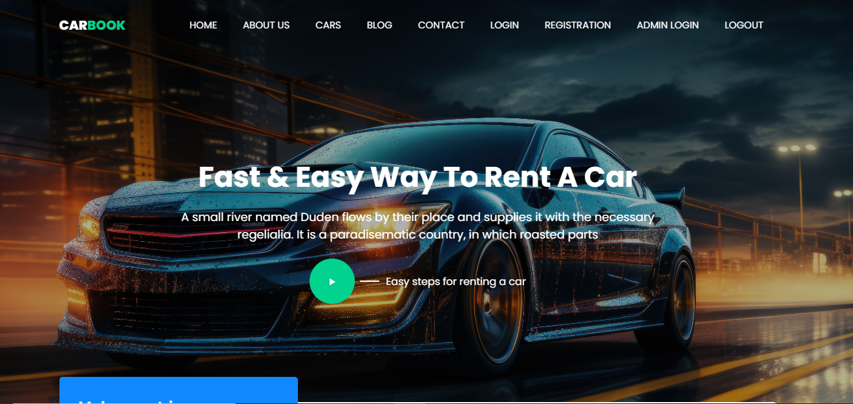

**2.REGISTRATION PAGE**

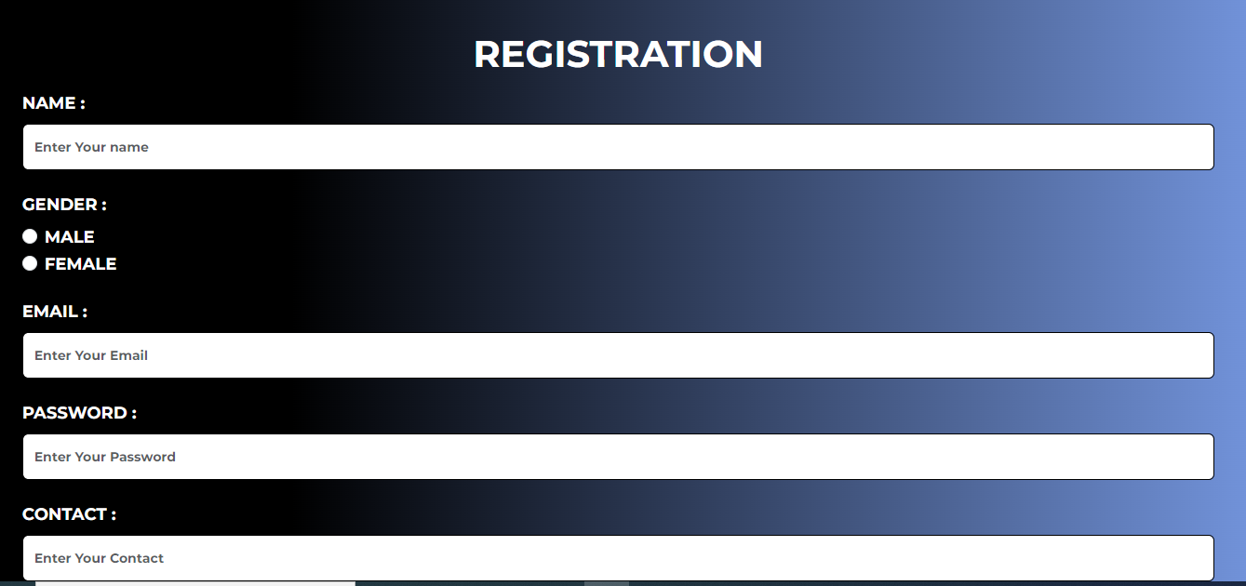

**3.LOGIN PAGE**

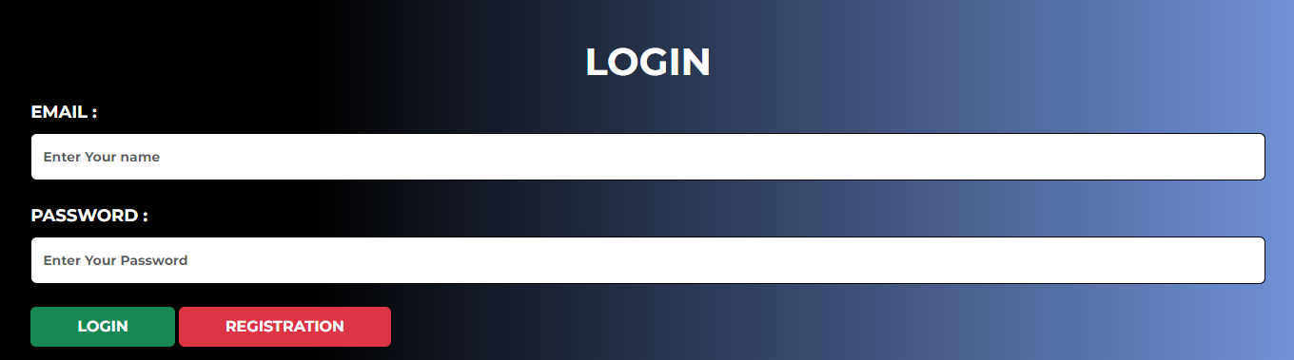

**4.CAR PAGE**

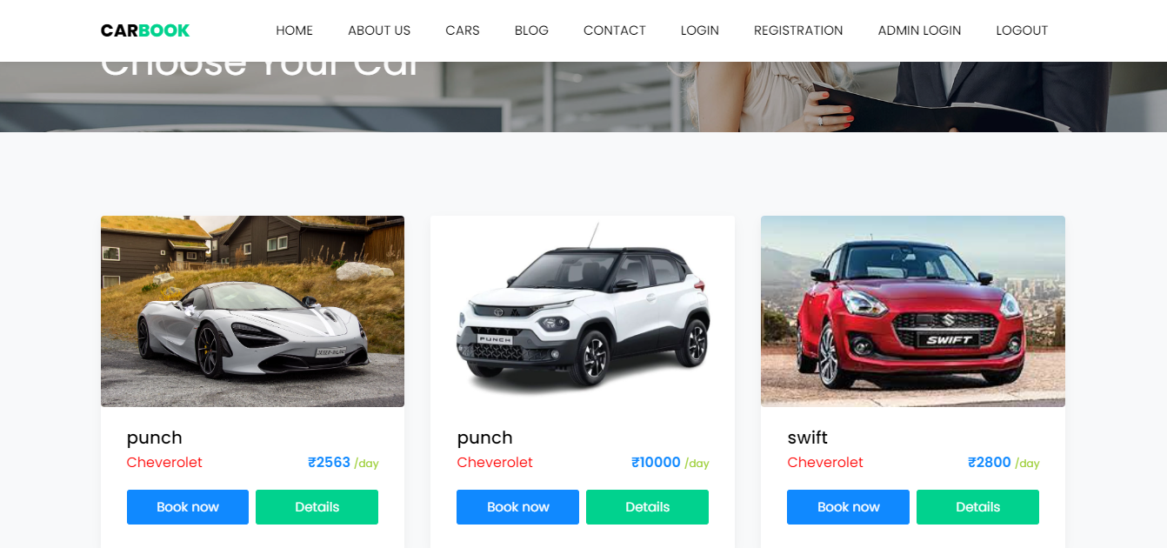

**5.BOOKING PAGE**

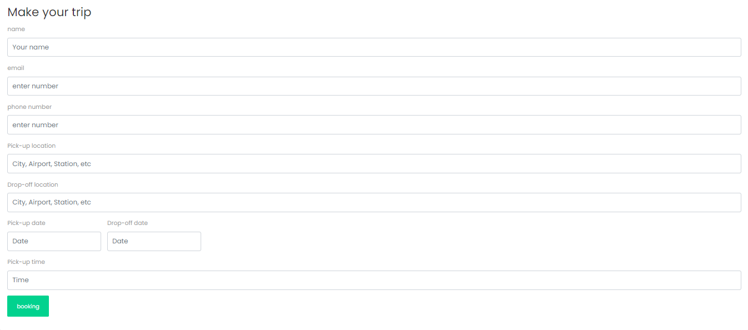

**6.CONTACT PAGE**

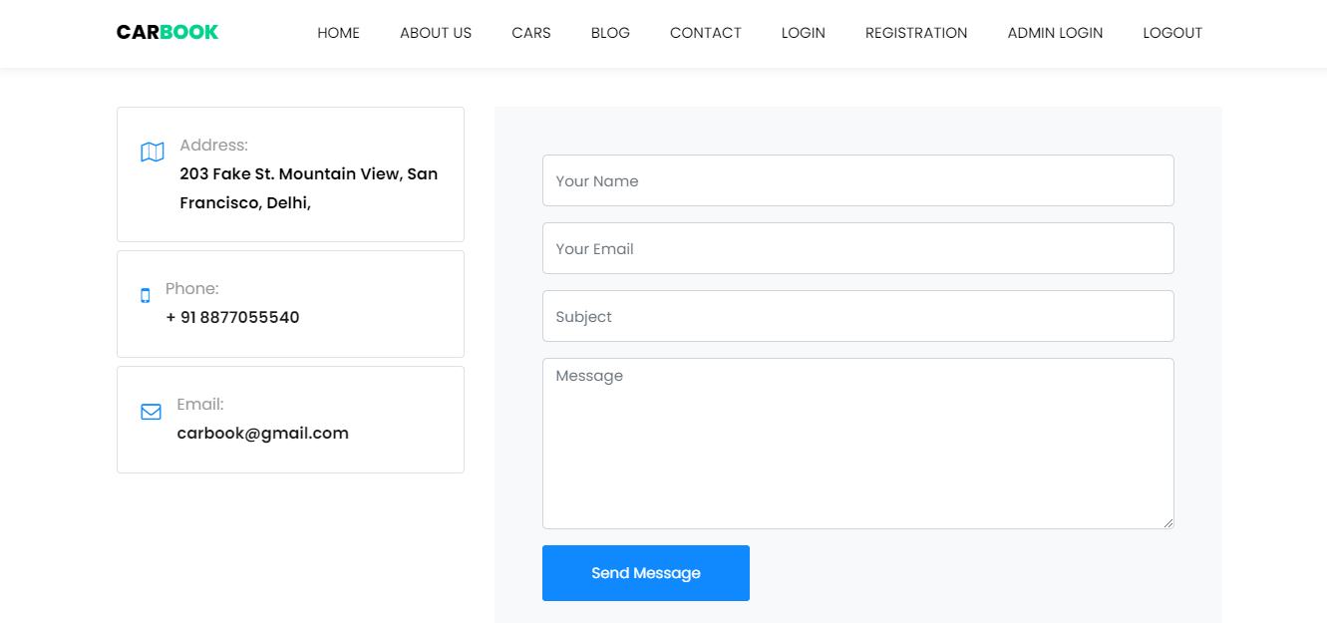

**ADMIN PENEL SCREENSHORT:**

**1.1.ADMIN LOGIN PAGE**

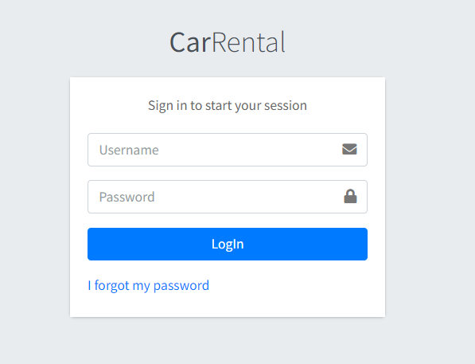

**1.2.ADMIN HOME PAGE**

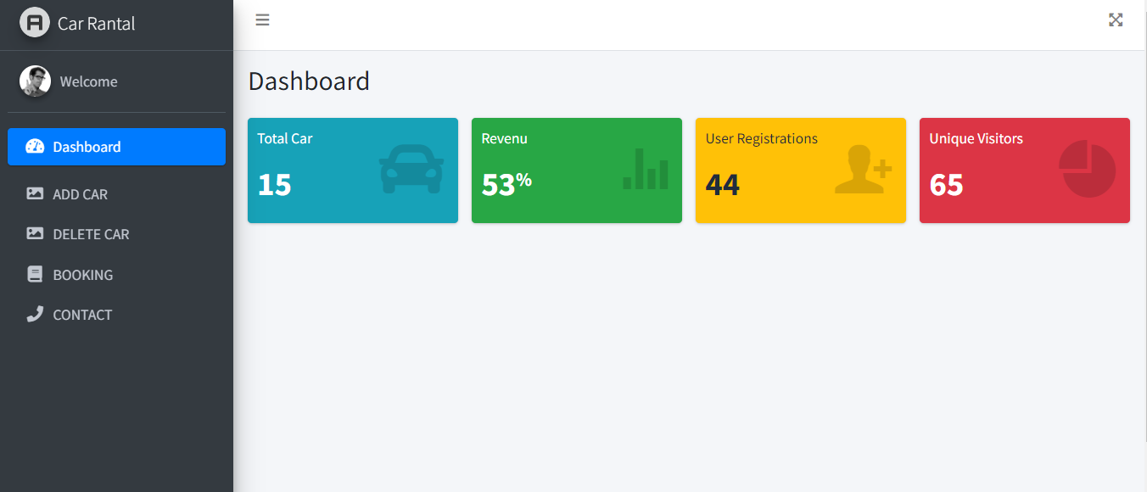

**1.3.ADMIN DASHBORD PAGE**

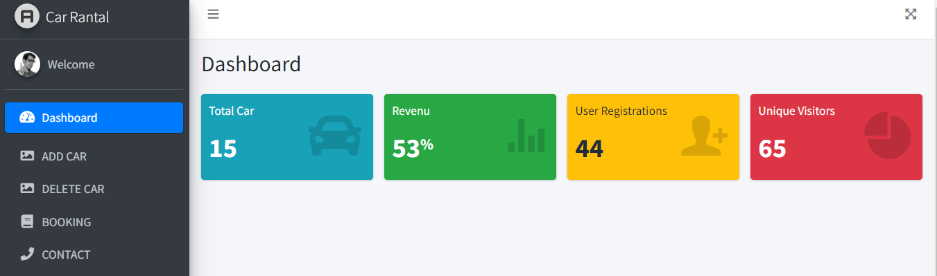

**1.4.ADMIN IMAGES ADD** **PAGE**

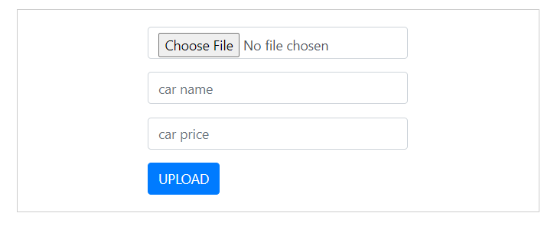

**1.5.ADMIN IMAGES UPDATE & DELETE** **PAGE**

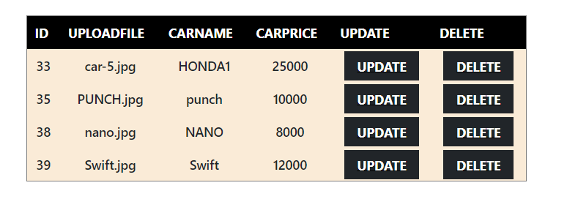

**1.6.ADMIN BOOKING PAGE**

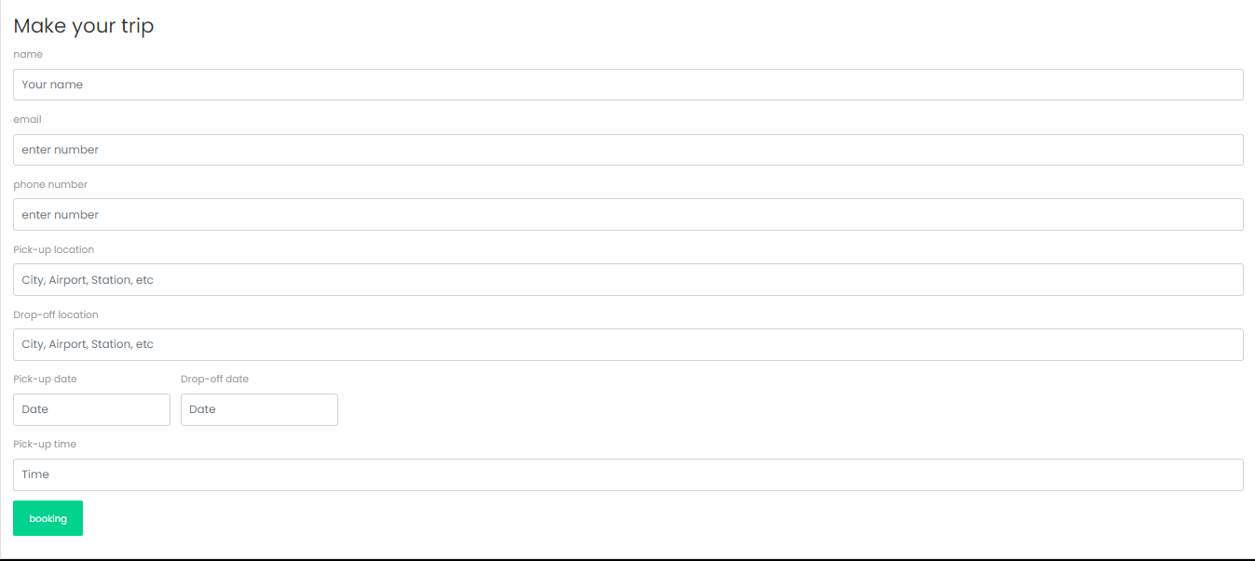

**1.7.ADMIN CONTACT PAGE**

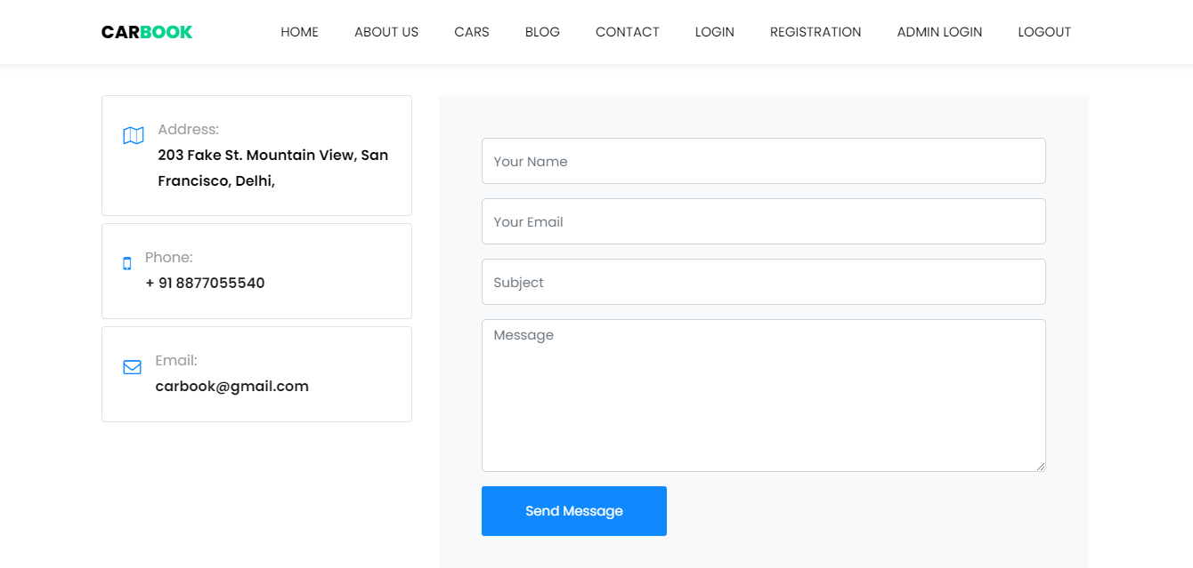

**Future Requirement of Project**

* We tried our best in developing this site in future.
* Some future updates of ToDo List are as under:
* User can update list
* Data should perfectly refresh.
* User can see password after click on show password icon.
* User can View and Update their Profile Picture.
* Some new functionality also available in early future.

**Limitation of Project**

* Though we tried our best in developing this site but as limitations are mere parts of any site so are of our site.
* Some limitations of Innovator to Investors portal are as under:
* Data has to be add manually.
* Data not perfect refresh.
* User's profile is not available.
* Only some limited functionality available right now.

**Webliography**

**I have taken help from the following sites:**

**Sites:**

* Google.com
* Getbootstrap.com
* Stackoverflow.com

**People:**

* My Project guide Professor Pranav Trivedi sir
* My helpful friends