**“Bundles of Dough” Bakery Data Visualization Project**

**Background:**

Who doesn’t love the smell of fresh bread? Bakeries draw in customers all different backgrounds, yet there are overarching trends in sales of different goods. This project will allow customers to view popular items to help inform their purchasing decisions.

**Project Proposal:**

Our aim is to highlight the most purchased items in a given bakery. We will provide them with details on transaction dates, times, and items in order to help them come to conclusions about trends.

1. Trend information will be based on most popular items sold
2. Weekend versus weekday sales can also inform purchasing decisions
3. Time of day, consisting of “morning,” “afternoon and” “evening” categories will also be available

**Team:**

Ghassan Aleqabi, Andrew Krog, Nikki Statum, Ava Prokop

*Team GitHub:* <https://github.com/ghassan100/GroupProject-2>

**Data Source:**

“Transactions from a bakery (Market Basket Analysis)” (Kaggle)

<https://www.kaggle.com/xvivancos/transactions-from-a-bakery/version/1>

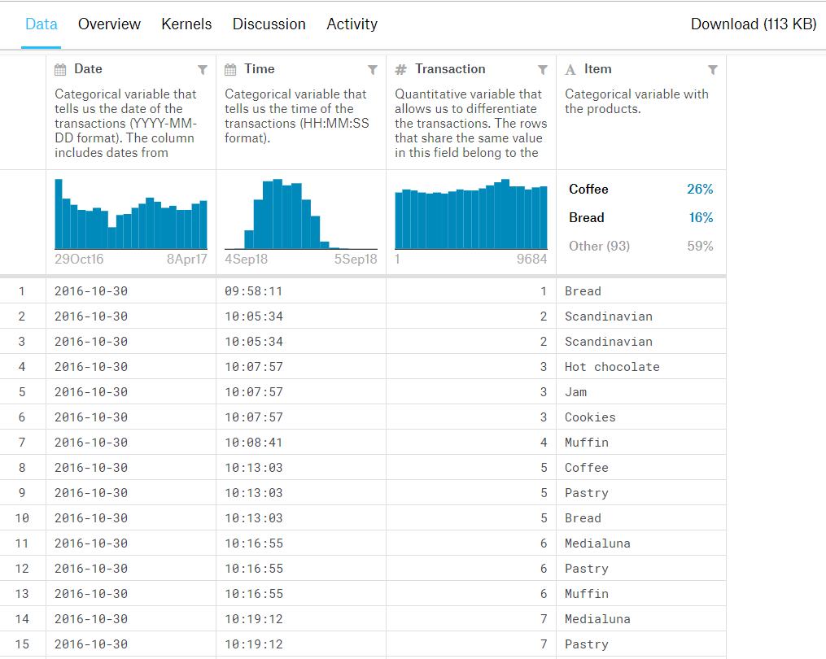

**Data Flow Diagram:**

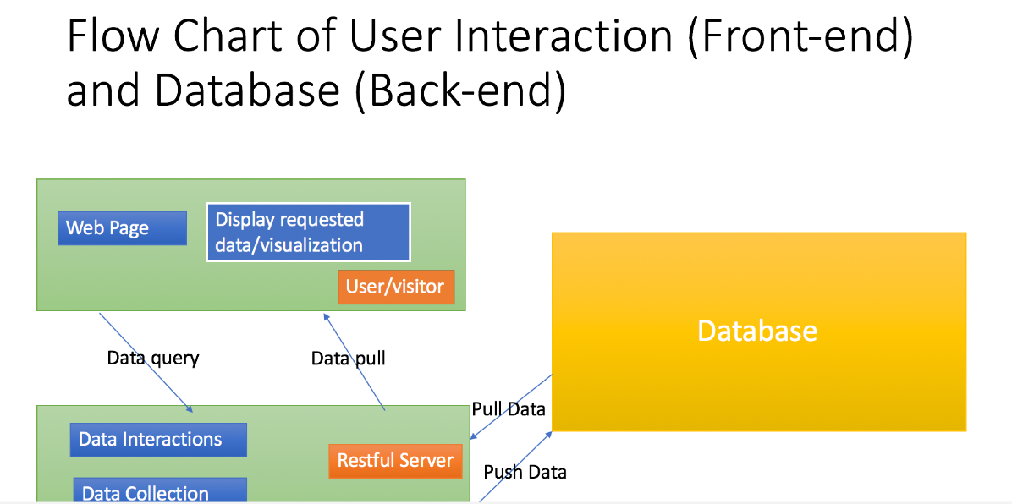

**Data Visualization Examples:**

