**Best Version: CPU Scheduling Algorithms in C**

# Aim

To create C programs for the different scheduling algorithms .

## To Perform

Create and execute C programs for following CPU Scheduling Algorithms :

1. . First Come First Serve (FCFS)
2. . Shortest Job First (SJF)
3. . Round Robin Scheduling

# First Come First Serve (FCFS)

# include <stdio.h> int main ( ) int n; print f ("Enter number of processes. 

scan f Ood" , int lot C n] , wt [n) , tat [n] print f ("Enter burst times : \ n") ;

for (int iscan f ( " cod" 

o; for (int i wt [i]wt [i 1] + bt [i-

for (int i tat  wt [i] + bt [i] ;

print f ; for (int 1 —

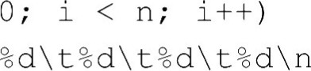print f ( " " , bt [i] wt [l] tat [i] ) ; return O ;

# Shortest Job First (SJF)

# include <stdio.h> void sort (int n, int bt [ ] int p [ l ) for (int i 1 , for (int j

< bt [i] ) int temp bt [i) ; bt [i) — bt [j ] bt [j ) - t emp ; temp = p [i] ; p [i]  temp ;

int main ( ) int n;

print f ( "Enter number of processes scan f ( " , &n) ; int bt Cn] , wt [n] , tat [n] , p [n) ;

print f ( "Enter burst times : \ n" ) ; for (int i

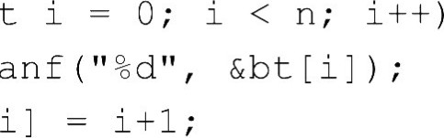

scan

sort (n, bt,

o; for (int i 

wt [i)+ bt [i-l)

for (int 1

tat  wt [i] + bt [l) ;

print f ;

for (int i

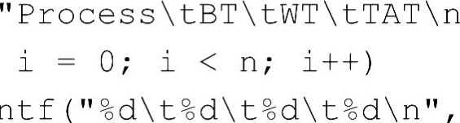

,

print f ( bt [i] wt [i) tat [i] ) ;

return 0;

# Round Robin Scheduling

# include <stdio .h> int main ( ) int n, tq; print f ("Enter number of processes .

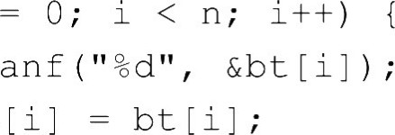scan f Ood" , &n) ; int bt [n) , rt [n] , wt [n] , tat [n) , ct [n] i; print f ("Enter burst times : \ n" ) ; for (i scan f rt C i J lot wt C i]0 ; ct Ci]0 ;

print f ("Enter time quantum.

scan f , &tq) ,

int time = 0, done; do { done — 1 ; for (i if (r t [i) > 0) done — O ; if (rt [i] > t q) time += tq; tq;

time + ct [i] t 1 me;

o;

} while ( ! done) ;

for (i

tat C i lct [i] • tat [i) bt [i] ;

print f ) ;

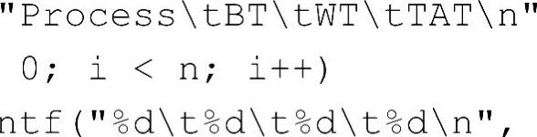for (i — print f ( bt [i] wt [i] tat [i] ) ;

return O ;