ProjectFlow
Project Management Tool
Executive Overview & Product Walkthrough
Prepared for CEO Review
April 3, 2026
Approved by: Account Managers, Project Managers, Production Team
Live Demo Links:
Clients Layer: 01-clients.html
Services Layer: 02-services.html
Kanban Layer: 03-kanban.html
Analytics Layer: 04-analytics.html

Contents
1. What is ProjectFlow?
2. The Problem We’re Solving
3. How It Works — The Three Layers
3.1 Layer 1: Clients
3.2 Layer 2: Client Dashboard & Services
3.3 Layer 3: Kanban Board
3.4 Analytics
4. Navigation Flow
5. Key Features Summary
6. Who Benefits and How
7. Current Status & Next Steps

1. What is ProjectFlow?
ProjectFlow is a custom-built project management tool designed around how our team actually works. It replaces scattered spreadsheets, chat threads, and sticky-note workflows with a single system that tracks clients, services, tasks, and performance in one place.
The tool follows a three-layer structure that mirrors our real workflow:
- Clients — See all clients at a glance. Know who’s active, who’s paused, and where the revenue sits.
- Services — Drill into a specific client. See what services we’re running for them, who’s assigned, meeting schedules, documents, billing, everything.
- Kanban Board — Open a service and see the actual tasks. Drag cards between columns. Know what’s in progress, what’s blocked, what’s done.
Each layer connects to the next. Click a client, see their services. Click a service, see the tasks. No switching tools, no context-switching.

2. The Problem We’re Solving
Right now, managing client work means juggling multiple tools and processes. Information lives in different places, and getting a full picture of a client’s status requires pulling data from several sources.
ProjectFlow solves this by centralizing everything into one tool that the whole team — account managers, project managers, and the production team — can use together.
What this means in practice:
- Account managers can see client health, revenue, and contract status without asking anyone
- Project managers can track progress across all services for a client in one view
- The production team has a clear kanban board showing exactly what to work on next
- Everyone sees the same data, updated in real time

3. How It Works — The Three Layers
The following pages walk through each layer with screenshots from the live mockup. You can also click the demo links on the cover page to interact with the tool directly.

3.1 Layer 1: Clients
Live Demo — Clients Page
https://nikkortrinidad-cpu.github.io/kanban-website/mockups/01-clients.html

This is the landing page. It shows every client we manage in a card-based grid that can be sorted, filtered, and searched.

What you see on this page:
- KPI summary cards at the top — Active Tasks (82), Average Tasks per Client (13.7), and Completion Rate (87%). These update from real data.
- A toolbar with search, sort (by name, tasks, services, revenue), filter (by service type), and a grid/list view toggle.
- Client cards showing: company name, industry, status (Active/Paused), number of services, task count, revenue, service tags, and last activity timestamp.
- Tabs to switch between Active Clients and Archived Clients.
- A 3-dot menu on each card for quick actions — change status or archive a client.

Grid View (default):
Cards are arranged in a responsive grid. Each card gives a quick snapshot of the client’s status, revenue, and active services.
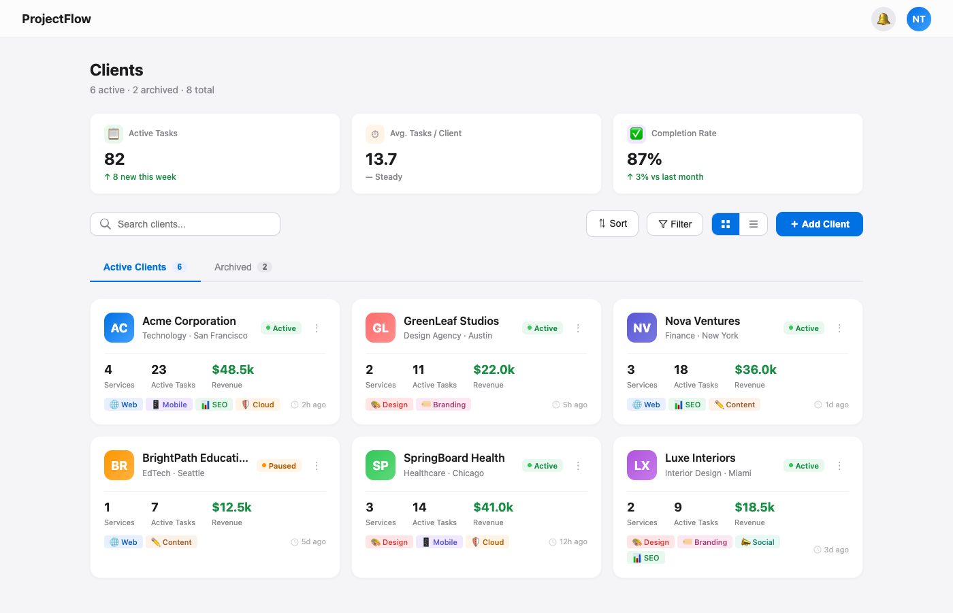
Figure 1: Clients page — Grid view with KPI summary, search, and toolbar

List View:
Toggle to list view for a compact, table-like layout with column headers (Client, Status, Services, Tasks, Revenue, Activity). Better for scanning large numbers of clients quickly.
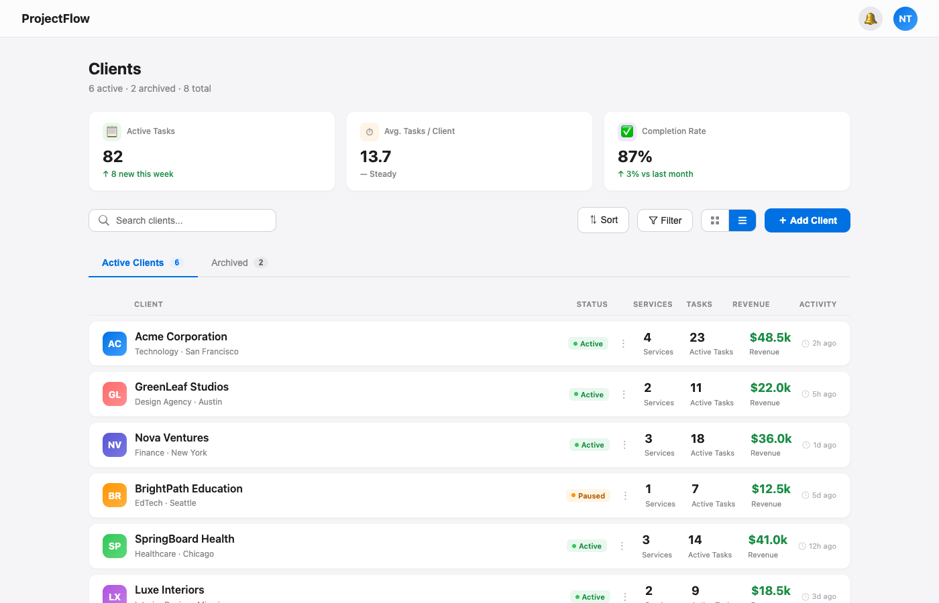
Figure 2: Clients page — List view with sortable columns

Key functions:
Function | What it does
Search | Filter clients by name in real time
Sort | 9 options: Default, Name (A-Z / Z-A), Most/Least Tasks, Most/Least Services, Highest/Lowest Revenue
Filter | Filter by service type: Web, Mobile, SEO, Cloud, Design, Content, Social, Branding
View Toggle | Switch between grid (cards) and list (table rows) layouts
Add Client | Create a new client record
3-Dot Menu | Change client status (Active/Paused) or archive the client
Tabs | Switch between Active Clients (6) and Archived (2)

3.2 Layer 2: Client Dashboard & Services
Live Demo — Services Page
https://nikkortrinidad-cpu.github.io/kanban-website/mockups/02-services.html

Click any client card and you land here. This is the full client dashboard — it shows everything about a specific client in one place.

Client Header & Service Cards
At the top: the client’s name, industry, location, and contact information. Two action buttons: open Analytics or Add a new Service. Below that, a quick actions bar for common tasks (Send Email, Schedule Meeting, Create Invoice, Add Note, Add Document, Add Contact). Then the active service cards, each showing the service name, status, progress bar, task count, and last updated timestamp.
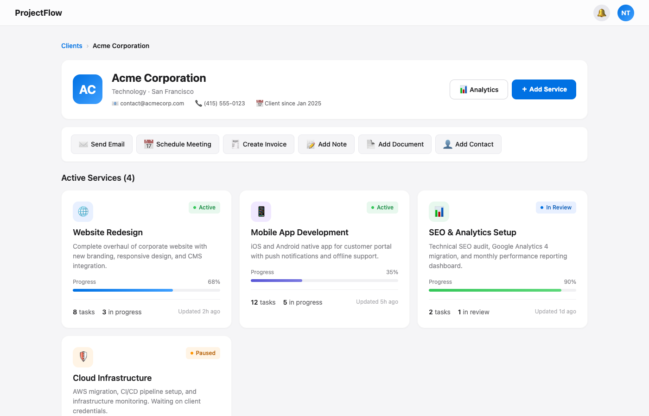
Figure 3: Client dashboard — Header, quick actions bar, and active service cards

Client Overview Section
Below the services, a grid of overview cards gives a complete picture of the client relationship:
Card | What it shows
People | Account manager and team members assigned to this client, with roles and contact shortcuts
Meetings | Last meeting, next scheduled meeting, frequency, attendees, links to recordings and agendas
Documents | Document checklist with signing status (Contract, NDA, SOW, Proposal, Brand Guidelines) plus Google Drive link
Billing | Payment status, current invoice amount, last payment date, next invoice date, recent invoice history, Xero link
Key Contacts | Client-side contacts with roles, email, phone, and quick action buttons
Contract Details | Contract type, start/end dates, auto-renewal status, monthly retainer, total contract value
Internal Notes | Timestamped notes from team members — preferences, upsell opportunities, important context
Communications | Recent activity log: emails sent, calls made, meetings held, Slack messages — with timestamps

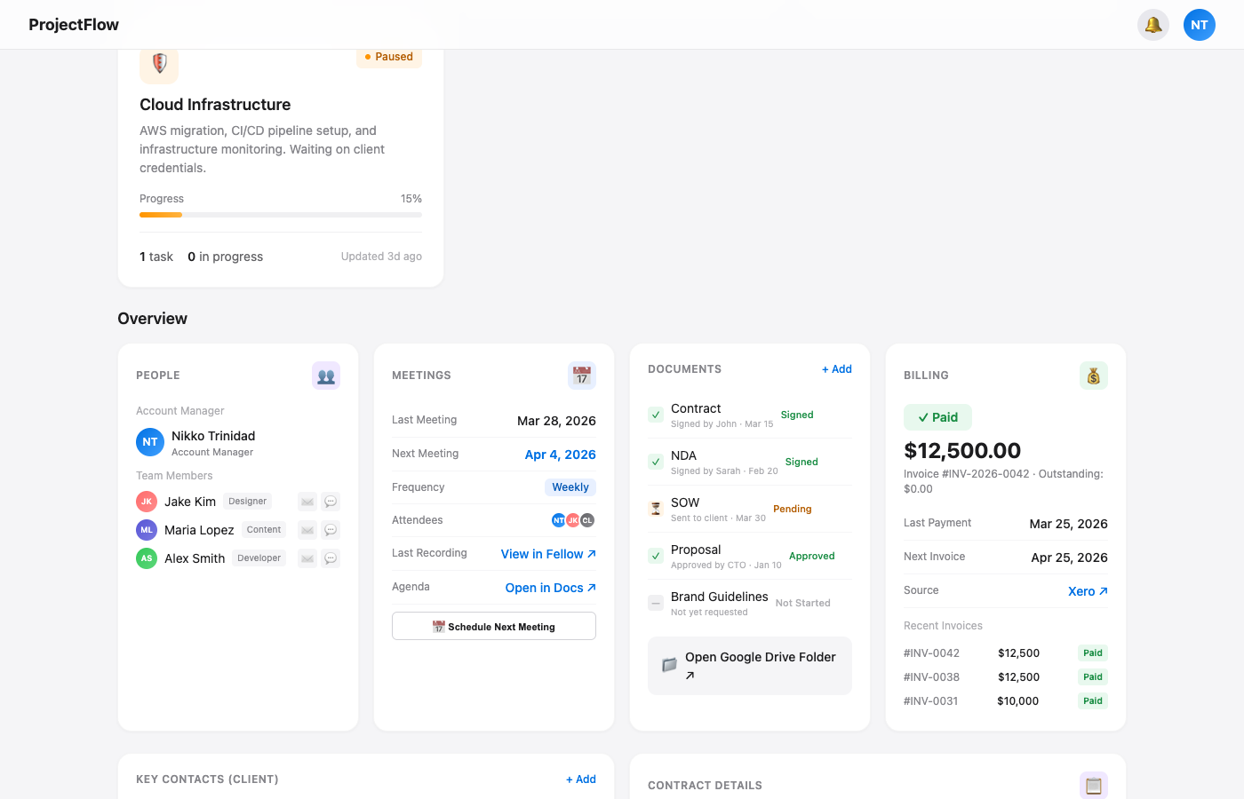
Figure 4: Overview cards — People, Meetings, Documents, and Billing
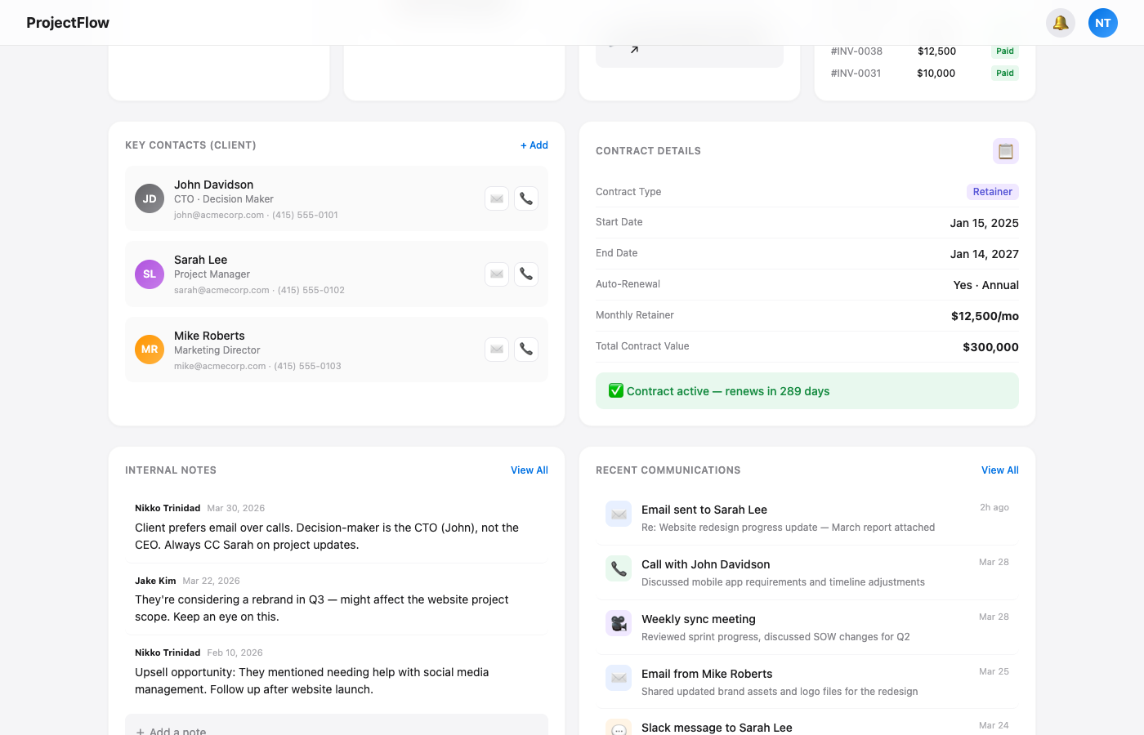
Figure 5: Overview cards — Key Contacts, Contract Details, Internal Notes, and Communications

3.3 Layer 3: Kanban Board
Live Demo — Kanban Board
https://nikkortrinidad-cpu.github.io/kanban-website/mockups/03-kanban.html

Click any service card and you get the kanban board for that service. This is where the production team lives day-to-day.

Board Structure
The board has four columns by default, representing the task lifecycle:
Column | Purpose
To Do | Tasks that are planned but not yet started
In Progress | Tasks currently being worked on
In Review | Tasks completed by the team, waiting for review or client feedback
Done | Tasks that are fully completed and approved

Task Cards
Each card on the board represents a task. Cards show:
- Priority indicator (red = high, orange = medium, green = low)
- Label badges (Design, Dev, Bug, Feature, Content) with color coding
- Task title
- Comment count and attachment count
- Assigned team member avatar
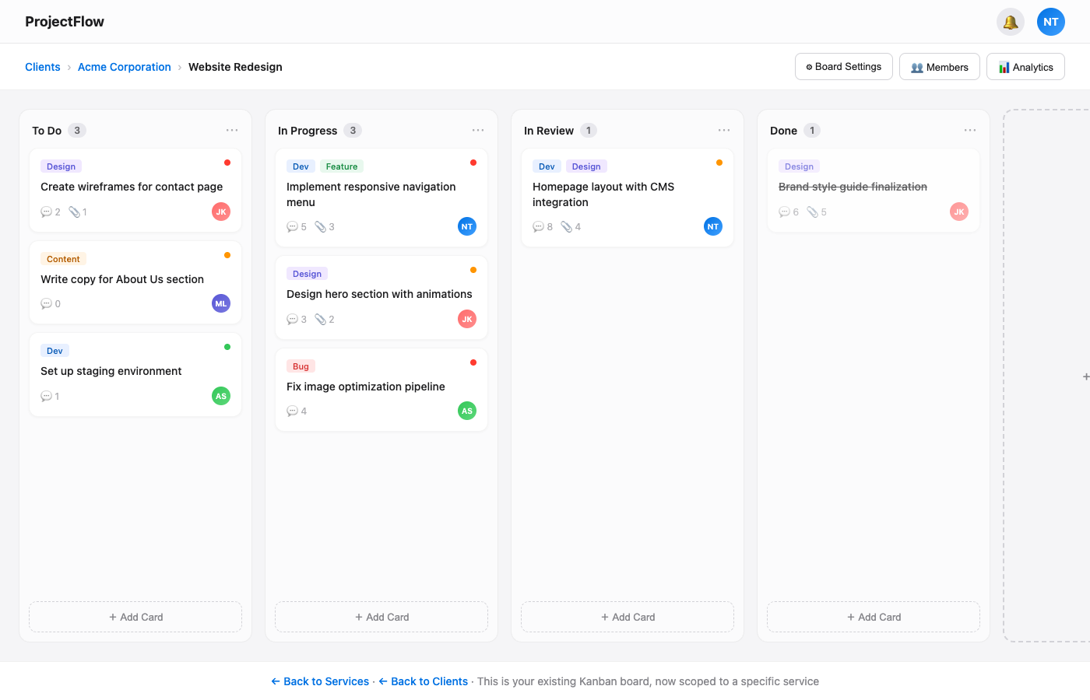
Figure 6: Kanban board for “Website Redesign” — 4 columns with task cards, breadcrumb navigation

Board Actions
- Drag and drop cards between columns to update task status
- Add new cards directly from any column
- Add new columns for custom workflows
- Board Settings for column configuration
- Members view for team assignment
- Analytics button to jump to performance data

3.4 Analytics
Live Demo — Analytics
https://nikkortrinidad-cpu.github.io/kanban-website/mockups/04-analytics.html

The analytics page gives a performance overview for a specific client. It’s accessible from the services page or the kanban board.

KPI Summary
Four metrics across the top, with trend indicators:
Metric | Value | Trend
Total Hours Worked | 247.5h | +12% vs last month
Total Billings | $37,500 | Same as last month
Tasks Completed | 34 | +8 more than last month
Profitability | +$13,125 | 54% margin

Charts & Breakdowns
- Task Breakdown — Donut chart showing distribution: Done (18), In Progress (13), In Review (11), Overdue (6), To Do (8)
- Task Velocity — Bar chart showing weekly completed tasks (W1–W8) to track team throughput over time
- Hours by Service — Which services are consuming the most time (Website Redesign: 98.5h, Mobile App: 82h, SEO: 45h, Cloud: 22h)
- Hours by Team Member — Individual contribution breakdown (Alex Smith: 88h, Jake Kim: 72.5h, etc.)
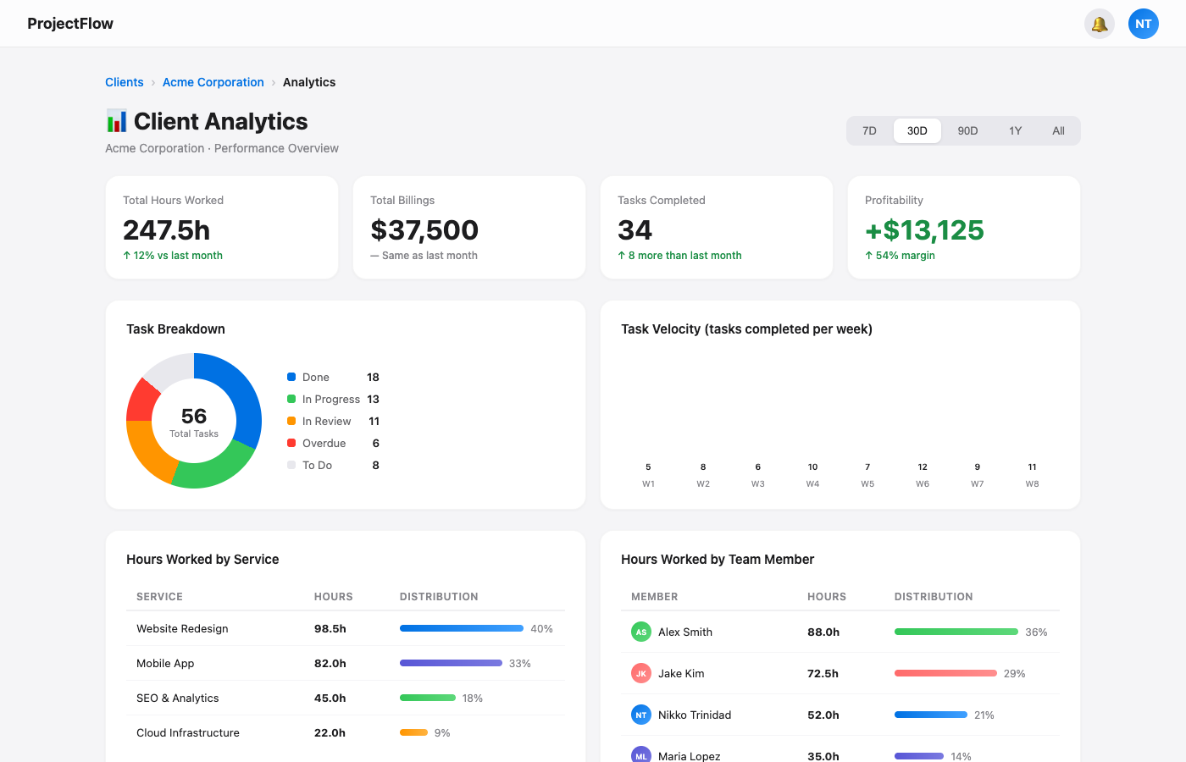
Figure 7: Analytics — KPI cards, task breakdown donut chart, velocity bar chart, and hours tables

Financial Overview
- Profitability Overview — Total revenue ($37,500), total cost ($24,375), net profit (+$13,125), profit margin (54%)
- Monthly breakdown comparing revenue vs. cost per month
- Billing History — Full invoice table with invoice numbers, dates, amounts, and payment status
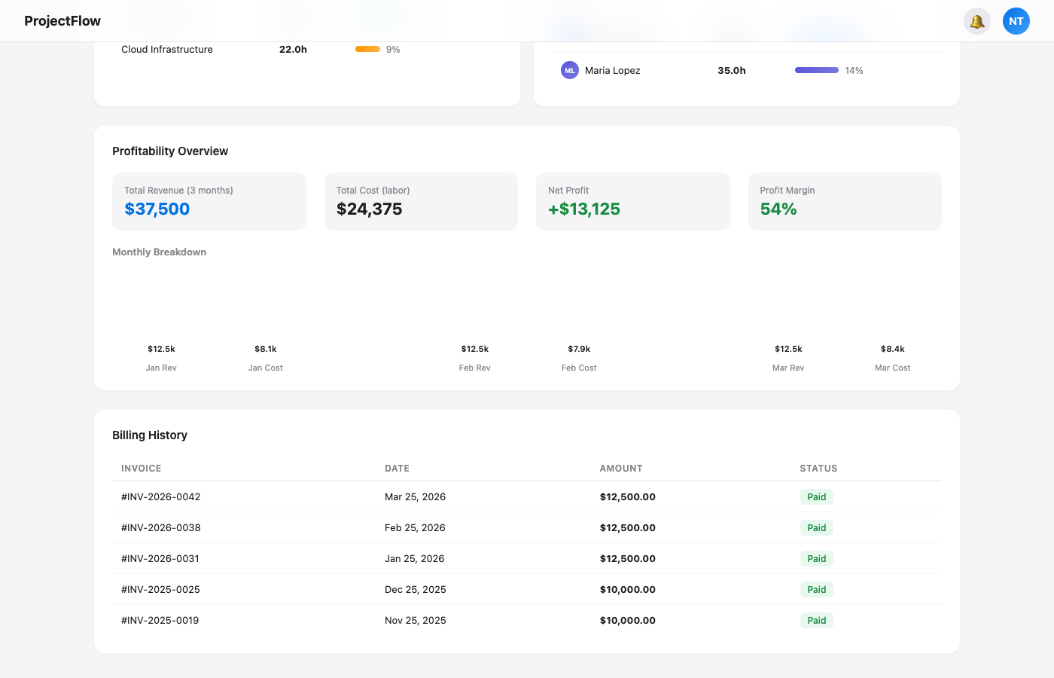
Figure 8: Analytics — Profitability overview, monthly comparison, and billing history table

4. Navigation Flow
The tool follows a simple drill-down pattern. Each layer connects to the next:

CLIENTS  All clients overview | → | SERVICES  Client dashboard + services | → | KANBAN  Task board per service

Breadcrumb navigation at the top of every page shows where you are and lets you jump back to any layer. Example: Clients > Acme Corporation > Website Redesign.
Analytics is accessible from the Services layer (via the Analytics button) and from the Kanban board, providing data at whichever level you need it.

5. Key Features Summary
Feature | Description
Client Management | Full client profiles with status, revenue, services, and activity tracking
Service Tracking | Per-client service cards with progress bars, task counts, and status badges
Kanban Boards | Drag-and-drop task management with columns, priorities, labels, and assignees
Analytics Dashboard | KPIs, charts, hours tracking, profitability analysis, and billing history
Quick Actions | One-click shortcuts for email, meetings, invoices, notes, documents, contacts
Search & Filter | Real-time search, multi-criteria sort, service type filtering, view toggles
Document Management | Signing status checklist, Google Drive integration, document upload
Billing Integration | Invoice tracking, payment status, Xero link, billing history with amounts and dates
Communications Log | Activity timeline: emails, calls, meetings, Slack messages with timestamps
Team Management | Assigned team members with roles, contact info, and quick action buttons

6. Who Benefits and How
Role | Primary Use | Key Benefit
CEO / Leadership | Client portfolio overview, revenue tracking, profitability | High-level visibility without asking for reports
Account Managers | Client health, contracts, billing, communications | Single source of truth for every client relationship
Project Managers | Service progress, task boards, team workload, analytics | Track all services and tasks without switching tools
Production Team | Kanban boards, task priorities, daily workflow | Clear visibility on what to work on next

7. Current Status & Next Steps

Where we are now:
- All four layers (Clients, Services, Kanban, Analytics) are built as interactive mockups
- Mockups are live and accessible via the demo links on the cover page
- Account managers, project managers, and the production team have reviewed and approved the design

Next steps (pending CEO approval):
- Begin development of the production application based on these approved mockups
- Set up the backend database and authentication system
- Build the client management layer first, then services, then kanban, following the same top-down structure
- Integrate with existing tools (Xero for billing, Google Drive for documents, Slack for communications)
- Roll out to the team in phases, starting with account managers

The mockups represent the agreed-upon design direction. Development can begin immediately upon approval.

