TRAVEL BUDDY
SOFTWARE REQUIREMENTS SPECIFICATION (SRS 2.1 + ARCHITECTURE & BLUEPRINT)
Centralized Travel Planning, Hospitality & Local Services Marketplace
Target Roles: Traveler | Travel Engine | Partners | Admin
Tech Stack: React + Vite + Tailwind CSS | Java 25 + Spring Boot | MySQL 8+ | Redis | JWT | Flyway
1. Document Control
Field | Specification Value
Document Title | Travel Buddy — Software Requirements Specification
Version | 2.0
System Type | Web-based travel planning, hospitality, and local-services marketplace
Frontend Stack | React + Vite + Tailwind CSS
Backend Stack | Java 25 + Spring Boot
Database | MySQL 8+
Caching Layer | Redis
Authentication | JWT (Access + Refresh Tokens) with Role-Based Access Control
Payments | Razorpay integration + development mock provider
Mapping Services | Leaflet / OpenStreetMap
DB Migration | Flyway
Deployment | Docker + CI/CD Pipelines

2. Executive Summary
Travel Buddy is a destination-first, full-stack travel planning and hospitality marketplace. It connects travelers with verified accommodation providers, local guides, and travel-focused transportation partners, while integrating destination discovery, trip planning, real-time inventory, secure booking and payment, digital verification, cancellation/refund management, reviews, support, commissions, and centralized administrative operations.
SRS 2.0 defines the complete functional scope, operational workflows, business rules, architecture, data model, API boundaries, security controls, non-functional requirements, UI/UX expectations, testing strategy, and implementation roadmap required to build and deploy the system as a robust production project.
3. Product Vision
The primary vision of Travel Buddy is to create one coherent travel platform where a traveler can seamlessly discover destinations, save points of interest, build structured itineraries, book accommodation, arrange local guides and transportation, pay securely, manage their journey, and resolve post-booking issues without navigating through disconnected external systems.
Unified Traveler Lifecycle
DISCOVER → PLAN → BOOK → PAY → TRAVEL → MANAGE → REVIEW

4. Problem Statement
Travel planning is currently fragmented across multiple disconnected web platforms—separating destination info, hotel bookings, guide hire, and transit booking.
Travelers face cognitive overload managing multiple bookings, separate payment receipts, and disconnected confirmation vouchers across unintegrated platforms.• Traveler Pain Points:
Local hospitality and transit service providers lack modern operational tools for KYC compliance, listing management, real-time daily availability calendar sync, earnings tracking, and automated payout handling.• Partner Pain Points:
Platform administrators lack centralized, granular control over user verification, listing approvals, payment reconciliation, disputes, commission tracking, and comprehensive audit logs.• Administrative Pain Points:
5. Objectives
• Destination-First Discovery: Provide rich, structured destination information integrated directly with service offerings.
• Reliable Accommodation Search: Provide real-time room inventory, daily price mapping, and transactional booking capabilities.
• Double-Booking Prevention: Implement strict concurrency-safe transactional inventory controls and automated temporary holds.
• Secure Payment & Refunds: Support end-to-end payment workflows with server-side verification and policy-driven refund processing.
• Local Marketplace Services: Enable onboarding, verification, and booking of certified local tour guides and transportation partners.
• Unified Trip Management: Give travelers a single dashboard workspace to manage all booked services, vouchers, and custom itineraries.
• Partner Operational Portal: Provide hotel, guide, and driver partners with functional dashboards for inventory, room assignment, and check-ins.
• Centralized Admin Control: Equip administrators with tools for KYC verification, financial reconciliation, review moderation, and audit logs.
6. System Scope
6.1 In Scope
✔ Authentication, authorization, and granular Role-Based Access Control (RBAC).
✔ Destination, region, state, city, and attraction content hierarchy management.
✔ Full-text search, multi-criteria filtering, and destination/property discovery.
✔ Property, room type, and daily room-level inventory management.
✔ Concurrency-safe booking holds, transactional confirmation, and double-booking protection.
✔ Payment processing, policy-driven cancellation, and refund state tracking.
✔ Unified 'My Trips' workspace and interactive bucket lists.
✔ Local guide marketplace with guide booking and assignment workflows.
✔ Transportation marketplace for drivers, vehicles, and custom trip transfers.
✔ Dedicated operational portals for Hotel, Guide, and Transportation partners.
✔ Partner KYC verification and administrative listing approval pipelines.
✔ User reviews, moderation workflows, support tickets, and dispute management.
✔ Digital booking vouchers with automated QR code verification.
✔ Commission structure management and partner payout settlements.
✔ Operational risk/fraud alerts, analytics, and immutable system audit logging.
6.2 Out of Scope (Current Release)
✖ Flight, long-distance train, and interstate commercial bus ticketing.
✖ Real-time dynamic ride-hailing ecosystem (Uber/Ola style dynamic routing).
✖ Native iOS / Android mobile applications (Web responsive UI is prioritized).
✖ Multi-currency dynamic conversion and international banking settlements.
✖ Cryptocurrency payments and decentralized wallet support.
✖ Social network feeds, public traveler forums, and direct messaging between guests.
✖ Full-scale loyalty points and rewards gamification ecosystem.
✖ Third-party affiliate inventory distribution networks (GDS integrations).
7. User Roles & Responsibilities
Role Name | System Authority | Primary Responsibilities
Guest | Unauthenticated Visitor | Browse public destinations, explore attractions, search available accommodations and services.
Traveler | ROLE_USER | Plan trips, save places, create bucket lists, book stays/guides/cabs, pay securely, manage trips, review services.
Hotel Partner | ROLE_HOTEL_PARTNER | Manage property profile, add/edit room types, manage daily inventory calendar, assign physical rooms, check-in guests, track earnings.
Guide Partner | ROLE_GUIDE_PARTNER | Manage guide bio, language proficiencies, offered service packages, set availability, manage guide bookings, track payouts.
Cab / Driver Partner | ROLE_CAB_PARTNER | Manage driver details, upload vehicle documents, define operational zones, set availability, accept transport bookings.
Super Admin | ROLE_ADMIN | Global system administration, partner KYC verification, property approvals, commission rule setup, disputes, refund approvals, audit logs.

8. High-Level System Architecture
The Travel Buddy backend follows a clean layered architecture pattern: Controller → Service → Repository → Entity, ensuring complete separation of concerns, testability, and maintainability.
System Layering Architecture
PRESENTATION LAYER: React + Vite UI | Partner Portals | Admin Operations Center
↓ (REST API over TLS / JWT Auth Header)
APPLICATION LAYER: Spring Boot Services (Auth, Booking, Payment, Inventory, Notification)
↓ (Transactional Logic / Redis Caching / JPA Hibernate)
PERSISTENCE LAYER: MySQL 8+ Database | Redis In-Memory Cache | Flyway Migrations
EXTERNAL SERVICES: Razorpay Payment Gateway | OpenStreetMap Geocoding

9. Core Operational Workflows & Lifecycles
9.1 Booking Lifecycle State Machine
Every reservation follows a strict state transition matrix to maintain data integrity and avoid overbooking:
1. INITIATED: Booking record created in database.
2. HELD: Daily room/service inventory is locked under a 10-minute temporary hold.
3. PAYMENT_PENDING: Traveler redirected to payment gateway.
4. CONFIRMED: Gateway payment verified server-side; inventory lock converted to permanent reservation; voucher generated.
5. ALTERNATE TERMINAL STATES: EXPIRED (hold timed out), CANCELLED (user/partner requested), COMPLETED (service rendered), REFUNDED (funds returned).
9.2 Payment & Verification Workflow
Payment success is NEVER accepted solely based on frontend response. The Spring Boot backend independently verifies payment signatures with Razorpay webhooks/REST APIs before updating the booking status to CONFIRMED.Security Rule:
9.3 Partner Onboarding & Operational Workflow
1. Registration → 2. KYC Document Upload → 3. Admin Verification → 4. Account Approval → 5. Service Listing Creation → 6. Daily Availability Management → 7. Reservation Fulfillment → 8. Financial Settlement.
10. Functional Requirements Matrix
Req ID | Requirement Module | Functional Description & Scope
FR-01 | Auth & RBAC | JWT access/refresh tokens, encrypted credentials, role guards for User, Partner, and Admin.
FR-02 | Destination Hierarchy | Hierarchical data structure: Country → Region → State → City → Destination → Attractions.
FR-03 | Search & Discovery | Multi-parameter search engine with geo-location, price range, rating, and amenity filters.
FR-04 | Property Management | Partner capability to register stays, upload images, manage amenities, and geo-coordinates.
FR-05 | Room Configuration | Configure room categories, max occupancy, base pricing, extra bed costs, and room features.
FR-06 | Inventory Control | Manage date-wise daily room availability, pricing overlays, manual blocks, and out-of-service states.
FR-07 | Double-Booking Protection | Pessimistic DB locking + Redis transactional locks to ensure concurrency safety during hold creation.
FR-08 | Temporary Booking Hold | Automatic 10-minute inventory reservation lock with scheduled TTL release on payment abandonment.
FR-09 | Booking Engine | End-to-end booking lifecycle management for Stays, Guides, and Transport services.
FR-10 | Payment Processing | Razorpay order creation, payment signature verification, receipt generation, and transaction logging.
FR-11 | Cancellation & Refunds | Automated tier-based cancellation fee computation and refund queue dispatching.
FR-12 | My Trips Dashboard | Traveler UI for viewing active, upcoming, completed, and cancelled itineraries.
FR-13 | Bucket List | Save favorite destinations, properties, and points of interest to personal trip wishlists.
FR-14 | Unified Trip Planner 2.2 | Guided date/city/place selection; optional hotel/cab/guide recommendations; centralized bucket list; itemized and total bill; final revalidation; single trip checkout; treasure-map visualization; post-trip review trigger.
FR-15 | Guide Marketplace | Discover accredited local guides filterable by spoken languages, expertise, and daily rates.
FR-16 | Guide Booking Flow | Direct guide calendar availability lookup, hourly/daily booking, and assignment confirmation.
FR-17 | Transport Marketplace | Browse local transit options, airport transfers, and private cab packages.
FR-18 | Driver Management | Driver profile onboarding, vehicle registration, license documentation, and shift availability.
FR-19 | Partner KYC Module | Secure upload and administrative verification interface for government identification & business licenses.
FR-20 | Listing Approval System | Admin review queue to inspect, approve, request edits, or reject new properties and listings.
FR-21 | Partner Inventory Grid | Operational calendar UI for partners to execute bulk price overrides and inventory blocks.
FR-22 | Physical Room Assignment | Hotel front-desk capability to map confirmed bookings to specific physical room numbers.
FR-23 | Check-In / Check-Out Ops | Partner operational dashboard for guest check-in validation, key issuance, and stay completion.
FR-24 | Digital Voucher & QR | PDF voucher generation embedded with encrypted QR codes for instant partner scan-verification.
FR-25 | Notification Engine | Automated email and in-app notifications for booking confirmation, payment success, and reminders.
FR-26 | Reviews & Ratings | Verified-stay-only review submission system with star ratings and detailed feedback.
FR-27 | Support Ticket Desk | Customer and partner support ticketing system with priority queues and status tracking.
FR-28 | Dispute Resolution | Formal dispute creation mechanism with document evidence attachment and administrative arbitration.
FR-29 | Content Moderation | Admin tools to flag, mask, or remove inappropriate user reviews or fraud listings.
FR-30 | Admin Command Center | High-level operational dashboard presenting platform metrics, real-time sales, and operational alerts.
FR-31 | User Management Ops | Admin interface to manage user permissions, suspend accounts, and view user history.
FR-32 | Destination Admin Tools | CRUD interfaces for updating destination guides, featured spots, and promotional media.
FR-33 | Financial Admin Desk | Payment ledger inspection, refund authorization, and manual reconciliation tools.
FR-34 | Commission Engine | Flexible percentage and fixed-tier platform commission logic per booking transaction.
FR-35 | Partner Payout Settlement | Automated calculation of net partner earnings post-commission and payout dispatch tracking.
FR-36 | Risk & Fraud Monitoring | Automated anomaly detection triggering alerts for suspicious rapid bookings or payment failures.
FR-37 | Interactive Map Engine | Embedded maps for visualizing destination boundaries, hotel locations, and trip routes.
FR-38 | Smart Budget Planner | Interactive budget breakdown calculator categorizing stay, transit, food, and activity expenses.
FR-39 | AI Trip Assistant | Intelligent trip recommendation engine providing customized itinerary suggestions.
FR-40 | Explainable Recommendations | Transparent recommendation logic displaying actionable criteria (e.g., 'Selected for high walkability').

11. Database Schema & Domain Mapping
• Identity & Access: users, roles, user_roles, refresh_tokens
• Geography & Content: countries, regions, states, cities, destinations, attractions
• Accommodation Domain: properties, property_images, amenities, property_amenities, room_types, room_inventory_daily, room_blocks, room_assignments
• Guide Marketplace: guides, guide_languages, guide_services, guide_availability, guide_bookings
• Transport Domain: drivers, vehicles, vehicle_documents, driver_availability, transport_bookings
• Trips & Itineraries: trips, trip_items, bucket_lists, bucket_list_items, itinerary_items
• Booking Engine: bookings, booking_items, hotel_booking_items, guide_booking_items, transport_booking_items, booking_holds
• Financials & Payments: payments, payment_events, refunds, commissions, partner_settlements
• Trust, Support & Safety: reviews, review_reports, support_tickets, disputes, kyc_documents, property_approvals, risk_alerts, audit_logs
12. REST API Specification
Domain Area | Base API Endpoint | Core Operations
Authentication | /api/v1/auth | POST /login, POST /register, POST /refresh
User Workspace | /api/v1/users | GET /profile, PUT /profile
Geography | /api/v1/geo | GET /countries, GET /states, GET /cities
Destinations | /api/v1/destinations | GET /search, GET /{id}
Accommodation | /api/v1/properties | GET /search, POST / (Partner)
Room Inventory | /api/v1/inventory | GET /availability, POST /block
Booking Engine | /api/v1/bookings | POST /hold, POST /confirm, POST /cancel
Payments | /api/v1/payments | POST /create-order, POST /verify
Guides & Transit | /api/v1/guides, /api/v1/transport | GET /search, POST /book
Admin Operations | /api/v1/admin | GET /kyc-queue, POST /approve-property

13. Non-Functional & Security Requirements
• Performance Target: API latency under 500ms for standard catalog queries; booking/hold creation under 1.5s.
• Scalability & Caching: Stateless Spring Boot application instances with Redis caching for daily inventory and destination catalogs.
• Data Reliability: Acid-compliant transactional booking engine using pessimistic locks to guarantee zero double-bookings.
• Security Standards: JWT statutory authentication, BCrypt password hashing, CORS protection, TLS 1.3 transport encryption.
• Auditability: Mandatory immutable audit logging for all partner KYC updates, refund approvals, and admin configuration edits.
14. Development Roadmap & Implementation Phases
• Phase 1: Foundation: Auth, RBAC, Base Spring Boot & React Setup, Database Schemas, Flyway Baseline.
• Phase 2: Destination Engine: Geography tables, Destination CRUD, Attraction listing, Full-text Search Engine.
• Phase 3: Accommodation: Property onboarding, Room Type configuration, Daily Inventory Calendar Setup.
• Phase 4: Booking Engine: Hold locks, Concurrency safety, State machine transitions, Razorpay Integration.
• Phase 5: My Trips & Vouchers: Traveler dashboard, PDF Voucher generation, QR Code engine, Email notifications.
• Phase 6: Local Services: Guide marketplace onboarding, Driver & Vehicle documents, Transit booking flows.
• Phase 7: Unified Trip Builder: Bucket list features, Drag-and-drop itinerary builder, Budget planner.
• Phase 8: Partner Portals: Hotel Front-desk UI, Room Assignment tool, Check-in/out workflows, Partner Analytics.
• Phase 9: Admin Center: KYC verification queue, Listing approvals, Refund desk, Dispute arbitration.
• Phase 10: Hardening & Deploy: Dockerization, CI/CD pipeline, Redis optimization, Load testing, Production launch.

MASTER ARCHITECTURE & PROJECT BLUEPRINT — SRS 2.3 — TRIP PLANNER UPGRADE
This section upgrades the supplied SRS 2.0 into an implementation-oriented master document. The original 40 functional requirements, technology stack, scope, roles, domain schema, APIs, security requirements and ten-phase roadmap remain the baseline. fileciteturn3file0L25-L34
System identity
Travel Buddy = Destination Discovery + Trip Planning + Accommodation + Local Guides + Travel-focused Transport + Booking/Payment + Partner Operations + Admin Governance

A. Final Architecture
The backend follows Controller → Service → Repository → Entity separation. React/Vite/Tailwind provides the traveler, partner and admin experiences; Spring Boot provides business logic; MySQL is the transactional system of record; Redis provides cache/short-lived coordination; Razorpay and map services are external integrations. This is consistent with the supplied high-level architecture. fileciteturn3file0L129-L138
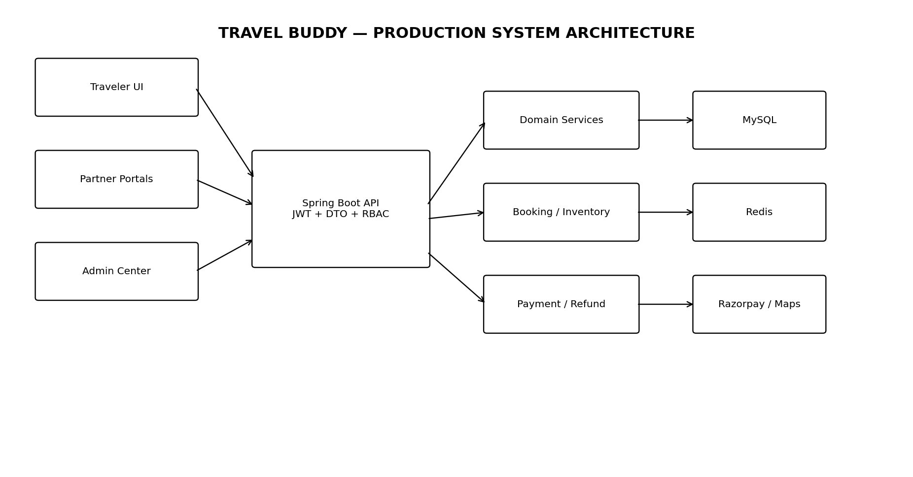

A.1 Backend Module Boundaries
- auth — registration, login, JWT, refresh tokens, RBAC.
- user — traveler profile and account operations.
- geo/destination/attraction — destination-first content hierarchy.
- property/room/inventory — accommodation configuration and availability.
- booking — unified booking orchestration, holds and state transitions.
- payment/refund — gateway order, verification, webhook, refund state.
- trip/bucket-list — trips, itinerary and saved places.
- guide — guide marketplace and guide bookings.
- transport/driver/vehicle — transport marketplace and partner operations.
- partner — KYC, partner profile and operational dashboard.
- review/support/dispute — trust, moderation and service recovery.
- commission/settlement — marketplace financials.
- risk/admin/audit — governance, alerts, analytics and administrative controls.
- common — DTOs, errors, security, utilities and shared infrastructure.

A.2 Architecture Rules
- DTOs at API boundaries; never expose JPA entities directly.
- Transactions around inventory, booking, payment state and settlement changes.
- MySQL remains the source of truth for booking/inventory correctness.
- Redis must never be the sole authority for inventory availability.
- All payment/webhook handlers must be idempotent.
- All sensitive admin and financial actions must be auditable.
- Partner APIs must enforce both role and resource ownership.

B. Product Workflow Blueprint
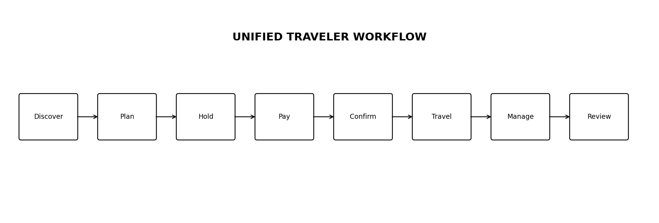

B.1 Traveler Workflow
- Guest explores Country → Region → State → City → Destination → Attractions.
- Traveler searches stays, guides and transport using filters and maps.
- Traveler saves destinations/properties/POIs to Bucket List.
- Traveler creates a Trip and adds itinerary items.
- Traveler chooses dates/occupancy/service options.
- System validates availability and creates a temporary hold.
- Backend creates payment order.
- Payment is verified server-side.
- Booking changes to CONFIRMED and voucher/QR is generated.
- Traveler manages hotel, guide and transport items in My Trips.
- Partner verifies the booking, performs service, and records completion.
- Traveler can submit eligible verified reviews or raise support/dispute requests.

B.2 Booking Workflow
- INITIATED → HELD → PAYMENT_PENDING → CONFIRMED.
- Hold expires automatically if payment is abandoned.
- Confirmed booking can move to COMPLETED, CANCELLED, NO_SHOW or REFUNDED according to business rules.
- Inventory is released only through controlled transactional state changes.
The supplied SRS specifies the 10-minute temporary hold and the canonical booking states. fileciteturn3file0L139-L148

B.3 Payment Workflow
- Frontend requests payment order from backend.
- Backend creates provider order.
- Frontend completes payment.
- Backend receives payment identifiers as untrusted input.
- Backend verifies signature/status with Razorpay.
- Verified payment changes booking state; duplicate callbacks are ignored safely.
- Payment events are persisted for reconciliation.
The original SRS explicitly states that frontend payment success is not enough and that the Spring Boot backend must independently verify payment before confirmation. fileciteturn3file0L149-L152

C. Partner Ecosystem Blueprint
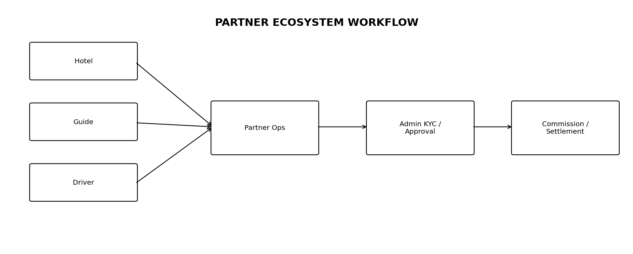

C.1 Hotel Partner
- KYC/business verification and property approval.
- Property profile, gallery, amenities, policies and location.
- Room types, occupancy, base pricing and extra-bed rules.
- Daily inventory calendar, bulk price changes and blocks.
- Maintenance/out-of-service room states.
- Booking queue and guest details.
- Physical room assignment.
- QR/voucher verification.
- Check-in/check-out and no-show handling.
- Earnings and settlement visibility.

C.2 Guide Partner
- Verified profile, bio, languages and expertise.
- Service packages and hourly/daily rates.
- Availability calendar and blocked dates.
- Booking/assignment workflow.
- Completion, earnings, reviews and support.

C.3 Cab/Driver Partner
- Driver onboarding and verification.
- Vehicle registration, category/capacity and document tracking.
- Operational zones and availability/shift management.
- Local taxi, airport/railway pickup and private-trip transport.
- Booking acceptance, trip completion, earnings and settlement.
- Safety/support escalation hooks.

D. Admin Operations Blueprint
Admin Area | Required Operations
Command Center | Users, bookings, revenue, commission, partner status and alerts
Users | Search, profile/history, permissions, suspend/reactivate
KYC | Document review, approve/reject/request changes, verification history
Properties | Listing review, approve/reject/request edits
Inventory | Availability anomalies, blocks, maintenance and conflicts
Bookings | Lifecycle inspection, cancellations, no-shows and fulfillment
Finance | Payment ledger, refund authorization and reconciliation
Disputes/Support | Evidence, priority, escalation and resolution
Moderation | Review/listing flags, mask/remove and reason logging
Commission | Percentage/fixed-tier rule management
Settlement | Partner net earnings, deductions and payout tracking
Risk | Rapid booking/payment failure anomalies and manual review
Content | Destination, attraction, featured content and media CRUD
Audit | Immutable records of sensitive operations

E. Data & Domain Blueprint
Domain | Core Tables
Identity | users, roles, user_roles, refresh_tokens
Geography | countries, regions, states, cities, destinations, attractions
Accommodation | properties, property_images, amenities, property_amenities, room_types, room_inventory_daily, room_blocks, room_assignments
Guides | guides, guide_languages, guide_services, guide_availability, guide_bookings
Transport | drivers, vehicles, vehicle_documents, driver_availability, transport_bookings
Trips | trips, trip_items, bucket_lists, bucket_list_items, itinerary_items
Booking | bookings, booking_items, hotel_booking_items, guide_booking_items, transport_booking_items, booking_holds
Financials | payments, payment_events, refunds, commissions, partner_settlements
Trust/Support | reviews, review_reports, support_tickets, disputes
Governance | kyc_documents, property_approvals, risk_alerts, audit_logs, system_settings
These domain groups correspond to the database/domain mapping already specified in SRS 2.0. fileciteturn3file0L310-L322

F. API Blueprint
Base API | Core Operations
/api/v1/auth | login, register, refresh, logout
/api/v1/users | profile
/api/v1/geo | countries, regions, states, cities
/api/v1/destinations | search, detail, admin CRUD
/api/v1/properties | search, detail, partner CRUD
/api/v1/rooms | room configuration
/api/v1/inventory | availability, blocks, calendar
/api/v1/bookings | hold, confirm, cancel, detail
/api/v1/payments | create-order, verify, webhook
/api/v1/refunds | request, detail
/api/v1/trips | trip and itinerary
/api/v1/bucket-list | list/add/remove
/api/v1/guides | search, detail, partner operations
/api/v1/transport | search, book
/api/v1/drivers | driver operations
/api/v1/vehicles | vehicle/documents
/api/v1/reviews | create/list/moderation
/api/v1/notifications | list/read
/api/v1/support | tickets
/api/v1/disputes | create/evidence/resolution
/api/v1/partners | onboarding/KYC/profile
/api/v1/commissions | commission rules
/api/v1/analytics | admin/partner metrics
/api/v1/admin | KYC, approvals, finance, risk, audit

G. Frontend Blueprint
The frontend should use separate application shells so traveler, partner and admin workflows remain visually and operationally distinct while sharing the same design system.
src/app — router, providers, global configuration
src/components — reusable UI primitives
src/design-system — buttons, cards, forms, modals, tables, badges
src/features/auth | destinations | stays | booking | payments | trips | bucket-list
src/features/guides | transport | partner | admin | support | notifications
src/layouts — TravelerLayout, PartnerLayout, AdminLayout
src/pages — route-level pages
src/services — Axios/API modules
src/hooks — auth, permissions, pagination, debounce
src/utils — validation, formatting, constants
src/styles — Tailwind/global design tokens

G.1 Premium UI/UX Rules
- Travel editorial + modern SaaS visual language.
- Large destination imagery with controlled overlays.
- Premium cards for stays, guides and transport with clear trust signals.
- Purposeful motion: page transitions, hover states, skeleton loading and map/list synchronization.
- Responsive desktop/tablet/mobile layouts.
- Strong loading, empty, error and success states.
- Accessible keyboard/focus behavior and semantic controls.
- Do not let animation interfere with payment or booking confirmation.

H. Security & Reliability Blueprint
- JWT access + refresh tokens with rotation/revocation.
- BCrypt password hashing.
- Role + resource ownership authorization.
- TLS in production and restricted CORS.
- Server-side payment verification and webhook validation.
- Secure KYC document access and storage.
- Signed/opaque QR verification tokens.
- File upload size/type/content validation.
- Rate limits for login, payment verification and abuse-prone endpoints.
- Append-only/immutable audit records for sensitive admin and financial operations.
- Database backups and restore testing.
Critical rule
A frontend payment-success response must never directly confirm a booking. Provider verification on the backend is required. fileciteturn3file0L149-L152

I. Non-Functional Requirements
Quality | Target
Performance | Standard catalog/search APIs target <500ms; booking/hold around 1.5s excluding provider latency.
Scalability | Stateless Spring Boot instances, Redis caching, indexes and pagination.
Reliability | ACID booking transactions, idempotent payment events and expiry-safe holds.
Security | JWT/RBAC, BCrypt, TLS, validation, secure CORS, audit logging.
Maintainability | Layered modules, DTO boundaries, tests and Flyway migrations.
Accessibility | Responsive UI, keyboard navigation and semantic controls.
Observability | Structured logs, correlation IDs, metrics and error tracking.
Data Integrity | Constraints, transactions and immutable financial history

J. Testing Blueprint
- Unit: booking rules, pricing, cancellation, refund, commission, availability and authorization.
- Integration: controller/service/repository and database migrations.
- Payment: mock provider, signature verification, webhook idempotency.
- Concurrency: simultaneous attempts to reserve the last inventory.
- Frontend: forms, protected routes, filters, checkout, partner/admin screens.
- End-to-end: Discover → Hold → Pay → Confirm → Voucher → My Trip.
- Security: invalid token, role escalation, upload validation and rate limits.
- Load: search, inventory and booking contention.
- UAT: traveler, hotel partner, guide partner, driver partner and admin journeys.

K. Deployment Blueprint
Recommended flow: Browser → Reverse Proxy/CDN → React assets + Spring Boot API → MySQL/Redis → Razorpay/Map services.
- Local: Vite + Spring Boot + local MySQL/Redis + payment mock.
- Development: Dockerized services and sandbox payment.
- Staging: production-like infrastructure and realistic test data.
- Production: HTTPS, secrets management, database backup, monitoring, CI/CD and live gateway credentials.
- Commit/PR
- Build and static checks
- Backend/frontend tests
- Security/dependency scanning
- Docker image build
- Deploy staging
- Smoke tests
- Production approval
- Production deploy + migration checks
- Monitor and rollback if required

L. Final Implementation Order
Phase | Deliverables
1. Foundation | Auth, RBAC, Spring Boot, React, MySQL, Flyway, security
2. Destination Engine | Geo hierarchy, destinations, attractions, search, maps
3. Accommodation | Properties, rooms, amenities, daily inventory
4. Booking Engine | Holds, locking, booking states, payment
5. My Trips | Dashboard, voucher, QR, notifications
6. Local Services | Guides, drivers, vehicles, transport
7. Trip Builder | Bucket list, itinerary, budget
8. Partner Portals | Hotel front desk, room assignment, check-in/out, guide/driver operations
9. Admin Center | KYC, approvals, refunds, disputes, moderation, commission, settlement, risk
10. Production Hardening | Tests, Redis optimization, Docker, CI/CD, monitoring, load/security testing
The ten phases preserve the roadmap in the supplied SRS 2.0 while making the implementation order explicit. fileciteturn3file0L354-L372

M. Final Feature Traceability
Feature Group | Covered Requirements | Workflow
Traveler | FR-01–FR-14, FR-37–FR-40 | Discover → Trip Planner → Dates → Cities → Places → Recommendations → Bucket List → Itemized Bill → Central Checkout → Confirm → Travel → Review
Guide | FR-15–FR-16 | KYC → Profile → Services → Availability → Booking → Completion → Earnings
Transport | FR-17–FR-18 | KYC → Vehicle → Zones/Availability → Booking → Trip → Settlement
Hotel Operations | FR-04–FR-08, FR-20–FR-25 | KYC → Property → Rooms → Inventory → Booking → Room Assignment → Check-in/out
Trust & Support | FR-24–FR-29 | Voucher/QR → Notifications → Review → Ticket → Dispute → Resolution
Admin & Finance | FR-30–FR-36 | Dashboard → KYC/Approval → Booking/Finance → Commission → Settlement → Risk → Audit

N. Definition of Done
- Database migration is committed.
- Backend DTO/controller/service/repository work is complete where required.
- Authorization and ownership rules are enforced.
- Frontend loading, empty, error and success states are present.
- Unit/integration tests exist for critical logic.
- Booking/payment flows are idempotent and concurrency-safe.
- Sensitive operations generate audit records.
- API documentation and deployment configuration are updated.
- Acceptance scenario passes without regression.

O. Final Project Statement
Travel Buddy — Final Definition
A destination-first, full-stack travel planning and hospitality marketplace connecting travelers with verified accommodation providers, local guides and travel-focused transportation partners while providing integrated trip planning, real-time inventory, secure booking/payment, digital verification, cancellation/refund management, reviews, support, commissions, settlements and centralized administrative operations.

TRIP PLANNER SYSTEM — SRS 2.3 MAJOR FEATURE UPGRADE
Design direction
The supplied treasure-map visual is used as UX inspiration: the planner should feel like a journey being discovered on a map, with a progressive dotted route, destination checkpoints, animated transitions and a final treasure/confirmation moment. It is inspiration for interaction and visual language, not a literal copy.

1. Revised Product Principle
Trip planning is the central orchestration layer. The traveler first defines the journey, then Travel Buddy intelligently recommends services around that journey, collects all selections into one Bucket List/Trip Cart, calculates every component bill, and only then performs a final availability/price recheck and centralized payment.
Critical distinction
SELECTED ≠ BOOKED. Adding a hotel, cab or guide to the planner records user intent. It does not permanently reserve inventory. Final booking occurs only after centralized checkout revalidates availability and payment succeeds.

2. Complete Revised User Workflow
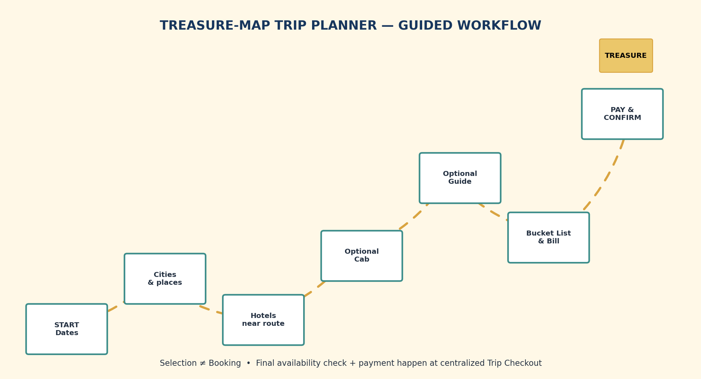
- Step 1 — Start Trip: Select Start Date and End Date. System calculates duration and initializes the planner.
- Step 2 — Choose Cities: Choose how many cities to visit, then select the cities.
- Step 3 — City Sequence Intelligence: System proposes a practical city order using distance, travel time and dates. User can accept or reorder.
- Step 4 — Choose Popular Places: For each city, select multiple popular places. User may skip this step.
- Step 5 — Hotel Intelligence: For each city/date window, recommend nearby hotels based on selected places, distance, availability, price, rating, amenities, occupancy and budget.
- Step 6 — Optional Cab: Suggest date/route-aware cab or transfer options. User may skip.
- Step 7 — Optional Guide: Suggest an appropriate guide for a selected place/city. User may skip.
- Step 8 — Bucket List / Trip Cart: Show all selected cities, places, hotels, guides and transport together with dates, prices and statuses.
- Step 9 — Bill Breakdown: Show hotel, guide, cab/transport, activity, taxes/fees, discounts and total trip cost.
- Step 10 — Final Validation: Recheck every selected service's availability, price, policy and eligibility.
- Step 11 — Centralized Payment: Pay for the finalized trip through one Travel Buddy checkout rather than separate hotel payment.
- Step 12 — Confirmation: Create confirmed bookings, references, voucher/QR and notifications.
- Step 13 — Active Trip: Show the confirmed journey as a treasure-map/timeline experience.
- Step 14 — Trip Completion: Move the trip to completed after the end date/service completion.
- Step 15 — Review Unlock: Open eligible hotel, guide and transport reviews.

3. Planner Inputs
Input | Required? | System Behavior
Start date | Yes | Defines trip start and first service date.
End date | Yes | Defines trip end and duration.
Number of cities | Yes | Controls city-selection scope.
Cities | Yes | Selected destinations become ordered trip stops.
Popular places | Optional | Multiple places per city; can be skipped.
Hotels | Optional selection, system recommends | Nearest suitable hotels are recommended around selected places/date windows.
Cab/transport | Optional | Route/date-aware suggestions; never auto-booked.
Guide | Optional | Place/city-specific guide suggestion; never auto-booked.
Budget/preferences | Optional | Improves recommendations and budget warnings.

4. Recommendation Intelligence
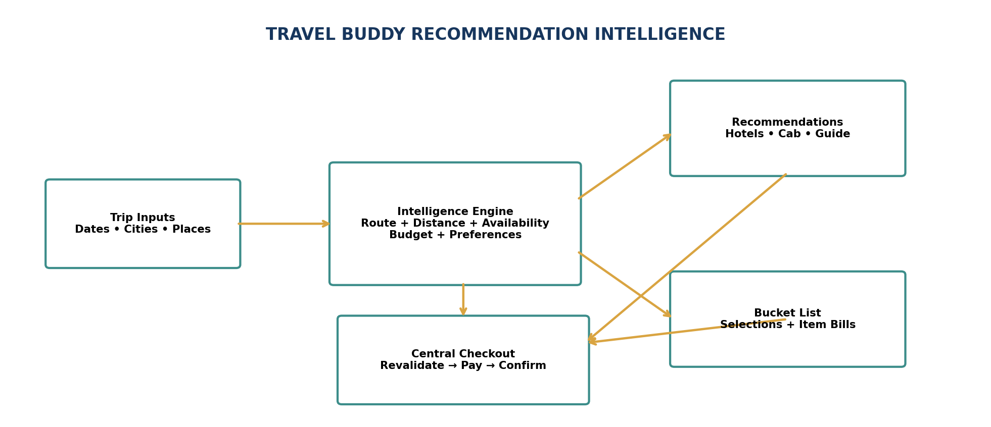
Recommendations must be contextual and explainable. Travel Buddy should use the user's actual trip inputs rather than generic popular-item ranking.

4.1 Hotel Recommendation
- Selected city + selected places + travel dates + occupancy are the primary context.
- Distance/proximity to selected attractions and route.
- Availability for the complete selected date range.
- Price/budget fit.
- Rating/review quality and property amenities.
- Approved/verified partner status and operational reliability.
- Explain reasons such as '2.1 km from your selected place' or 'available for all dates'.

4.2 City Sequence Intelligence
- Reduce unnecessary backtracking.
- Respect dates and practical minimum stay duration.
- Consider inter-city distance/travel time.
- Keep the proposed sequence editable.
- Warn rather than silently changing the user's plan.

4.3 Cab Intelligence
- Use city sequence and dates.
- Identify supported local/inter-city/airport/rail transfer needs.
- Suggest vehicle category from group size/luggage assumptions.
- Show estimated fare and inclusions.
- Keep the service optional.

4.4 Guide Intelligence
- Match expertise to selected place/category.
- Check language, date/time availability and rate.
- Default to one guide for a selected popular place for simplicity.
- Allow skip and later selection.
- Do not book before final checkout.

4.5 Budget Intelligence
- Show estimated total throughout planning.
- Break down accommodation, transport, guide, activity, taxes/fees and discounts.
- Show per-city and full-trip subtotals.
- Warn if selections exceed an optional budget.
- Offer cheaper alternatives without replacing user choices automatically.

5. Bucket List → Planned Trip Cart
The Bucket List is upgraded into two complementary concepts: ordinary saved items and a Planned Trip Cart for the active trip. The Trip Cart is the source for the final bill and checkout.
Item | City | Dates | Status | Amount
Hotel — selected room | City A | Day 1–3 | Selected / not booked | ₹X
Hotel — selected room | City B | Day 3–5 | Selected / not booked | ₹Y
Popular Place | City A | Day 2 | Planned | ₹0 / ticket if supported
Cab — optional | City A → B | Day 3 | Selected / not booked | ₹Z
Guide — optional | Selected Place | Day 2 | Selected / not booked | ₹G

5.1 Bill Structure
- Hotel subtotal grouped by property/city/date.
- Transport subtotal for each selected transfer.
- Guide subtotal for each selected guide service.
- Activity/attraction subtotal where paid inventory is supported.
- Taxes and platform/service fees shown explicitly.
- Discounts/promotions shown separately.
- Total Trip Cost clearly displayed.
- Payable Now clearly displayed.

6. Centralized Trip Checkout
Payment moves out of individual hotel/guide/cab screens and becomes a Trip Checkout capability. The traveler reaches payment only after reviewing the complete journey.
- Click Review Trip & Checkout.
- Recheck hotel room inventory for every selected date.
- Recheck guide availability.
- Recheck transport availability.
- Recheck current price and cancellation policy for every service.
- Recalculate the final bill.
- If something changed, show the exact affected line item and require confirmation.
- Create final booking holds for the checkout set.
- Create one centralized payment order.
- Verify Razorpay payment server-side.
- Confirm the applicable hotel/guide/transport bookings with idempotent recovery.
- Generate individual booking references plus one Trip/Checkout reference.
- Generate voucher/QR information and notifications.
- Show the confirmed trip in My Trips.
Failure-safe checkout
If one service becomes unavailable before payment, do not silently substitute it or charge for a different trip. Recalculate and ask for confirmation. If payment succeeds but confirmation needs recovery, reconcile from persisted payment events rather than charging twice.

7. Treasure-Map UI/UX Specification
The attached visual establishes the intended metaphor: a start marker, winding route, checkpoints, obstacles/landmarks and a final destination. For Travel Buddy, this becomes a polished interactive journey map.
- Start marker = trip start/date checkpoint.
- City markers = selected city stops.
- Place markers = selected attractions.
- Hotel markers = selected/recommended stays near places.
- Cab route = optional route between city checkpoints.
- Guide marker = optional guide attached to a selected place.
- Completed checkpoints animate after real milestones.
- Treasure marker = final confirmed trip.
- Dotted route progressively draws as planning steps are completed.
- Map camera pans/zooms to newly selected city/place.
- Use compass, flag, suitcase, hotel, guide and transport micro-animations.
- On mobile, transform the map into a vertical journey timeline with animated route segments.

7.1 Planner Screens
Planner Landing: Start New Trip, Saved Trips and Bucket List.
Date Selection: Start/end picker with duration preview.
City Selection: Search, chips, map and city ordering.
Popular Places: Per-city place cards with multi-select and Skip.
Hotel Recommendations: Map/list split view with recommendation reasons.
Optional Transport: Cab/transfer recommendations with Skip/Select.
Optional Guides: Guide cards with Skip/Select.
Trip Review: Treasure map plus complete schedule and selections.
Bill & Checkout: Itemized bill, fees/taxes, total and Pay.
Confirmation: Treasure/flag completion animation plus booking references.
Active Trip: Animated map/timeline with today's checkpoint.
Post-Trip Review: Eligible services ready for review.

8. Trip Planner Data Model
Entity | Purpose
trips | Master journey, dates, status, title and overall totals.
trip_cities | Ordered city stops with arrival/departure dates and sequence.
trip_places | Selected popular places/attractions per city.
trip_selections | Hotel/guide/transport selections before checkout.
trip_bill_items | Immutable checkout line-item snapshot.
trip_checkout | Central checkout reference, total and payment/confirmation state.
trip_recommendations | Recommendations shown and explanation/reason metadata.
trip_milestones | Planner/travel progress used by treasure-map animation.
review_unlocks | Eligibility for post-trip reviews.

9. Trip Planner Requirements
ID | Requirement | Acceptance
TP-01 | Date-driven planning | Start/end dates are mandatory and duration is calculated.
TP-02 | Multi-city selection | User chooses the number and identity of cities.
TP-03 | City sequence intelligence | System proposes a practical route and explains why.
TP-04 | Popular place selection | Multiple places per city; user may skip.
TP-05 | Nearest hotel recommendation | Uses place proximity, dates, availability, quality and budget.
TP-06 | Optional transport | Cab recommendations are route/date aware and optional.
TP-07 | Optional guide | Place/city guide can be selected or skipped.
TP-08 | Central trip cart | All selected services are visible together before payment.
TP-09 | Itemized billing | Every service, fee, tax, discount and total is visible.
TP-10 | Central checkout | Final revalidation and payment happen in Travel Buddy Trip Checkout.
TP-11 | Treasure-map experience | Selections and progress animate as a journey.
TP-12 | Post-trip reviews | Review UI unlocks after eligible trip/service completion.

10. Revised Review Workflow
- Trip reaches end date and required service completion states are recorded.
- System evaluates which bookings are eligible for review.
- Review Center becomes available.
- Each eligible hotel/guide/transport service receives a review card.
- Traveler submits rating, text and optional media if supported.
- Review is linked to the completed booking and marked verified.
- Moderation/risk rules can flag content.
- Approved review updates the service's aggregate rating.

11. Revised Status Model
Object | States | Notes
Trip | DRAFT → PLANNING → READY_FOR_CHECKOUT → CONFIRMED → IN_PROGRESS → COMPLETED → REVIEW_OPEN → CLOSED | Planner and travel state are distinct.
Selection | SELECTED → REVALIDATING → READY_FOR_CHECKOUT → BOOKED / UNAVAILABLE / REMOVED | Selection is not a reservation.
Checkout | CREATED → REVALIDATING → PAYMENT_PENDING → PAID → CONFIRMED / RECOVERY_REQUIRED / FAILED | Central payment lifecycle.
Review | LOCKED → ELIGIBLE → SUBMITTED → PUBLISHED / FLAGGED | Eligibility is booking-based.

12. Intelligence & Safety Rules
- Never recommend a hotel as available if its selected dates are unavailable.
- Never recommend a guide whose availability conflicts with the selected place/date.
- Never recommend transport that creates a known itinerary conflict.
- Detect impossible or extremely compressed itineraries and warn the traveler.
- Detect overlapping hotel stays or inconsistent city dates.
- Detect excessive route backtracking and offer a better sequence.
- User choices remain authoritative; recommendations never silently replace them.
- Recommendations explain their reasons.
- Bill recalculates whenever a selection changes.
- Inventory and price are always revalidated before payment.

13. Frontend Route Blueprint
Route | Screen
/trip-planner | Trip Planner start
/trip-planner/dates | Date selection
/trip-planner/cities | City selection
/trip-planner/places | Popular places
/trip-planner/hotels | Hotel recommendations
/trip-planner/transport | Optional cab/transport
/trip-planner/guides | Optional guides
/trip-planner/review | Treasure-map trip review
/trip-planner/checkout | Centralized bill + payment
/trip-planner/confirmation | Trip confirmation
/my-trips/:id | Active trip / treasure map
/my-trips/:id/reviews | Post-trip reviews

14. Revised Master Workflow
MASTER FLOW
DISCOVER DESTINATION → START TRIP → SELECT DATES → SELECT CITIES → OPTIMIZE CITY ORDER → SELECT/SKIP POPULAR PLACES → RECOMMEND NEARBY HOTELS → SELECT HOTEL → OPTIONAL CAB → OPTIONAL GUIDE → TREASURE-MAP TRIP REVIEW → BUCKET LIST / TRIP CART → ITEMIZED BILL → FINAL AVAILABILITY & PRICE RECHECK → CENTRAL PAYMENT → CONFIRM HOTEL/GUIDE/TRANSPORT → VOUCHER + QR → ACTIVE TREASURE-MAP TRIP → TRIP COMPLETION → REVIEW CENTER

15. Architecture Impact
- Trip Planner becomes an orchestration module, not merely a UI page.
- Booking services remain domain-specific but are coordinated by Trip Checkout.
- Hotel, guide and transport modules expose availability/quote information to the planner.
- Payment is centralized while financial records remain itemized per service.
- Recommendation Engine consumes geo, dates, availability, distance, budget and service metadata.
- Review eligibility is derived from completed booking/service records.
- Map animation is driven by Trip Milestones rather than hard-coded visual progress.

16. Updated Build Sequence
- Create/extend Trip and Trip City models.
- Implement planner date and city-selection APIs/UI.
- Implement popular place selection per city.
- Implement geo-distance service for nearest hotels.
- Expose date-aware hotel recommendation/availability APIs.
- Add optional transport recommendation.
- Add optional guide recommendation.
- Create Trip Selection/Trip Cart layer.
- Create itemized Trip Bill and price snapshots.
- Implement centralized Trip Checkout and final revalidation.
- Integrate Razorpay at centralized checkout.
- Generate unified Trip confirmation and individual booking references.
- Build treasure-map animation and milestone state.
- Build Active Trip journey view.
- Implement completion detection and review unlock.
- Add end-to-end tests for multi-city planning, unavailable services, price changes and payment recovery.

17. Final UX Goal
The experience
The traveler should feel that Travel Buddy is building the journey with them: choose dates, draw the route, discover places, find nearby stays, optionally add transport and guides, see the entire trip and bill together, pay once, travel through an animated treasure-map journey, and finally review the services after the trip.

18. Trip Planner Acceptance Checklist
- ☐ Start/end date selection works.
- ☐ Trip duration is calculated.
- ☐ User chooses number of cities.
- ☐ User selects and can reorder cities.
- ☐ System warns about impractical city sequences.
- ☐ User can select multiple popular places per city.
- ☐ Popular-place step can be skipped.
- ☐ Nearby hotel recommendations respect dates and inventory.
- ☐ Cab recommendations are optional.
- ☐ Guide recommendations are optional.
- ☐ All selected things appear in the Trip Cart/Bucket List.
- ☐ Each selected service has its own bill.
- ☐ Total trip bill is calculated.
- ☐ Payment is centralized.
- ☐ Final availability/price revalidation occurs before payment.
- ☐ Successful payment confirms eligible bookings.
- ☐ Treasure-map animation reflects actual selections.
- ☐ Active trip shows confirmed route and services.
- ☐ Review section unlocks after trip completion.
- ☐ Only eligible completed services can be reviewed.

MASTER UPDATE — SRS 2.3
This update extends SRS 2.2 with two important product decisions: (1) the Home page becomes a true discovery experience, and (2) Custom Trip Planner becomes the structured entry point for personalized trip creation. The existing multi-city planner, optional cab/guide, centralized Trip Cart, itemized billing, final revalidation, centralized payment, treasure-map journey and post-trip review workflow remain active.

1. Updated Product Philosophy
Home = Discover. Planner = Decide. Trip Cart = Control. Checkout = Pay.
The traveler should not land on a generic booking dashboard. Home introduces destinations and attractions, while Custom Trip Planner converts the traveler's preferences into a customizable proposed trip. The traveler remains in control of every important selection.

2. New Home Page — Discovery-First Experience
The Home page is now a proper discovery page rather than only a marketing landing page. Its primary purpose is to help users discover destinations, attractions, hotels and travel experiences before or while starting a custom trip.
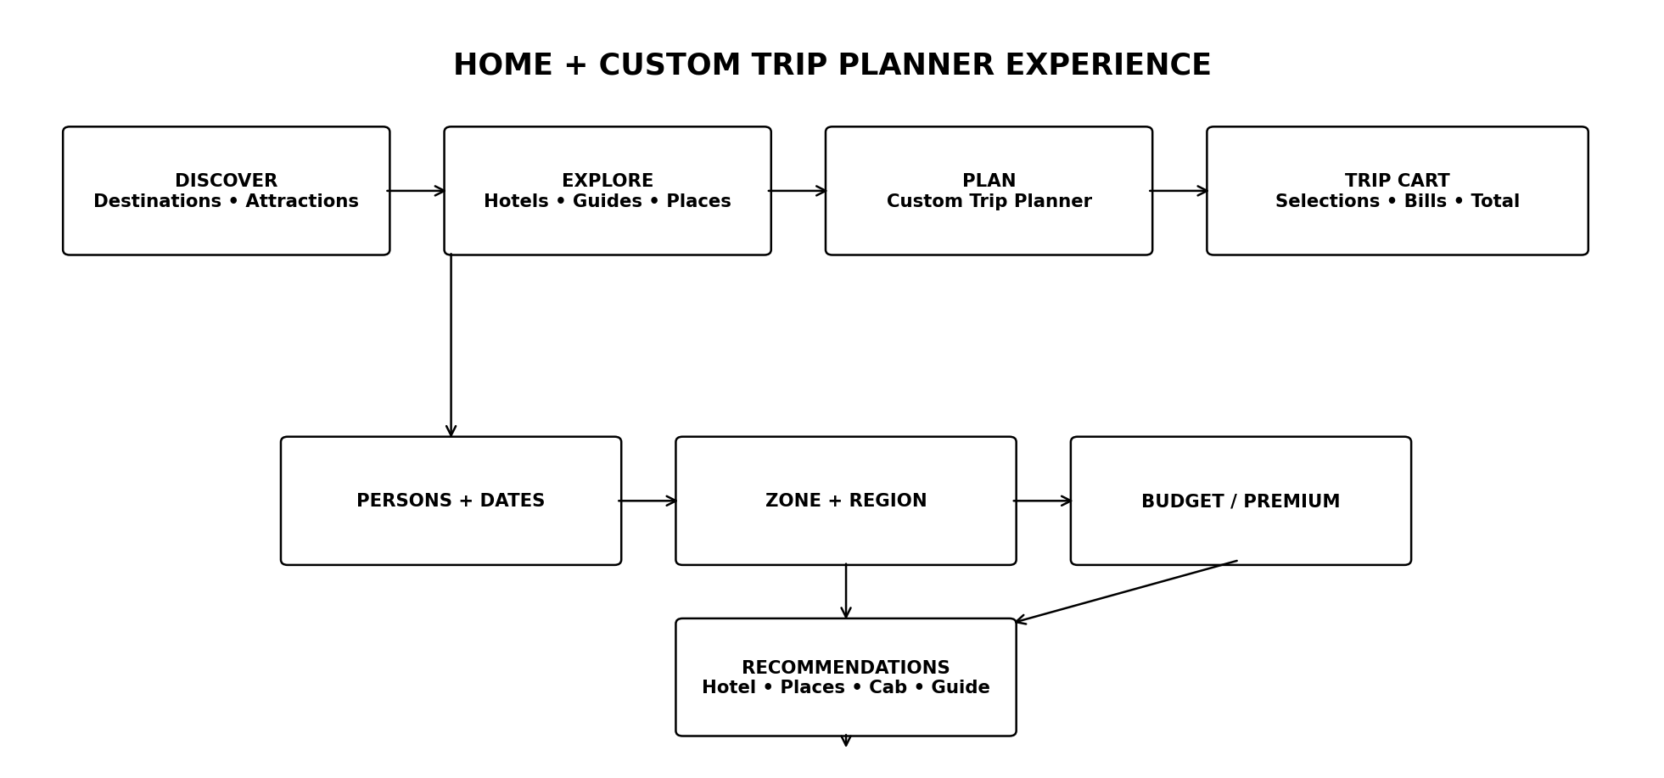

2.1 Home Page Sections
Section | Purpose
Hero / Discovery Search | Large travel visual, destination search, quick exploration and entry to Custom Trip Planner.
Featured Destinations | Curated destination cards with image, region, highlights and discovery CTA.
Popular Attractions | Multiple attraction cards with category, location, short description and save/explore action.
Explore by Zone | Zone-level discovery so users can understand the broader travel area before choosing a region.
Explore by Region | Region cards leading to destination and attraction collections.
Popular Places | High-interest places associated with destinations; multiple places can later be selected in the planner.
Stay Discovery | Selected/featured hotel cards with useful property details and discovery links.
Local Experiences | Guide/experience discovery connected to destinations.
Travel Inspiration | Visual collections that lead into destination or planner flows.
Custom Trip Planner CTA | Persistent high-visibility action: Start Custom Trip.

2.2 Attraction Card Standard
- Attraction image and name.
- Destination/city context.
- Category or attraction type.
- Short description.
- Estimated visit duration where available.
- Map/location action.
- Save to Bucket List.
- Add to current trip when a trip exists.
- Explore details CTA.

3. Custom Trip Planner — New Primary Input Flow
Custom Trip Planner is the structured planning wizard. It starts with traveler requirements and then progressively generates recommendations. The system must not lock the traveler into its suggestions; every recommendation can be inspected, changed or removed.
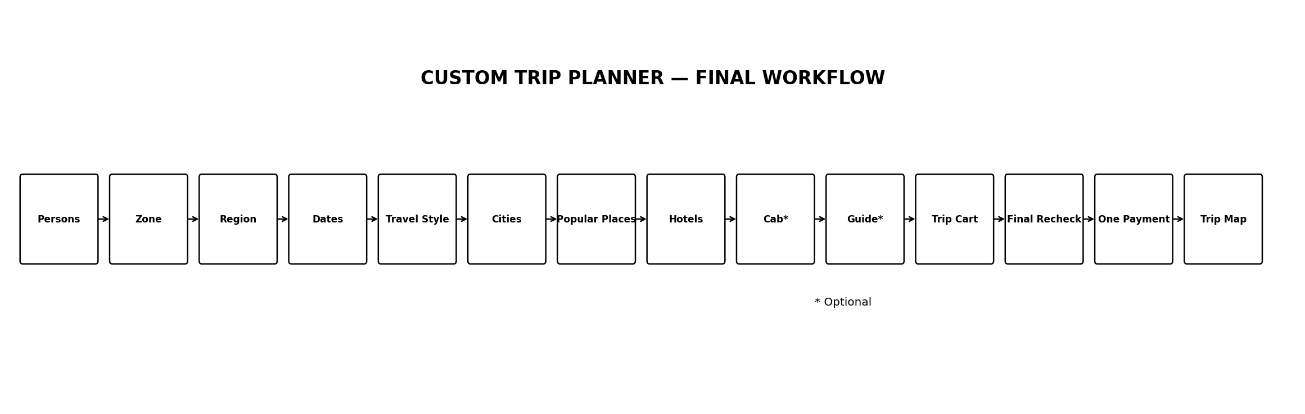

3.1 Step 1 — Number of Travelers
- User selects total number of persons.
- System stores adult/child composition if the UI collects it.
- Occupancy and room recommendations use this value.
- Cab capacity and vehicle recommendations use this value.
- Guide suitability can use group size.

3.2 Step 2 — Select Zone
- User selects a broad travel zone.
- The system loads relevant regions and destinations inside that zone.
- Zone selection is the first geographic constraint for recommendation.

3.3 Step 3 — Select Region
- User selects one or more supported regions as allowed by the planner design.
- The system loads cities/destinations available in the selected region.
- The planner should show geographic context on the map.

3.4 Step 4 — Start Date & End Date
- User chooses trip start date.
- User chooses trip end date.
- System validates end date >= start date.
- Trip duration is calculated automatically.
- Hotel availability, pricing, cab suitability, guide availability and itinerary timing use these dates.

3.5 Step 5 — Travel Style
The user chooses one of two clear planning modes:
Mode | System Behavior | Important Rule
Budget Travel | Prioritize value, reasonable location, essential amenities and cost-efficient transport/services. | Do not simply choose the cheapest item; minimum quality/trust rules still apply.
Premium Travel | Prioritize higher-rated properties, stronger amenities, better locations, premium room categories and more convenient transport/service options. | Premium recommendations remain availability- and budget-aware.

4. Recommendation Engine — What Happens After Inputs
After the planner has persons, zone, region, dates and travel style, Travel Buddy generates a proposed trip. Recommendations are suggestions, not automatic bookings.
Recommendation | Intelligence
Cities | Suggest relevant cities/destinations inside the selected geographic scope, using dates, travel style, popularity, distance and trip duration.
Popular Places | For each selected city, show popular attractions/places. User can select multiple places or skip the selection.
Hotels | Recommend suitable hotels near the selected city/popular places, considering dates, occupancy, availability, travel style, price, rating, amenities and location.
Cab | Optionally suggest suitable cab/transport options using group size, cities, dates and planned movement.
Guide | Optionally suggest one guide for selected popular-place/city coverage based on availability, language, expertise, rating and group size.

4.1 Recommendation Transparency
Each recommendation should show why it was suggested. Example signals: near selected attraction, available for all dates, suitable for group size, matches Budget/Premium mode, highly rated, within preferred price range, convenient route position.
Important design rule
The recommendation engine proposes; the traveler decides. The user must be able to replace, remove, skip or customize recommended items.

5. City & Popular Place Selection
- System presents suggested cities based on zone, region, dates and travel style.
- User selects the cities they actually want to visit.
- System calculates a sensible city order using geographic distance and trip dates.
- For each city, system presents popular places.
- User can select multiple popular places for the city.
- User can skip popular-place selection and continue.
- Selected places become itinerary candidates rather than confirmed bookings.

6. Hotel Recommendation & Full Customization
Hotel recommendations are generated after the city/place context is known. If a user selects a popular place, nearby suitable hotels are prioritized, while broader city hotels remain available.

6.1 Hotel Recommendation Factors
- Availability for the complete requested stay.
- Number of travelers and room occupancy.
- Distance from selected popular places.
- Distance from city center/important travel points where relevant.
- Budget vs Premium travel mode.
- Rating and verified reviews.
- Amenities and room facilities.
- Cancellation policy.
- Property verification/trust status.
- Total estimated stay cost.

6.2 Hotel Customization
The traveler can open full hotel details and change the recommended option. The hotel detail page should show property overview, images, location/map, amenities, room types, occupancy, price breakdown, policies, cancellation terms, ratings/reviews and availability.
- Replace recommended hotel.
- Choose a different room type.
- Change number of rooms where supported.
- Inspect full property details.
- Change dates only through the planner so the rest of the itinerary can be revalidated.
- Remove hotel from the trip.
- Return to recommendation list without losing the rest of the plan.

7. Optional Cab & Guide

7.1 Cab
Cab/transport remains optional. The system can suggest a suitable option after cities and dates are known. Suggestions can consider number of travelers, vehicle capacity, city-to-city movement, airport/rail transfers and planned attractions.

7.2 Guide
Guide booking remains optional. For selected popular places, the planner can suggest one suitable verified guide. The traveler may accept, replace, skip or remove the guide.
Optional services rule
Cab and guide suggestions must never block trip creation. A traveler can complete a trip plan with hotels and places only.

8. Trip Cart / Bucket List — Single Source of Selected Items
The existing Bucket List concept is extended into a Trip Cart view for an active trip. It contains everything selected during planning.
- Trip dates and traveler count.
- Selected zone and region.
- Selected cities and city order.
- Selected popular places/attractions.
- Selected hotel/property and room.
- Optional cab/transport selections.
- Optional guide selection.
- Planned itinerary items.
- Estimated individual costs.
- Service fees/taxes where applicable.
- Total estimated trip cost.

8.1 Itemized Billing
Item | Displayed Bill | Status
Hotel | Room rate × nights + applicable taxes/fees | Selected / Revalidated / Booked
Cab | Trip/transfer/service price + applicable charges | Optional
Guide | Guide service price × selected duration/units | Optional
Other planned services | Individual service amount | Selected
Trip Total | Sum of selected billable items | Estimated → Final

9. Centralized Checkout — No Direct Hotel Payment
Payment remains centralized at the Travel Buddy Trip Checkout. The traveler does not separately pay a hotel, guide or cab during the planning flow.
- Traveler reviews the complete Trip Cart.
- System shows each bill and the total.
- Traveler can edit/remove selections.
- Traveler clicks Proceed to Checkout.
- Backend revalidates hotel/room availability, prices, guide availability and transport availability.
- Backend calculates the final payable amount.
- Final temporary holds are created only for the checkout transaction.
- Payment order is created centrally.
- Traveler completes one payment.
- Backend verifies payment.
- Successful verification confirms the relevant booking items.
- Voucher/QR/confirmation records are generated.
- My Trips receives the complete trip.
Selected ≠ Booked
Items inside the planner/Trip Cart are selections. They do not hold inventory indefinitely. Final holds and booking confirmation happen only during centralized checkout after fresh revalidation.

10. Treasure Map Trip Experience
After confirmation, the selected journey becomes a visual treasure-map style trip experience. The map should reflect the actual itinerary rather than being only decorative.
- Start flag = trip starting point/date.
- City markers = selected cities in route order.
- Place markers = selected popular attractions.
- Hotel marker = confirmed stay.
- Cab/transport marker = confirmed movement where applicable.
- Guide marker = confirmed guide service where applicable.
- Dashed route = planned journey path.
- Completed locations visually change after the traveler reaches/completes them.
- Locked/unvisited locations remain as future milestones.
- Trip completion triggers the review stage.
The treasure-map concept supplied by the user is treated as the visual direction: a journey path with milestones, destination markers and progressive completion.

11. Post-Trip Review Workflow
- System determines the trip/service completion state.
- After the relevant end/completion condition, review eligibility opens.
- Traveler sees completed hotel, guide, transport and eligible attraction/service items.
- Traveler can submit ratings and reviews for eligible completed services.
- Verified review is linked to the completed booking/service.
- Review status becomes visible to the relevant partner after moderation rules.
- Review data feeds future discovery/recommendation signals.

12. Updated End-to-End User Workflow
The complete experience is now:
FINAL FLOW
HOME DISCOVERY → CUSTOM TRIP PLANNER → PERSONS → ZONE → REGION → START/END DATES → BUDGET/PREMIUM → CITY SUGGESTIONS → USER CITY SELECTION → POPULAR PLACES → HOTEL RECOMMENDATIONS → HOTEL CUSTOMIZATION → OPTIONAL CAB → OPTIONAL GUIDE → TRIP CART / BUCKET LIST → ITEMIZED BILL → TOTAL BILL → FINAL REVALIDATION → CENTRAL PAYMENT → BOOKING CONFIRMATION → TREASURE-MAP TRIP → TRAVEL → TRIP COMPLETION → REVIEWS

13. Updated Functional Requirements
ID | Requirement | Description
TP-01 | Custom Planner Entry | User can start a custom trip from Home or planner navigation.
TP-02 | Traveler Count | User selects number of travelers; recommendation engines use it.
TP-03 | Geographic Scope | User selects zone and region.
TP-04 | Trip Dates | User selects start/end date; duration is calculated and validated.
TP-05 | Travel Style | User selects Budget Travel or Premium Travel.
TP-06 | City Suggestions | System proposes cities/destinations within the selected scope.
TP-07 | Popular Places | User can select multiple popular places per city or skip.
TP-08 | Hotel Intelligence | System suggests suitable hotels using dates, occupancy, geography, places and travel style.
TP-09 | Hotel Customization | User can inspect, replace, customize or remove hotel/room selections.
TP-10 | Optional Transport | System can recommend suitable cab/transport without requiring it.
TP-11 | Optional Guide | System can recommend one suitable guide for selected places without requiring it.
TP-12 | Trip Cart | All selected cities, places and services appear in one active-trip view.
TP-13 | Itemized Billing | Each billable service displays its own estimated/final amount.
TP-14 | Central Checkout | One centralized payment flow handles the complete selected trip.
TP-15 | Final Revalidation | Availability and prices are rechecked before payment.
TP-16 | Treasure Map | Confirmed itinerary is represented as an animated map journey.
TP-17 | Trip Completion | System marks relevant itinerary/service completion states.
TP-18 | Post-Trip Reviews | Eligible review forms open after completion.

14. Updated Data Model Additions
Entity/Table | Purpose
trip_plans | Custom planner master record: persons, zone, region, dates, travel style and planning status.
trip_plan_cities | Cities selected/recommended for a plan, order, dates and route metadata.
trip_plan_places | Popular places selected/skipped/recommended for each city.
trip_plan_recommendations | System-generated hotel/cab/guide/place recommendations with explanation signals.
trip_cart_items | Selected services/items and their estimated/current price snapshot.
trip_bill_items | Itemized billing records for hotel, transport, guide and other services.
trip_checkout | Centralized checkout/revalidation state.
trip_route_points | Treasure-map route/milestone data.
trip_completion_events | Completion milestones used to unlock reviews.
review_eligibility | Links completed booking/service to review eligibility.

15. Updated Frontend Route Structure
/ → Discovery Home
/destinations → Destination discovery
/destinations/:id → Destination details
/attractions/:id → Attraction details
/trip-planner → Custom Trip Planner wizard
/trip-planner/cities → City selection
/trip-planner/places → Popular-place selection
/trip-planner/stays → Hotel recommendations
/trip-planner/services → Cab/Guide recommendations
/trip-planner/cart → Trip Cart + itemized billing
/checkout → Centralized checkout/payment
/my-trips → Confirmed trips
/my-trips/:id/map → Treasure-map journey
/my-trips/:id/reviews → Post-trip reviews

16. Updated Build Order
- Upgrade Home into the discovery-first experience.
- Create Custom Trip Planner data model and API.
- Build persons + zone + region + date + travel-style wizard.
- Build city recommendation and city-selection UI.
- Build popular-place multi-selection with skip behavior.
- Connect hotel recommendation engine to actual inventory/search.
- Build complete hotel detail/customization flow.
- Add optional cab recommendation.
- Add optional guide recommendation.
- Build Trip Cart/Bucket List consolidation.
- Build itemized billing and total calculation.
- Build centralized checkout and final revalidation.
- Integrate centralized payment and confirmation.
- Build treasure-map trip UI and completion milestones.
- Unlock post-trip reviews after completion.
- Then connect partner/admin operational workflows and analytics.

17. Updated Acceptance Scenarios
- A guest opens Home and can discover multiple destinations and attraction cards.
- A user starts Custom Trip Planner and selects persons, zone, region, dates and Budget/Premium.
- The system proposes cities appropriate to the selected scope.
- The user selects multiple cities and the system establishes a route order.
- For each city, multiple popular places can be selected or skipped.
- Hotels are recommended using dates, occupancy, location, travel style and selected places.
- The user can replace a recommended hotel and inspect full property/room details.
- Cab and guide suggestions are optional and can be removed.
- All selected items appear in one Trip Cart.
- Each bill and the total bill are visible before payment.
- Changing a selection recalculates the affected bill and total.
- Checkout performs final availability and price revalidation.
- One centralized payment confirms the selected booking items.
- The confirmed trip is rendered as a treasure-map journey.
- After trip/service completion, eligible review forms become available.
- A review is not available for an uncompleted/unqualified service.

18. Final Updated Product Architecture
Travel Buddy v2.3
DISCOVERY PLATFORM + CUSTOM TRIP PLANNER + UNIFIED TRIP CART + CENTRAL CHECKOUT + PARTNER MARKETPLACE + TREASURE-MAP TRIP COMPANION + POST-TRIP REVIEW ENGINE

This update makes the Home page the discovery surface and the Custom Trip Planner the controlled planning engine. Hotel, guide and transport modules become coordinated components of a single trip rather than isolated booking pages.

TRAVEL BUDDY — FINAL SRA 3.0
Software Requirements + System Architecture + Product Blueprint + Final Workflow Specification
FINAL / FROZEN IMPLEMENTATION BASELINE
This section integrates the approved v2.3 scope with the additional intelligence features: feasibility analysis, route optimization, day-by-day itinerary, conflict detection, budget optimization, recommendation explanations, fallback alternatives, change-impact detection and Trip Health. These are now part of the final SRA baseline.

1. Final Product Architecture
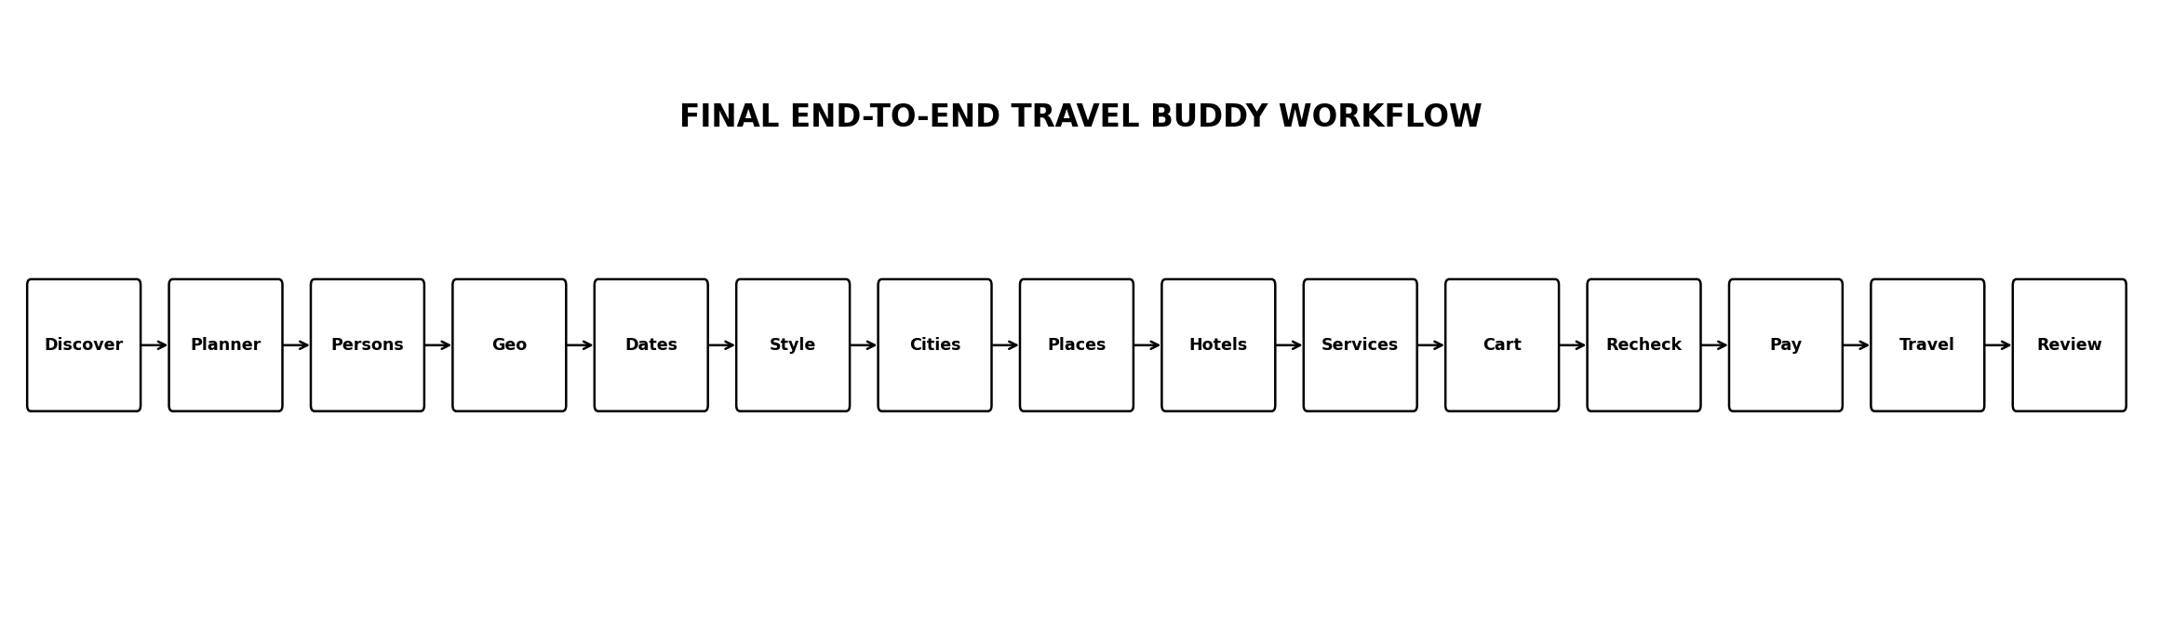
The final product is organized around five engines:
- Discovery Engine — Home, destinations, regions, cities, attractions, hotels and experiences.
- Custom Trip Planner — traveler count, geography, dates, travel style, cities, places and service selection.
- Trip Intelligence Engine — feasibility, route, itinerary, recommendations, budget, conflicts and alternatives.
- Marketplace & Transaction Engine — hotel, guide and transport inventory, booking, payment, cancellation, refunds, commission and settlement.
- Trip Companion Engine — Trip Cart, centralized checkout, treasure-map travel mode, notifications, completion and reviews.

2. Final Home Page
- Discovery-first Home, not a generic booking dashboard.
- Featured destination cards.
- Multiple attraction cards.
- Explore by zone and region.
- Popular places.
- Hotel/stay discovery.
- Guide/local experience discovery.
- Travel inspiration.
- Save to Bucket List.
- Start Custom Trip CTA.
UX principle
Home answers: “Where can I go and what can I experience?” Custom Trip Planner answers: “What should my complete trip look like?”

3. Final Custom Trip Planner Workflow
- Select number of travelers.
- Select zone.
- Select region.
- Select start and end dates.
- Select Budget Travel or Premium Travel.
- System suggests suitable cities/destinations.
- User selects cities and can manually reorder them.
- System checks trip feasibility.
- User selects multiple popular places per city or skips the section.
- System creates a sensible day-by-day itinerary proposal.
- System recommends hotels based on dates, occupancy, location, selected places, travel style and availability.
- User opens full hotel details and can replace/customize the hotel or room.
- System optionally recommends cab/transport.
- System optionally recommends one guide for relevant selected places.
- Everything selected appears in the active Trip Cart.
- Each bill and the total trip amount are displayed.
- User can change selections at any point.
- Change Impact Analysis identifies affected items.
- Final checkout revalidates availability, prices and service eligibility.
- One centralized payment confirms the applicable bookings.
- Confirmed trip opens in Treasure-Map Travel Mode.
- Completion events unlock eligible reviews.

4. Trip Intelligence Engine
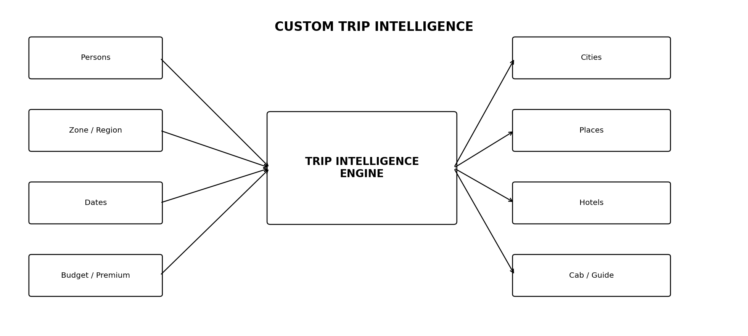
Intelligence | Behavior | Priority
Trip Feasibility | Warn when selected cities/places cannot reasonably fit the dates and estimated travel/visit time. | P1
Route Optimization | Suggest efficient city order; user can accept or manually reorder. | P1
Day Allocation | Distribute places across days with travel and buffer time. | P1
Conflict Detection | Flag overlapping/impossible itinerary timings. | P1
Hotel Recommendation | Match dates, occupancy, location, travel style, price, rating and amenities. | P0
Cab Recommendation | Use group size, dates, route and vehicle capacity. | P1
Guide Recommendation | Use availability, language, expertise, place and group size. | P1
Budget Optimization | Show category spend and cost-saving alternatives. | P1
Recommendation Explanation | Show why each recommendation was selected. | P1
Fallback Alternatives | Offer alternatives if selected inventory becomes unavailable. | P1
Change Impact | Revalidate dependent hotel/guide/cab/itinerary items after changes. | P1
Trip Health | Healthy / Attention Needed / Action Required. | P1
Conversational AI | Natural-language planning assistant. | P2

5. Trip Feasibility & Route Rules
- User-selected cities remain authoritative.
- System calculates approximate travel burden between cities.
- System considers available trip days.
- System considers attraction visit duration where available.
- System inserts configurable buffer time.
- System warns about over-packed plans instead of silently accepting them.
- User may reduce cities, remove places, extend dates or keep the plan manually.
- Route optimization is advisory and can be overridden.
Example
If a user selects 4 cities and 12 attractions for a short trip, the planner should identify the schedule as tight and explain which cities/places create the pressure.

6. Day-by-Day Itinerary
Selected attractions become itinerary candidates. The system proposes a day-by-day schedule, while the traveler retains control.
- Arrival/check-in awareness.
- Hotel location awareness.
- Attraction opening/availability data where available.
- Estimated visit duration.
- Estimated travel time.
- Buffer time.
- City transfer days.
- Drag/reorder support.
- Conflict warnings.
- Manual override.

7. Recommendation Transparency & Customization
Why this hotel?
Available for your complete stay • suitable for your group size • close to selected attractions • matches Budget/Premium mode • strong verified reviews • appropriate cancellation policy.

The user can replace any recommendation. The system must never silently replace a user selection without showing the change.
- Best Location hotel.
- Best Value hotel.
- Premium Choice hotel.
- Full property details.
- Room types and occupancy.
- Price breakdown.
- Amenities.
- Policies.
- Map.
- Verified reviews.
- Replace/remove.

8. Trip Cart & Budget
Trip Cart is the single planning workspace for the active trip.
- Travelers and dates.
- Zone/region.
- Selected cities and order.
- Popular places.
- Hotel/room.
- Optional cab.
- Optional guide.
- Itinerary items.
- Individual bills.
- Estimated food/other budget categories where supported.
- Total estimated/final payable amount.
Category | Example | Status
Hotel | Room × nights + taxes/fees | Selected → Revalidated → Booked
Cab | Transfer/private/local service | Optional
Guide | Hourly/daily service | Optional
Activity/Service | Paid selected service | Selected
Trip Total | Sum of payable items | Estimated → Final

9. Centralized Checkout & Transaction Rules
Selected ≠ Booked
Planner selections do not create long-lived inventory holds. Final holds are created only during checkout after fresh revalidation.

- Traveler reviews the complete Trip Cart.
- System recalculates affected bills.
- Change Impact Analysis identifies dependent items.
- Checkout revalidates inventory, prices and eligibility.
- Final temporary holds are created.
- Central payment order is created.
- Payment is verified server-side.
- Confirmed booking items are created atomically where possible.
- Failed/expired payment releases temporary holds.
- Voucher/QR/notifications are generated.

10. Trip Health
Status | Meaning
🟢 HEALTHY | Required bookings/services are confirmed and no known action is required.
🟡 ATTENTION NEEDED | A service changed or needs traveler review/reselection.
🔴 ACTION REQUIRED | Payment, availability, booking or another critical issue needs action.

11. Change Impact & Fallback System
Changing a foundational trip input must not silently break downstream selections.
- Date change → recheck hotel, guide, cab and itinerary.
- City change → recheck places, hotel and transport.
- Hotel change → update budget and location-dependent itinerary.
- Travel-style change → recalculate recommendations.
- Traveler-count change → recheck room occupancy and vehicle capacity.
- Unavailable selected service → offer comparable alternatives.
- Any affected item receives an explicit revalidation status.

12. Treasure-Map Travel Mode
- Planning mode: editable route.
- Confirmed mode: confirmed booking milestones.
- Travel mode: completed/current/upcoming milestones.
- City, attraction, hotel, transport and guide markers.
- Animated/dashed route.
- Current location/milestone emphasis where supported.
- Completion events.
- Trip Health.
- Notifications tied to upcoming milestones.
The treasure-map UI is a visual layer over the real trip data. Booking, payment and inventory remain authoritative in the backend.

13. Post-Trip Review System
- Trip/service reaches completion.
- Review eligibility is created.
- Traveler sees eligible hotel/guide/transport/service reviews.
- Traveler submits rating and optional text.
- Review is linked to the completed booking/service.
- Moderation rules apply.
- Verified review can contribute to future discovery/recommendation signals.

14. Final Partner Workflow
- Become a Partner.
- Guest → Login/Register.
- Choose Hotel / Guide / Cab-Driver.
- Submit profile and KYC/documentation.
- Admin review.
- Approve / Reject / Request Changes.
- Approved user receives partner dashboard.
- Create service/listing.
- Required listing approval.
- Publish.
- Receive/fulfill bookings.
- Complete service.
- Earnings and settlement.

15. Final Data Additions
Entity | Purpose
trip_plans | Planner master record: travelers, geography, dates, travel style and state.
trip_plan_cities | Selected/recommended cities, order and route metadata.
trip_plan_places | Selected/skipped/recommended places.
trip_plan_recommendations | Recommendation records plus explanation signals.
trip_cart_items | Active trip selections.
trip_bill_items | Itemized financial presentation/snapshots.
trip_checkout | Central revalidation/checkout state.
trip_route_points | Treasure-map route/milestones.
trip_completion_events | Completion milestones.
trip_health_events | Trip operational health changes.
review_eligibility | Completed service → review eligibility mapping.

16. Final API Additions
API | Purpose
/api/v1/home | Discovery feed/cards
/api/v1/trip-plans | Planner CRUD and recommendations
/api/v1/trip-plans/{id}/route | Feasibility and route optimization
/api/v1/trip-plans/{id}/itinerary | Day allocation and conflict detection
/api/v1/trip-plans/{id}/cart | Trip Cart
/api/v1/trip-plans/{id}/budget | Bills, totals and optimization
/api/v1/trips/{id}/health | Trip Health
/api/v1/trips/{id}/map | Treasure-map/travel mode
/api/v1/trips/{id}/completion | Completion milestones
/api/v1/reviews/eligibility | Review eligibility

17. Final Scope Freeze
Priority | Features | Decision
P0 — Core | Discovery Home, Custom Planner inputs, cities/places, hotel recommendation/customization, inventory, Trip Cart, bills, central checkout/payment, booking, My Trips, partner KYC/approval | Build now
P1 — Intelligence & Operations | Feasibility, route optimization, day itinerary, conflict detection, budget optimization, explanations, fallbacks, change impact, Trip Health, cab/guide, treasure map, notifications, reviews, admin/partner operations | Build as core project scope
P2 — Future | Conversational AI, advanced personalization, predictive analytics, trip memories | After final baseline

18. Final Implementation Roadmap
Phase | Area | Deliverables
1 | Foundation | Auth, RBAC, database, Flyway, API foundation, security
2 | Discovery | Home, destinations, attractions, geo, search, maps
3 | Planner Core | Persons, zone, region, dates, travel style
4 | Planner Intelligence | Cities, route, feasibility, places, itinerary/conflicts
5 | Marketplace | Hotels, rooms, inventory, guides, transport
6 | Trip Cart | Selections, itemized bills, budget, Trip Health
7 | Checkout | Revalidation, holds, payment, confirmation, refunds
8 | Partner/Admin | KYC, approval, partner dashboards, admin operations
9 | Trip Companion | Treasure map, travel mode, notifications, completion
10 | Trust/Finance | Reviews, disputes, commissions, settlement, risk, audit
11 | Advanced AI | Conversational planner and advanced recommendations
12 | Production | Testing, load/security, Docker, CI/CD, monitoring, backup/restore

19. Final Acceptance Checklist
☐ Discovery-first Home | ☐ Destination/attraction cards | ☐ Custom Trip Planner

☐ Traveler count | ☐ Zone/region | ☐ Start/end dates

☐ Budget/Premium | ☐ City selection/order | ☐ Feasibility

☐ Popular places multi-select/skip | ☐ Day-by-day itinerary | ☐ Travel-time conflicts

☐ Hotel recommendations | ☐ Full hotel customization | ☐ Optional cab

☐ Optional guide | ☐ Recommendation explanations | ☐ Trip Cart

☐ Individual bills | ☐ Budget total | ☐ Budget optimization

☐ Change-impact analysis | ☐ Fallback alternatives | ☐ Final revalidation

☐ Central payment | ☐ Double-booking protection | ☐ My Trips

☐ Trip Health | ☐ Treasure-map travel mode | ☐ Trip completion

☐ Post-trip reviews | ☐ Hotel/Guide/Driver partners | ☐ KYC/approval

☐ Admin operations | ☐ Commission/settlement | ☐ Support/disputes

☐ Risk/audit | ☐ Security/testing/deployment

20. Final System Definition
TRAVEL BUDDY SRA 3.0
A destination-first intelligent travel planning and hospitality marketplace where users discover destinations and attractions, define travelers, geography, dates and travel style, customize cities/places/hotels/services, review transparent trip costs, pay centrally, experience their confirmed itinerary through a treasure-map travel mode, and complete the journey with verified reviews.

20.1 Final Engineering Principle
Correctness before intelligence. Inventory, booking, payment, authorization, auditability and recovery are the system foundation. Recommendation and AI features assist the traveler but never override transactional truth or user control.

20.2 Change-Control Rule
SRA 3.0 is the frozen implementation baseline. New features should be handled as post-SRA change requests unless they are required for security, data integrity, legal/compliance, or production-critical correction.

