**Paper Title :** Abnormality Detection in Mammography using Deep Convolutional Neural Networks

**Author :** Xi et al

**Year :** 2018

**Dataset :** CBIS-DDSM

Patches : 200*200 pixels

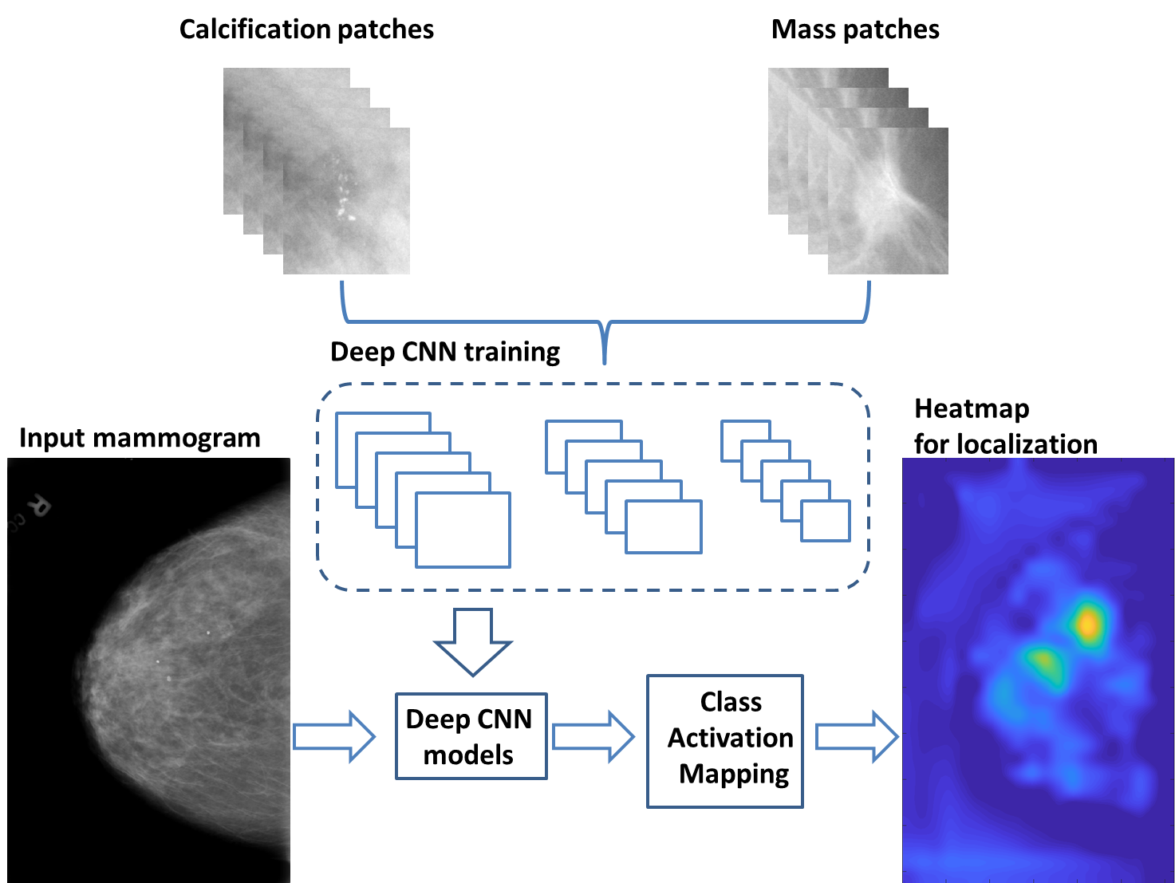

**Steps:**

1. With training image patches from calcification and mass cases, a binary classifier is trained with state-of-the-art deep CNN architectures using transfer learning.

2. The pre-trained CNNs are modified at output layers to have two output classes. The output layers are then fine-tuned while the first part of the network is frozen.

3. The fine-tuned patch neural network is then used to localize mammographic abnormalities in full-size mammograms.

**Procedure to generate class activation map:**

Feeding the full-size mammogram image into the patch classifier and computing class activation mapping near the end of the output layers produces a heatmap for the localization of abnormalities.

Class Activation Mapping (CAM) is a technique for identifying regions in an image using a CNN for a specific class. deep CNN needs to be cut after the last convolution layer and a global average pooling layer and a fully connected layer are appended. The new model needs to be retrained for learning the weights w i (i = 1, 2, ...n) at the output layer.

The feature maps from the output of the last convolution layer are denoted as fi (i = 1, 2, ...n). It can identify the importance of the image regions by projecting back the weights of the output layer onto the convolution feature maps

**Implementation of CAM:**

B. Zhou, A. Khosla, L. A., A. Oliva, and A. Torralba, “Learning Deep Features for Discriminative Localization.” CVPR, 2016.

**Paper Title :** Characterization of clustered microcalcifications in digitized mammograms using neural networks and support vector machines

**Author :** Papadopoulos

**Year :** 2005

**Dataset :** MIAS and Nijimen

**Steps:**

(a) the **cluster detection stage** to identify clusters of microcalcifications

(b) the **feature extraction stage** to compute the important features of each cluster

(c) the **classification stage**, which provides with the final characterization

In the classification stage, a rule-based system, an artificial neural network (ANN) and a support vector machine (SVM) are implemented.

**Detection Methodology:**

Papadopoulos A, Fotiadis DI, Likas A. An automatic micro-calcifications detection system based on a hybrid neural network classifier. Artif Intell Med 2002;25:149—67.

**Paper Title :** Microcalcification Detection in Digital Mammograms using Novel Filter bank

**Author :** Balakumaran

**Year :** 2010

**Dataset :** DDSM

1. Multi-resolution based histogram equalization techniques

2. Use Multi scale hessian matrix

***Logic: Suppress Low frequency components and reconstruct high frequency components***

**Paper Title :** Microcalcification Segmentation from Mammograms: A Morphological Approach

**Author :** Ciecholewski

**Year :** 2017

**Dataset :** DDSM

**Steps:**

1. Detect micro-calcification morphologically

Approximate area of calcification determined

Contrast improved

Noise Reduced

2. Watershed Segmentation

**Paper Title :** Breast Microcalcification Diagnosis Using Deep Convolutional Neural Network from Digital Mammograms

**Author :** Cai et al

**Year :** 2019

**Dataset :** DDSM

