
Plasmid Innovation
Date: 05/09/2025
Major Project
Report on Charts
Domain: Data Analytics
Student Name: Nikhil Sharma
Registration no. : PCE23IT800

1. Introduction
The purpose of this project is to examine the sales performance of a chain of coffee shops through Microsoft Power BI. The project illustrates how raw transactional data can be converted into actionable insights through data cleaning, transformation, modeling, and interactive dashboards.
Key points of this project:
- Interpret sales trends by products, categories, and locations.
- Evaluate performance through KPIs like Revenue, Profit, and Average Order Value.
- Choose best-selling products and categories driving revenue.
- Evaluate store locations to emphasize top performers and low-performing stores.
- Facilitate decision-making through actionable recommendations.
Power BI was selected for this project due to its:
- Seamless importability of Excel datasets.
- Strong DAX (Data Analysis Expressions) for calculated measures.
- Dense set of interactive visuals (bar charts, line charts, maps, cards, slicers).
- Capacity to publish and share dashboards with stakeholders.
It describes the step-by-step methodology adopted to create the dashboard and insights and findings developed through the analysis.

2. Data Source
File Used: Coffee_sales.xlsx
Type of Data: Transactional sales data of coffee shops.
Main Columns in Dataset:
Column Name | Description
Transaction Date | Date of purchase
Product Category | Type of product sold (Coffee, Tea, Snacks, etc.)
Product Name | Specific item sold
Quantity Sold | Number of units sold
Sales Amount | Total revenue from transaction
Profit | Profit earned per transaction
Store Location | City/branch where sale occurred

The dataset included several months of sales across different store locations. This allowed for trend analysis and comparisons.

3. Data Cleaning & Transformation
The raw Excel data needed to be preprocessed prior to report building. The below steps were used in Power BI:
- Null & Duplicate Removal
  - Deleted missing values to prevent incorrect analysis.
  - Deleted duplicate transactions.
- Data Type Formatting
  - Transaction Date → Changed to Date hierarchy (Year, Quarter, Month, Day).
  - Sales/Profit → Altered to Decimal Numbers.
  - Quantity → Whole Number.
- New Calculated Columns & Measures
  - Total Revenue = SUM(Sales Amount)
  - Total Profit = SUM(Profit)
  - Profit Margin = DIVIDE(Profit, Sales Amount)
  - Average Order Value = Sales Amount ÷ Number of Transactions
- Data Modeling
  - Defined relationships between Date, Products, and Sales tables.
  - Designed a star schema for efficient analysis.
These conversions made the dataset correct, organized, and ready to be analyzed.

4. Dashboard Design
The dashboard for this project is a single interactive page created using Power BI Desktop. It has been professionally designed to integrate all key sales insights on one page so users can easily view performance without jumping between several reports.
Most Important Visuals Placed on the Dashboard:
- KPI Cards
  - Total Revenue, Total Profit, and Average Order Value are prominently displayed.
  - These give a quick look at business performance.
- Line Chart – Trend in Monthly Sales
  - Indicates how sales vary across various months.
  - Identifies peak-selling months and seasonal patterns in demand.
- Donut Chart – Contribution of Categories
  - Splits sales into categories (Coffee, Tea, Snacks, etc.).
  - Clearly shows which category contributes the largest revenue.
- Bar Chart – Top Products on the Basis of Sales
  - Presents best-selling products in terms of revenue.
  - Useful for determining customer favorites and hit menu items.
- Map Visualization – Store Performance by Location
  - Displays aggregate revenue for every store location.
  - Allows instant comparison of top-performing vs. struggling branches.
- Interactive Filters (Slicers)
  - Date, Product Category, and Store Location filters are included.
  - Users can drill down on a particular month, product category, or city to access personalized insights.
Dashboard Features:
Single-page layout means that all key insights remain visible at a glance.
Interactive nature enables users to click on visuals to dynamically refresh corresponding charts.
Easy-to-use design with clear graphics, enabling managers and decision-makers to quickly understand results.

Snapshot of Major Project
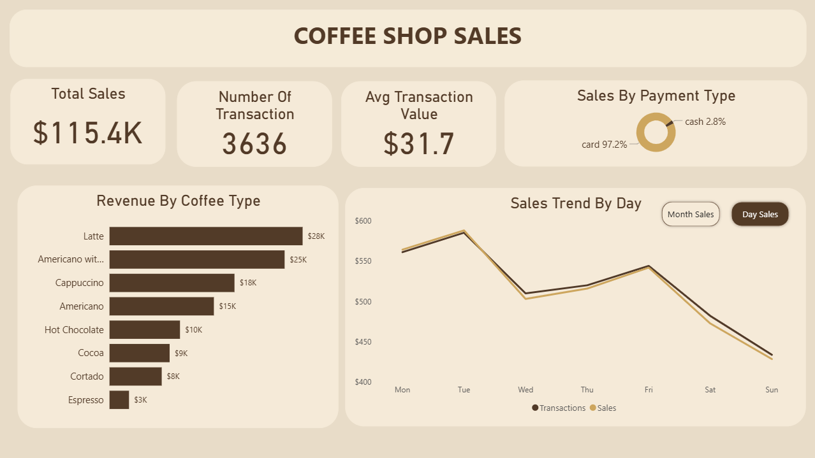

5. Key Findings
The analysis uncovered a number of key findings:
- Sales Trend:
  - Sales peak on weekends and holiday months.
  - There are dips in some months, which could be indicative of seasonal demand.
- Category Performance:
  - Coffee yields the largest sales percentage.
  - Specialty drinks are more profitable than standard coffee.
- Top Products:
  - The top 5 products bring more than 40% of overall revenue.
  - Some snack items are low sellers and should be reviewed.
- Location Performance:
  - Downtown store brings the highest revenue
  - Some units underperform and will require marketing or promotionals.

6. Conclusion
Power BI gave an effective platform for transforming raw data into actionable insights.
The dashboard enables the coffee shop to monitor revenue, profit, product trends, and store performance.
Decisions regarding business such as expansion, marketing, and product optimization can be made with more confidence.

