TNL TRACK An Integration of Customer Relationship Management Tracking and Agent Management

A Capstone Project
Presented to the Faculty of the

COLLEGE OF INFORMATION TECHNOLOGY
CENTRAL BICOL STATE UNIVERSITY OF AGRICULTURE – SIPOCOT
Sipocot, Camarines Sur

In Partial Fulfillment of the Requirements for the Degree of
BACHELOR OF SCIENCE IN INFORMATION TECHNOLOGY

KATHLEEN A. HERRERO- 3C
JOHN ROBERT G. INFELIZ- 3C

May 2026

CHAPTER I
THE PROJECT AND ITS BACKGROUND

Introduction
Businesses that rely on manual or disconnected processes may experience difficulties in organizing customer information, monitoring transactions, tracking inventory, and maintaining accurate operational records. Digital transformation allows businesses to improve these processes by adopting technologies that support better information management, communication, and operational efficiency. Galoyan et al. (2023) emphasized that digital transformation influences the activities and adaptation strategies of business entities, particularly through the gradual implementation of digital technologies. Similarly, digitalization among small businesses can support the transition from traditional or manual practices toward more organized information systems that respond to actual business requirements.
Customer Relationship Management (CRM) is also important for businesses that regularly interact with current and potential customers. Salesforce (2023) defines CRM as a system used to manage a company's interactions with customers and prospects in order to improve relationships and streamline business processes. CRM systems can organize customer and prospect information, identify sales opportunities, and support marketing activities within a centralized platform. In addition, Hasan et al. (2023) found that CRM can support customer interaction and communication while helping small businesses maintain relationships with existing customers and reach potential customers through technology-based channels. These concepts support the inclusion of contact management, lead management, and marketing automation in the proposed system.
Aside from customer information, proper monitoring of inventory, orders, and related operational activities is important in maintaining organized business processes. Priniotakis and Argyropoulos (2018) explained that inventory management is an important component of supply chain management and can significantly affect business performance. Effective inventory management involves controlling stock levels and reducing the possibility of stock shortages while supporting customer satisfaction. These findings support the need for systematic inventory monitoring and organized order and delivery information within a business management system.
For businesses that operate using commission-based sales agents, accurate recording of sales performance and commissions is also important. Katigbak (2017) identified the need for structured sales-commission processes to improve the monitoring of sales performance and provide agents with information regarding approved commissions. More recent research on digital commission applications also emphasizes the importance of transparent and structured commission records in supporting sales-related performance (Suwandi et al., 2025). These findings provide support for maintaining organized records of agent deals and corresponding commissions in the proposed system.
The study will be conducted at TNL IT & Mobile Enterprises, located along San Juan Avenue, Sipocot, Camarines Sur. The enterprise is owned and managed by Mariane Bocago-Pesigan. TNL IT & Mobile Enterprises operate within the IT and mobile hardware industry, offering products and services that cater to the technological needs of its customers. This enterprise was chosen as the research locale because of difficulty in communication between the business and customers. It currently relies on manual and logbook-based processes in handling customer information, sales monitoring, order and delivery records, inventory monitoring, and agent-related records.
To address these problems, the researchers propose TNL-TRACK, a centralized web-based platform for CRM, order and delivery tracking, inventory, and field-agent performance. Admins define product packages and their selling prices and commission terms. Field agents offer those terms, handle customer requests, and enter orders for admin approval. A verified customer portal and guided chatbot provide catalog access, order requests, owned-order status, and tracked agent follow-up. Built-in workflows support durable staff notices, transactional customer updates, and consent-based marketing.
General Objective:
To design and develop TNL-TRACK, a web-based integrated system for Customer Relationship Management (CRM), workflow automation, and agent performance management for TNL IT & Mobile Enterprises to improve customer-related processes, automate order, delivery, and inventory workflows, and manage agent deals and commissions.
Specific Objectives:
1. To develop a CRM for contact management, marketing automation, and leads.
2. To automate workflows — order management, deliveries, and inventory.
3. To manage field-agent performance through completed sales and commissions based on saved package terms, earned after whole-order delivery and full payment.
Conceptual Framework
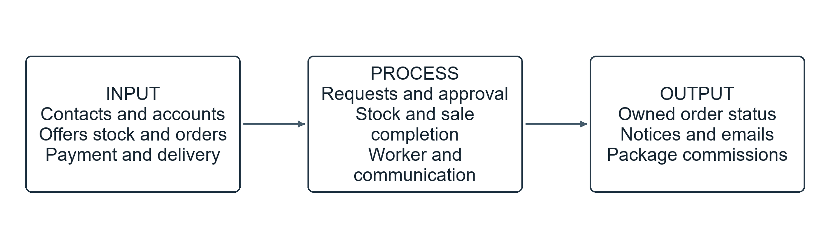
Figure 1.1

TNL-Track: An Integration of Customer Relationship Management, Tracking, And Agent Management

The inputs include CRM contacts, leads, verified customer accounts, marketing consent, campaigns and schedules; products, stock and package contents; confirmed customer requests, orders, payment records and delivery stages; and field-agent assignments and package commission rules. Package selling prices and fixed or percentage commission values are saved with each request or order.
The process organizes CRM records and verified customer access, presents catalog offers through staff screens and guided conversations, routes customer requests to an active assigned agent or an admin queue, and converts each request to one pending order. Admin approval reserves aggregated stock and fixes agent credit. Forward delivery deducts stock once; delivery and full payment together earn saved package commission once. A separate worker executes durable events and pending actions with state rechecks, retries, and outcome tracking.
The outputs include customer and lead records, confirmed request and order histories, safe delivery and payment status, available-stock information, staff notices, customer emails, per-recipient campaign outcomes, completed-sale records, and package commission breakdowns. These outputs support customer communication and operational and field-agent monitoring.
Finally, the Feedback component consists of evaluations, comments, and suggestions gathered from authorized users during system testing and evaluation. The gathered feedback will serve as a basis for identifying necessary improvements in the CRM, workflow automation, tracking, and agent performance functions of TNL-TRACK.

Scope and Delimitations
This study focuses on the design and development of TNL-TRACK: An Integration of Customer Relationship Management, Tracking, and Agent Management for TNL IT & Mobile Enterprises. The system is developed as a web-based application intended to improve the company's customer relationship processes, automate its operational workflows, and support the monitoring of agent performance.
The CRM scope includes contact and lead management, verified customer accounts, and marketing automation. Customers register or accept staff invitations and verify email before account linking. Existing contact records are not overwritten by registration. The portal provides catalog browsing, confirmed requests, owned-order history, marketing preferences, and follow-up replies. Campaigns have all-eligible or selected audiences, explicit send times, recipient previews, and one-time runs. Marketing requires opt-in and unsubscribe; contacts begin unsubscribed and import placeholders are excluded.
Order management supports admin-defined packages and standalone products, with captured prices and terms. Requests reserve no stock and preserve customer-confirmed selections at conversion. Admin approval rechecks availability and reserves quantities aggregated across package components and standalone items. Delivery stages may move or skip forward, repeated stages are a no-op, and backward changes are rejected. Public tracking returns only status and stage timestamps, omitting contact and payment details, full addresses, coordinates, and internal notes.
Field-agent performance covers completed sales and package commission records. A sale is financially complete only after whole-order delivery and full payment, whichever occurs last. Fixed commission is package quantity multiplied by its saved peso amount; percentage commission is the saved package line selling total multiplied by its percentage. Each line is rounded to centavos before summation, and one record with a breakdown is posted per eligible package order. Standalone products earn no commission. Existing legacy records remain unchanged and discrepancies are flagged for review.
This study is limited to the operational requirements and business processes of TNL IT & Mobile Enterprises and only covers the functions identified under the three specific objectives of the study: CRM, workflow automation, and agent performance management. The system is intended for use by authorized administrators, agents, and customers, with access to system functions determined by their assigned roles and permissions. The study does not include CRM functions that require customer information not collected or required by the company, and the system's communication and marketing functions are limited to the customer information and communication channels supported by the available system data.
Workflow automation is limited to configured order updates, approval/payment/delivery reminders, low-stock notices, one-time scheduled campaigns, opted-in welcome and purchase follow-up emails, and durable staff notices. Scheduling uses Asia/Manila and UTC storage. The application records payments through authorized staff; external banking, payment gateways, external logistics integration, POS, payroll, refunds, commission adjustments and payouts are excluded. The guided chatbot uses predefined topics with live data rather than an LLM or platform dependency, and follow-up is a tracked agent request rather than general live chat. The system is web-based.
The study also does not cover business operations outside TNL IT & Mobile Enterprises or deployment to other companies. System testing, evaluation, and validation are limited to selected users and authorized personnel of the company and are based on the operational requirements and data available during the period of the study. The effectiveness of the system is therefore evaluated only within the defined scope, environment, users, and processes of TNL IT & Mobile Enterprises.

Significance of the Study
This study, covers the development of TNL-Track: An Integration of Customer Relationship Management, Tracking, and Agent Management, which
will be significant to the following:
Business Owner/Admin. TNL-TRACK will provide the business owner/admin with centralized access to customer information, lead records, orders, deliveries, inventory, agent deals, and commission records. Through organized reports and status information, the system can support better monitoring of business operations and provide relevant information that can assist the owner in making operational decisions.
Agents. TNL-TRACK will provide agents with an organized platform for accessing relevant customer and transaction information and recording completed deals. The system will also allow agents to monitor corresponding commission records, providing greater transparency regarding their sales-related activities and commissions.
Customers can verify their accounts, browse products and packages, submit confirmed requests, view only their own orders and safe delivery/payment details, manage marketing preferences, and read tracked agent replies. Guests may browse, receive budget/category recommendations, and use privacy-limited tracking. The guided chatbot connects these predefined tasks to live backend data.
Future Researchers. This study serves as a reference for future academic and practical explorations of web-based CRM systems with integrated tracking and workflow automation. It provides insights into how technology can transform traditional business processes in IT hardware enterprises.
System Developers and Programmers. The project offers valuable technical insights into designing and implementing CRM systems with tracking and workflow automation features. Developers can use this study as a foundation for creating similar applications, improving technical approaches, and innovating solutions for other industries.

Definition of Terms
Agents. Refers to commission-based representatives of TNL IT & Mobile Enterprises who facilitate customer transactions and sales-related activities. Operationally, agents use TNL-TRACK to manage relevant customer and deal information, record completed deals, and monitor corresponding commission records based on the business rules established by the enterprise.
Customers. It is defined as a person who purchases goods or services from another party. Operationally, this refers to the end-users of TNL IT & Mobile Enterprises, while technically it refers to data entities within the TNL-Track CRM system.
Customer-Relationship Management (CRM). Refers to a business approach and information system used to manage interactions and information involving current and potential customers. Operationally, the CRM component of TNL-TRACK covers contact management, lead management, and marketing automation.
Business Owner. Refers to the primary stakeholder responsible for overseeing the operations of TNL IT & Mobile Enterprises. Operationally, the business owner uses TNL-TRACK to manage customer-related information, orders, deliveries, inventory records, agent information, completed deals, commissions, and system reports.
Web-Based Application. Refers to software accessed through a supported browser. TNL-TRACK provides staff CRM and sales screens, public catalog and limited tracking, and a verified customer portal backed by the Express API and MySQL database.
TNL IT & Mobile Enterprises. Refers to the research locale and case company of the study, located in Sipocot, Camarines Sur. It serves as the setting for the development and implementation of TNL-TRACK, addressing its existing manual and logbook-based processes for managing customer data, payments, sales, deliveries, inventory, and agent-related activities.
Tracking System. Refers to a technological system used to record and monitor the status and progress of operational activities. In TNL-TRACK, tracking refers specifically to monitoring order status, delivery progress, and relevant inventory information.

Notes
Galoyan, D., Mkrtchyan, T., Hrosul, V., Buhrimenko, R., Smirnova, P., & Balamut, H. (2023). Formation of Adaptation Strategy for Business Entities in the Context of Digital Transformation of the Economy.
https://refpress.org/wp-content/uploads/2023/06/Paper-3_REF.pdf
Salesforce. (2023). What Is CRM (Customer Relationship Management)? Salesforce. https://www.salesforce.com/ap/crm/what-is-crm/
Hasan, G., Andrew, A., Agustin, C., Seren, S., & Enjelia, Y. (2023). Membangun CRM (Customer Relationship Management) pada usaha UMKM Bola Ubi di Kota Batam. eCo-Buss, 6(1), 217–228. https://jurnal.kdi.or.id/index.php/eb/article/view/734
Priniotakis, G., & Argyropoulos, P. (2018). Inventory management concepts and techniques. IOP Conference Series: Materials Science and Engineering, 459(1), 012060.https://doi.org/10.1088/1757-899x/459/1/012060
Katigbak, M. S. L. (2017). Operational improvement on sales support center: Develop a sales commission guidelines and process for Asia Pacific sales agents [Master's thesis, De La Salle University]. Animo Repository.
https://animorepository.dlsu.edu.ph/etd_masteral/5390/
Suwandi, S., Hatta, M., Turini, T., Akbari, S., & Yanti, L. A. (2025). Pengembangan aplikasi insentif dan komisi salesman sebagai strategi peningkatan kinerja SDM marketing. JDMIS: Journal of Data Mining and Information Systems, 3(1).
https://journal.yp3a.org/index.php/jdmis/article/view/4066
CHAPTER II

REVIEW OF RELATED LITERATURE AND STUDIES
This chapter reviews studies on Customer Relationship Management, order and inventory tracking, workflow automation, and field-agent sales and commission management as integrated business functions.

Web-Based Application
Web-based applications have become an important tool for organizations seeking to improve accessibility, efficiency, and the management of business operations. The use of web-based systems allows organizations to replace manual processes with centralized platforms that support information management, decision-making, and operational activities.
To establish the role of web-based systems in improving organizational operations, Amer and Mostafa (2023) introduced a web-based management solution designed to address the needs of small businesses and evaluated its effectiveness through rigorous testing and user evaluation. The study emphasized the use of accessible, efficient, and user-friendly platforms to streamline operations, particularly in inventory and purchasing processes, while supporting productivity and decision-making.
Beyond operational management, web-based applications can also support organizations in making timely and informed decisions. Dastres and Soori (2021) examined the progression of web-based Decision Support Systems (DSS), highlighting their role in enabling faster, more integrated, and more effective decision-making processes for modern organizations. This supports the development of TNL-TRACK as a unified platform that can provide real-time information related to customer relationships, operational logistics, and agent performance.
Another important application of web-based systems is the reduction of errors associated with manual recordkeeping and business processes. Labastida et al. (2024) introduced a system designed to reduce manual errors, maintain accurate records, and provide business owners with tools that enhance operational efficiency. Their study highlights the importance of developing platforms that are technically reliable while also providing practical benefits for businesses managing orders and inventory.
Web-based systems are also being applied to improve coordination and service-related processes in different business environments. Jiangmin (2024) demonstrated how technology-driven innovations can modernize restaurant workflows, strengthen coordination between owners and staff, and improve service quality and customer satisfaction. The study reflects the broader shift from traditional pen-and-paper processes toward flexible web-based platforms capable of supporting diverse organizational functions.
Building on these applications, web-based systems can also be used to integrate specific operational functions into a single platform. Kurniawan et al. (2025) demonstrated how a web-based Production Planning and Inventory Control (PPIC) system can modernize manufacturing workflows by integrating production planning and inventory control. The study addressed the problem of handwritten inventory records and logbook-based recording, showing how web-based solutions can reduce manual inputs, improve scheduling accuracy, and enhance overall operational efficiency.
Customer-Relationship Management (CRM)
Customer Relationship Management (CRM) has become an important approach for organizations seeking to systematically manage customer information and strengthen interactions with customers. Recent studies have examined how CRM systems and relationship-oriented practices contribute to organizational processes and business performance.
To understand the factors that influence the effectiveness of CRM in small and medium-sized enterprises, Wiid and Senooane (2025) examined the factors that influence CRM among small and medium-sized enterprises and found that relationship marketing value, stakeholder relationships, and business systems contribute to CRM outcomes. Their study emphasized that CRM effectiveness involves both technological systems and relationship-oriented business practices. This is relevant to our study because the proposed CRM component is intended to organize customer information and support business processes involving current and potential customers.
In addition to examining the factors affecting CRM, it is also important to consider how CRM systems contribute to overall business performance. Martinho et al. (2025) examined the impact of CRM systems on the business performance of Portuguese SMEs. Their study highlighted the role of CRM systems in supporting business processes and improving organizational performance. The findings demonstrate the importance of integrating customer-related information into a structured system rather than relying on disconnected or manual records. This supports our study about the development of a centralized CRM component that can help authorized users manage customer-related records more systematically.
Beyond individual studies, systematic reviews provide a broader understanding of how CRM systems are applied across different organizations. Nethanani et al. (2024) reviewed studies concerning CRM systems and their impact on SME performance. Their systematic review emphasized the role of CRM in improving the way businesses manage customer information and relationships. CRM systems can provide organizations with structured information that supports customer-related activities and business decision-making. This is applicable to our project because the system seeks to organize customers and lead information within a unified platform.
Another perspective on CRM focuses on its contribution to organizational performance and the management of customer-related processes. Esmat (2025) examined CRM systems and their relationship with organizational performance. The study emphasized the contribution of CRM systems to the management of customer-related activities and organizational processes. The use of CRM technology allows organizations to manage information in a more organized manner and use available customer information to support business operations. This supports the inclusion of CRM functionality in our study to improve the management of customer and prospective customer records.
Building on these findings, CRM can also be viewed as a technology-supported approach for organizing customer relationships and business activities. Vishwakarma et al. (2025) discussed CRM as an approach for managing customer relationships and supporting organizational activities. Their work further demonstrates the importance of structured customer information and technology-supported relationship management. For our study, these concepts are relevant to contact management, lead management, and marketing-related activities within the CRM component.
Building on the role of CRM in organizing customer-related information and supporting business activities, CRM applications can also provide specific functions for managing potential customers and sales opportunities. Duran and Ekinci (2020) examined the contributions of CRM applications to company performance, particularly in relation to sales efficiency, lead management, sales pipelines, customer tracking, and customer loyalty. Their study discussed how CRM applications and sales-force automation can help organizations manage lead records, sales activities, and customer-related information more systematically. The study also described lead management as a process for identifying potential customers, recording lead information, planning activities, and determining criteria for lead qualification.
Following the role of CRM applications in lead management, Espadinha-Cruz et al. (2021) examined lead management optimization in the telecommunications sector using data-mining techniques. The study identified data quality and insufficient lead follow-up as factors that can affect lead management and proposed a methodology for classifying and segmenting leads. The researchers examined the lead management process from capture to conversion and demonstrated how structured lead information can support lead segmentation and conversion. This study is relevant to TNL-TRACK because its CRM component includes lead management, where lead records can be organized, classified, and monitored according to their status and progression toward conversion.
In addition to organizing and optimizing leads, the integration of lead management with CRM is important for maintaining continuity throughout the customer journey. Woelke (2023) examined the interaction between Lead Management and CRM along the customer journey and emphasized the importance of linking these processes so that generated leads can be qualified and transferred to appropriate stages of the sales process. The study highlighted the coordination between marketing and sales in the evaluation and handover of leads. This is relevant to our project because the proposed CRM component integrates lead management with other customer-related functions, allowing lead records to be monitored from initial entry through qualification and potential conversion into customers.

Order Management, Inventory, and Workflow Automation
Efficient order management and inventory control are essential to maintaining smooth business operations, particularly for small and medium-sized enterprises that may still depend on manual processes. Automating these activities can help businesses organize transactions, monitor inventory levels, reduce errors, and improve operational efficiency. Teerasoponpong and Sopadang (2022) developed a decision support system for adaptive sourcing and inventory management in small and medium-sized enterprises. The system used data-driven approaches to support sourcing and inventory decisions under uncertain conditions, including demand, prices, supply lead times, and material availability. Their findings demonstrated that integrating data into inventory and ordering decisions can help SMEs improve inventory policies and reduce purchasing and inventory-related costs. This study supports the importance of systematic inventory management and automated decision support in business operations.
The integration of inventory and order processing can also reduce the limitations associated with manual business procedures. Ladia et al. (2023) developed a web-based system for ABACUS Ship Management Ltd. that addressed manual processes involving inventory flow, order tracking, receiving, issuance of orders, and historical order reporting. The system was designed to automate the company's inventory and ordering processes and was evaluated as having attained its intended objectives. This study is relevant to our project because it demonstrates how a web-based system can integrate inventory monitoring and order processing into a centralized platform.
Order management systems can further improve how SMEs process and monitor business transactions. Jimenez et al. (2024) presented the design and evaluation of order management software intended for SMEs in Lima. The system focused on improving order management through a software-based approach, with the researchers evaluating usability, design, user satisfaction, and perceptions of operational efficiency among 308 SME employees. The results indicated high acceptance of the proposed system and highlighted the usefulness of an intuitive order management platform for SME operations. This study supports the development of our study in order management functions for recording, processing, and monitoring customer orders.
Inventory management systems can also provide practical solutions for businesses transitioning from manual to digital processes. Usita et al. (2025) evaluated iProSES, a web-based inventory management system developed for food-sector micro, small, and medium enterprises in the MIMAROPA region of the Philippines. The system was designed to facilitate the transition from manual, paper-based inventory processes. The study reported improvements in inventory accuracy, operational efficiency, and error reduction, while usability and functionality were identified as important factors affecting system acceptance. This study is particularly relevant to our study because it demonstrates the application of a web-based inventory management system in a Philippine MSME context.
The automation of ordering processes can also improve operational efficiency among small and medium-sized businesses. Kim et al. (2025) examined the adoption and activation of order automation systems among small and medium-sized manufacturing enterprises. Through interviews with six SMEs and IT solution providers, the study identified a progression from recognizing the inconvenience of manual work to adopting and expanding order automation systems. The study reported that order automation contributed to improved work efficiency, reduced errors and risks, better inventory and cost management, and strengthened organizational reliability. These findings support the integration of automated order management and inventory-related processes in our project.
Inventory management is also an important component of broader supply-chain automation. Grützner et al. (2025) proposed an interlinked process-reference model for mature inventory management and emphasized that inventory management plays a central role in supply-chain automation. Their study highlights how structured inventory processes can support the automation and autonomization of different operational processes. This provides a basis for integrating inventory monitoring with other workflow components rather than treating inventory as an isolated function.
Agent Performance, Deals, and Commission Management
Effective agent performance management is important in organizations that rely on sales personnel to generate and complete business transactions. Understanding the factors that influence salesperson performance provides a foundation for managing completed deals and determining appropriate incentives. Good et al. (2022) conducted a meta-analysis examining the relationship between intrinsic and extrinsic motivation and salesperson performance. Based on 293 effect sizes from 127 studies involving 77,560 participants, the study found a significant association between motivation and salesperson performance. The researchers also discussed the importance of sales-force monitoring and compensation in motivating sales personnel. These findings support the importance of monitoring agent performance and recognizing the role of incentives in encouraging sales-related performance.
In a Philippine context, Bagares and Pilar (2024) examined the relationship between motivational factors and the sales performance of real estate sales agents in Davao City. The study involved 80 real estate agents and considered monetary and non-monetary incentives, productivity, and efficiency as indicators related to sales performance. The findings reported positive relationships between motivational factors and sales performance and emphasized the role of financial and non-financial incentives in improving the performance of sales agents. This study is relevant to our study because it demonstrates the relationship between agent motivation, incentives, and sales performance within a Philippine setting.
Sales performance is also influenced by how sales opportunities and compensation plans are managed. Claro et. al (2023) investigated the effects of sales compensation plan types and sales opportunity coverage on sales performance. Their study examined salesperson data before and after the implementation of a new compensation plan and found that the number of sales opportunities pursued could influence sales goal and quota achievement. The researchers also noted that pursuing too many opportunities could increase workload and reduce goal commitment and performance. These findings highlight the importance of properly recording and monitoring sales opportunities and completed deals when evaluating agent performance.
Compensation structures are another important component of sales-force management. O'Donnell and Marsh (2022) reviewed literature concerning the effects of compensation structures on salesperson perceptions and behaviors. Their review examined both incentive-based and salary-based compensation and discussed how compensation structures can align and motivate salespeople toward sales and organizational objectives. The study provides a basis for incorporating commission-related information into agent performance management because financial incentives are directly connected to the way sales personnel are rewarded for their work.
The use of digital systems can further improve the management of incentives and commissions. Suwandi et al. (2025) developed a web-based application for managing salesman incentives and commissions. The study identified problems associated with manual commission processes, including calculation inaccuracies, payment delays, and limited transparency. The developed application was designed to improve accessibility and transparency in calculating incentives and commissions through requirements analysis, system design, implementation, and testing. This study is particularly relevant to our project because it demonstrates how a digital system can support the recording and calculation of sales commissions while providing a more organized approach to managing sales-agent performance.
Synthesis of Related Reviewed Literature and Studies
The reviewed literature and studies are organized into four major themes that support the development of TNL-TRACK: Web-Based Applications; Customer Relationship Management (CRM); Order Management, Inventory, and Workflow Automation; and Agent Performance, Deals, and Commission Management. Collectively, these studies demonstrate how digital technologies can help organizations improve accessibility, information management, operational efficiency, and performance monitoring while reducing dependence on manual processes.
First, studies on Web-Based Applications emphasize their role in providing accessible and centralized platforms for managing organizational activities. The reviewed literature shows that web-based systems can support inventory and purchasing processes, decision-making, record management, workflow coordination, and operational planning. These systems can reduce manual recording and provide users with centralized access to business information. This theme provides the technological foundation for TNL-TRACK because the proposed system is designed as a web-based platform that integrates CRM, operational workflows, and agent performance management.
Second, the literature on Customer Relationship Management (CRM) emphasizes the systematic management of customer information, relationships, and prospective customers through technology-supported processes. The reviewed studies indicate that CRM systems can contribute to customer-related activities, organizational processes, and business performance by providing structured information and centralized access to customer records. The literature on lead management further expands this theme by showing that CRM can support the organization, classification, monitoring, qualification, and progression of potential customers. These findings demonstrate the connection between CRM and lead management, particularly in organizing lead information and supporting the progression of potential customers through the sales process.
Third, studies concerning Order Management, Inventory, and Workflow Automation demonstrate the advantages of replacing manual and paper-based procedures with structured digital processes. The reviewed studies show that inventory systems can improve inventory accuracy and reduce errors, while order management systems can support the recording, processing, and monitoring of business transactions. Other studies demonstrate that order automation can improve work efficiency, reduce repetitive tasks, and strengthen inventory and cost management. These findings support the workflow automation component of TNL-TRACK, which integrates order management, delivery processes, and inventory monitoring into a centralized system.
And lastly, literature on Agent Performance, Deals, and Commission Management emphasizes the relationship between salesperson performance, sales opportunities, motivation, and financial incentives. The reviewed studies indicate that monitoring sales performance and providing structured incentives can support sales-related activities. Research on compensation and digital commission applications further demonstrates the value of organized systems for recording deals and calculating commissions. These findings support the agent management component of TNL-TRACK, particularly its functions for recording completed or closed deals and managing commissions according to established business rules.

NOTES
Amer, N. D. S., & Mostafa, S. A. (2022, June 5). Bliese system: A web-based management system for small business. Applied Information Technology and Computer Science Journal, 3(2), 1–8. Universiti Tun Hussein Onn Malaysia.
Dastres, R., & Soori, M. (2021, October 6). Advances in web-based decision support systems. International Journal of Engineering and Future Technology. HAL.
Labastida, P., Simbulan, M., Estrella, C. J., Flores, W., & Centeno, C. (2024, June). Web-based ordering system for start-up business with forecasting. World Journal of Advanced Research and Reviews, 22(3), 357–368.
https://doi.org/10.30574/wjarr.2024.22.3.1721
Jiangmin, L. (2024). Development of a web-based food ordering system. Asia Pacific Journal of Management and Sustainable Development, 12(2, Part 3). Philippine E-Journals.
Kurniawan, I., Saraswati, T., & Ongkopratama, P. D. P. (2025, February). Enhancing production planning and inventory control with a web-based system: A case study in an Indonesian packaging manufacturer company. Jurnal Teknik Industri, 26(1), 105–126. https://doi.org/10.22219/JTIUMM.Vol26.No1.105-126
Wiid, J. A., & Senooane, B. C. (2025, September). Drivers of SME customer relationship management: Perspectives from owners/managers. Small Business International Review.
Martinho, D., Farinha, J., & Ribeiro, V. (2025, June). The impact of customer relationship management systems on business performance of Portuguese SMEs. Sustainability, 17(12), 5647.
Nethanani, R., Matlombe, L., Vuko, S. N., & Thango-Mabizela, B. (2024, October). Customer relationship management (CRM) systems and their impact on SMEs performance: A systematic review. ResearchGate.
Esmat, A. (2025). The study of customer relationship management (CRM) systems and their impact on organizational performance. International Journal of Public Sector Performance and Social Responsibility, 4(3).
Vishwakarma, V. K., Pandey, P., Sharma, P., & Kapur, S. (2025, April). Analysing the impact of hotels customer relationship management strategies on customers satisfaction and loyalty with hotels of Bhopal. Pragyaan: Journal of Hospitality and Tourism.
Duran, C., & Ekinci, Y. (2020). Contributions of CRM applications to company performance. PressAcademia Procedia, 11(1), 7–10. https://doi.org/10.17261/Pressacademia.2020.1230
Espadinha-Cruz, P., Fernandes, A., & Grilo, A. (2021). Lead management optimization using data mining: A case in the telecommunications sector. Computers & Industrial Engineering, 154, 107122. https://doi.org/10.1016/j.cie.2021.107122
Woelke, A. (2023). Interaction of lead management and CRM along the customer journey. In U. Hannig & U. Seebacher (Eds.), Marketing and sales automation (pp. 289–296). Springer. https://doi.org/10.1007/978-3-031-20040-3_18
Teerasoponpong, S., & Sopadang, A. (2022). Decision support system for adaptive sourcing and inventory management in small- and medium-sized enterprises. Robotics and Computer-Integrated Manufacturing, 73, 102226. https://doi.org/10.1016/j.rcim.2021.102226
Ladia, J. M., Cuaresma, S. A., & Deynata, D. R. (2023). Web-based Abacus Ship Management asset tracking and order processing with decision support system. Letran Calamba Research Report, 19(1)
Jimenez, L. V., Espinoza, H. G., Jimenez, S. R., Gamarra, J. G., & Marrujo-Ingunza, C. (2024). Software design aimed at proper order management in SMEs. International Journal of Advanced Computer Science and Applications, 15(12). https://doi.org/10.14569/IJACSA.2024.0151209
Usita, M. M., Escultor, M. D., Garcia, A. B., Manuel, A. R., & Guinanao, G. O. (2025). Evaluating the acceptance of iProSES: A web based inventory system for food sector MSMEs using the Technology Acceptance Model (TAM). Asian Journal of Economics, Business and Accounting, 25(7), 43–54. https://doi.org/10.9734/ajeba/2025/v25i71874
Kim, S. D., Kim, D. H., & Oh, C. S. (2025). A study on the adoption and activation of order automation systems in small and medium-sized manufacturing enterprises. Journal of Channel and Retailing, 30(4), 93–116. https://doi.org/10.17657/jcr.2025.10.31.93
Grützner, L., Voss, D., & Breitner, M. H. (2025). Mature inventory management for supply chain automation: An interlinked process-reference model. Electronic Markets, 35, 34. https://doi.org/10.1007/s12525-025-00783-x
Good, V., Hughes, D.E., Kirca, A. et al. A self-determination theory-based meta-analysis on the differential effects of intrinsic and extrinsic motivation on salesperson performance. J. of the Acad. Mark. Sci. 50, 586–614 (2022). https://doi.org/10.1007/s11747-021-00827-6
Bagares, H. L., & Pilar, J. G. (2024). Relationship of motivational factors towards real estate sales agent's sales performance. International Journal for Multidisciplinary Research, 6(3). https://doi.org/10.36948/ijfmr.2024.v06i03.23175
Claro, D. P., Plouffe, C. R., & Vieira, V. A. (2023). Sales compensation plan type and sales opportunity coverage: “Double-edged” sword effects on sales performance. Industrial Marketing Management, 113, 153–167. https://doi.org/10.1016/j.indmarman.2023.05.022
O’Donnell, E., & Marsh, L. (2022). The Impact of Compensation Structure on Salesperson Perceptions and Behaviors: Insights From the Sales Literature. Compensation & Benefits Review, 54(1), 3-11. https://doi.org/10.1177/08863687211043441
Suwandi, S., Hatta, M., Turini, T., Akbari, S., & Yanti, L. A. (2025). The Development of a Salesman Incentive and Commission Application as a Strategy to Improve Marketing Human Resource Performance . JDMIS: Journal of Data Mining and Information Systems, 3(1), 36–42. https://doi.org/10.54259/jdmis.v3i1.4066
CHAPTER III

METHODOLOGY
This chapter presents the research methodology, development process, tools, and procedures used in the development of TNL-Track: An Integration of Customer Relationship Management, Tracking, and Agent Management. The methodology focuses on the achievement of the three specific objectives of the study: (1) develop a CRM for contact management, marketing automation, and lead management, (2) automate workflows — order management, deliveries, and inventory, and (3) manage an agent's performance — deals and commissions.

Research Design
The study uses a developmental-descriptive research design for TNL IT & Mobile Enterprises. The descriptive work examines customer communication, manually maintained sales and inventory records, order and delivery monitoring, and field-agent sales and commission records. These findings establish the CRM, tracking, workflow automation, and agent-performance requirements stated in Chapter I.
The developmental work guides creation of the web application around those requirements. The platform integrates CRM, package and order management, inventory, delivery stages, verified customer access, and field-agent deals and commissions. Payment recording and completed-sale eligibility follow the agreed business rules.

Research Methodology

Scrum provides iterative development and feedback for CRM, package sales, inventory and delivery tracking, customer access, and agent performance. Implementation proceeds through sales and commission foundations, durable automation, verified customer requests and follow-up, guided conversation topics, and rollout verification. Focused automated checks verify calculations, concurrency, authorization, token expiry, and worker recovery; documented manual acceptance checks verify staff and customer screens.
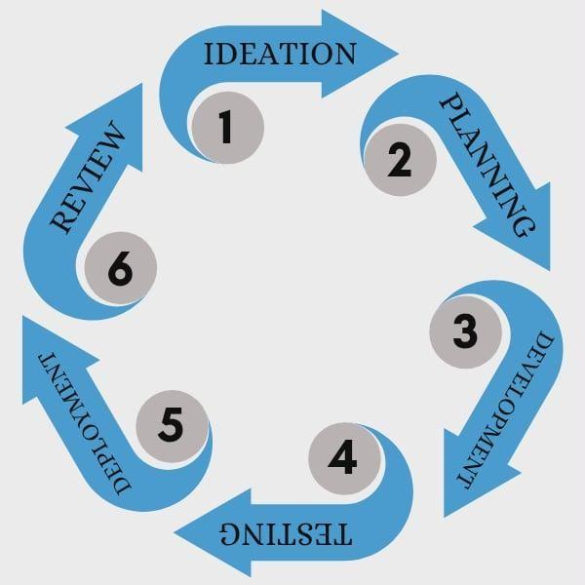

Figure 2.1

Agile Development Methodology

Phase 1: Ideation
The planning phase identifies the enterprise requirements described in Chapter I: CRM contacts and leads, manually maintained inventory and sales records, order and delivery communication, and field-agent deals and commissions. The agreed flow begins with an offered package or product, proceeds through a confirmed customer request or staff order and admin approval, and ends with delivery and full payment.
TNL-Track is implemented with Angular 22 and TypeScript for the browser interface, Express 5 and Node.js with TypeScript for the HTTP API, and MySQL 8 with InnoDB for persistence. A separately supervised MySQL-backed worker processes durable automation actions. Both the API and worker must run for a complete deployment; the frontend communicates through the documented HTTP API.
Table 1.1 describes the software environment. Current supported browsers display the responsive web interface. Node.js runs the API and worker; MySQL 8 supports transactions and queue claiming through locking reads. SMTP provides supported email communication. HTTPS protects deployed browser/API traffic, environment-based CORS limits frontend origins, and PUBLIC_APP_URL identifies customer activation, recovery, and unsubscribe links.
Category | Minimum | Recommended
Client browser | Current supported browser | Latest supported Chrome Firefox or Edge
Runtime | Node.js 24 compatible runtime | Separate supervised API and worker
Frontend and API | Angular 22 Express 5 TypeScript | HTTPS with configured CORS
Database | MySQL 8 InnoDB | UTC sessions and durable backups
Email and network | SMTP and application connectivity | HTTPS external portal origin
Table 1.1

Software Requirements for TNL-Track: An Integration of Customer Relationship Management, Tracking, and Agent Management
Table 1.2 provides client hardware guidance for browser access. Server capacity must be measured against actual concurrent requests, database size, and automation backlog; the listed client specifications do not establish server throughput or a guarantee of performance.
A desktop, laptop, or phone with a supported browser and reliable access to the deployed HTTPS application can use TNL-Track. Remote operation requires the deployment to expose authorized application access. Delivery information consists of staff-recorded stages; this release does not provide continuous location telemetry or external logistics integration.
Category | Minimum | Recommended
Hard Drive | 16 GB free space | 50 GB free space (SSD preferred)
Memory (RAM) | 4 GB | 8–16 GB
Processor | Intel Core i3 (3rd Gen) | Intel Core i5 (5th Gen) or higher
Desktop | Any desktop /laptop with a web browser | Mid-range desktop/laptop with web  browser
Network | Stable WAN/Wi-Fi, 3–5  Mbps | High-speed WAN/Wi-Fi,  10 Mbps or higher
Table 1.2

Hardware Requirements for TNL-Track: An Integration of Customer Relationship Management, Tracking, and Agent Management
The researchers prepared a Gantt chart (see Figure 2) to serve as a roadmap for the project’s development. This chart established timelines and key milestones, ensuring that tasks remained aligned with the overall schedule and were completed within the deadlines set by the teacher.
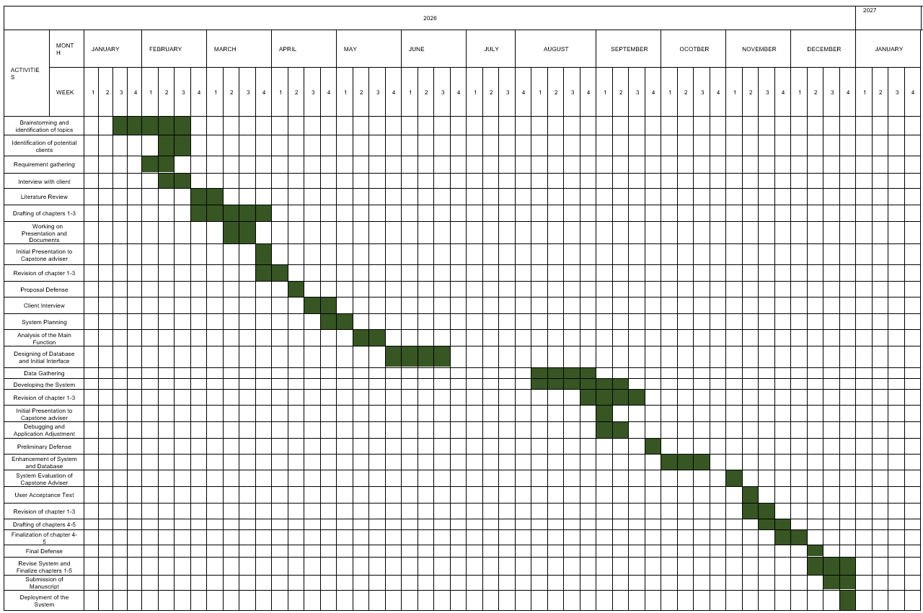
Figure 3
Gantt Chart of the Development of TNL-Track: An Integration of Customer Relationship Management, Tracking,

and Agent Management

Phase 2: Planning
During the Elaboration Phase of Agile methodology, the system’s requirements and its required architecture are assessed and analyzed. After cautiously deliberating all gathered data, the researchers created the system architecture and data models for TNL-Track.
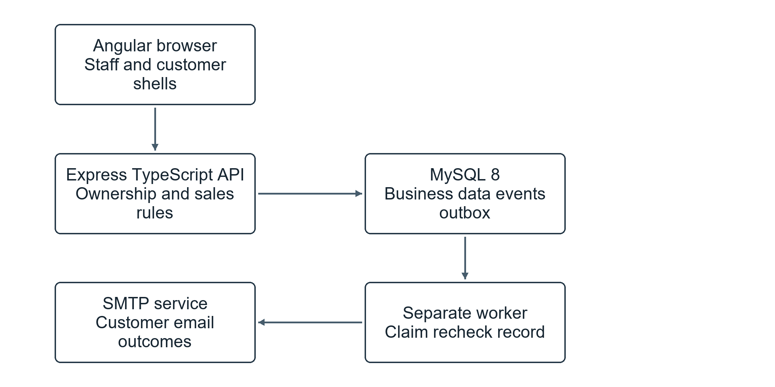
Figure 4
System Architecture of TNL Track
Figure 4 shows staff and customer browser interfaces connecting to the Express API. Public catalog and tracking are separated from staff operations and verified customer ownership. The API validates business actions and commits orders, stock movements, commissions, structured events, and pending actions through MySQL transactions.
A separate worker claims durable pending actions, rechecks current conditions and marketing consent, stores staff notifications, and dispatches customer emails through SMTP. Persisted leases, deduplication keys, attempts, heartbeat, and execution outcomes support recovery. SMTP acceptance is recorded separately from confirmed inbox delivery; uncertain sends require admin review before retry. No payment gateway is integrated.
The data flow diagrams describe verified access, catalog selection, confirmed requests, agent conversion, admin approval, stock reservation, forward delivery and payment recording, one-time commission posting, and durable communication. Business validation is shared by ordinary staff screens, customer request conversion, and guided conversations.
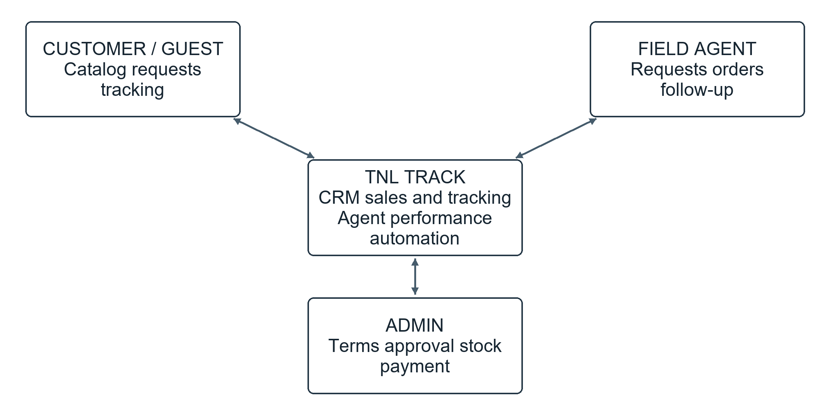
Figure 5
Level 0 Data Flow Diagram of TNL Track
Figure 5 shows the three primary application roles: Customer, Field Agent, and Admin. Guests access public catalog, recommendations, and limited tracking, while verified customers access only their own account-linked records.
Customers submit verified registration data, reviewed catalog selections, delivery information, marketing preferences, and tracked follow-up requests. The system returns owned request and order histories, safe delivery/payment status, and agent replies. Transactional updates and consent-based marketing use supported email communication.
Admins supply package terms, product and inventory updates, assignments, approval decisions, payment records, and supported automation and campaign configuration.
The system returns sales and inventory summaries, commission records, durable alerts, worker health, recipient outcomes, and legacy discrepancies for review. The admin role manages field-agent access and responsibilities rather than payroll or human-resource records.
Field agents enter orders at catalog terms, convert assigned customer requests, update forward delivery stages, and answer tracked follow-ups. The system returns assigned customer context, request and order queues, persistent notices, and earned package commission information.
MySQL transactions enforce stock and financial rules. The independent worker executes committed communication actions and operational reminders. Public tracking and customer read models exclude internal staff information.

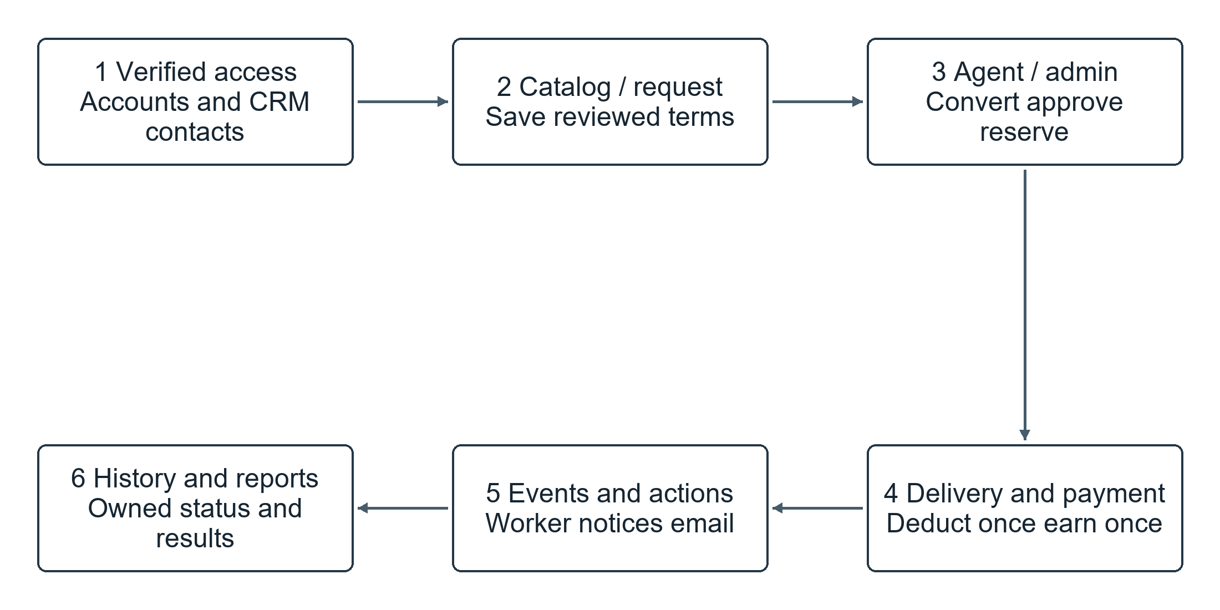
Figure 6

Level 1 Data Flow Diagram of TNL Track

Figure 6 separates access and account verification, catalog and confirmed request entry, agent handling and admin approval, delivery/payment completion, and durable automation. Staff accounts and verified customer accounts have separate identity and ownership rules.
Authentication validates active staff identities or verified customer accounts. Registration and invitation tokens link an account to a CRM contact only after verification; password recovery uses expiring single-use tokens and revokes previous customer sessions.
Catalog selection captures immutable package contents, selling prices, and commission terms. Customer requests route to the active assigned agent or the admin assignment queue without reserving stock. Idempotent conversion creates one pending order while preserving the confirmed snapshot.
Approval rechecks aggregated component availability, fixes the credited field agent, and reserves inventory. Delivery advances forward and deducts reserved quantities once. Payment and delivery transactions both evaluate whole-order eligibility and post one package commission record only when delivery and full payment are complete.
Business mutations persist structured events and associated actions in the same transaction. The worker claims due actions with persisted leases, rechecks reminder state or marketing consent, records staff notice/read state and per-recipient outcomes, and sends supported emails. Follow-up replies are stored with the owned order.
Dashboard and history queries summarize CRM, inventory, orders, completed sales, commissions, automation state, and campaign results. Existing orders and posted commissions remain legacy, with no inferred packages, historical commission backfill, or historical customer email replay.
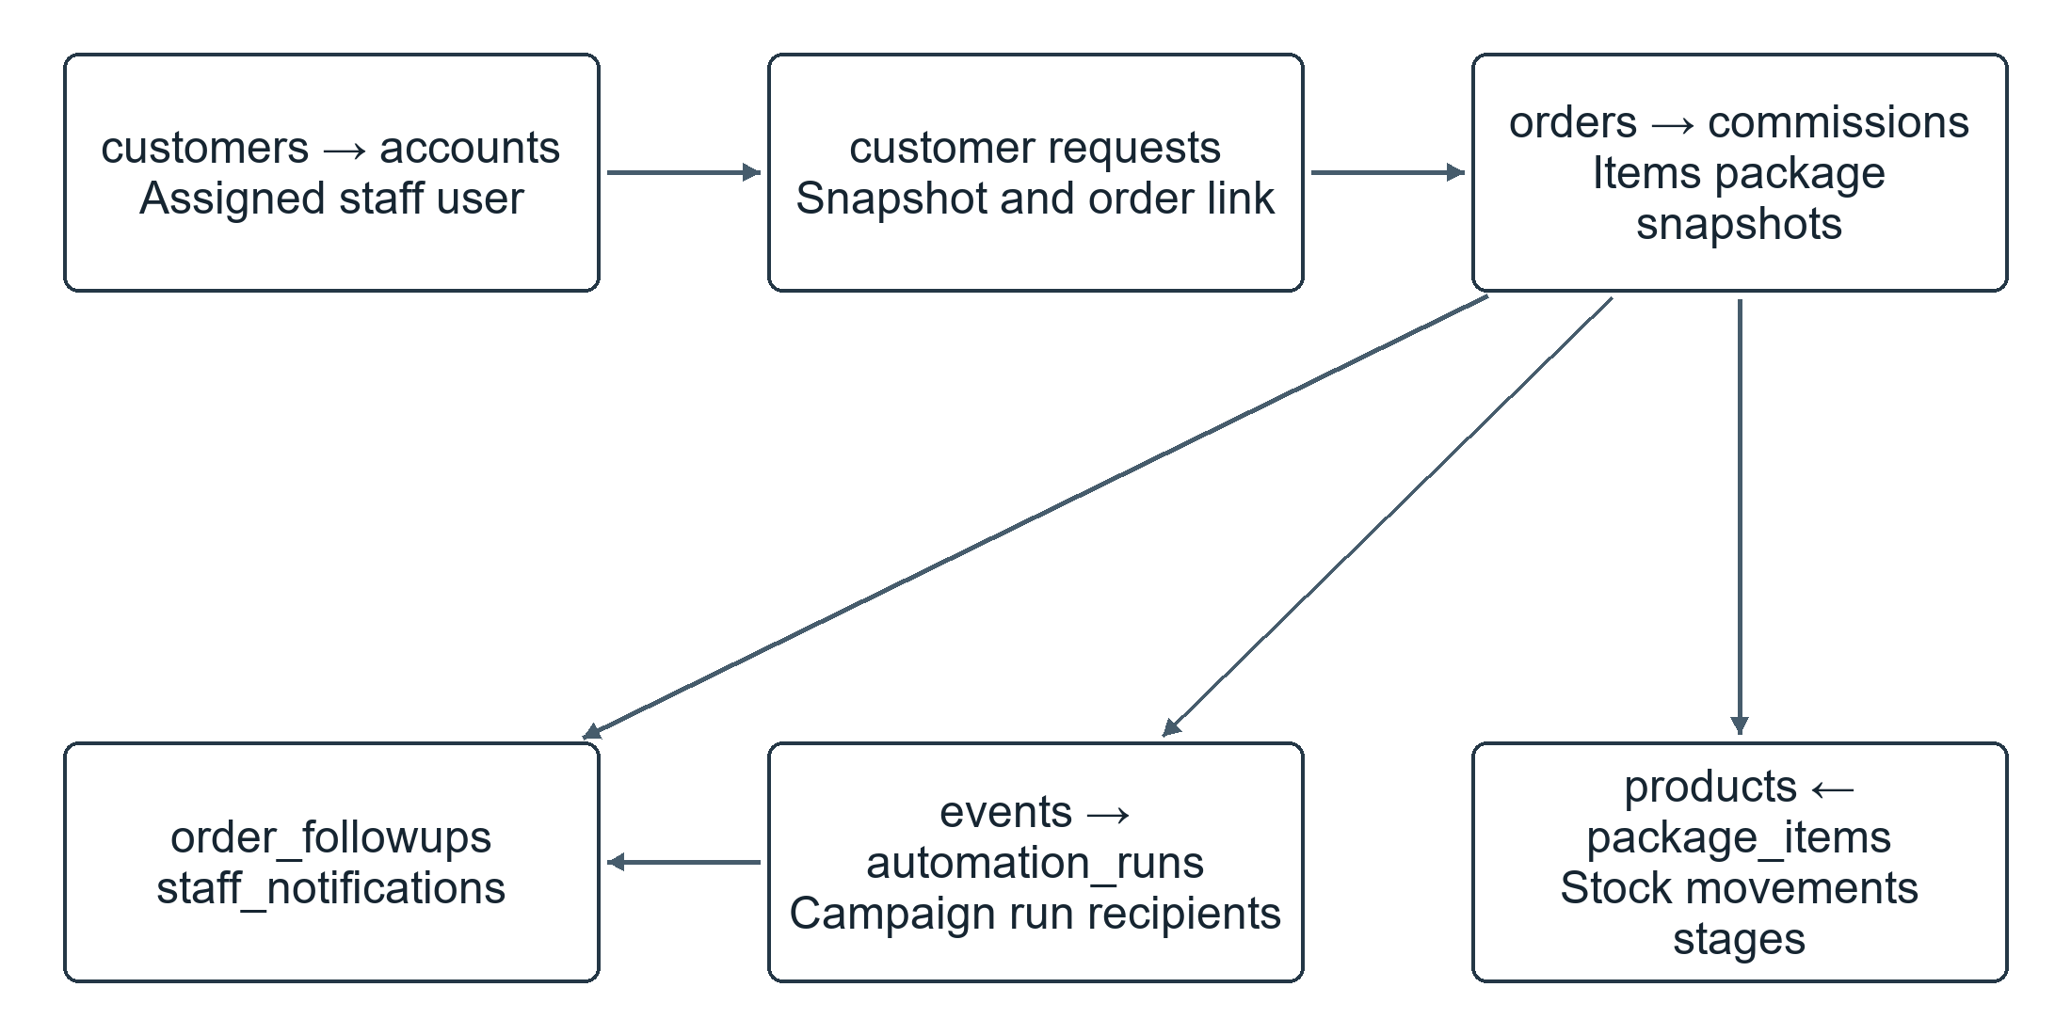
Figure 7

Entity Relationship Diagram of TNL Track
Figure 7 summarizes the implemented relational model. Staff users have Admin or Agent roles. CRM customers may have an assigned agent and one verified customer account. Customer requests retain a sales snapshot and may link to exactly one converted order; the order records customer and agent ownership.
Packages connect to products through package_items. Orders store standalone order_items separately from immutable order_packages snapshots, including captured component quantities and commercial terms. Products maintain on-hand and reserved quantities. Inventory movements and delivery_events retain the operational history. Commissions have a unique order reference, credited agent, amount, source, and package breakdown.
order_followups store a customer request and one agent reply. campaigns and campaign_runs retain audiences, schedules, captured content, and one execution per campaign. domain_events and automation_runs retain transactional dispatch intent, deduplication, leases, attempts, and outcomes. staff_notifications persist per-user read state; automation_episodes track low-stock recovery and worker_heartbeats expose execution health.
The model supports owned customer access, aggregated stock checks, one-time financial posting, durable communication, and controlled recovery. Legacy records are preserved; refunds, payouts, employee payroll, payment gateways, and general messaging entities are outside the implemented scope.

Notes
Agile Alliance. (n.d.). What is Agile? | Agile 101. Agile Alliance. Retrieved April 10, 2026,
Waja, G., Shah, J., & Nanavati, P. (2021). Agile software development. International Journal of Engineering Applied Sciences and Technology, 5(12). https://doi.org/10.33564/IJEAST.2021.v05i12.011
Sihombing, D. J. C. (2024). Agile-based CRM system development to improve customer satisfaction in cargo companies. Jurnal Ekonomi, 13(1), 2344– 2353.

