Milestone 03: Research Methodology

Revisions

After consulting the mentor with the existing research aim, hypothesis, and research questions, it has been concluded that the title and hypothesis will remain as proposed originally. The research questions will be slightly modified to include resource constrained devices as suggested by the mentor.

**Research Questions:**

1. How does containerization affect power consumption in IoT applications?
2. How do container orchestration platforms contribute to enhancing power efficiency in IoT deployments?
3. What container orchestration strategies can be used to ensure energy efficiency for resource constrained devices?

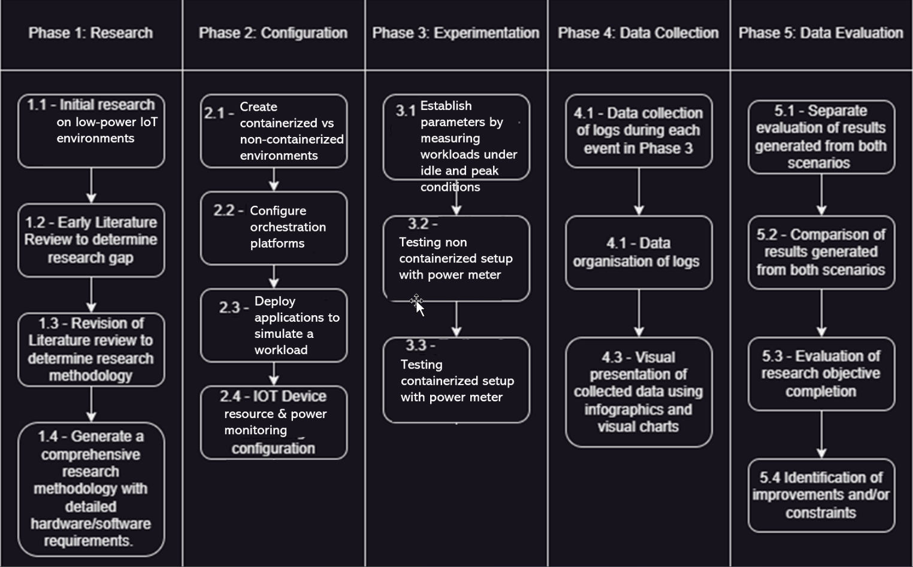Research Pipeline

Phase 1

This phase involves initial investigation into low-power IoT environments and container-based technologies. Early literature is reviewed to determine the research gap in energy optimization through containerization and orchestration. From this, the research methodology is refined. Final outputs include a detailed research plan outlining hardware/software requirement, and a comparison framework to assess containerized vs. non-containerized scenarios.

Phase 2

This phase sets up two parallel environments: one containerized, the other non-containerized. Orchestration platforms are configured. Applications simulating IoT sensor workloads are deployed. Power/resource monitoring tools are configured alongside a power metering setup. This ensures repeatable experiments can be conducted under similar conditions for both environments.

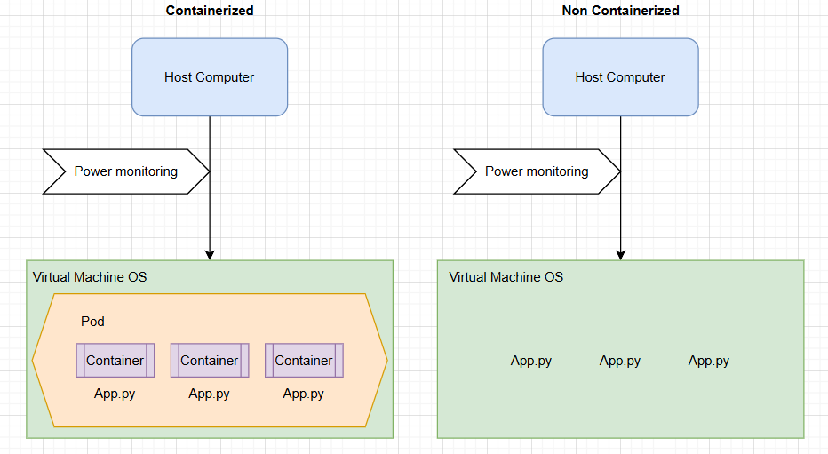

Phase 3

Experiments are conducted to measure performance and energy metrics across both environments. Workloads are evaluated under idle, typical, and peak conditions. The non-containerized and containerized setups are tested separately using a power meter.

Phase 4

Logs and metrics from all experiments are systematically collected. These include resource usage over time, and power consumption. The data is organized based on each test scenario and visualized using infographics and charts to clearly compare the performance of containerized vs. non-containerized IoT environments.

Phase 5

This phase consists of the data collected in Phase 4 being evaluated for the purpose of answering the Research questions initially proposed. Analysis will take place to determine if the research objective has been satisfied, and any improvements or limitations will be identified accordingly.

Research Methodology

Various experiments related to the research objective will be conducted to determine availability variables in both scenarios and provide a cross comparison of the two. Containerized applications with functional IOT capabilities such as data logging and periodic synchronisation will be configured on each virtual worker node to simulate a containerized IOT Device. Both configurations will be handling dummy data related to Agricultural IOT sensors, such as humidity and temperature to simulate a typical working load. Critical network and hardware failures will be simulated to analyse how availability is affected in relation to containerization. Availability will also be tested under simulated maintenance conditions. A tool such as Prometheus is ideal for monitoring the Virtual Machine data and Ansible is a potential tool that may be useful for certain configurations.

The data generated from these experiments is quantitative in nature, as it deals with values such as downtime recovery time, failover delay, load balancing performance, and status, which can all be objectively quantified. Various testing will be conducted to determine power efficiency differences between containerized and non-containerized low-power IoT environments. The study will focus on resource-constrained devices as virtual IoT nodes. Two environments will be compared: one containerized using orchestration platforms, and the other running natively without container overhead. Each configuration will be deployed with lightweight applications simulating periodic data logging and processing tasks typically found in low-power IoT systems. Power consumption will be estimated using either external power meters or internal monitoring where supported. Both setups will operate under controlled idle, active, and peak load conditions to simulate real-world IoT activity. The data collected will be quantitative, focusing on power consumption (W) and efficiency (%) metrics, and time spent under load (s). These metrics will allow objective evaluation of which configuration is more energy efficient under equivalent workloads.