Milestone 4

Abstract

This research investigates the role of container orchestration in enhancing power efficiency on low-power IoT devices, using a Raspberry Pi as the experimental platform. The study compares the performance of compute-intensive scripts executed directly on the system with their orchestrated counterparts deployed through Docker Swarm. Key metrics such as power consumption, CPU utilization, and device temperature were recorded and compared. The findings indicate that orchestration provides noticeable improvements in resource management, resulting in reduced power usage and thermal output. These results align with existing studies in the field and support the hypothesis that container orchestration can optimize workload efficiency on constrained edge devices. The research offers a practical, replicable evaluation framework and lays the groundwork for future studies exploring scalable and energy-aware IoT deployments.

Findings

This study investigated the power efficiency of container orchestration on low-power IoT devices by comparing standalone execution of Python scripts to their orchestrated deployment using Docker Swarm on a Raspberry Pi. The results showed a consistent difference in power usage, CPU load, and thermal output between the two configurations.

On average, the standalone setup consumed **7.00W**, utilized **98.94%** of the CPU, and maintained an operating temperature of **61.77°C**. In contrast, the Docker Swarm deployment showed improved resource management, averaging **5.97W** in power consumption, **63.23%** CPU usage, and a reduced temperature of **59.82°C**. These results confirm that container orchestration provides a tangible benefit in power efficiency and thermal regulation, particularly for long running or concurrently executed workloads.

The observed results suggest that the orchestrated environment effectively distributed and managed the script execution load, minimizing resource contention and unnecessary spikes in CPU cycles. This supports our research hypothesis that containerization and orchestration improve the availability and efficiency of IoT workloads.

Standalone results over 1 minute

|  |  |  |  |
| --- | --- | --- | --- |
| **Time (s)** | **Power (W)** | **CPU Usage (%)** | **Temperature (°C)** |
| 0 | 7.162 | 99 | 58.4 |
| 2 | 6.97 | 100 | 58.9 |
| 4 | 6.91 | 96 | 60.3 |
| 6 | 6.809 | 98 | 59.9 |
| 8 | 7.155 | 100 | 60.3 |
| 10 | 7.118 | 100 | 60.3 |
| 12 | 6.813 | 100 | 60.3 |
| 14 | 7.296 | 99 | 60.3 |
| 16 | 7.158 | 100 | 60.3 |
| 18 | 6.819 | 100 | 60.3 |
| 20 | 6.901 | 98 | 60.3 |
| 22 | 7.074 | 99 | 60.3 |
| 24 | 6.828 | 99 | 60.8 |
| 26 | 6.839 | 97 | 61.3 |
| 28 | 7.14 | 99 | 62.8 |
| 30 | 7.077 | 99 | 61.3 |
| 32 | 6.982 | 99 | 61.8 |
| 34 | 7.147 | 99 | 62.3 |
| 36 | 6.878 | 99 | 63.3 |
| 38 | 6.862 | 99 | 62.3 |
| 40 | 7.181 | 99 | 62.3 |
| 42 | 6.87 | 99 | 63.7 |
| 44 | 6.857 | 99 | 62.8 |
| 46 | 7.151 | 99 | 63.7 |
| 48 | 6.872 | 100 | 63.3 |
| 50 | 6.857 | 97 | 64.2 |
| 52 | 7.1 | 99 | 63.3 |
| 54 | 7.034 | 99 | 63.3 |
| 56 | 7.168 | 99 | 64.2 |
| 58 | 7.035 | 99 | 63.7 |
| 60 | 7.089 | 99 | 64.7 |

Orchestrated results over 1 minute

|  |  |  |  |
| --- | --- | --- | --- |
| **Time (s)** | **Power (W)** | **CPU Usage (%)** | **Temperature (°C)** |
| 0 | 6.095 | 74 | 59.9 |
| 2 | 6.03 | 59 | 58.9 |
| 4 | 5.71 | 59 | 59.9 |
| 6 | 6.373 | 73 | 60.8 |
| 8 | 5.81 | 59 | 60.3 |
| 10 | 5.92 | 59 | 59.4 |
| 12 | 6.088 | 74 | 59.4 |
| 14 | 5.783 | 59 | 58.9 |
| 16 | 5.7 | 60 | 59.9 |
| 18 | 6.118 | 73 | 59.9 |
| 20 | 5.807 | 60 | 60.3 |
| 22 | 5.72 | 59 | 60.3 |
| 24 | 6.401 | 71 | 60.3 |
| 26 | 6.283 | 63 | 60.8 |
| 28 | 5.777 | 59 | 61.3 |
| 30 | 5.878 | 67 | 59.4 |
| 32 | 5.986 | 66 | 59.4 |
| 34 | 5.747 | 59 | 59.4 |
| 36 | 6.146 | 62 | 60.8 |
| 38 | 6.034 | 71 | 59.9 |
| 40 | 5.697 | 60 | 62.3 |
| 42 | 5.841 | 60 | 60.8 |
| 44 | 6.021 | 73 | 60.3 |
| 46 | 5.729 | 59 | 59.4 |
| 48 | 5.911 | 59 | 60.8 |
| 50 | 6.391 | 74 | 59.4 |
| 52 | 6.093 | 59 | 50.9 |
| 54 | 6.008 | 60 | 59.4 |
| 56 | 6.22 | 50 | 60.3 |
| 58 | 5.786 | 60 | 60.8 |
| 60 | 5.935 | 60 | 60.8 |

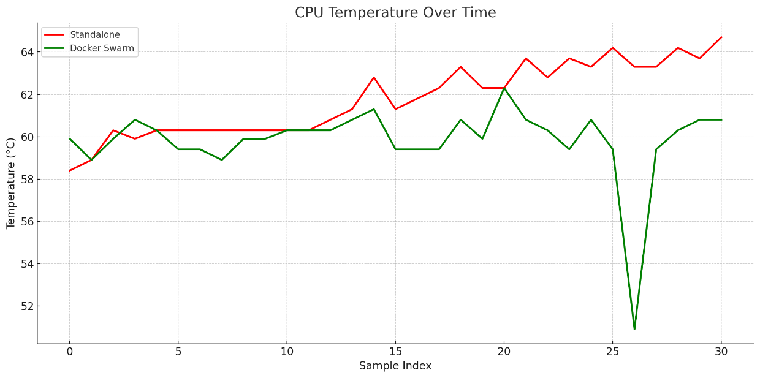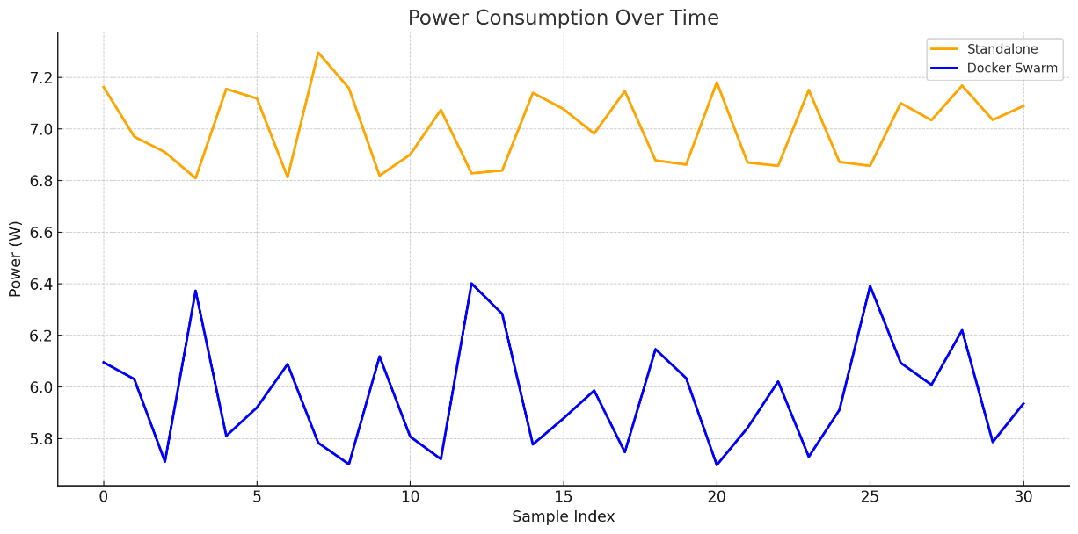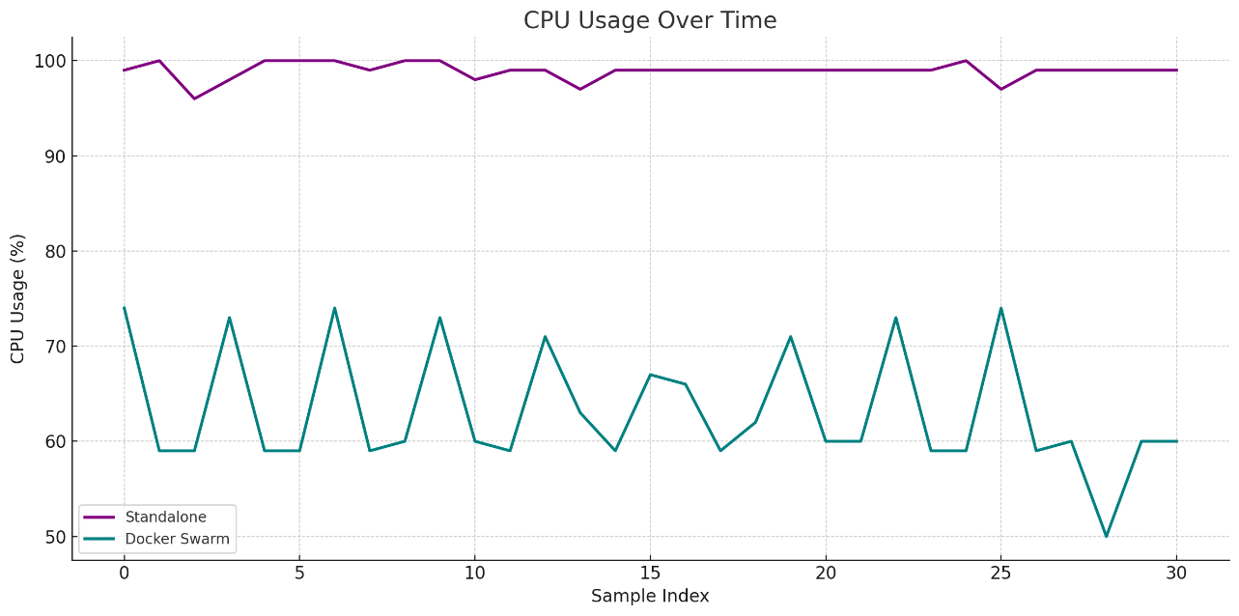

Figure 3: CPU Temperature

Figure 2: Power Consumption

Figure 1: CPU Usage

Conclusion

This research has demonstrated that using container orchestration, specifically through Docker Swarm, can yield measurable improvements in power efficiency when managing concurrent workloads on low-power IoT devices such as the Raspberry Pi. The orchestrated deployment consistently outperformed the standalone execution in key metrics, including lower power consumption, reduced CPU usage, and decreased operational temperature. These outcomes affirm the initial hypothesis that orchestrated containerization enhances the efficiency and availability of resource-constrained systems. Compared to the findings in existing literature, these findings align with the outcomes of Kaiser et al. [6], who demonstrated that orchestrated workloads using containers could improve energy efficiency by dynamically allocating resources. Similarly, Wang et al. [5] highlighted how container orchestration frameworks enable resource-aware scheduling and efficient task management on edge and IoT nodes. Our results support these conclusions, showing that lightweight orchestration like Docker Swarm can reduce unnecessary CPU usage and thermal stress, even with compute-heavy tasks.

Despite its contributions, the research does have limitations. The experiments were limited to a single-node Raspberry Pi setup and did not include network traffic or real-world IoT conditions such as environmental variability. Furthermore, while Docker Swarm provided basic orchestration capabilities, it does not offer the advanced features of more sophisticated platforms like Kubernetes, which could yield even better results under different conditions. Future work should explore a broader range of orchestration tools, include networked devices and traffic simulations, and scale testing to multi-node environments to fully assess the implications of orchestration in real-world agricultural or industrial IoT deployments. Nonetheless, this study successfully supports the hypothesis and offers a replicable foundation for further research into power-efficient containerized IoT systems.