  Annova Solutions Pvt Ltd solution

Ticket Management Tool

**INDEX**

|  |  |
| --- | --- |
| **S no.** | **Content** |
| 1. | Problem definition |
| 2 | Introduction |
| 3 | Roles |
| 4 | features |
| 5 | Use case diagram |
| 6 | Sequence diagram |
| 7 | Conclusion |

**Ticket management tool**

1. Problem definition

The conventional system used for solving any user queries were executed with the help of e-mail which was much time consuming & unorganized in the nature. In this approach user is not able to properly track and see the status of raised query.

1. Introduction -

The main aim of proposed Helpdesk Ticketing system is to generate tickets for the queries & get the required solution to solve the queries. This management system provides an online platform to raise tickets, view raised tickets & check status of the raised tickets.

1. Roles –

Following are the possible roles in this application

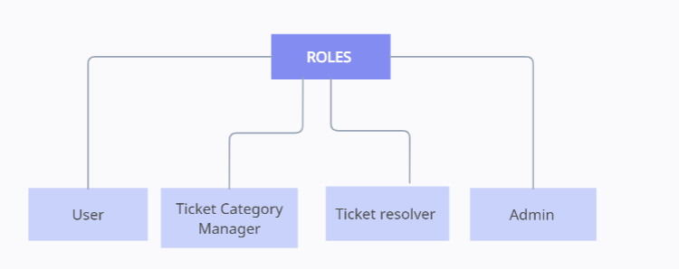

* User – who can raise ticket
* Ticket category manager – who can assign ticket and resolve ticket
* Ticket resolver – who can resolve ticket
* Admin – who can manage ticket management tool.

1. Features –

Features of this application is accessible bases on role

* User

1. Raise ticket - User can raise ticket in this tool
2. Close Ticket - User can close ticket if issue got resolved from users side
3. Ticket history – user can able to see all ticket raise in the past.
4. Ticket mailer – once user raise ticket email will be send to the user.

* Ticket category manager (TCM)

1. View ticket – ticket category manager can see all ticket belong to the category
2. Assigned ticket – TCM can assigned ticket to himself or to ticket resolver
3. Resolve ticket – TCM can resolve ticket by updating status of ticket or adding comment to the ticket.

* Ticket resolver –

1. View ticket – ticket resolver can see all the ticket belong to particular category
2. Resolve ticket – ticket resolver can resolve ticket by updating status of ticket or adding comment

* Admin –

1. Generate report – admin can generate report of the ticket belong to all the category
2. Add – admin can add user, ticket category manager, ticket resolver.
3. Remove – admin can remove user, ticket category manager or ticket resolver.
4. Manager ticket category – admin can add or remove ticket category
5. Use Case Diagram –

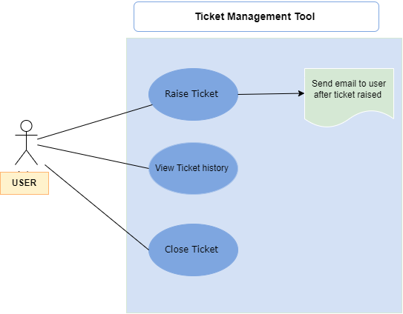

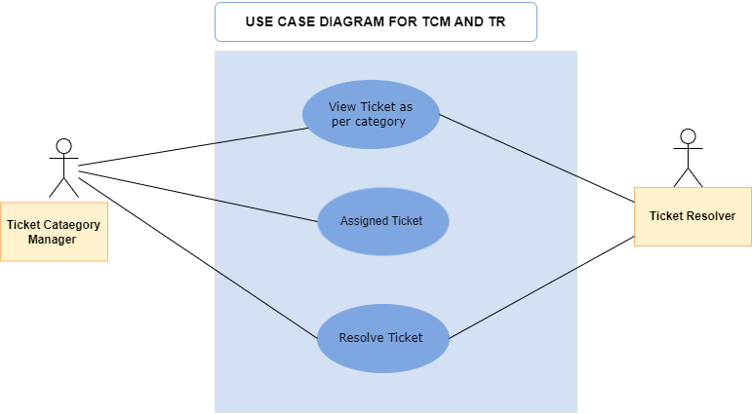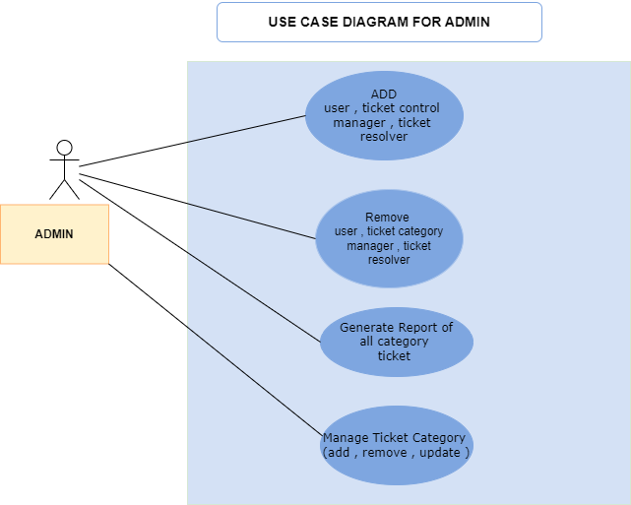

1. Sequence diagram -

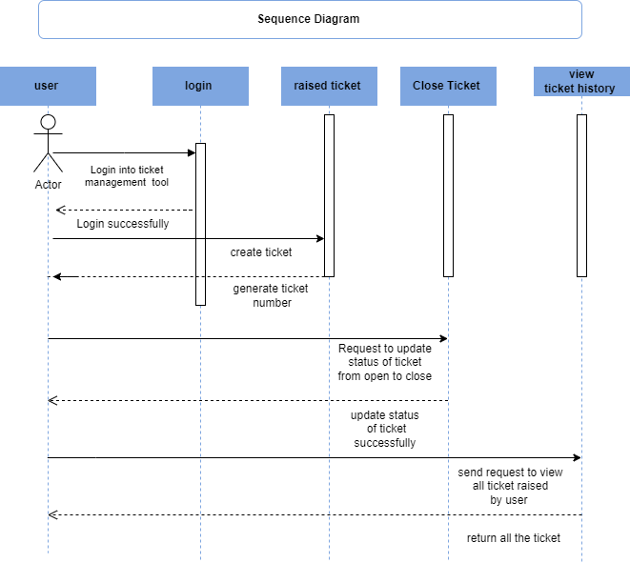

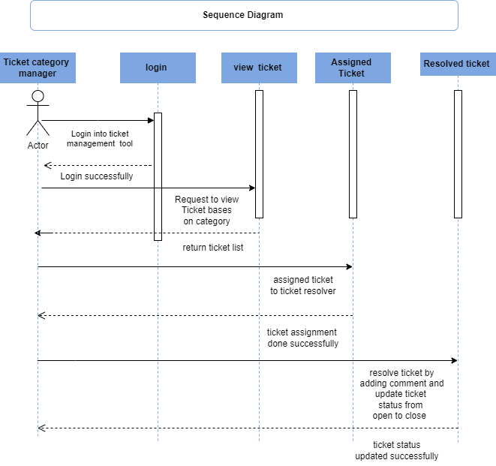

1. Conclusion –

* Ticket management tool is help user to easily raise their queries/tickets and track the status of ticket.
* Ticketing system has increased the productivity for many users in the organization.
* Ticketing system lets you solve the queries with the help of online platform via a web-based environment.
* The user can raise tickets for even the minute queries so as to work smoothly & effectively.