Image Segmentation Using Semantic Learning

Prudhvi Suggula
Nikitha Kona

Abstract—This paper gives a detailed explanation of retraining the last layer of the inception model and incorporating two fully connected layers one for image classification and another layer for bounding boxes
Index Terms— Semantic Learning, Inception Model, Semantic Learning

Introduction
Image Classification and Segmentation has become a part of our everyday life such as face recognition, pattern recognition, object classification. We have seen many applications that classifies different objects in a given Image, but drawing bounding boxes around the objects or semantic segmentation of different objects in a given image yields specific positions of the objects and provide the user with better understanding. In this paper, we will build an inception model from the scratch to retrain the last layer and add two fully connected layers for classifications and regression that generates bounding boxes around the image.

Related WORK
Before the success of Convolution neural network the widely-used object detection methods include HOG, SIFT and Fisher Vector. The present state of art for localization, object detection is RCNN which divides the detection into two categories namely classification and then using regression to get the coordinates for bounding boxes. There are several recent works such as YOLO and RCNN that are used for objet detection and classification

PROPOSED WORK
  - Proposed Models
There are various ways to train the model. But its tiring to get the optimal weights for a given dataset so that we can achieve optimal accuracy for the set of weights. The most common way of training the dataset is using Convolution Neural Networks, instead we used pretrained model called Inception Model which was trained on Image Net. The main advantage of using Inception Model is we have well defined weights which saves us computational power and time.
  - Algorithms and Pseudocode
In our paper, we have used inception model to train the model and retrained the last layer of inception model with our dataset
To get optimal weights for the fully connected layer and then instead of a traditional single fully connected layer we have used two fully connected layers namely classification head for object classification and regression head to draw bounding boxes around the images. There are various nets available to train the dataset like VGNET and various algorithms like Fast RCNN, YOLO for detection and localization

IMPLEMENTATION AND EVALUATION

System Design and Implementation

Software architecture
As explained in the previous sections the below image depicts the architecture of our implementation. Given an image we use convolution and pooling to extract features from different scales and we perform pooling for dimensionality reduction and after achieving the final convolution feature map we have two fully connected layers one that predicts the class score which can be done by using classifiers such as softmax and the next one is regression head that produces coordinated for the bounding boxes.
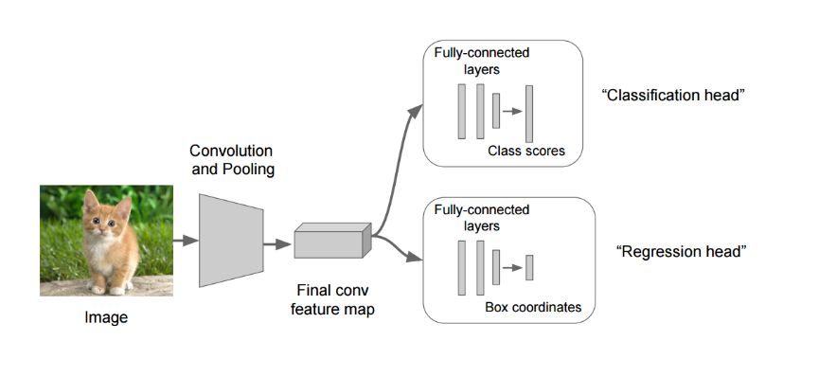

IMPLEMENTATION DETAILS
We have implemented the inception model by downloading the weights and we have removed the fully connected layer and passed our dataset and achieved optimal weights. We have used python and Tensor Flow for implementation purpose. We haven’t used any GPUS for implementing our model. For the web application we have used HTML,jquery and we have connected tensorflow at the backend that fetches the details based on the user input

EVALUATION PLAN
  - Dataset
We have used PASCAL VOC 2012 dataset that is mainly used for object localization and detection. It consists of 20 classes. And we have taken three classes for our project
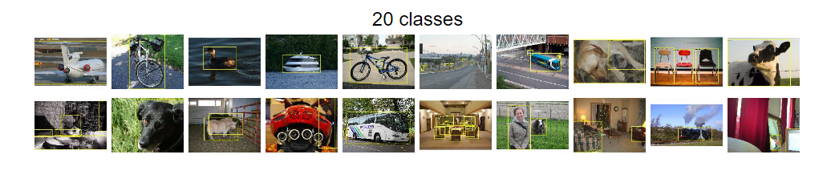
Each image has annotation which has the below format where we extract the (xmin,ymin) and (xmax,ymax) for drawing the bounding boxes
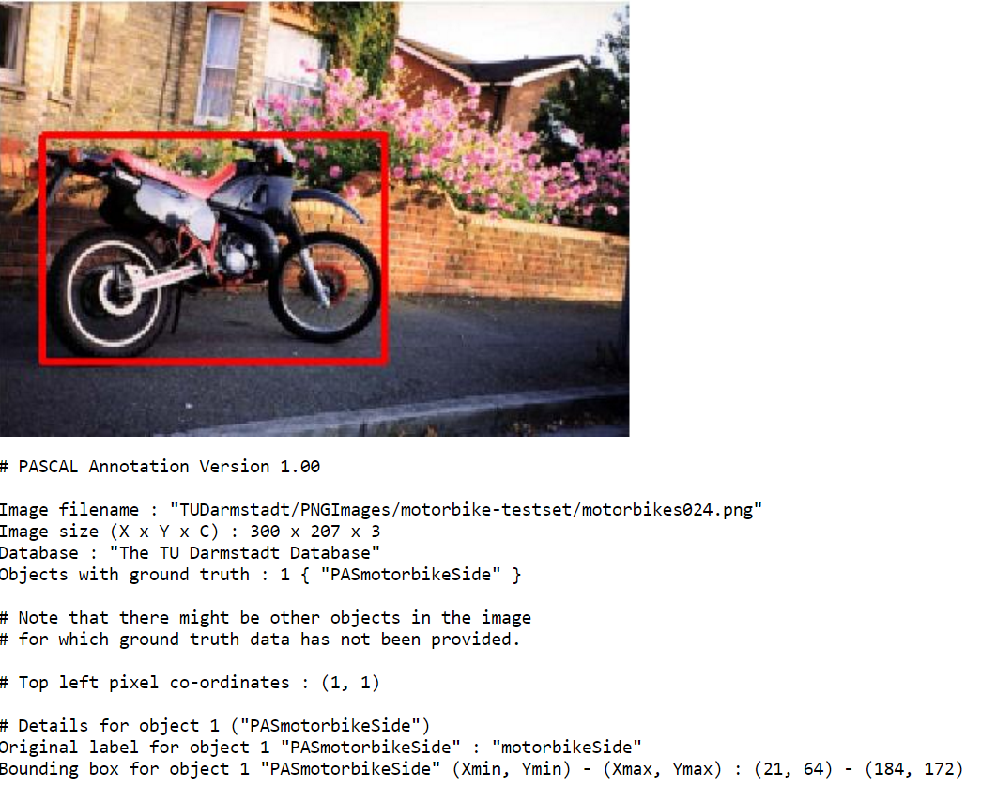
Each image has a label in the form of a text file which has the above description.

  - System Specifications and Measurements

EVALUATION AND RESULTS

Discussion AND LIMITATIONS

CONCLUSIONS

Acknowledgment

References
- J. Clerk Maxwell, A Treatise on Electricity and Magnetism, 3rd ed., vol. 2. Oxford: Clarendon, 1892, pp.68–73.
- I. S. Jacobs and C. P. Bean, “Fine particles, thin films and exchange anisotropy,” in Magnetism, vol. III, G. T. Rado and H. Suhl, Eds. New York: Academic, 1963, pp. 271–350.
- K. Elissa, “Title of paper if known,” unpublished.
- R. Nicole, “Title of paper with only first word capitalized,” J. Name Stand. Abbrev., in press.
- Y. Yorozu, M. Hirano, K. Oka, and Y. Tagawa, “Electron spectroscopy studies on magneto-optical media and plastic substrate interface,” IEEE Transl. J. Magn. Japan, vol. 2, pp. 740–741, August 1987 [Digests 9th Annual Conf. Magnetics Japan, p. 301, 1982].
- M. Young, The Technical Writer's Handbook. Mill Valley, CA: University Science, 1989.

