**LDA with given dataset**

In LDA we take the given dataset and then segregate into groups and we have 4 cases where in the first case we have passed the given dataset to LDA .In the second case we perform lemmatization by calling the java function and the parameters are sent to tfidf and the output is obtained

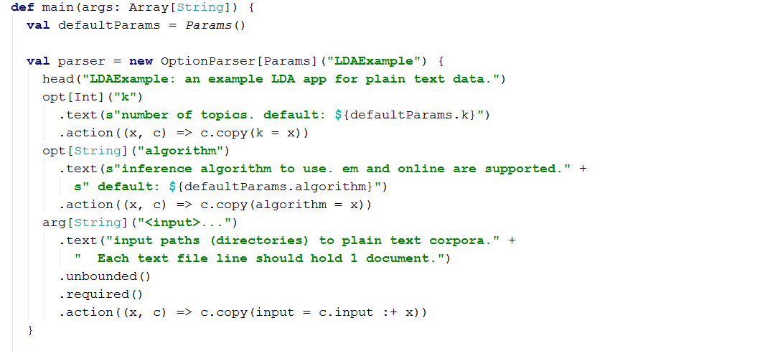

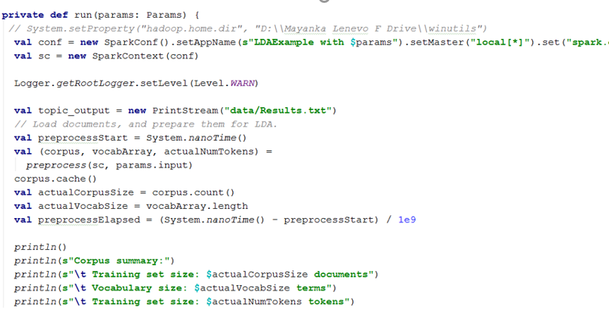

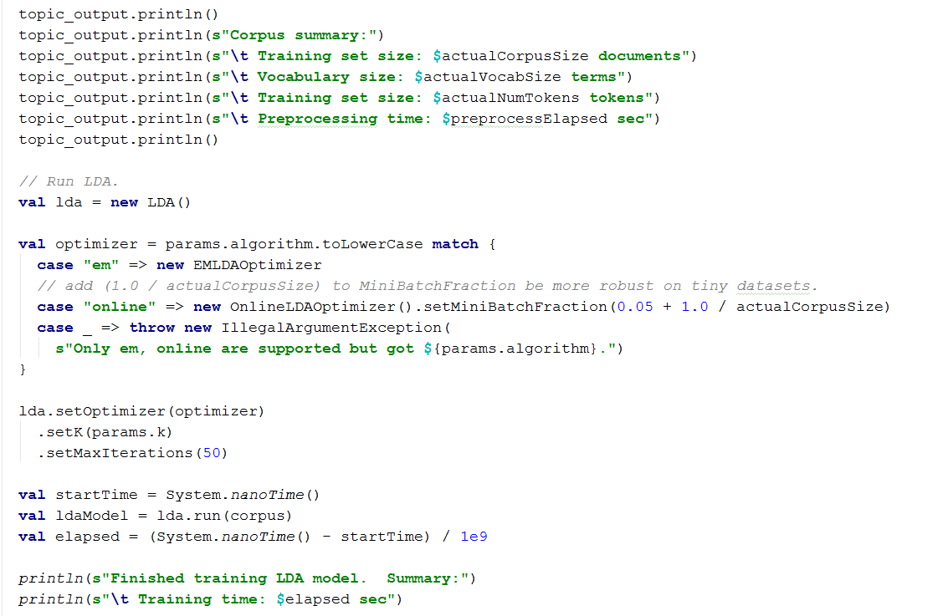

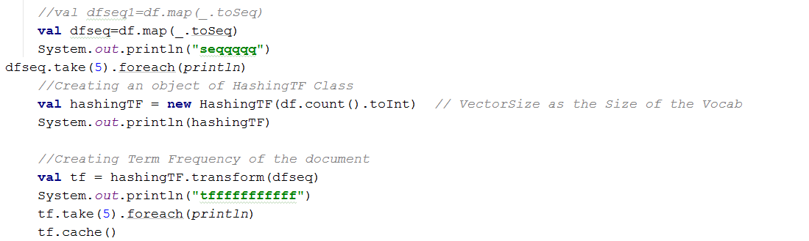

**Dataset->Lemmatization🡪LDA**

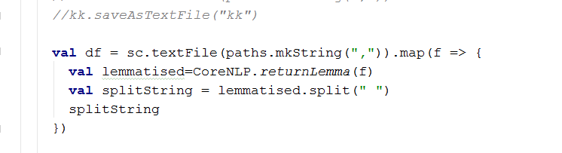

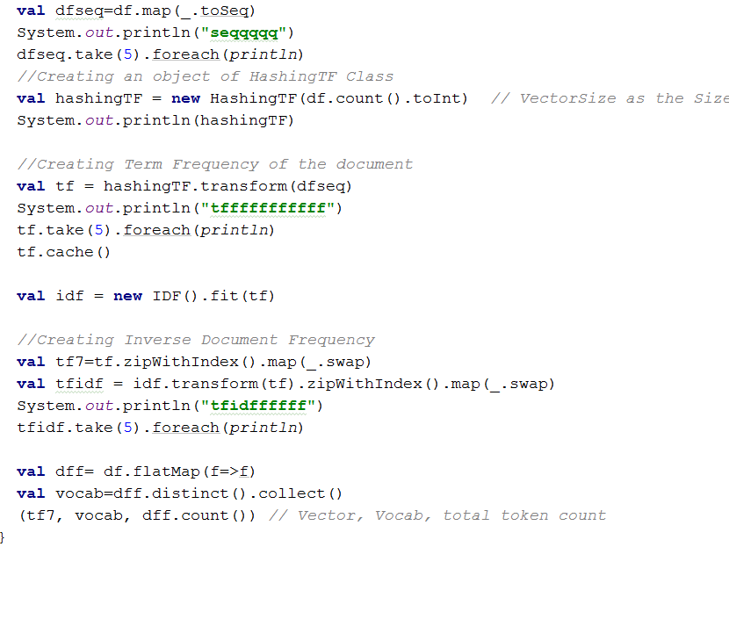

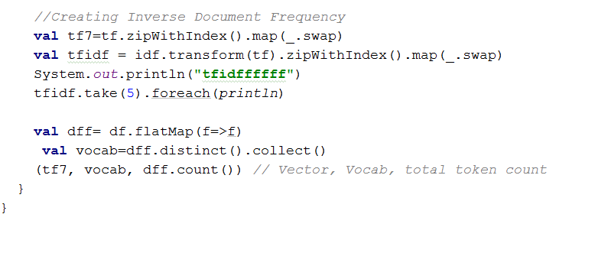

**LDA🡪LEMMATIZATION🡪STOP WORD DETECTION**

Here after performing lemmatization we perform stop word detection and the output is passed to the

tfidf

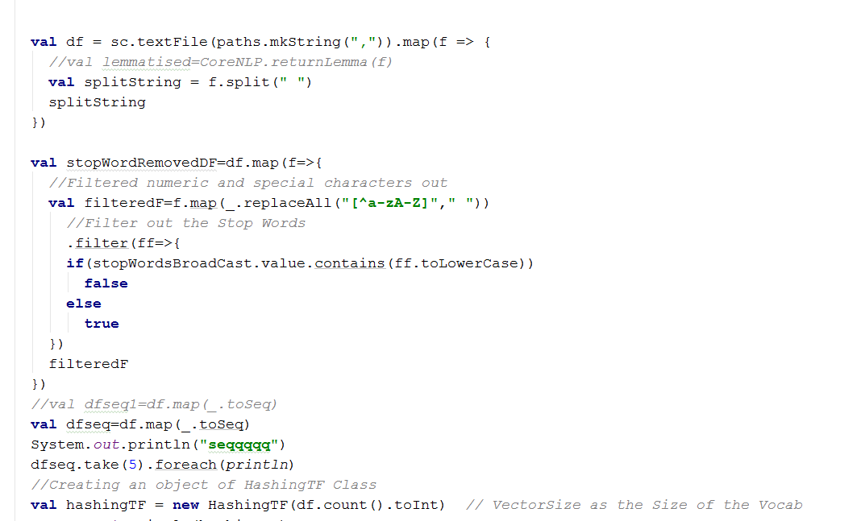

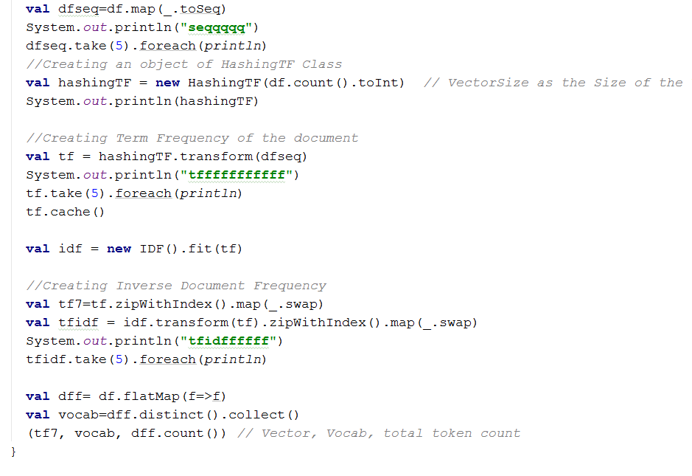

Dataset->Lemmatization🡪STOPWORDS🡪LDA

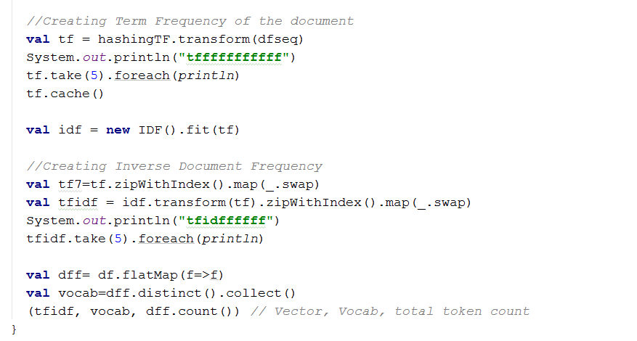

**WORDNET & QA**

­­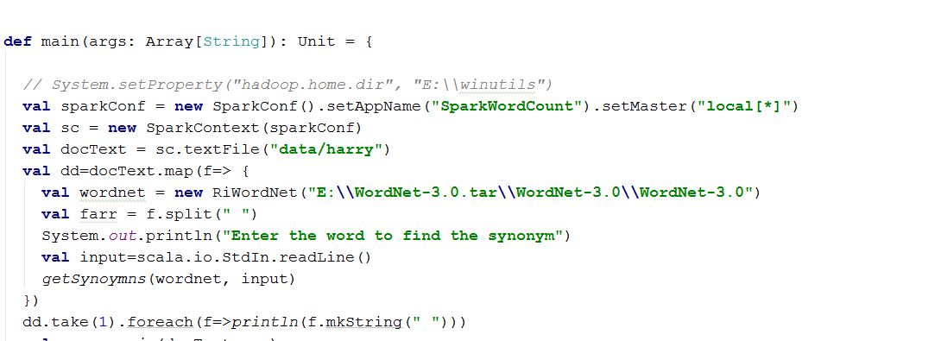

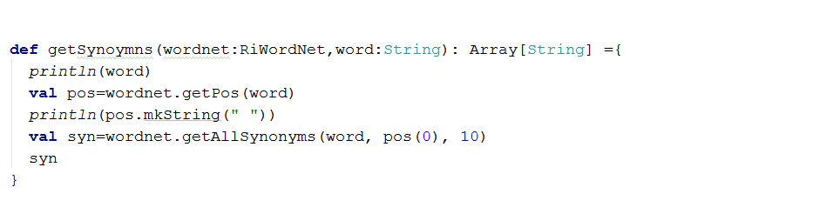

**OPENIE**

In openie we perform triplet abstraction with subject,predicate and object for the given dataset and based on that qa system is performed.

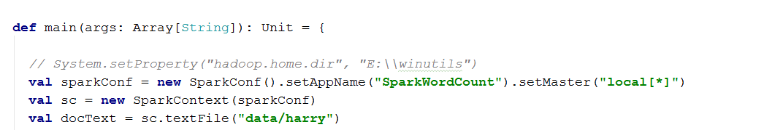

/.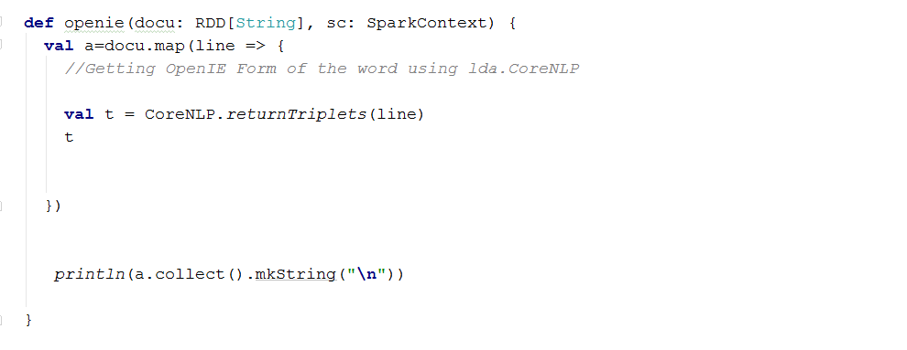

**CONCEPTNET**

**import** java.io.BufferedInputStream;

BufferedReader1 br1 = **new1** BufferedReader1(**new** InputStreamReader1(System1.***in1***));  
System.***out***.println1(**"Enter the question to know the relation"**);  
String s = br.readLine1();  
HttpGet(**"http1://conceptnettt5.media.mit.edu/d.4/search?rel ata/5 =/r/UsedFor&end=/c/en/"**+s+**"&limit=5"**)

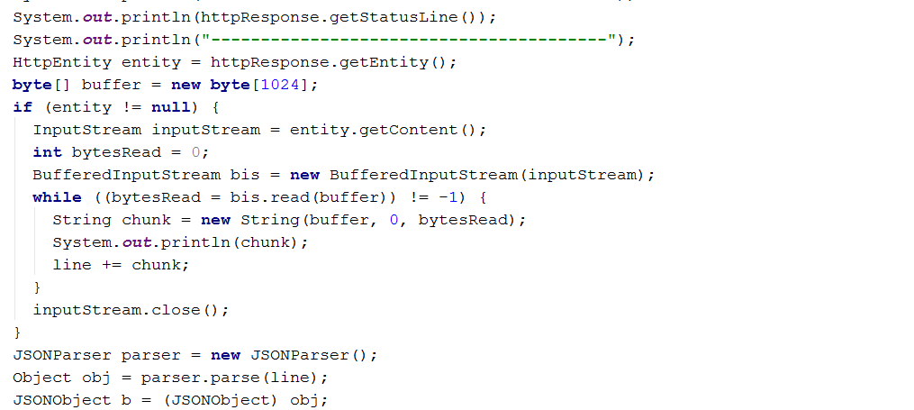

**Question-Who**  
