02427 Advanced Time Series Analysis E18

Computer exercise 3

Niklas Christoffer Petersen

2018-11-07

# Part 1

## Question 1a

Plot the realizations of *Y* 1 and *Y* 2 and make a phaseplot of (*Y* 1, *Y* 2). Repeat for *σ* = 0*.*10*,*0*.*20*,*0*.*30 and 0*.*40. Comment on the effect of adding noise to the equations.

Figure 1 shows the realizations of *Y* 1 and *Y* 2 for *σ* = 0. We see nice and repeated signal for both after *T* ' 6.

(a) *Y* 1 (b) *Y* 2

Figure 1: Realized values of *Y* 1 amd *Y* 2 for *σ* = 0

Figure 2 shows the faseplot of (*Y* 1, *Y* 2). Again we see som initial stabilization, but afterwards the signal repeats with no variation (as *σ* = 1).

Figure 2: Phase Plot *Y* 1 amd *Y* 2 for *σ* = 0

(a) *Y* 1 (b) *Y* 2

Figure 3: Realized values of *Y* 1 amd *Y* 2 for *σ* = 0*.*10

(a) *Y* 1 (b) *Y* 2

Figure 4: Realized values of *Y* 1 amd *Y* 2 for *σ* = 0*.*20

(a) *Y* 1 (b) *Y* 2

Figure 5: Realized values of *Y* 1 amd *Y* 2 for *σ* = 0*.*30

(a) *Y* 1 (b) *Y* 2

Figure 6: Realized values of *Y* 1 amd *Y* 2 for *σ* = 0*.*40 We repeat for *σ* = 0*.*10*,*0*.*20*,*0*.*30 and 0*.*40 as shown in Figures 3 to 6, and phaseplots shown in Figure 7.

We see that it is still quite stable for *σ <* 0*.*20, but at *σ* = 0*.*30 the system begin to switch between two phases, in a nonobvious way. At *σ* = 0*.*40 the phases become even more chaotic.

(a) *σ* = 0*.*10 (b) *σ* = 0*.*20

(c) *σ* = 0*.*30 (d) *σ* = 0*.*40

Figure 7: Phaseplots values of (*Y* 1, *Y* 2)

## Question 1b

Let *σ* = 0*.*10 and simulate using the approximation. Partition the phase plane in 100 × 100 equal cells. Count the number of trajectories that passes through each cell. Repeat for *σ* = 0*.*20*,*0*.*30 and 0*.*40.

Which extra information does the plot contain, compared to the standard phase-plot?

What we have plotted in Figure 8 is count heatmap, and not the number of time a trajectory passes through each cell. We think that the count heatmap is more informative, as it can revieel the speeds of the trajectories at each cell. Higher counts could indicate slower moving passes of the cell.

(c) *σ* = 0*.*30 (d) *σ* = 0*.*40

Figure 8: Realized values of *Y* 1 amd *Y* 2 for *σ* = 0*.*20

# Part 2

We start our analysis with a exploration and some descriptive statistics of the source data. Figure 9 shows correlations in the input data. We emphasize some insights:

1. All the four room temperatures, *yT*1*,...yT*4, are quite strognly lineary correlated.
2. The ambient tempeture, *Ta* seems to cause a lower bound on the four room temperatures *yT*1*,...yT*4. I.e. when it is hot outside, it will also be hot inside, which makes good sense, as there are no cooling units in the building.
3. The solar radiation, *Gv*, seems to cause a lower bound on the ambient temperature. I.e. when the sun is shining strong, it will be warmer, which also makes good sense. With the above in mind, this also influences the inside temperatures.
4. The heaters obviously influences the inside temperature, *yT*1*,...yT*4, but from this visualization, I argue, that it is not possible to see a difference. I.e. even though the northern circuit heater (*Ph*1) is closer to room 1 and 2 (*yT*1*,yT*2), the correlation is almost the same as with the southern circuit heater *Ph*2.

Figure 9: Correlations in input data

## Question 2a

We modified the CTSM-R-model to include the 5 basis spline functions. For the initial guess for the 5 new paremeters *a*1*,...,a*5 we simply use 1 and [10−5; 105] for the bounds. Figure 10 show the difference before and after the modification over the time of day. Table 1 show the improvement in MSE before and after the modification.

Model MSE

|  |  |
| --- | --- |
| Before modification | 0.0852 |
| After modification | 0.0635 |

Table 1: Mean Squared Error (MSE) before and after modification.

(a) Before modification (b) After modification

Figure 10: Error over time of day before and after modification.

## Question 2b

In this section we explore some improvements to the model from 2a. Concrete we will consider the following two improvements:

1. Incorporate heat transfer to/from nearby rooms. We think this could improve the model, since the rooms share walls which surely can transfer heat.
2. Incorporate heat transfer directly between thermal mass and the ambient air. This idea arowse since we are at the second floor, and a lot of the thermal mass of the building could be exposed to the ambient air.

For the first improvement to be considered we have the following SDE-system:

 (1)

 (2)

Where), and *Rin* is the thermal resistance between the current and nearby room, with temperature *Tn*. We run our expiriment on room *i* = 1 with the nearby room set to *n* = 2. After several tries we were unable to estimate parameters, even though we provided good initial guess for the new parameters (including *a*1*,...,ak*). Further analysis showed that it is espacially the *A*(*t*)-term that causes the computational challange. We therefore chose to replace *A*(*t*) with *Aw* (as in the original model proposed in the excercise) and benchmark our improved model against the model *before the modification* made in Section 2.1.

The output of the parameter estimation is shown in Figure 11. We see the value of our new parameter *Rin* = 25 and is considered significant. This is also visible in the MSE for *Ti* which is 0.0810 for our improved model compared to the original unmodified model with MAE for *Ti* = 0.0852.

Figure 11: Parameter estimates for *Improved Model 1*

For the second improvement we further modify the SDE to the following. I.e. we include a new parameter *Rma* for the heat transfer between the thermal mass and the ambient temperature.

(3)

(4)

Unfortunately this does not improve the model, as the CTSM-algorithm terminales after only 6 iterations with MAE = 0*.*1305.

## Question 2c

In this section we present a multi-room model that describes the heat dynamics of the 4 rooms that we got measurements from.

In order to simplefy the model we make some assumptions:

1. The thermal resistance between the air and thermal mass is the same for all rooms, denoted *Rm*. This is assumed since all the rooms are on the same floor, and it seem likely that the floor is made of the same material in all the rooms.
2. The thermal resistance between the internal air and the outside is the same for room 1 and 4 (*Ro*), and room 2 and 3 (*Rh*). This is assumed since both room 1 and 2 are offices close to the outside, while room 2 and 3 seem like hallway and is more central in the building.
3. The thermal capacity is the same for room 1 and 4 (*Co*), and room 2 and 3 (*Ch*). This is assumed since both room 1 and 2 are offices of similar size, while room 2 and 3 seem like hallway and larger.
4. We estimate the window area size for each room (*Aw,*1*,...,Aw,*4) independently of the time, but allows for different windows areas (and directions of the way)

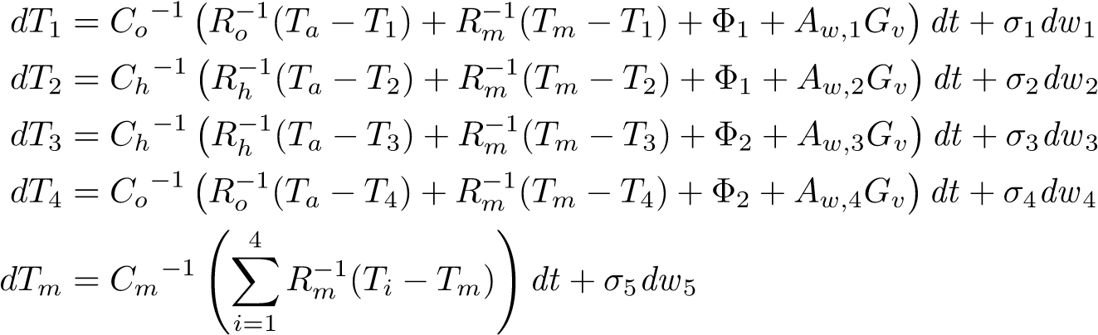(5)

(6)

(7)

(8)

(9)

(10)