 | SyncroTESS New Concrete Optimisation  Abstract Multishift (Draft)

The new concrete optimisation will support a rolling planning horizon instead of strictly optimising from 0-24 hours. The optimisation will be built to support the following scenario: trucks can have set up two shifts. Shift one starts at day one and ends at day one. Shift two starts at day one and ends at day two during night/in the morning. If there is a big order which requests over night transports the deliveries of that order are planned on trucks which have a shift at that night. Truck shifts that start at day two will only get proposals for deliveries of day two. The following sketch shows how such a scenario would look like:
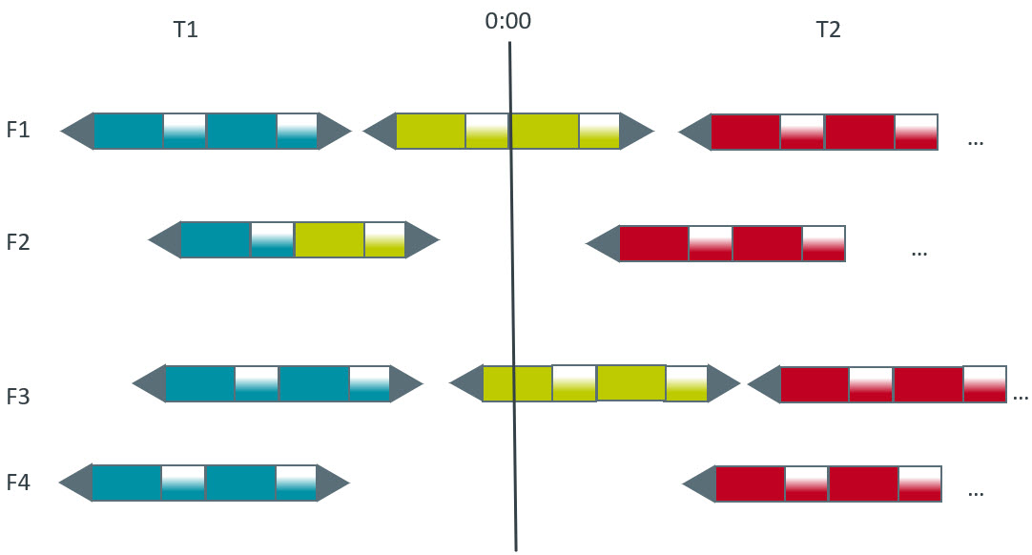
Figure 1: Multishift
The blue and green deliveries would be planned in the optimisation of day 1. The red deliveries would be planned in the optimisation of day 2.

