MIXOR – Motivation for Reworked Improvement Heuristics Concept
A plan that is only determined by simple Plant Dispatch does not utilize the full degree of freedom for decisions to reduce lateness and the number of orders that cannot be fulfilled. The options of delivering from alternative loading plants of an order or changing the working plant of a vehicle are not covered by Plant Dispatch. Therefore, algorithms must be developed to enable the full range of capabilities. Improvement heuristics can be used to exchange work and/or resources in form of deliveries and vehicles between plants. The following document describes the motivation and the approach of the new concept of transformations compared to the current approach of the First-In-First-Out (FIFO)-optimization approach.

What types of transformations can be identified?
Plant Dispatch provides deliveries from the principal plant by vehicles with principal plant of the order as the defined working plant. Transformations allow for the delivery from alternative plants or for vehicles to work from other plants during the day. The current approach considers four types of transformations as follows:
- Alternative Plant [AP]
A delivery is planned to be loaded at an alternative plant.
- Approach from Plant [AfP]
A vehicle is planned to travel empty from the working plant to another plant and to work from the destination plant.
- Approach from Customer [AfC]
A vehicle is planned to return to another plant as the loading, principal plant of a delivery and to work from the destination plant.
- Approach by Delivery [AbD]
A delivery is planned to be loaded at an alternative plant while the corresponding vehicle is planned to return to the principal plant of the delivery and to work from it afterwards.
On the one hand, plants that get additional resources or pass on deliveries are called acceptor plants because help is accepted. On the other hand, plants that provide vehicles or handle additional deliveries are called provider plants. The costs of a transformation consist of the cost differences at the acceptor and the provider plant and the transformation itself. For the sake of simplicity, it can be described as
additional costs at provider - cost reduction at acceptor plant + costs for additional travel | (1)
The cost terms differ for the different types of transformations. AP transformations include costs for additional travel while AfP, AfC, and AbD transformations must consider additional travel to other locations, especially the additional travel for the return run to the home plant of the vehicles. In addition, AfP and AfC transformations include additional travel to the acceptor plant and AbD transformations the additional travel to the customer location. Plant costs can consist of costs for delay and early loading of the planned deliveries and overtime and idle times of the planned vehicles. The focus is usually the delay cost.

What are the idea and issues with the current approach?
The plant costs are represented by the average cost per delivery over all deliveries at the plant and the most expensive delivery of the plant. Specific situations such as missing vehicles with certain truck type or properties are not fully taken into account. Plant pairs with high and low cost at the plants are selected as candidates for transformations. For AP transformations the deliveries are chosen based on delay, rare properties, and priorities while the delay costs are the focus. AfP, AfC, and AbD transformations require a vehicle to be transferred. The selection of a vehicle is based on its empty drive and the assigned deliveries, more precisely the delay of that deliveries. For each candidate the transformation costs are estimated including the vehicle availability at the acceptor plant, a malus for First-Round deliveries, and a bonus for additionally planned deliveries and not yet available truck types. There is no systematical approach of selecting orders and/or vehicles for a transformation, or at least generating transformation types systematically.
In the current approach full plans are calculated for each plant. For each plant the costs are determined as described and transformations are investigated. If a transformation for improvement is identified, the corresponding plans of the plants are re-build from the time of the transformation and the plant costs are re-calculated. That is iteratively continued until a maximum of iterations is reached or until there is no more transformation with an improvement. Re-building the plan and the non-systematically investigation of types of transformations can be very time-consuming.
An analysis of the current approach is very complex to hardly impossible because of not fully documented changes made over time. Adaptions are hard to identify because they had to be made within the existing approach even if the implementation of the actual approach was never made for it. In addition, some of the integrated ideas need to be reviewed again. As a simple example, AfP transformations only make sense at the beginning of a shift.

What is the general idea of the new approach?
For a new approach the general concept of transformations exchanging work and resources should be maintained. The identified types of transformations should also be used. However, the rules for decision-making should be changed to cope with the increased complexity caused by the optimization constraints. More precisely, the focus for transformations should not only be based on delays, but also include a stronger focus on taking into account to select matching vehicles and deliveries.
An integrated approach that includes the exchange of work and resources into the build-up method is another option. A first prototype proved the corresponding challenges and motivated the development of a two-step approach with Plant Dispatch as the first step. However, the first step can be extended by a pre-processing where work and resources are moved from its principial and home plant if there are specific situations, e.g., an overbooked plant. As a result, the situation for the first Plant Dispatch is adapted, e.g., by AP transformations, to reduce the downstream effort to find appropriate transformations. More details for an integrated approach are provided in the next sections.

First step of the new approach – Situation Analysis
Decisions about useful types of transformations can be made while building up the plan. In a first step, the current situation at the plants can be evaluated to allow for a systematically selection of transformations. The systematical selection of types of transformations requires an analysis of the situation for each plant independently. Therefore, the approach is described for one plant.
Technically, at the beginning of an optimization run all deliveries for each order are initialized without (resource and plant) capacity constraints and using the defined truck type of the order. The relevant data, load and unload time windows and quantities, of these deliveries can be updated during an optimization run. Several variables as follows are required to model the first step of the new approach:
Sets and indices
$$i$$ | order index
$$j$$ | delivery index
$$k$$ | shift index
$$b$$ | break time window index
$$p$$ | planning period index
Parameters
$$s_{ij}$$ | wanted start of load time interval of delivery $d_{ij}$
$$e_{ij}$$ | wanted end of load time interval of delivery $d_{ij}$
$$l_{ij}$$ | load duration of delivery $d_{ij}$
$${gi}_{ij}$$ | gate in duration of delivery $d_{ij}$
$${dt}_{ij}$$ | turnaround duration of delivery $d_{ij}$ (= load + approach + unload + return duration)
$${ss}_{k}$$ | earliest start time of shift $k$
$${se}_{k}$$ | latest end time of shift $k$
$${bs}_{kb}$$ | start time of break time window $b$ of shift $k$
$${be}_{kb}$$ | end time of break time window $b$ of shift $k$
$${bl}_{kb}$$ | length of break $b$ of shift $k$
$${is}_{p}$$ | start time of planning period $p$
$${ie}_{p}$$ | end time of planning period $p$
$$il$$ | length of a planning period
$$n_{p}$$ | number of loading slots of period $p$
Decision variables
$$s_{ij}^{'}$$ | start of load time interval of delivery $d_{ij}$
$$h_{ij}$$ | delay of delivery $d_{ij}$
$$t_{k}$$ | next availability of shift $k$ at plant
$$o_{k}$$ | start time of shift $k$
$${sl}_{k}$$ | remaining work duration of shift $k$
$$R$$ | set of remaining deliveries
Next, the shift utilizations are determined in order to identify if there is a capacity bottleneck. Therefore, a histogram with the number of used and idle shifts and loading slots of the plant and the delay of deliveries can be calculated. First, a simple assignment of deliveries and shifts is made by using the FIFO-rule without consideration of assignment restrictions as properties/exclusions and updating time windows and load-spacing during the analysis. Delivery $j$ of an order $i$ is selected that must be loaded next, i.e., with lowest start load time $s_{ij}$, and assigned to the next available shift $k$.
As a starting point, an equidistant decomposition, called grid, of the considered planning horizon is defined. As an example, a planning horizon of one hour can be separated into 12 equidistant time intervals of five minutes, called planning periods. Thus, a planning period defines an interval $\left[{is}_{p}\right.,\left.{es}_{p}\right)$. Each planning period $p$ has a maximum number $n_{p}$ of loading slots for loading deliveries. For each period $p$ a set of KPIs as follows is determined:
$$l_{p}$$ | duration in period $p$ used for loading, i.e. blocking loading slots at the plant
$$u_{p}$$ | number of used shifts during period $p$
$$w_{pk}$$ | idle time of shift $k$ during period $p$
$$d_{p}$$ | delay caused in period $p$, i.e. time span between wanted latest end $e_{ij}$ and expected earliest start $s_{ij}^{'}$ of load time interval
$$d_{pk}$$ | number of delayed deliveries for shift $k$ in period $p$
$$r_{p}$$ | number of remaining deliveries in period $p$
On the one hand, the used loading duration, delays, and number of used shifts are initialized with zero. On the other hand, the idle times are initially set according to the available shifts. All values are updated while the assignment of deliveries to shifts is determined. If there is
- a loading phase,
- a delivery that should start loading but does not, or
- a working vehicle
across a planning period $p$ ,
- the duration for loading $l_{p}$ ,
- the delay $d_{p}$, and
- the number of used shifts $u_{p}$
are increased accordingly, respectively. In addition, the number of delayed deliveries $d_{pk}$ in that period for a shift $k$ is increased by one, if the delayed delivery is assigned to shift $k$. If there is an assignment of a delivery to shift $k$, the idle time $w_{pk}$ of the periods $p$ the corresponding vehicle is busy are reduced accordingly.

Delivery – shift assignments
The remaining time ${sl}_{k}$of each shift after the next availability $t_{k}$ at the plant is set first. For all available shifts, i.e. with ${se}_{k}>now$ and $o_{k}+{sl}_{k}>now$, the availability of the shifts is initialized at the beginning by $t_{k}≔max\left(now,{ss}_{k}\right)$. Next, the list of available shifts is sorted according to the availability $t_{k}$ at the plant. The list of all deliveries is sorted according to the expected start $s_{ij}$ of the load time interval.
Then, the first delivery is assigned to the first shift candidate that has sufficient shift time available, i.e., $max\left(s_{ij},t_{k}\right)+{dt}_{ij}≤min\left({se}_{k},t_{k}+{sl}_{k}\right)$. The start load time of the delivery is updated to $s_{ij}^{'}≔max\left(s_{ij},t_{k}\right)$. The remaining work duration of the shift is set to ${sl}_{k}={sl}_{k}-s_{ij}^{'}+{dt}_{ij}-t_{k}$. Based on the assignment, the KPIs for the utilization histogram are determined as follows:
- Load phases $l_{p}$
The load duration phase $l_{p}$ is increased for each planning period $p$ where the load phase starts, ends, or is included in the period, i.e. ${is}_{p}≥s_{ij}^{'}+{gi}_{ij}-il$ and ${es}_{p}<s_{ij}^{'}+{gi}_{ij}+l_{ij}+il$. The load duration phase $l_{p}$ of the identified periods are increased by the duration within that period that is used for loading.
- Used shifts $u_{p}$
The same rule applies for the number of used shifts $u_{p}$. For each planning period $p$ with ${is}_{p}≥s_{ij}^{'}-il$ and ${es}_{p}<s_{ij}^{'}+{dt}_{ij}+il$ the number of used shifts $u_{p}$ is increased by the proportionate part that the corresponding vehicle is working.
- Shift idle times $w_{pk}$
The idle time $w_{pk}$ of the shift $k$ that is assigned to the delivery is reduced for each of the identified periods $p$ by the working time of the corresponding vehicle in that period.
- Delays $d_{p}$
If the delivery $j$ that is assigned to the shift is delayed, i.e. $s_{ij}^{'}>e_{ij}$, the delay $d_{p}$ of period $p$ where the delivery is wanted to be started loading is increased by the delay, i.e. $h_{ij}=max\left(0,s_{ij}^{'}-e_{ij}\right)$.
- Shift delays $d_{pk}$
The counter for delayed deliveries $d_{pk}$ of the corresponding shift $k$ of the same period $p$ is increased by one if there is a delay $h_{ij}$ of the assigned delivery $i$.
The next availability of the shift is updated to $t_{k}≔s_{ij}^{'}+{dt}_{ij}$. A break $b$ of a shift $k$ is assumed to be required if the work duration exceeds the defined end ${be}_{kb}$ of the break time window minus twice the length of the break ${bl}_{kb}$. Thus, if the shift is available after $max\left({bs}_{kb},{be}_{kb}-2{bl}_{kb}\right)$ for a break $b$, a break must be taken and the shift availability is set to $t_{k}≔s_{ij}^{'}+{dt}_{ij}+{bl}_{kb}$. Finally, the next delivery is assigned to the next available and valid shift.
If there are no more valid shifts for the next delivery, the delivery is skipped, added to the set $R$ of remaining deliveries, and the number of remaining deliveries $r_{p}$ of the period $p$ defined by the wanted start load time $s_{ij}$ of the delivery is increased by one.

Histogram interpretation
As a result, a histogram that represents the utilization of the available vehicle capacity can be derived. An exemplary, graphical representation of such a histogram is depicted in Figure 1.
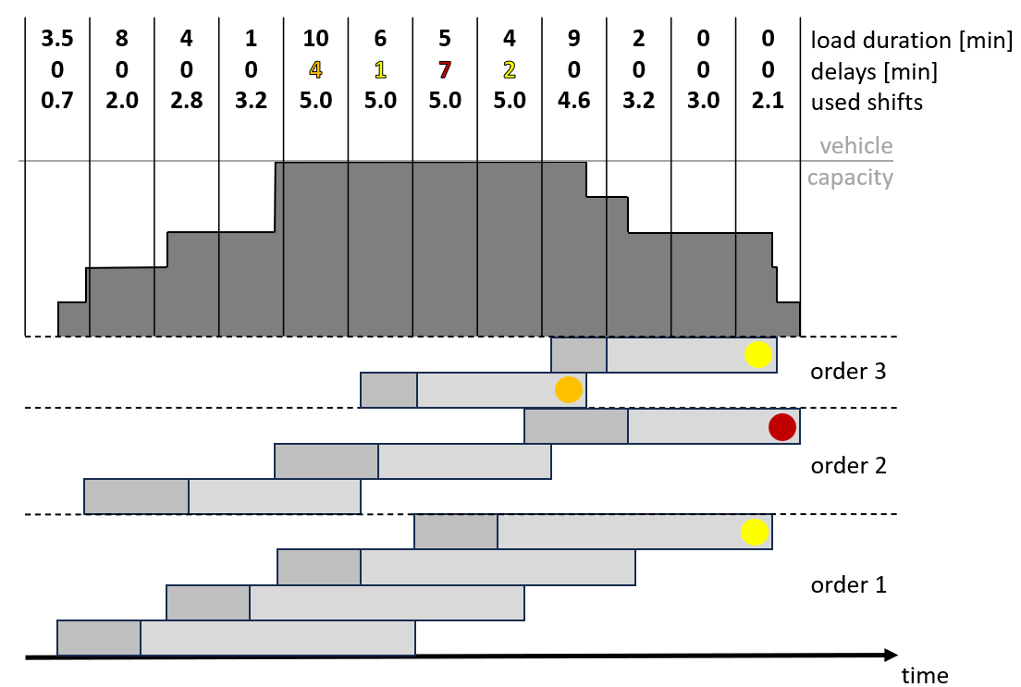
Figure 1 - Vehicle Utilization Histogram
For each planning period, the number of available shifts can be determined using the defined shift times of the vehicles. Based on the number of available and used shifts for each period the fleet utilization can be calculated. If there is full fleet utilization with delayed or remaining deliveries in a period, the period is short of vehicles.
The plant capacity can be checked by the duration of loading phases in a period. The number of available loading slots $n_{p}$ in a period $p$ defines the maximum available plant capacity at the plant in that period. If the used load duration of a period exceeds that limit, the period is short of plant capacity. A graphical presentation of the corresponding histogram based on the previous example is shown in Figure 2.
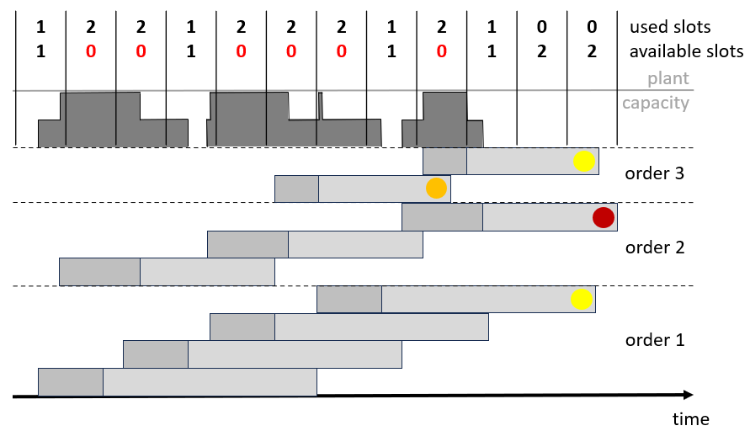
Figure 2 - Plant Utilization Histogram
Early loading can be checked to overcome the situation of plant capacity shortage. For a period $p$ with plant capacity shortage the available loading duration and the number of available vehicles of the previous period(s) $p-m$, $m>0$ can be checked. If there is sufficient available fleet and plant capacity in period $p-m$ to compensate the shortage in period $p$, early loading can be used to help of the situation with plant capacity shortage.
In case of available shifts or available shifts and loading slots in a period, there are capacities to support other plants by the transformations AfC, AfP, and AbD (send available vehicles) and AP (make alternative plant deliveries), respectively.

Second step of the new approach – Exchange
todo

