3.3: SQL for Data Analysis

1. Ein Bild, das Tisch enthält.

   Automatisch generierte BeschreibungWrite a SELECT command to find out what film genres exist in the category table.
2. You’re ready to add some new genres! Write an INSERT statement to add the following genres to the category table: Thriller, Crime, Mystery, Romance, and War

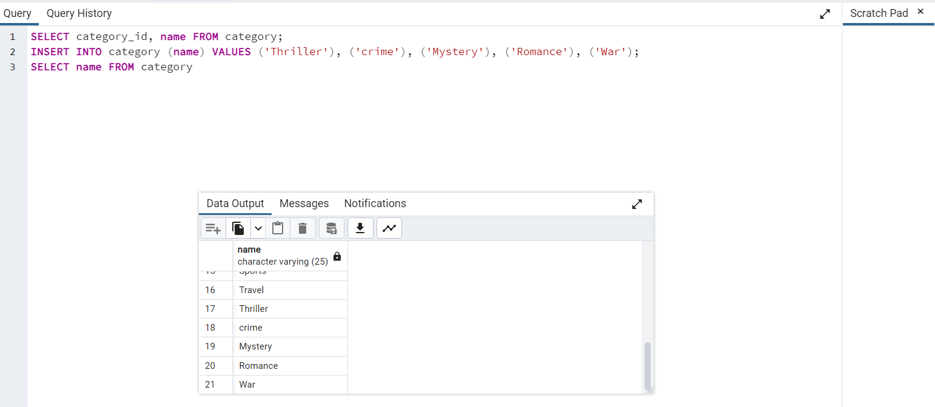

The CREATE statement below shows the constraints on the category table. Write a short paragraph explaining the various constraints that have been applied to the columns. What do these constraints do exactly? Why are they important?

* NOT NULL – the constraints makes sure that there are no missing values in every column
* PRIMARY KEY – Category_id is the primary key column. The primary key column can`t contain any null or duplicate values.

1. 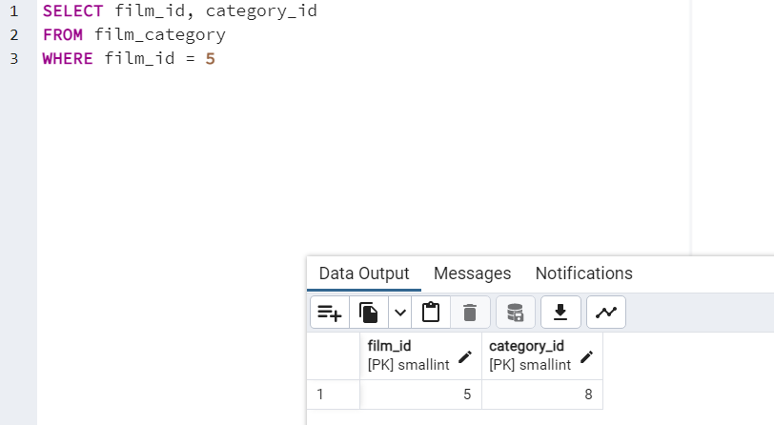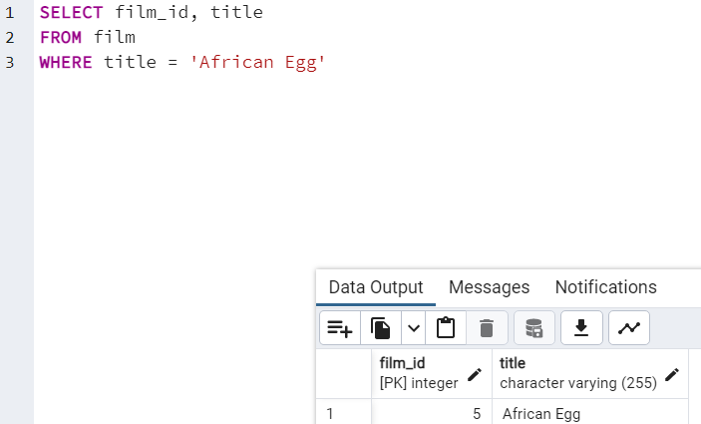The genre for the movie African Egg needs to to be updated to thriller. Work through the steps below to make this change.

Ein Bild, das Text enthält.
Once you have the film_ID and category_ID, write an UPDATE command to change the category in the film_category table (not the category table). Copy-paste this command into your answers document.

Ein Bild, das Text enthält.

1. Since there aren’t many movies in the mystery category, you and your manager decide to remove it from the category table. Write a DELETE command to do so and copy-paste it into your answers document.

Ein Bild, das Text enthält.

1. Based on what you’ve learned so far, think about what it would be like to complete steps 1 to 4 with Excel instead of SQL. Are there any pros and cons to using SQL? Write a paragraph explaining your answer.

Excel provides a easier insight in the dataset and is more intuitive.. However, SQL is easier to manipulate and to change, edit, and delete data. It is faster because it requires only a few commands, while in Excel you need to physically identify the values to delete them.

SQL is more beneficial for datasets with more rows where more scrolling would be required in Excel.