**3.4: Database Querying in SQL**

1. **Refining Your Query**

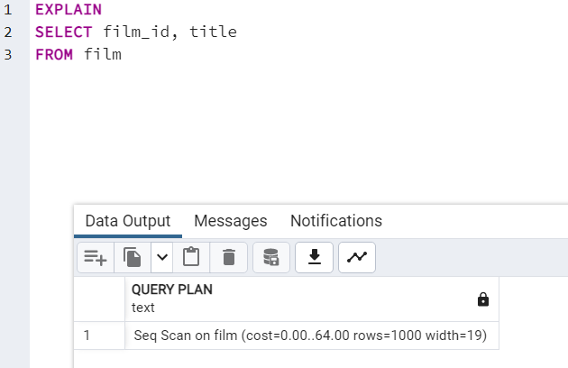

* This query is much cleaner and only pulls the required information for mailing addresses

Ein Bild, das Text enthält.

* This query may pull in other data also stored in the customer table, such as phone numbers, activity dates, and notes from sales and customer service.

**2. Ordering the Data**

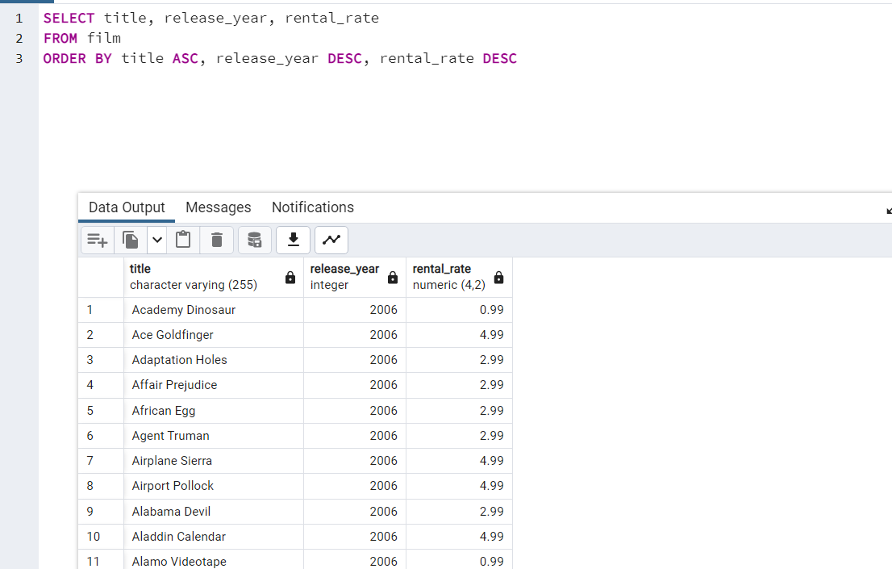

Please find the extracted sheet in the other attachment (3_4_2)

**3. Grouping Data**

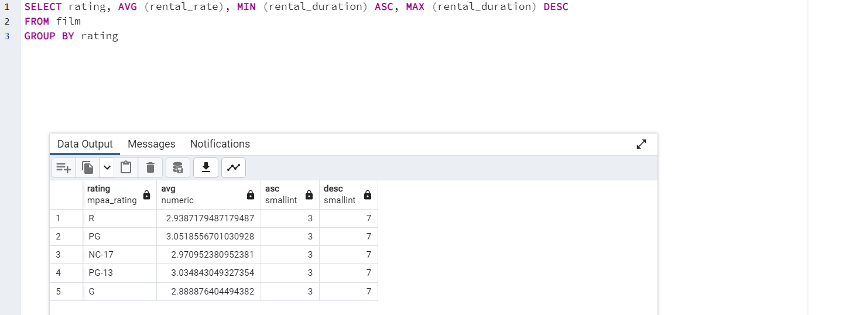

Please find the extracted sheet in the attachment (3_4_3)

**4. Database Migration**

• Can you outline the procedure for migrating the data and who will be responsible for it?

1. Extract: Gathering data from multiple different sources

2. Transform: Extracted data converted into another format.

3. Load: Transformed data is inserted into the new database.

• What problems do you foresee if you start analyzing the data before it’s been loaded into the data warehouse?

If a data analyst analyzes the data before is has been loaded into the data warehouse, the data will not be consistently formatted. Thereby it will be very difficult to retrieve and manipulate the data or to get insights and meaningful conclusions from it.