**3.5: Filtering Data**

1. Write some SQL queries to return a lists of films that meet the following conditions. (**Hint:** These queries are not building upon each other, they are separate! Hence, when running the query for 1b. you don’t need to take into account 1a, for example.) Your results tables should include the columns “film_ID,” “title,” and “description”.

a) Film title contains the word Uptown in any position

**Ein Bild, das Text enthält.
**

b)Film length is more than 120 minutes and rental rate is more than 2.99

**Ein Bild, das Text enthält.
**

c) Rental duration is between 3 and 7 days (where 3 and 7 aren’t inclusive)

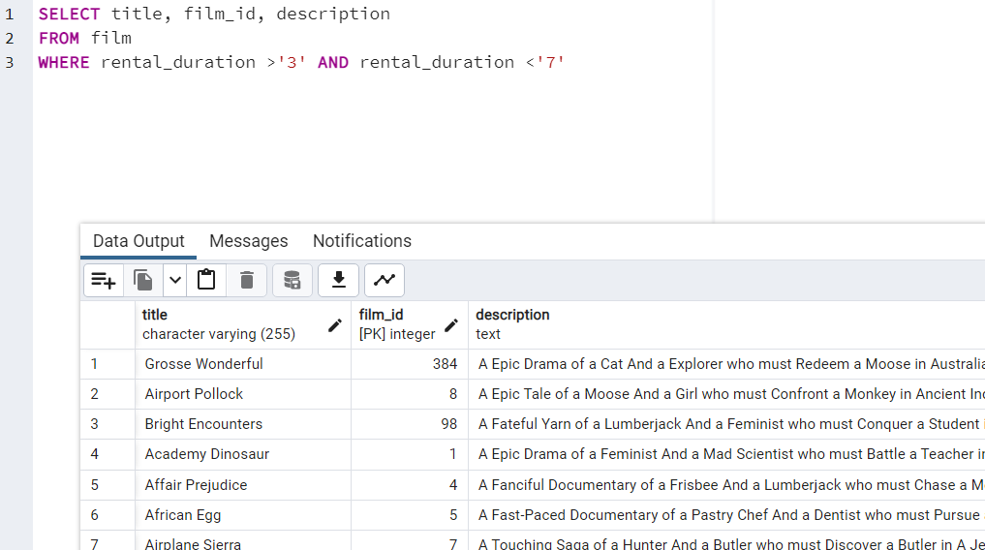

d)Film replacement cost is less than 14.99

**Ein Bild, das Text enthält.
**

e) Film rating is either PG or G

Ein Bild, das Text enthält.

2. Please find the document in the other attachment.

3. The query you wrote in step 1e returned a list of movies that meet certain criteria (film rating is either PG or G). The inventory team has asked for the following information about this list.

1. Count of the movies 🡪 372
2. Average rental rate 🡪 2,9734
3. Maximum rental duration and minimum rental duration 🡪 7,3

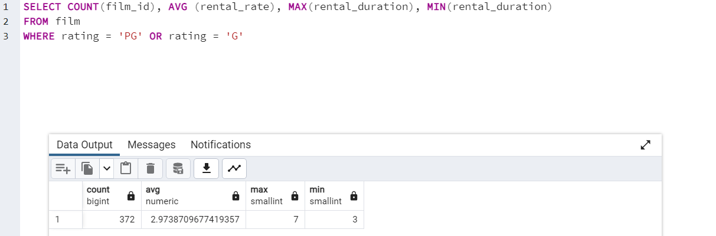

4) To make the output easier for your coworkers to understand, give your aggregate columns the following aliases: “count of movies,” “average movie rental rate,” “maximum rental duration”, and “minimum rental duration”. Run the query and transfer the result into your Excel file on a new sheet as well as the code you used to get there.

Ein Bild, das Text enthält.

5) The customer team would like to see the fields you calculated in step 3 grouped by rating. The totals in your results table should look the same as in step 4 but broken down by the rating column. Copy-paste your query and its output into your answers on a new sheet.

