Case 1

* Successfully runs everything till Dubins path algorithm. But only that aircraft flies too far from the way-points and lines in between. But I think this can be fixed by tuning the algorithm.
* Uses same equation of CL and CD in Forces and Moments file as all the old folders. (in case 2 we will change these formulae)

Case 2

* Modifications inspired by Jacob Moroni
* Successfully runs everything till Dubins path algorithm. But only that aircraft flies too far from the way-points and lines in between. But I think this can be fixed by tuning the algorithm.
* Uses **modified CL and CD equations** in Forces and Moments. Now rectified to exact equations as in the textbook.
* **Path follow.m**: changed tuning parameters.

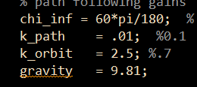

* **Vtol_parameters.m**: Initializing pd0 = 0 instead of commanded height

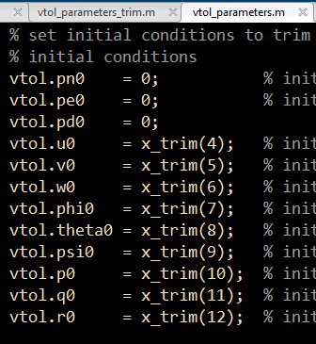

* **Compute_trim.m**:

