..\2_PropulsionFix+CL,DalphaFix\

* Uses **Va, alpha, beta** in body frame
* Uses **full propulsion equations** mentioned in the errata
* Until this case file, in all the previous test cases included in the folders—

..\ e_version\**4_fm**\testcases\**1_VaAlphaBeta_bodyframe**

.. \e_version\**4_fm**\testcases\**2_VaAlphaBeta_inertialframe**

The expressions used in the ‘**forces_moments.m’** file for calculating CLalpha & CDalpha was flawed wherein I have simply substituted C_L_alpha & C_D_alpha respectively in C_X_alpha expression. From this test folder onwards, I have corrected it using—

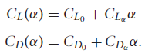

This correction has resolved so many issues.

Case 1

* vtol_parameters.m

**vtol.Va0 = 1;**

gamma = 0*pi/180;

R = Inf;

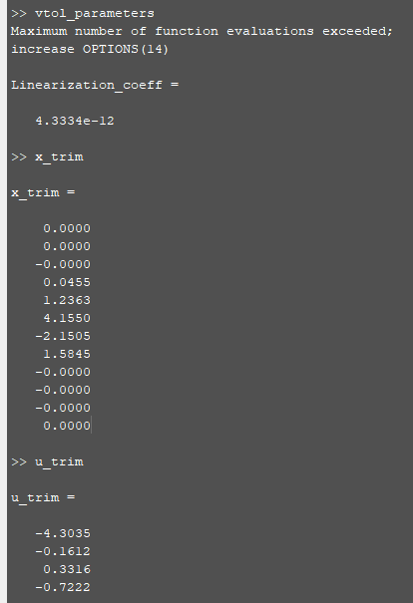

**Observations**

* At very low velocities like this (1 m/s), trimming algorithm cannot hold the aircraft to desired path for too long. I think since the values that are desired to be maintained constant are so low that the numerical errors become significant and the system becomes unstable too soon.
* ‘Va’ errors are significant beyond 40 seconds.
* Look at this to convince yourself that after a certain while, due to numerical errors, the deviations start kicking in. Hence the results are as expected. Trimming cannot hold parameters constant forever.

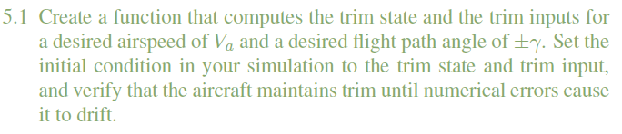

Case 2

* vtol_parameters.m

**vtol.Va0 = 5;**

gamma = 0*pi/180;

R = Inf;

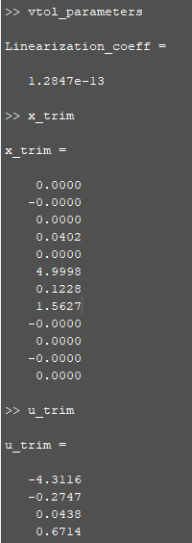

**Observations**

* At 5 m/s, trimming does slightly better than at 1 m/s.
* ‘Va’ errors are significant beyond 60 seconds.

Case 3

* vtol_parameters.m

**vtol.Va0 = 10;**

gamma = 0*pi/180;

R = Inf;

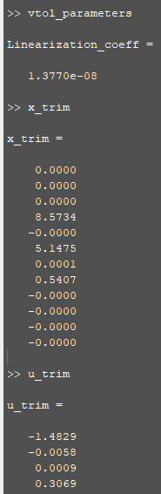

**Observations**

* This case does not fit my assumption in cases 1, 2 that at higher velocities, trimming can hold ‘Va’ constant for much longer. Because though 10 m/s is higher than 5 m/s, Va stays constant for only about 40s.

Case 4

* vtol_parameters.m

vtol.Va0 = 10;

**gamma = 5*pi/180;**

R = Inf;

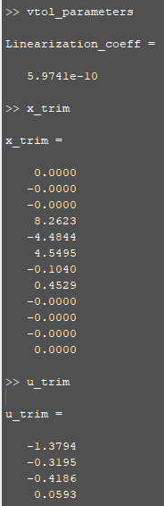

**Observations**

* Drifts after about 50s.

Case 5

* vtol_parameters.m

vtol.Va0 = 10;

**gamma = 10*pi/180;**

R = Inf;

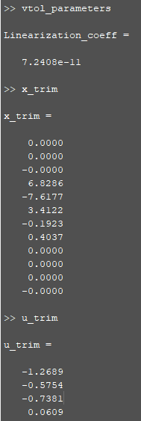

**Observations**

* Drifts after about 60s.
* But there is a lot of movement in E-W direction.

Case 6

* vtol_parameters.m

vtol.Va0 = 10;

**gamma = -10*pi/180;**

R = Inf;

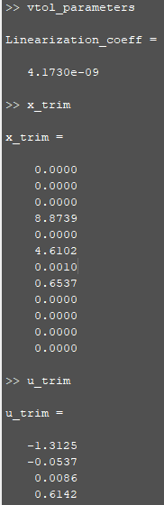

**Observations**

* Drifts after about 48s.
* Don’t know why in case of **gamma = 10 rad (case5)**, E-W movement was huge but in case of **gamma = -10 (case6)**, this movement is regulated much better.

Case 7

* vtol_parameters.m

vtol.Va0 = 10;

**gamma = 0*pi/180;**

**R = 150;**

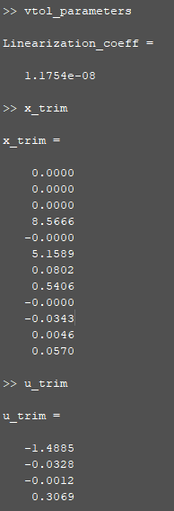

**Observations**

* fff

Case 8

* vtol_parameters.m

vtol.Va0 = 10;

gamma = 0*pi/180;

**R = -150;**

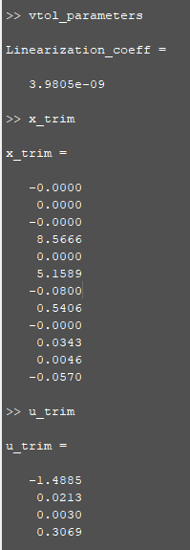

**Observations**

* fff

Case 9

* vtol_parameters.m

vtol.Va0 = 10;

**gamma = 5*pi/180;**

**R = 150;**

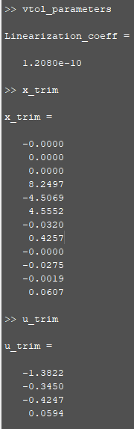

**Observations**

* fff

Case 10

* vtol_parameters.m

vtol.Va0 = 10;

**gamma = -5*pi/180;**

**R = 150;**

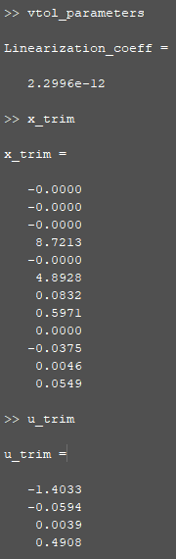

**Observations**

* fff

Case 11

* vtol_parameters.m

**vtol.Va0 = 17;**

gamma = 0*pi/180;

R = Inf;

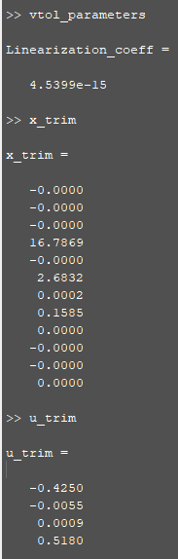

**Observations**

* fff

Case 12

* vtol_parameters.m

vtol.Va0 = 17;

gamma = 0*pi/180;

**R = 150;**

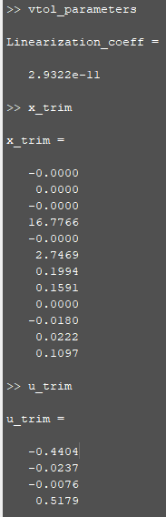

**Observations**

* fff

Case 13

* vtol_parameters.m

vtol.Va0 = 17;

**gamma = 10*pi/180;**

**R = Inf;**

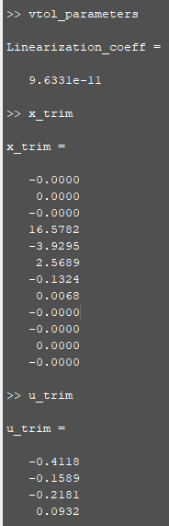

**Observations**

* fff

Case 14

* vtol_parameters.m

vtol.Va0 = 17;

**gamma = 10*pi/180;**

**R = 150;**

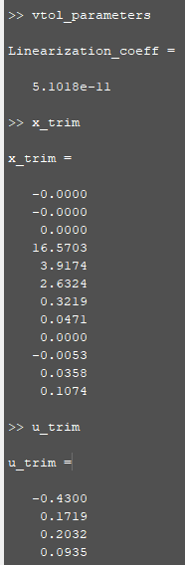

**Observations**

* fff

Case 15 (Textbook Design Project 5.5)

* vtol_parameters.m

vtol.Va0 = 10;

gamma = 0*pi/180;

**R = 50;**

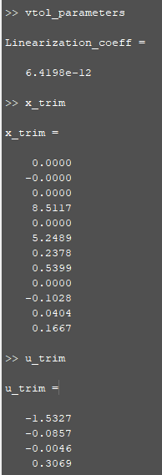

**Observations**

* fff