**Date**: 29/Jun/2020

**Author**: Nikhil Madduri (nikhil.madduri@gmail.com)

**../3_replacing_S_function_with_own_rk4/**

* To understand the background first refer to “..\e_version\3_kin_dyn\testcases\5_replacing Sfunction with own rk4”.
* This folder was an attempt to run trimming algorithm while using own vtol_dynamics (with own rk4 and sixDOF) instead of S-function.
* Main target for improvement in this case was “vtolsim_trim.slx” model.
* When I run vtol_parameters.m file which contains the line for trimming –



It throws errors as follows—

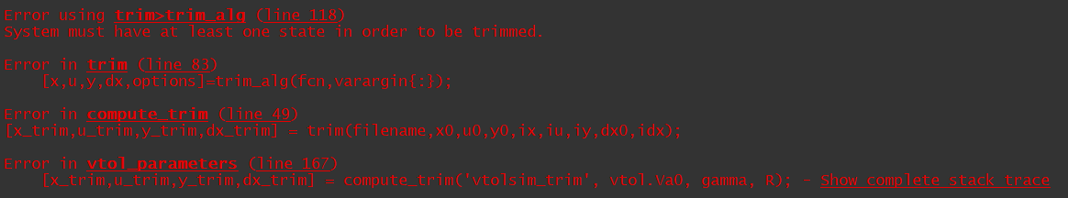

* **Unsuccessful.**

(Hence I thought of a Jugaad – I will use old trim file with S-function for trimming, whereas I will use my new vtol_dynamics function with own rk4, sixDOF for solving the rest of the code – this strategy was implemented in “**\e_version\6_ap\testcases\results\case3\files**\”)