**Date**: 29/Jun/2020

**Author**: Nikhil Madduri (nikhil.madduri@gmail.com)

**..\e_version\6_ap+refinement\own_rk4**

* It uses my own vtol_dynamics+rk4+sixDOF rather than S-function vtol_dynamics.
* In this case, **flightgear integration** has been done for visuals.
* Open runfg.bat as administrator.
* Note that inside “vtolsim_trim.slx” model, it used “vtol_dynamics_trim.m” file which is the old s-function.
* If you want to tune all the loops for the trimmed values, “**vtol_parameters_trim.m**” to generate trim values and then hardcode trim values in “**vtol_parameters.m**“ file and again run “**vtol_parameters.m**”. This second run will create all the transfer functions and state-space matrices. Then you can normally open roll_loop.slx, pitch_loop.slx as usual and trim them by setting design parameters in the file “**compute_autopilot_gains.m**”.
* Once all the design parameters are tuned in the file “**compute_autopilot_gains.m**”, open “**autopilot.m**” file and set the throttle, pWo_prev and Kr_prev as follows –

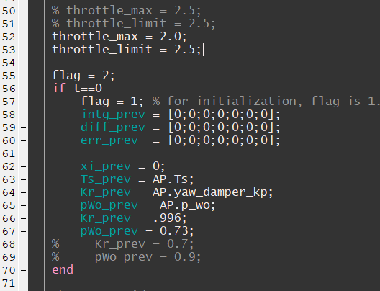

* Now run autopilot_vtolsim.slx file after setting the input commands as follows –

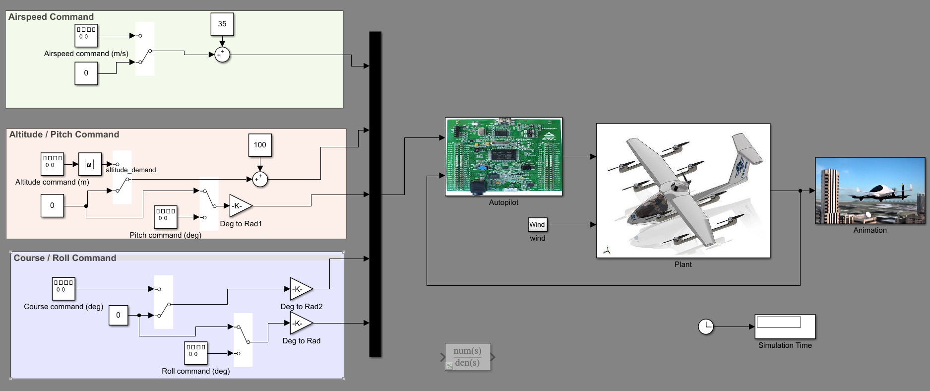

**Case 1 – Issue: code crash for high velocities fixed**

1. Till now code used to run for initial value and commanded value of velocity of 35 to 45 m/s but if I input large values like 55 or say 111 m/s, code crashes.
2. For this, I changed mass, Moments of Inertia, S (wing area), b, c of the aircraft and also increased the throttle. Basically need to give 2500 kg and large MoI so that 111 m/s corresponds to larger aircraft. Code does not crash anymore.
3. However there are issues with the oscillations.

**Case 2 – Issue: delta_r the rudder always runs at +/-45**

Note that all the following observations were done at the following conditions in autopilot.m file:

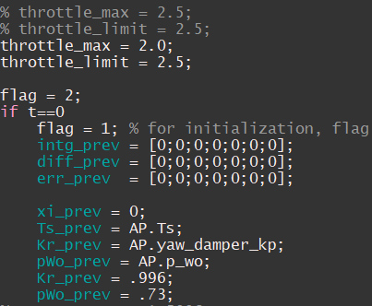

1. Aileron (delta_a) always remains saturated even after all other parameters stabilize once the aircraft reaches the commanded altitude. Always oscillated between +/- 45 deg – the saturations value I put for aileron deflection.
2. Reason: ***vtol.C_ell_delta_a*** parameter controls the aileron. This value is given as **0.08** in textbook and again corrected to **0.17** in errata.
   * This value (0.17) causes the aileron to stay saturated always for commanded velocity of **35 m/s**.

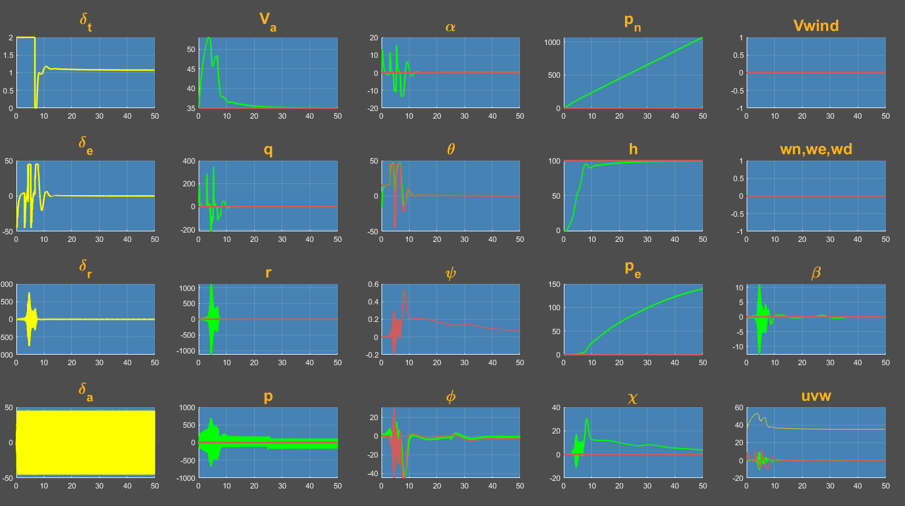

* + But when I command a velocity of **10 m/s**, aileron does not saturate (though there are oscillations) but to maintain the altitude at such small velocities, elevator struggles and stays saturated most of the time.

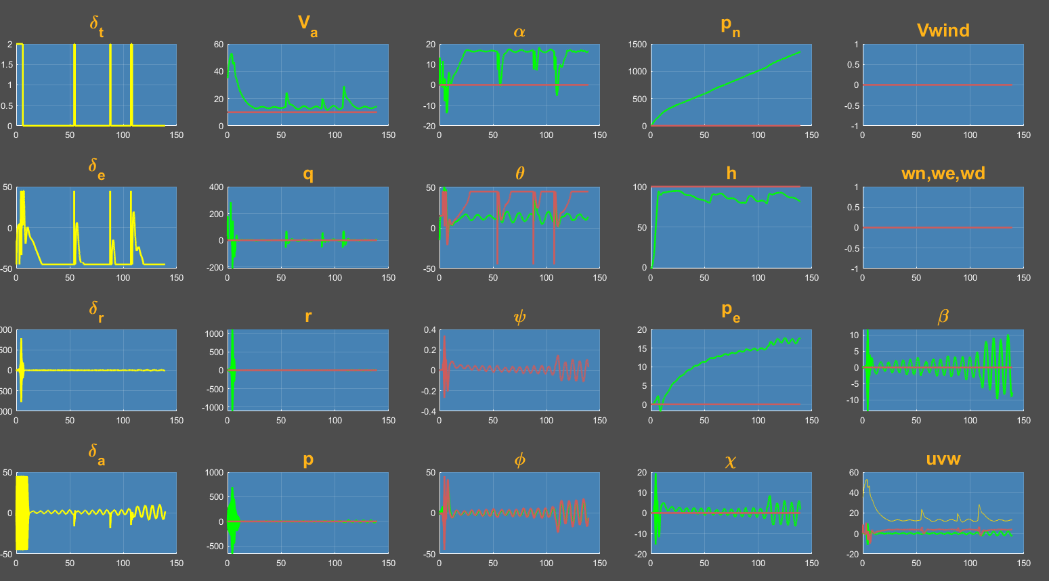

* + Now I tried randomly setting *vtol.C_ell_delta_a*= **0.1**, and aileron does not saturate even at **35 m/s**.

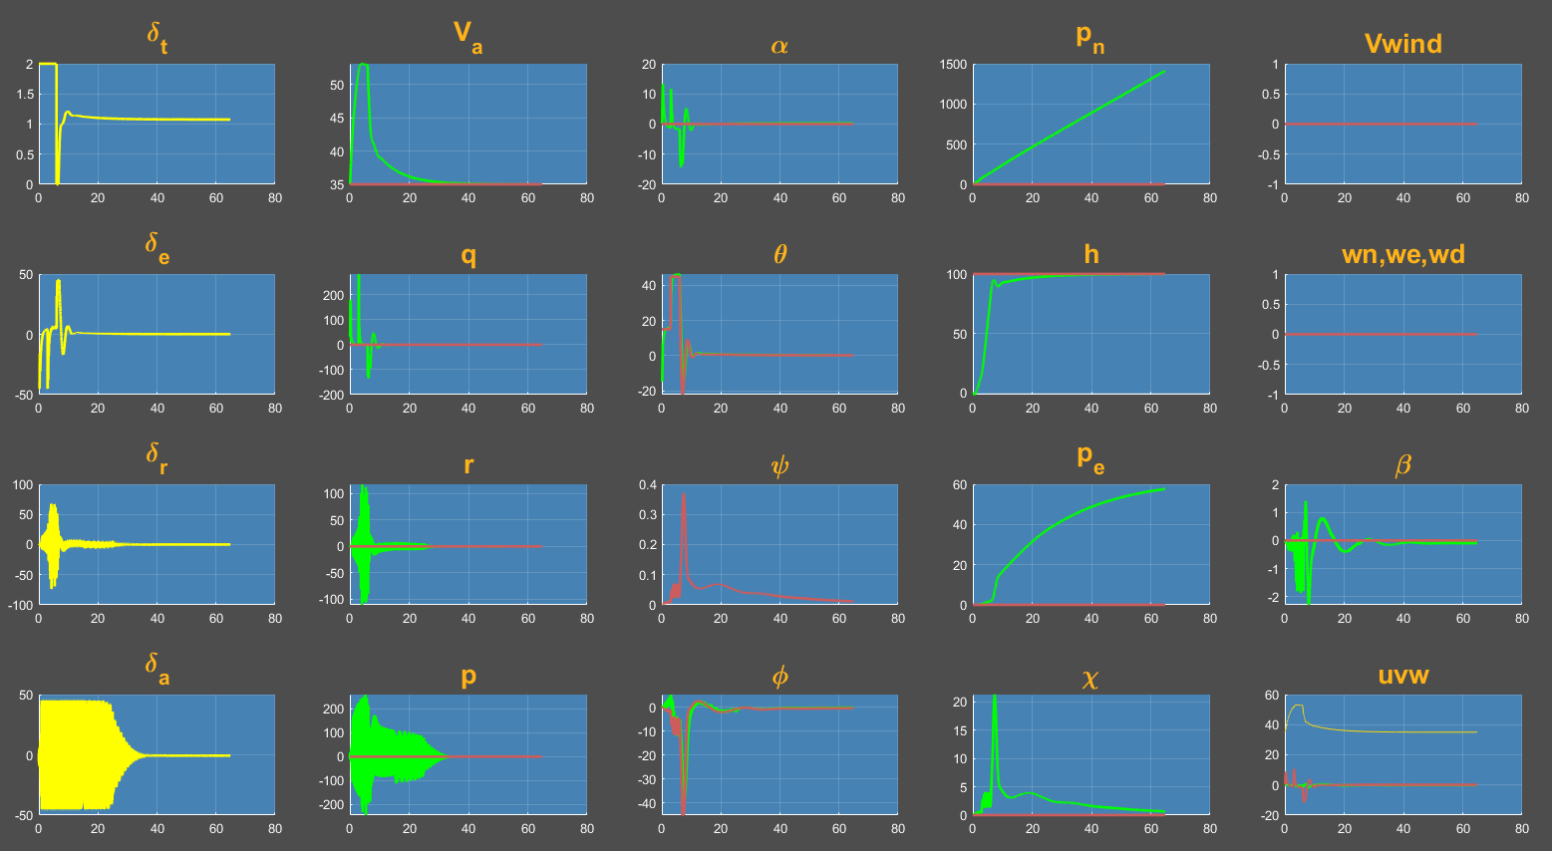

This makes me feel that the value of *vtol.C_ell_delta_a*= **0.17** given by the errata is not suitable for this velocity of normal cruise. We need a much lower value of this derivative.

**Case 3 – Issue: aircraft shaky till climbs to commanded alt**

This happens because there is a huge error between the commanded altitude and initial condition of zero altitude. In actual autopilot, initial and commanded values will be close to each other and guidance algorithm will slowly demand the increment in altitude. Hence it won’t be shaky. But for now since we do not have the guidance yet, we command the alt all of a sudden.