**Date**: 29/Jun/2020

**Author**: Nikhil Madduri (nikhil.madduri@gmail.com)

**..\e_version\6_ap+refinement\own_rk4**

* It uses my own vtol_dynamics+rk4+sixDOF rather than S-fucntion vtol_dynamics.
* In this case, **flightgear integration** has been done for visuals.
* Open runfg.bat as administrator.
* Note that inside “vtolsim_trim.slx” model, it used “vtol_dynamics_trim.m” file which is the old s-function.
* If you want to tune all the loops for the trimmed values, “**vtol_parameters_trim.m**” to generate trim values and then hardcode trim values in “**vtol_parameters.m**“ file and again run “**vtol_parameters.m**”. This second run will create all the transfer functions and state-space matrices. Then you can normally open roll_loop.slx, pitch_loop.slx as usual and trim them by setting design parameters in the file “**compute_autopilot_gains.m**”.
* Once all the design parameters are tuned in the file “**compute_autopilot_gains.m**”, open “**autopilot.m**” file and set the throttle, pWo_prev and Kr_prev as follows –

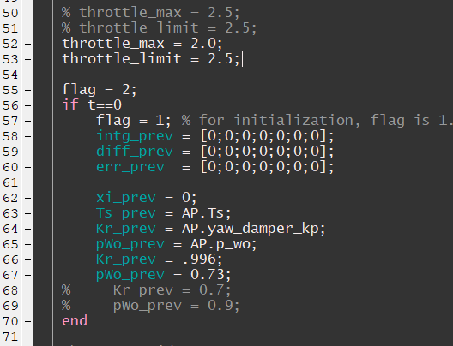

* Now run autopilot_vtolsim.slx file after setting the input commands as follows –

