**Date**: 29/Jun/2020

**Author**: Nikhil Madduri (nikhil.madduri@gmail.com)

**..\e_version\6_ap\testcases\results\case3\files\**

* To understand the background first refer to –

“..\e_version\**5_ldm**\testcases\3_replacing_S_function_with_own_rk4\”

In that we’ve seen that trimming is not working with own vtol_dynamics that uses own rk4, sixDOF.

* Hence I’m using a **jugaad** of first trimming using S-function in vtol_dynamics and then using my own vtol_dynamics for the normal running of the code.
* The procedure for doing this is as follow—
  + Go to – “..\e_version\6_ap\testcases\results\case3\files\”
  + First run “>>**vtol_parameters_trim**”. This uses the file ***vtol_parameters_trim.m*** calls the following line –



Which uses S-function type vtol_dynamics block (old)—

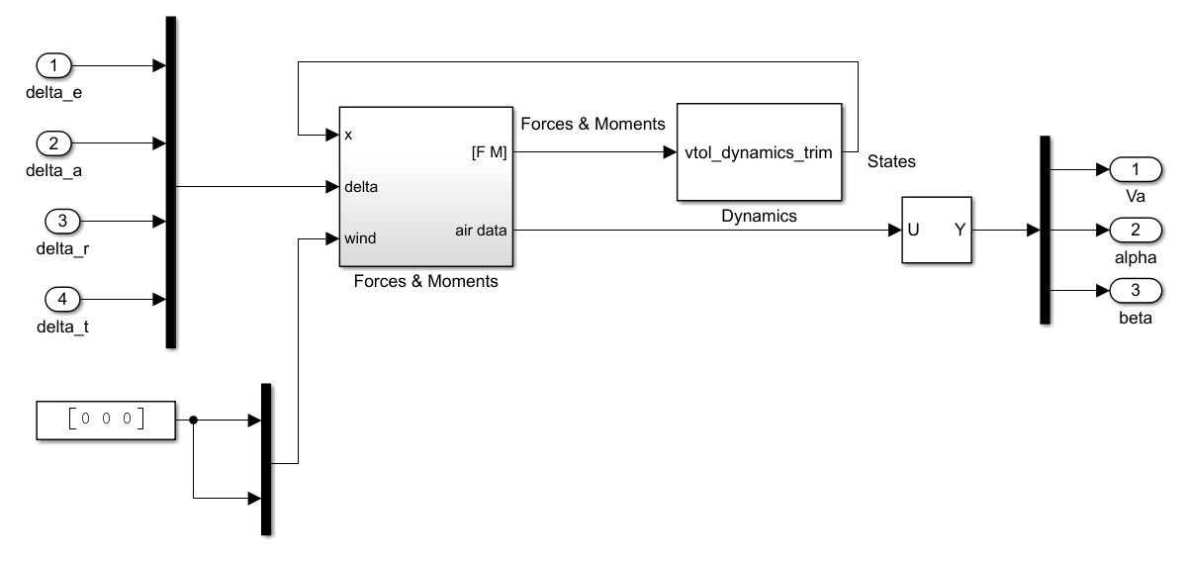

* + Using the above old model of vtol_dynamics, it will create the following parameters—

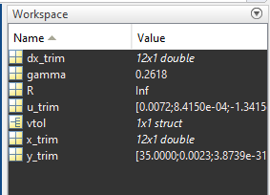

* + Now hard code **x_trim, u_trim, y_trim, dx_trim** in the file ***vtol_parameters.m*** as shown –



This can be done easily by double click on say x_trim variable in workspace and selecting all the cells in which numbers are filled and simply pasting into ***vtol_parameters.m***.

* + Following lines of code will use the above trim values –

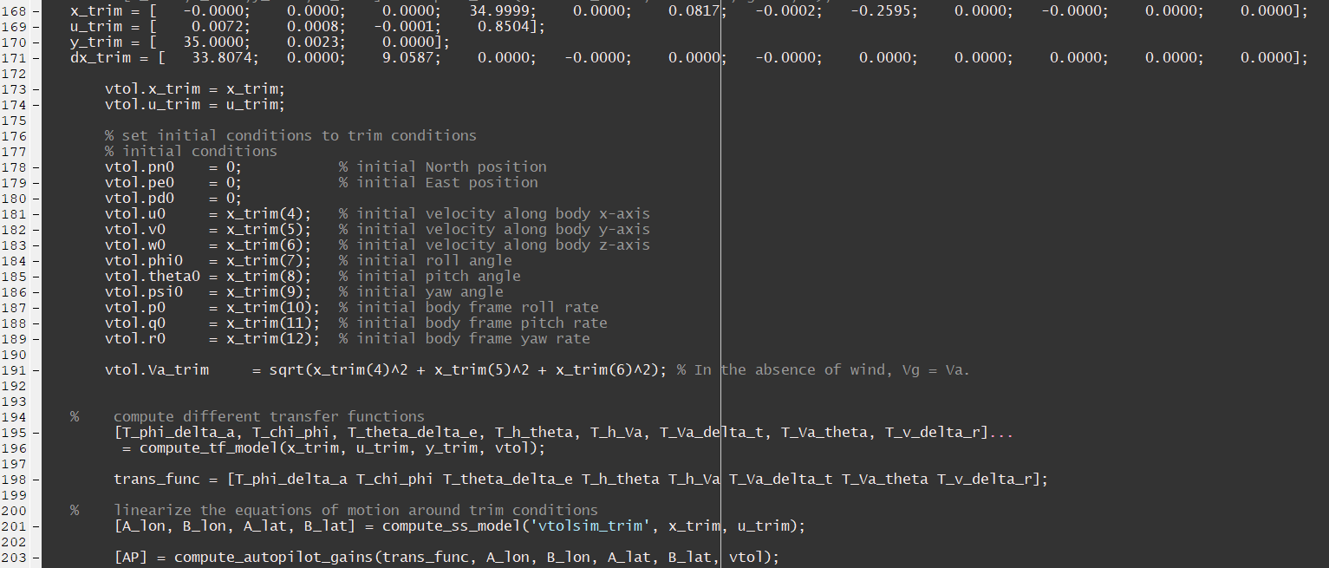

* + Note that each time you change the initial values in the below lines –

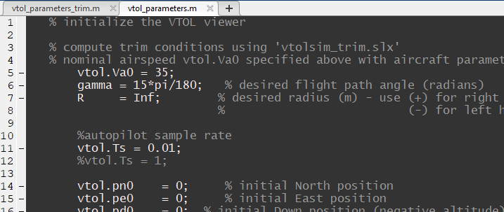

you will have to generate new trim values first using ***vtol_parameters_trim.m*** andhard code them inside ***vtol_parameters.m.*** For example if you set vtol.Va0 = 45 m/s, then you’d have to again do trimming and change the hard coded values.

* + Once the trimmed inputs are hard coded into ***vtol_parameters.m***, simply open autopilot_vtolsim.slx, set the input commands (airspeed, altitude, roll, course etc) and run the model –

