1_test

1_roll_loop

* Initially there was an error in the transfer function of the roll loop. I’ve fixed it and tuned the roll loop Simulink model first and then ran the autopilot code and found that the roll plot looks perfect.
* For testing the roll plot alone without concerning about course loop, have to uncomment phi_c = uu(5+NN) so that manual input will be sent to the roll loop to bypass the course command which used to dictate the phi_c –

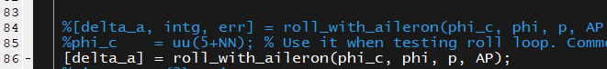

2_course_loop

* Since the transfer function issue is fixed, course loop also works accurately.
* I now changed the factor to exactly what was suggested in the book (=1/10th of dutch roll frequency in the *compute_autopilot_gains.m* file) and tuned again and the course loop looks works well.

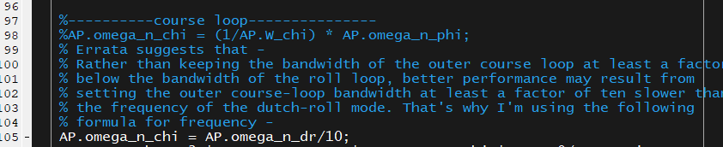

* Note that the in the signal generator through which we set the command signal has to be se properly –
  + If we set a frequency of input signal to as high as 0.2, course hold does not work well—

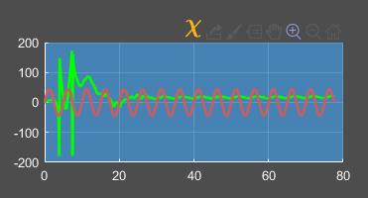

* + But I then tried setting it 0.012 which is lower frequency it works well—

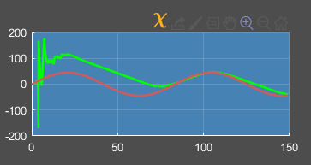

* In the successive loop closure technique, the very premise is that the inner loops are 5-10 times faster than the outer loops. Hence we need to set the frequency of course loop at least 5-10 times lower than the roll loop.
* Also check that in *true_states.m* file, **chi** depends on wind as well—

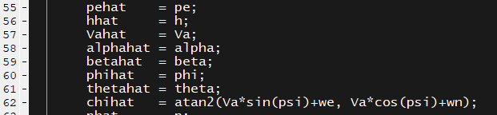

To first check the course loop, I’ve made all the **wind components zero**.

* Later on I tried one case by setting **WIND.Va0 = 10 m/s** inside *wind_parameters.m* the course loop was **unable to handle** it –

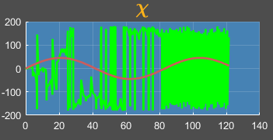

* But when I tried **WIND.Va0 = 5 m/s,** it works fine.

Case files were not saved for 1_test folder. So tried to do again in 2_test to generate similar results.

2_test

1_roll_loop

Commands:

Va_c = 35

h_c = 100

theta_c = 0

chi_c = 0

roll_c = square, 45, 0.1

Throttle limit = 1.5

2_course_loop

Commands:

Va_c = 35 +/- 7

h_c = 100

theta_c = 0

chi_c = sine, 45, 0.012

roll_c = 0

Throttle limit = 1.5

3_pitch_loop

Commands:

Va_c = 35

h_c = 100

theta_c = sine, 20, 0.1

chi_c = 0

roll_c = 0

Throttle limit = 1.5

4_airspeed_loop

1. Commands:

Result file: ***4_airspeed_throttle_1.5.jpg***

Va_c = 100 +/- 25

h_c = 100

theta_c = 0

chi_c = 0

roll_c = 0

Throttle limit = 1.5

1. Commands:

Result file: ***4_airspeed_throttle_4.5.jpg***

Va_c = 100 +/- 25

h_c = 100

theta_c = 0

chi_c = 0

roll_c = 0

Throttle limit = 4.5

No matter how much I increase throttle, there seems to be a saturation limit on the airspeed. Never able to go beyond 100 m/s. Have to fix this bug. If I give too high a throttle to make airspeed cross 100, there is error and the code stops running. But it works fine for Va_c = 70 or such values lesser than 100. Look at the case below.

1. Commands:

Result file: ***4_airspeed_throttle_2.5+.jpg***

Va_c = square **70 +/- 5**, at freq 0.012

h_c = 100

theta_c = 0

chi_c = 0

roll_c = 0

Throttle limit = 2.5

Does achieve commanded velocity but not commanded height. Height saturates below 25 meters. It means that the throttle is not sufficient for this aircraft to reach the commanded height. So I increased **throttle_max** to 2.5 and also set this as the throttle value during takeoff and climb as well.

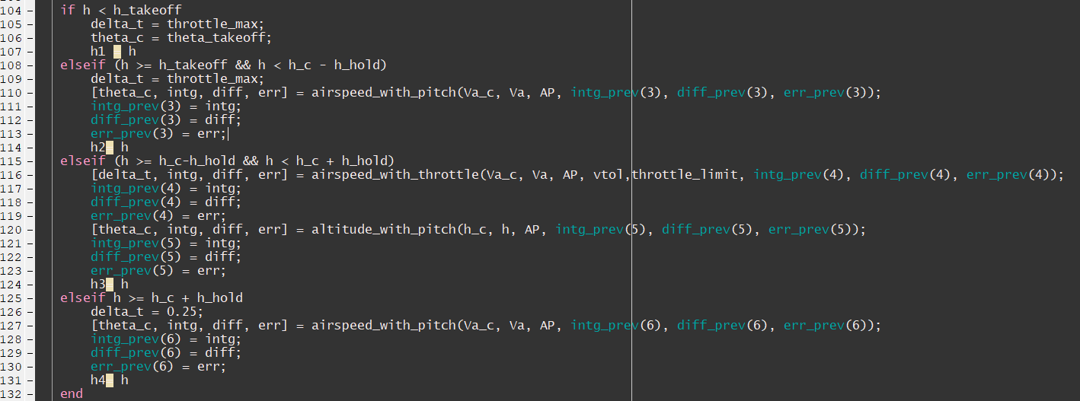

5_altitude_loop

1. Commands:

File: ***5_altitude_loop_1000m.jpg***

Va_c = square **70 +/- 5**, at freq 0.012

h_c = **1000**

theta_c = 0

chi_c = 0

roll_c = 0

Throttle limit = 2.5

1. Commands:

File: ***5_altitude_loop_10000m.jpg***

Va_c = square **70 +/- 5**, at freq 0.012

h_c = **10000**

theta_c = 0

chi_c = 0

roll_c = 0

Throttle limit = 2.5

During the climb it runs for entire 10 km climb in full throttle. Hence to be able to climb, it is maintaining a higher velocity. So it is achieving 70 and above values. But it is not achieving commanded velocity below 70 because it cannot climb if it reduces velocity. But you can observe that once it reaches 10 km altitude, it reduced the throttle and it now achieves both lower and upper limits on velocity.

