Solution 3

* Inside the main folder, open **“prob_3” folder** for Simulink model and Matlab script.
  + First run “params.m” script alone and then run the Simulink model.
  + To switch simulation between problems 3a and 3b, "params.m" file has to be opened and "**scraft.hy0**" value has to be changed (set it to either 0 or -5). Then the simulink model can be run.
* To be able to see the difference between cases 3a and 3b, I had set a longer simulation time of 20,000s.

**Case 3a** (hy = 0)

* **Until 499 seconds**, even if $ω_{y}≠0$, we find that $θ=0$ because the first term on RHS is cancelled out by the third term since $ω_{y}= -n$.



* Likewise, other euler angles $ϕ and ψ$ also remain zero until torque is applied.

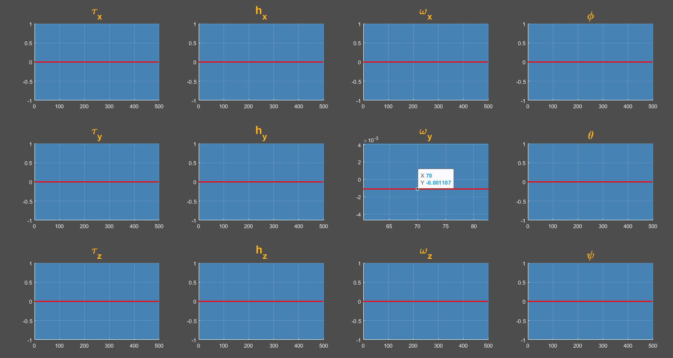

* **After 500 seconds**, once the torque is applied as a 5 second pulse and then stopped, hx continues at a constant value. But $ω_{x}$ does not remain constant as there is cross-coupling terms with other axes. Hence there are oscillations in angular velocities which lead to oscillations in Euler angle values.

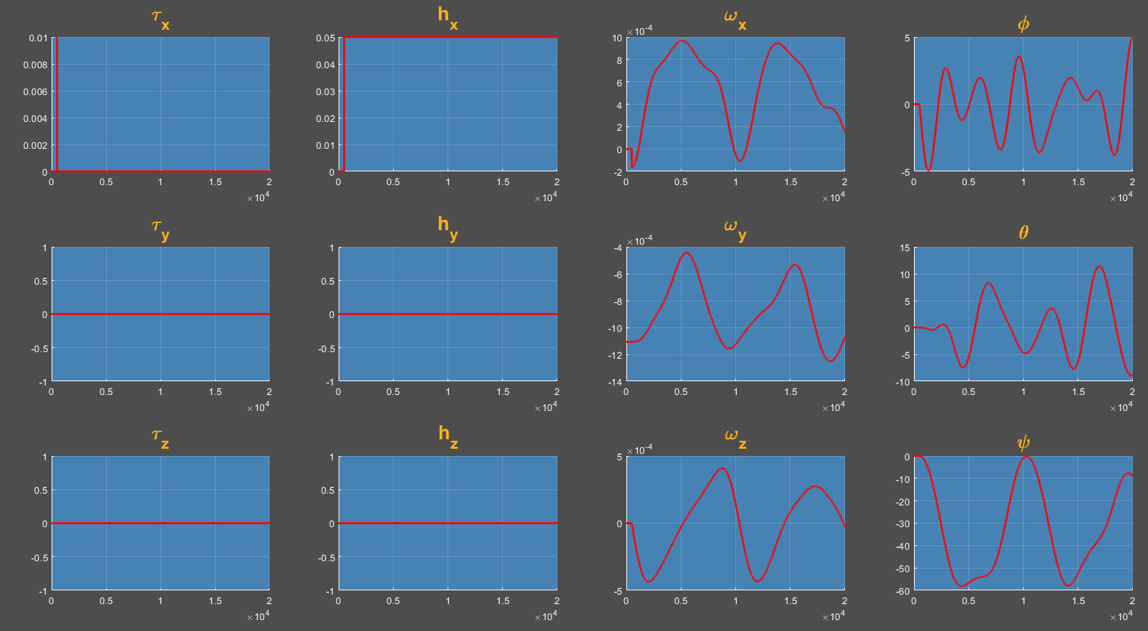

**Case 3b** (hy = -5 N-m-s)

* **Until 499 seconds**, $ω_{y}= -n$ and $h_{y}= -5$ and all three euler angles remain zero.
* **After 500 seconds**, once the torque is applied as a 5 second pulse and then stopped, hx continues at a constant value. Only $h_{z}= 0$ while all other components of angular momentum as well as angular velocities along all the three axes remain non-zero. This leads to oscillations even in all the euler angle values.

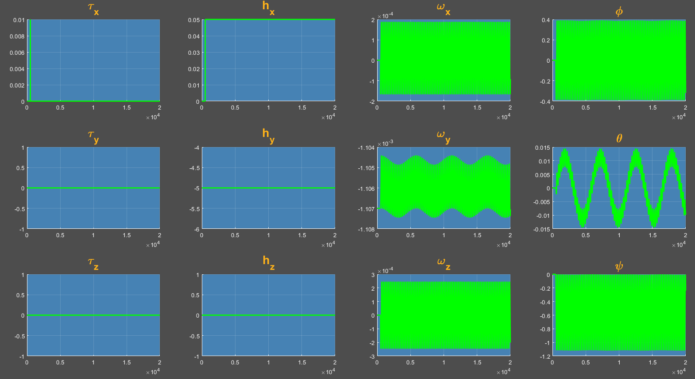

**Comparing cases 3a & b**

* Though there are oscillations in euler angles in case 3b, when we compare cases 3a and 3b,we can observe that spinning up the momentum wheel along y-axis causes it to resist large changes in the euler angle $θ$ because of conservation of angular momentum. Essentially, the effect of spinning it up has the stabilization of theta (look at the plots below to see comparison of theta in both cases) along the desired direction.
* In the absence of hy, we can see that the oscillations are huge and the satellite is unable to orient itself in the desired direction.

