Lean CAD Kit - User Guide
How to install the kit, start a project, talk to the agent, and what the kit can do
2026-11-06 - written from the kit release built on 2026-11-06 - for the person who runs the kit and hands it to others

What is in this guide
 | Chapter | What it answers
1 | What the kit is | What it does, who does what, and the words it uses
2 | Installing it | Python, FreeCAD, Claude Code and the kit folder - once per computer
3 | Starting a project | The project folder, the four files you fill in, the starting model, the first session
4 | Talking to the agent | How to ask, what it will ask you and why, what you never do by hand
5 | What the kit can do | Every edit type, one edit end to end, the rebuild route, the mesh and print routes, delivery
6 | The gates, and why each exists | The checks that hold the agent to the method
7 | What lands where | The project folder in one table
8 | Updating the kit and handing it on | After an update, several projects, removing it, giving it to someone
9 | Known limits | What the kit does not do today, and what to do instead
10 | Cheat sheet | The commands you type, and the sentences that work
How to read it. Chapters 2 and 3 are done once; chapter 4 is the one to read before the first session; chapter 10 is the page to keep beside you. The kit's own documents call the person the agent works for the client - in this guide that is you.

1. What the kit is
The Lean CAD Kit lets Claude Code (Anthropic's coding agent) make controlled, checked changes to FreeCAD solid models. You say what you want changed, in your own words; the agent does the CAD work through the kit; you are shown pictures and asked for decisions. You never write a script, run FreeCAD from a command line or measure anything yourself.
The kit works the way a careful CAD engineer does. Every change is one small, named feature: a flat shape drawn on a known plane and given depth (a block, a hole, a pocket), or two flat shapes joined by straight sides (a wedge, a taper). Each feature is built as its own small solid, checked, looked at from every side, and only then joined to the model. Nothing is sculpted, nothing is "smoothed" by guesswork, and nothing goes into the model until the pictures say it is right.
The kit is three things: the method (a handful of pages the agent reads), one command (kit) that runs every step, and a set of gates - Claude Code hooks and checks inside the command that refuse a step done the wrong way. The gates are why the kit exists: an agent left to itself guesses, skips the pictures, and writes files everywhere. Chapter 6 lists them.

Who does what
Who | What they do
You (the client) | Say what you want; fill in the project's facts and acceptance table; look at the pictures you are sent; answer the few questions that need you; give rulings; confirm regions; say when a model is delivered; open the delivery in FreeCAD.
The orchestrator | The Claude Code session you talk to, on an Opus- or Fable-class model. It owns every number, every measurement and every acceptance: it finds the place, writes the job card, runs the job (or hands it to a worker), reviews the pictures, checks the numbers and puts the result into the model.
Workers | Smaller helper agents (Haiku, Sonnet, or Opus for the hardest type) that the orchestrator may launch for one job each. A worker copies a fixed template, fills in the numbers from the card, runs it, opens the pictures and reports. It never measures and never chooses a number; a missing number makes it stop and ask.
Reviewers | Helper agents that each look at one arc of the picture orbit after an edit and report what they see, in a fixed form. The orchestrator still opens the pictures and gives the verdict itself.

The words the kit uses
These words appear in the agent's messages and in the kit's pages. Each is explained again where it first matters.
Word | Meaning
Model of record | The one current version of your part: a single valid solid saved as a .brep file. Every edit is made against it and produces the next one.
Bank | The folder that holds the model of record and its earlier versions (claude_code\bank\). Named R01_..., R02_... as edits land.
REV | A revision label: R01, R02 and so on. Pictures and deliveries are filed by revision.
Job | One edit in progress, with its own folder (claude_code\jobs\<name>\) holding the card, the script, the pictures and the result.
Card (job card) | The written plan for one job: the edit type, the shape and its numbers, the plane, the depth, how far it may go, which acceptance row it serves, and what the result should look like. Checked by the kit before anything runs.
Edit type | One of the kit's allowed kinds of change (hole, pocket, wedge, gap fill ...). Chapter 5 lists them.
Piece | The small solid one job builds (the boss, the hole's cutter) before it is joined to or cut from the model.
Region | A named feature of your part as you would name it ("the mounting flange", "the left rib"). Cards say which region they touch.
Atlas (region atlas) | The map of your part's regions, made once the part has taken shape and confirmed by you. It is shown as a coloured FreeCAD model.
Frozen region | A region no edit may change (a sealing face, a mounting face). If an edit has to pass through it, it is put back exactly and measured.
Dossier | A region's measurements, taken once and reused, so the same thing is never measured twice.
Orbit review | The set of pictures taken after every edit: 32 views of the changed area from above, below and all sides, each judged.
Frame | One of those pictures.
Trial | In the rebuild route (chapter 5): the rebuilt piece put into a copy of the real model so it can be judged in place before it is accepted.
Deliverable / delivery | What you are given at the end of a round: a coloured FreeCAD document (and, for printing, the print file), in Deliverables\<REV>\model\.
Ruling | A decision you gave, recorded in your words with its date. The newest ruling on a subject stands.
Round | A batch of edits that ends in a delivery.
B-rep / mesh | Two ways a shape is stored. B-rep: exact faces and edges (FreeCAD's solids, .brep, .step). Mesh: triangles (.stl). Most edits are B-rep; print files are meshes.

2. Installing it - once per computer
Everything below was tested on Windows 11. Every command is one PowerShell line. Replace <you> with your Windows user name and the example folders (C:\CAD\LEAN_KIT, C:\CAD\Projects\MyPart) with your own.

What you need
Piece | Version tested | What it is for
Windows | Windows 11 (Windows 10 should work) | Linux and macOS are not tested.
Python | 3.12, 64-bit, from python.org, with numpy, scipy, pillow, matplotlib | Runs the kit command and the Claude Code hooks; draws the review pictures.
FreeCAD | 1.1 | The geometry engine. The kit runs its command-line program in the background, one step at a time; you use the normal FreeCAD window to open deliveries.
Claude Code | The Claude desktop app's Code tab, or the command-line version; a Claude Max plan; the ultra tier is recommended | The agent. Sign in with an account that can run an Opus-class model (for the orchestrator) and Haiku / Sonnet (for workers).
Git for Windows | current | Required: Claude Code's requirement on Windows; the kit's guard reads its commands.
Disk space | a few GB free | Pictures, meshes and model copies add up.
Code tab, not Cowork. The kit's hooks run in Claude Code sessions - the desktop app's Code tab or the command-line version. A Cowork session runs in its own sandbox and is not where the kit is used.

Step 1 - Python
- Download the Python 3.12 Windows installer (64-bit) from python.org/downloads/windows and run it with "Install Now". It lands at C:\Users\<you>\AppData\Local\Programs\Python\Python312\python.exe. Adding it to PATH is optional.
- Install the four packages with that Python:
& "C:\Users\<you>\AppData\Local\Programs\Python\Python312\python.exe" -m pip install numpy scipy pillow matplotlib
- Not sure where your Python is? py -0p lists every installed Python with its path.
The Python trap. On Windows the bare word python is often not Python at all but a Microsoft Store stub that opens the Store or prints nothing. The kit therefore always names Python by its full path, and refuses the bare word. To stop the stub getting in your own way: Settings > Apps > Advanced app settings > App execution aliases, turn off python.exe and python3.exe.

Step 2 - FreeCAD
- Install FreeCAD 1.1 from freecad.org/downloads.php.
- Check the command-line program answers:
& "C:\Program Files\FreeCAD 1.1\bin\FreeCADCmd.exe" --version
- The kit already looks in C:\Program Files\FreeCAD 1.1\ and FreeCAD 1.0\. If yours is somewhere else, put the path of its FreeCADCmd.exe first in the list freecadcmd_candidates in LEAN_KIT\kit\env.json (this computer's own settings file).

Step 3 - Claude Code
Install Claude Code (the desktop app's Code tab, or the command-line version) from claude.com/claude-code and sign in. Pick an Opus-class model for the session you talk to. Claude Code asks before it runs a command: approve the kit's commands as they come, or add allow rules for them. The kit's hooks refuse what the kit forbids whatever Claude Code allows.

Step 4 - put the kit in place
- Copy the release's LEAN_KIT folder to a permanent place, for example C:\CAD\LEAN_KIT. Keep the folder name LEAN_KIT.
- One copy per computer. Every project runs this one copy; nothing of the kit is copied into a project.
- Projects live outside it, never inside the kit folder or any folder named lean_kit (the installer refuses that).
- Not under the Windows temp folder. The agent may write anywhere under temp, so a project there would have no write boundary.

Step 5 - check the kit itself
The kit carries 28 self-test suites. They need no project and take about six minutes. The last line must read failing: none.
& "C:\Users\<you>\AppData\Local\Programs\Python\Python312\python.exe" "C:\CAD\LEAN_KIT\_run_selftests.py"

3. Starting a project

Make the folder and wire it
- Make the project folder, for example C:\CAD\Projects\MyPart.
- Copy the contents of the release's project_template folder into it: CLAUDE.md, PROJECT_FACTS.md, PROJECT_SUCCESS_CRITERIA.md and claude_code\PA12_MJF_Rules_EVALUATED.md.
- Run the installer for the project:
& "C:\Users\<you>\AppData\Local\Programs\Python\Python312\python.exe" "C:\CAD\LEAN_KIT\install_lean_hooks.py" --project "C:\CAD\Projects\MyPart"
The installer wires the kit's hooks into the project's .claude\settings.json (an existing file is kept as a .bak copy, its other settings preserved), copies the four helper-agent definitions into .claude\agents\, makes the working folders (claude_code\jobs, claude_code\bank, Deliverables, references), writes claude_code\WHERE_THE_KIT_IS.md with this computer's command lines, records the kit's checksums, and ends by printing its status. Every hook line should end OK.
- Check the wiring at any time with the same line and --status. A moved kit reads HOOK SCRIPT NOT FOUND: keep the kit where it was installed, or run the installer again.

The four files you fill in
The agent reads these before it asks you anything. The more they hold, the fewer questions you get.
File | What you put in it
PROJECT_FACTS.md | What the part is and does, what it mates to, the process and material; the units; which way is front, up and left, and how to tell from a picture; the named features (with which are frozen); the key dimensions and where each came from. Section 6 is the log of your rulings - the agent appends to it, in your words, with the date.
PROJECT_SUCCESS_CRITERIA.md | The acceptance table. One lettered row per thing that must be true, in your words, with the test that decides it ("A - the four mounting holes stay on their 50 mm pitch: measured centre to centre"). Every job names its row; nothing is accepted without one.
claude_code\PA12_MJF_Rules_EVALUATED.md | The rules of the process the part is made by - minimum wall, hole, gap, tolerance, build size, the file the maker accepts - as numbers, each with its source. The file keeps this name whatever the process is; the kit pushes it into every session. Only you edit it: the agent is refused.
CLAUDE.md | The project's entry page. Fill in the paragraph about the part, the frozen features, and any standing orders of your own (units, naming, which end is front, review views you want).

The starting model
The kit edits one valid solid saved as a .brep file. In FreeCAD: open or build the part, select the solid, File > Export, choose "BREP format", and save it as claude_code\bank\R01_BODY_MASTER.brep. A STEP file is converted the same way: import it into FreeCAD, then export the solid as BREP. The kit reads .brep and .stl only.
Starting from nothing, or from purchased parts: leave the bank empty. The agent's first session then follows the first-body route (chapter 5, "Starting from nothing").

The first session
- Open Claude Code on the project folder itself - not its parent. Claude Code reads the hooks from the folder it has open; opened on a parent folder it finds none and nothing says so. Hooks load when a session starts: if a session was already open before the install, start a new one.
- Say what you want changed, in your own words. Before your first message the kit has already given the agent its standing rules and the project's state.
- On a project's first session the agent reads the method once, answers three questions about the rules, opens the session on the model of record, and then works out what kind of edit you asked for.
- To check the gates are live, ask it to run kit status. It should report the guard alive. A line saying the guard is NOT RUNNING means Claude Code is open on the wrong folder or the session started before the install. On a brand-new project the guard has simply not run yet before the first tool call; ask again after one command.

4. Talking to the agent

How to ask
- Say what, where, and what for. "Add a 6 mm hole through the mounting tab, centred, for an M5 bolt." The agent turns your words into the edit type (the kit has a router for this) and asks only what the record does not answer.
- Name features the way you think of them. "The left rib", "the cover seat". Once the atlas exists, those names are its regions.
- Give dimensions, not coordinates. Sizes, distances from a named edge or face, "centred", "flush with". The agent will not put coordinates in a message to you either - it works them out from the model.
- For anything with a direction, say what it is for. "The sloped face looks up and back at the viewer." A feature with a direction is checked against that sentence, not against its own numbers (a screen once came out facing away from the viewer with every number right).
- One change per sentence is easiest; a list is fine. The agent runs one job per feature, in order. Related changes go in the acceptance table as rows.
- Say when you want it delivered. A delivery is made on your word.
Sentences that route cleanly, one per edit type, are in chapter 5 and on the cheat sheet.

What happens after you ask
You will see the agent work through a fixed sequence; each kit command prints the next step. In plain terms:
- It names the edit type and finds the place on the part.
- It opens a job, writes the card, and the kit checks the card before anything runs.
- It renders the area before the change and looks at it, then measures only what the pictures point at.
- It builds the piece (itself, or through a worker), then runs the orbit review: 32 frames of the result, every one judged.
- It checks the numbers: one valid solid, the volume and face count as planned, nothing changed outside the edit's area, no hole punched where none was meant.
- It accepts the job and writes the next model of record (R02, R03 ...).
- At the end of the session it writes a handoff for the next one.
A small edit (a hole, a pocket, a boss) takes a few minutes of machine time. Long steps run in the background; on long work the agent sends a one-line status about every 30 minutes.

What the agent will ask you, and why
It asks | When | Why
Whether now is the time to make the region atlas | At the end of every turn, once the project has a model and no atlas yet | Regions are what cards cite and what frozen features are checked against. Answer "make it now" or "not yet - when <your words>"; "not yet" keeps the question quiet until the next model of record.
To confirm a region | When the atlas is made or a region is added | Only a region you confirmed can be cited on a card. You are shown a coloured model; you can click faces in FreeCAD and paste the selection lines back to say exactly which faces you mean.
Which of two readings you meant | Only when your words could build two different shapes, and the record does not settle it | It asks once, with a picture of each reading, after the measurement that frames the choice. If both readings build the same shape it picks one and builds.
For a ruling | When a decision is yours (which openings are designed, what may be changed) | Your answer is recorded in PROJECT_FACTS.md section 6, in your words, dated. The agent's own interpretation is filed separately as a "reading", never as your ruling.
To look at pictures | After an edit you should see, before a delivery | Pictures for you go to Deliverables\<REV>\review\, each captioned so it explains itself. The pictures are the acceptance.
For your word to deliver | When a round is ready | A delivery is made on your word only.
To name a sealing fix | When the only problem is construction (a gap, a sliver) and not shape | Construction-only fixes run last and only when you named them.
To run a command for it | Rarely - something only you can do on your machine | It gives one generated PowerShell line to paste, never one typed by hand.
Nothing, but it stops | When disk space runs low | It warns you and stops before a disk-space crash.

Things that look odd but are deliberate
- The apology sentence. If the agent measures something before it has looked at a picture of it, or tries to undo work the pictures passed, it is locked until its next message to you opens with a fixed sentence: "I'm a silly dum dum - I'm so very sorry! ...". You see each one as it happens. It is part of the process (your rule: it must announce it every time); it is also the only time the agent says sorry.
- "RENDER EXCEPTION". All pictures come from the kit. If the agent wants a script to draw its own, it must tell you why in a line starting RENDER EXCEPTION, and again when asked "Are you sure?".
- A red RENDER DEFECTIVE band on a picture. The kit checks every picture's mesh against the real surfaces before it draws; a picture that fails is stamped and counts as no evidence. The agent makes it again.
- Refusals. A kit command or a hook that refuses is doing its job; the refusal names what to do. The agent follows it.
- It will not stop with work open. If you want it to stop anyway, say so - it records your reason and stops.

What you never need to do by hand
- Write scripts, cards or FreeCAD macros; run FreeCAD's command-line program.
- Measure anything, or keep a list of measurements - the agent files every number it measures.
- Record your own decisions - say them; the agent records them as rulings in your words.
- Colour or assemble the delivery - kit deliver builds the coloured FreeCAD document from a template.
- Prepare the print file - kit printfile and kit printcheck do it and report.
- Keep track of where things are - the layout is fixed (chapter 7) and the agent cannot write outside it.
What stays yours: exporting a starting .brep (or STEP converted to .brep) from FreeCAD; filling in the four project files; approving commands; looking at pictures; rulings and region confirmations; saying when to deliver; opening the delivery in the FreeCAD window - that look is the delivery's acceptance; running the installer after a kit update.

Steering a session from outside, and ending one
- Just type in the chat. That is the normal way.
- The inbox. Someone outside the session (you from another window, or whoever maintains the kit) can post a note into claude_code\INBOX.md with kit inbox --append <file.md> --from "<who>" run from the project's claude_code\ folder. It is printed at the top of the agent's next kit command and outranks what it was about to do. The kit's pages call whoever writes there "the auditor".
- Ending. The session ends with kit close, which writes SESSION_HANDOFF.md: where the design stands, what is left, improvements and new facts. The next session starts from it.

5. What the kit can do

The ordinary edits - one paragraph each
Each edit type has a fixed template and a card. The "Say" line is a sentence that routes to it. Tier is the smallest helper agent proven to run it from a filled card.
Type | What it does | Say
Sketch extrude | A closed flat outline - rectangle, rounded rectangle, circle, or straight sides with drawn arcs - on a plane, given depth, added or cut. Blocks, pads, walls, ribs, pockets, recesses, slots, bosses. Rounded corners are drawn into the outline, never filleted afterwards. Not for patching a curved surface (that is sketch connect). Tier: haiku. | "Add a 10 mm round boss, 8 mm tall, on the top face." / "Cut a 12 x 8 mm pocket 3 mm deep."
Sketch connect | Two closed outlines on two planes joined by straight sides: a wedge, a taper, an angled face, a transition block. Also two special uses: the bedsheet (a patch that follows a sound curved skin to fill a shallow dent) and the window pane (a defect in a curved skin cut out and closed with a piece shaped from the skin's own sections). Tier: haiku. | "Make a tapered wedge from the 20 x 10 base up to 10 x 5 at 15 mm."
Hole | A round bore from a named face to a depth or through, with an optional counterbore or countersink. Insert sizes come from your facts file. No threads. Tier: haiku. | "Drill a 6 mm hole through the plate at its centre."
Gap fill | The air between neighbouring surfaces becomes material, touching every neighbour by construction - a slit, a channel, a floor brought flush. The fill's faces are the neighbours' own surfaces. A channel that carries air is not filled without your word. Tier: haiku (the orchestrator sets it up). | "Fill the gap between the web and the wall."
Cutter | Removes a whole feature that should not be there - a plate, a shelf, a web, a stub, a boss - by drawing an independent cutting tool from measured sections and cutting once, with two picture checks of its own. Not for smoothing. See the known limits (chapter 9). Tier: opus helper. | "Remove the stub on the underside."
Mirror / pattern | Copies a piece already built across a mirror plane or along a spacing, then adds or cuts all copies at once: bolt patterns, both sides of something. The far side is sectioned first - a name being symmetric does not mean the shape is. Tier: haiku. | "Repeat that hole on the other side." / "Six of them, 10 mm apart."
Split | Divides the body at a plane into two parts and keeps both - a base and cover, any two-part print. Lips and rebates are separate edits afterwards. Tier: haiku. | "Split the housing into base and cover at the parting plane."
Edge round | A round on the edges of a fresh, simple piece before it is joined (a softened box edge). Never on the assembled body - there the round is drawn into the outline instead. Tier: haiku. | "Round the top edge of the new boss 1 mm."
Revolve | A closed outline turned about an axis: a stepped round boss, a lip ring. Tier: haiku (first runs are the test). | "Add a stepped round boss, turned."
Shell | Hollows a plain box-like solid from one open face with a wall thickness - once, early, on a simple solid. Tier: haiku (first runs are the test). | "Hollow the box from the top, 2 mm walls."
Move | Moves a whole part, or turns it about an axis and moves it, with no change of shape. A placement alone (an exported part put into your frame) is done without a job and recorded in the project's frame map. Tier: haiku. | "Turn the board 90 degrees and move it 50 mm forward."
Region look | No edit: pictures of a region for you or for the agent. Tier: haiku. | "Show me the corner by the mounting tab."
When the request is not a clean match, the router prints a symptom table instead: what a section through the problem shows, what it is, and which type fixes it. A shape problem (the outside is wrong) comes first; a construction problem (a sliver, a lamination, a punch-through) comes last and only when you named it.

One edit, end to end
A boss, a hole or a pocket runs this way. The agent drives every step; the kit refuses a step out of order.
Step | What happens
Route | The kit names the edit type, its tier and its sequence.
Job and card | A job folder with a read-only link to the model of record; a card scaffold with every slot the type needs and its known traps.
Look, then measure | The area is rendered and looked at first; then only what the pictures point at is measured, and filed.
Card check | Every slot filled, the numbers in range, the traps of that type checked. A card that fails cannot be run.
Build | The template is filled with the card's numbers and run in FreeCAD under a time cap.
Orbit review | 32 frames: 12 round the part from above, 12 from below, the six straight views and two isometric views, on the changed area. Every frame judged pass, fail or cannot-see; a defect is real only when a second frame confirms it.
Numbers | One valid solid, volume and faces as planned, nothing changed outside the box round the edit, no punch-through.
Own reading | The agent types back codes stamped in the frames - proof it opened them - with one line per frame.
Accept and apply | The last gate, then the piece joins the model of record and the next revision is written.
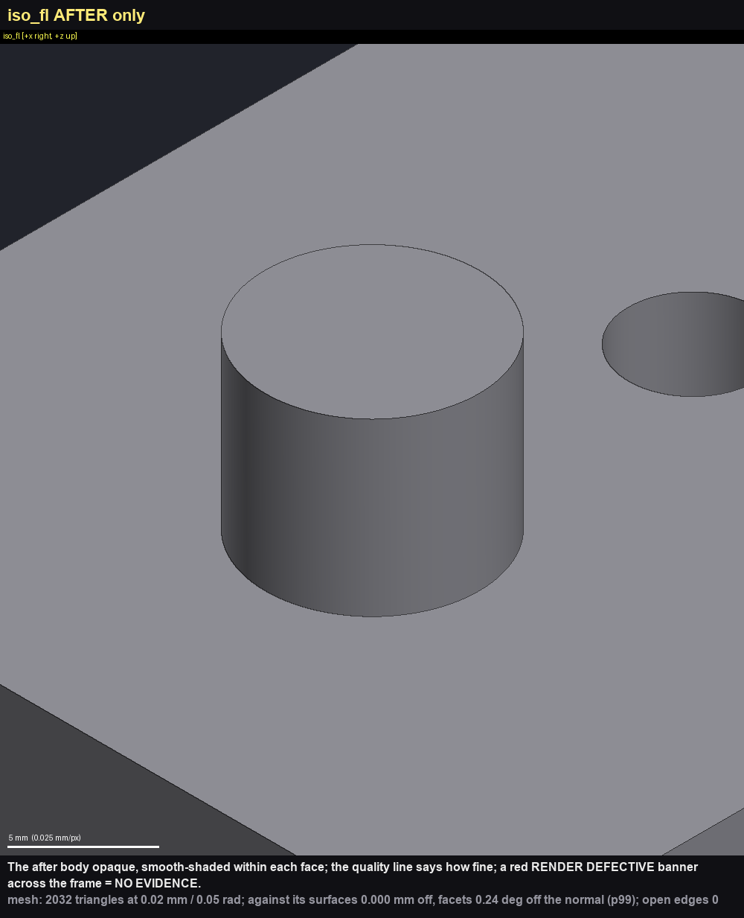
Figure 1 - one frame of a kit orbit review (a scratch test: a 10 mm boss added to a plate beside an earlier hole). Every frame says what it shows, its scale, and how faithful its mesh is; a red RENDER DEFECTIVE band would mean the frame is no evidence.

The rebuild route (the "burrito") - a messy region made clean
Some regions are wrong in their construction rather than their shape: slivers, gaps, spikes, overlapping skins, a lumpy blend, a face that punches through. The kit's burrito route re-makes such a region as clean solid geometry and sews it back into the body. It is run by the orchestrator only, one kit step at a time, each step judged on its own pictures. What it must produce:
- Solid in, solid out - one valid solid, never a mesh in the model.
- The junk gone - gaps and enclosed pockets filled, spikes and shards removed by the rebuild itself, nothing under the print tolerance.
- Simple and smooth, with few faces - about as few as the region had, or fewer.
- Fits back exactly: where new meets old, a step of 0.15 mm at most.
- Designed openings stay open (which openings are designed is your ruling); frozen regions put back; symmetric where the design is.
How it runs, in plain terms. The agent marks the edit region (a box and its cut walls) and makes the exact faces where the new piece will meet the body - first, before anything else. It then picks which of the original faces to keep, groups them into features you would name ("a spine, a vane, a support"), and draws the wireframe: every border one simple line, arc or curve, chosen from the pictures. The original is the starting reference, not a constraint - borders can be moved, faces split or joined. Surfaces are built through the wires, the piece is looked at, and then it is put into a copy of the real model as a trial.
The pictures decide. Every step of this route is judged on its pictures, every frame opened; a verdict on pictures nobody opened is refused. A piece judged right stands - only a picture can overturn it. The trial is the acceptance: it is reviewed by two independent reviewer agents and by the orchestrator, and once it passes it is not rebuilt (your words: "If a trial passes, do not rebuild it, do not reinsert it"). A trial file is made for you only when you ask for one.
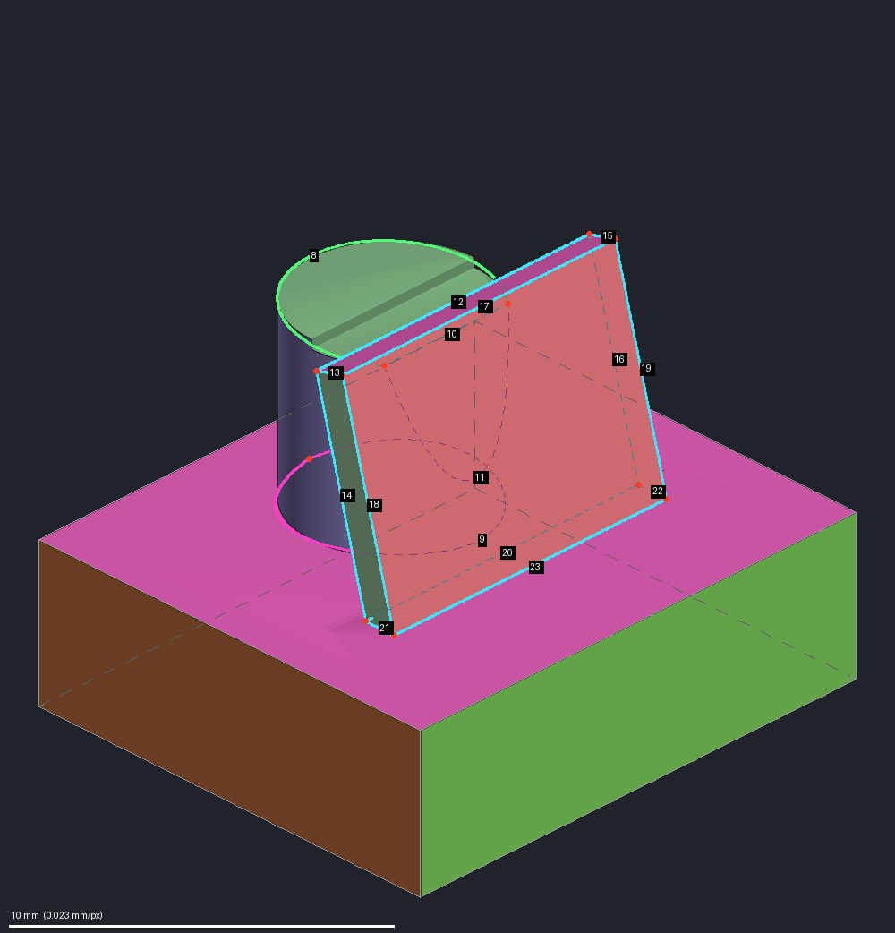
Figure 2 - a wireframe frame from a scratch run of the rebuild route (a test part: a plate with a round boss and a thin fin leaning against it). Each border is drawn as one simple curve and coloured by its kind - cyan a straight line, green one arc, yellow one cubic curve, magenta more than one span (its points need fixing); dotted where it runs behind the part. The numbers are what the agent's decisions refer to.
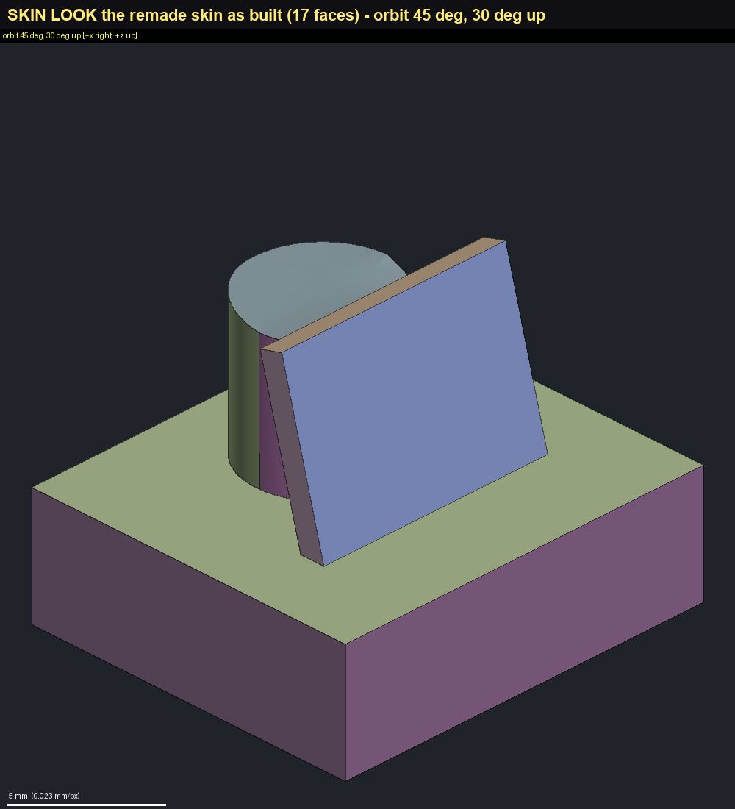
Figure 3 - the same region rebuilt: 17 faces, each its own tint, judged for shape - one simple surface per face, clean borders, no lump or fold.
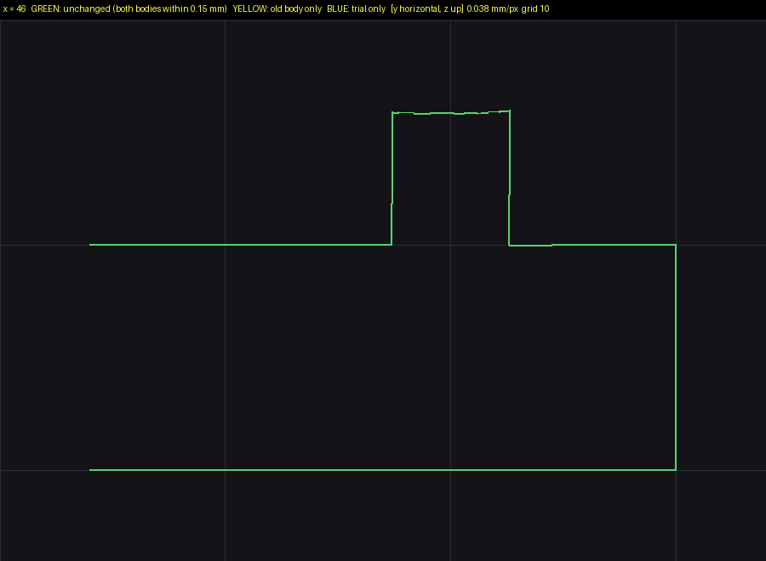
Figure 4 - a station frame of the trial: a section through the old and the new body on one camera. Green = both bodies agree within 0.15 mm; yellow would be the old body only, blue the new body only.

The mesh routes - when the deliverable is a print mesh
When what you will print is a mesh (an STL) and the solid model is no longer edited for the order, two routes work on the mesh. Both are run by the orchestrator, and both work on a cropped piece of the mesh round the edit, never the whole body, which is then spliced back.
Route | What it does | Say
Mesh union | The default for anything that can be drawn: a rail, a slab, a boss, a pad, a notch fill, a flush cut, a strip re-surfaced. A drawn closed solid is added to (or cut from) the crop exactly, in seconds, then spliced back. | "Add a 3 mm rail along the print mesh's edge."
Voxel smooth | One kind of defect only: a concave junction or crack between two sheets that wants a fillet. It fills; it does not remove material; it is slow (minutes a piece) and its settings are fixed per project from a recipe. | "Fillet the concave junction at the base of the fin on the print mesh."

Getting a part ready for a print shop
Run once, at the end of a round, on the finished model - not after every edit. Two commands do the mechanical part; the agent judges the pictures and the shop's rules.
- kit printfile makes the file the shop will see: welds duplicates, drops loose fragments, opens and closes thin air films (laminations, slits), fixes pinched edges, fills holes, reduces the file to the shop's size limit, and writes a report beside the STL.
- kit printcheck judges it against a shop: build size, file size, watertight, a wall-thickness survey with every thin place sectioned and named by region, and the holes against a spec. Verdict ORDERABLE, ORDERABLE with questions, or NOT ORDERABLE, with the kit action that clears each row.
- Two shop rule sets ship: JLCPCB MJF PA12 and JLCPCB SLA 9000HE resin. Another shop is a rule set added to LEAN_KIT\kit\print_rules.json by hand, then the installer re-run. Re-read the shop's page before an order - limits change.
- The agent writes order notes for you (which faces face up for SLA, slits that keep powder for MJF, the tolerance at the part's size) and delivers the usual coloured FreeCAD model with the print mesh in it, the STL and the reports beside it. The STL goes to the shop, never STEP.

Delivering a coloured FreeCAD model
A delivery is a coloured FreeCAD document built by kit deliver and checked by kit deliverycheck - never a file re-saved by a script, because FreeCAD's command-line program silently drops every colour. It is built from a template saved once from the FreeCAD window.
- The kit's blank template (LEAN_KIT\templates\BLANK_MODEL.FCStd) has six groups: 1 the part (shown), 2 assembly context, 3 reference, 4 marker blocks, 5 source (hidden), 0 the named colours (hidden). The colours: light grey for the part you make, steel blue for purchased or assembly parts, sand for references and scans, red for marker blocks. The first delivery puts your model in place of its placeholder body; every delivery after that starts from the previous one.
- Or your own template: import the model in FreeCAD, colour it, add any reference objects you want in every delivery, and save it in references\ (for example references\MyPart_TEMPLATE.FCStd). The agent needs the body object's internal Name, not its label: select it and run this in FreeCAD's Python console (View > Panels > Python console):
Gui.Selection.getSelection()[0].Name
- Other parts (a board, a bracket) are added into a group with a colour and, if needed, a position and turn.
- Your look is the acceptance. The kit checks the file's colour wiring, but only opening it in the FreeCAD window proves the colour paints. The delivery lands in Deliverables\<REV>\model\.
- A delivery is reviewed like any edit; skipping the review needs your quoted words, and the next delivery then runs the full review.

Starting from nothing, from purchased parts, or with an assembly
- From nothing: the first body is a sketch-extrude block with no base, looked at, promoted to R01 - then edited like any model.
- From purchased parts: export each as .brep (or .stl) from FreeCAD; each part is placed and turned into your frame and recorded; the parts are delivered together in one coloured document.
- An assembly (several solids in one file) is edited as it is: every solid kept, a pattern's copies kept separate, and a region can be copied out of it with its solids for a job of its own. The rebuild route still works on one solid.
- The atlas waits until the model has made real progress - "not yet" to the atlas question, as above.

6. The gates, and why each exists
Each gate exists because an agent did the thing it now refuses. Where your own words gave the reason, they are quoted.
Gate | What it does | Why
The guard (every tool call) | Refuses a file written outside the two working places, FreeCAD run outside the kit, the bare word python, stopping a process by name, a detached background job, and a worker running the orchestrator's commands. | "It should only produce work in two folders. The one it's working in and Deliverables." A process killed by name once took down unrelated FreeCAD servers.
The stop hook (end of every turn) | Refuses to end a turn with a job open, a task on the clock still running, an unclosed session or unread inbox text; names the work and the honest way out (finish it, or stop with a stated reason). Asks the atlas question. | "I want an agent to be gated ... to continue working when there is work left to be done (I haven't approved a stop)."
The look gate | Refuses a measurement until a picture of exactly that place was opened in the last 20 minutes. Measuring blind, or undoing what the pictures passed, is a strike: the apology sentence, and more pictures owed for later measurements. | "For any step, in any process, the agent must be pushed to render review if a measurement is about to be taken."
The wall clock | Knows how long each step usually takes; flags a step at 1.5 times its typical time; a step still printing progress is extended, a silent one is stopped; every background task is collected or stopped. | "Any clock that runs 1.5x what a typical job runs is a red flag"; "tasks should only be killed when they are for sure not working correctly."
The measurement counter | Three bare measurements are allowed between cards; the fourth is refused until a card, a filed dossier number or a recorded failure reopens it. | "Only measure as a LAST resort." Pictures answer most of what an instrument would be built for.
The orbit review | Every edit is reviewed on 32 frames before its numbers are checked; check, accept and delivery all refuse without a complete review. | A number can be right while the shape is absurd: two 64 mm fins once stood through three deliveries with every check green.
Other checks that work the same way: kit run scans every script for forbidden operations and runs it under a time cap; kit card refuses an incomplete card; kit accept refuses a job that was never checked or looked at; a worker cannot finish without its run record and picture lines; every session start lists any kit file that changed since the install; a watcher that crashes reports itself instead of going quiet ("Dead guards report").

7. What lands where
The agent writes in exactly two places: claude_code\ and, under Deliverables\<REV>\, its review\ and renders\ folders. The kit's own commands write the delivered model, the bank and the root record files. The guard refuses anything else.
Where | What | Written by
CLAUDE.md, PROJECT_FACTS.md, PROJECT_SUCCESS_CRITERIA.md | The entry page, the part's facts and your rulings, the acceptance table | You (rulings appended by the kit)
SESSION_HANDOFF.md, FAILURES.md, PROCESS_IMPROVEMENTS.md | Where the work stands; process failures; friction and its fix - one of each, never dated copies | The kit (kit close, kit failure)
.claude\ | The hook settings and helper-agent definitions | The installer only
claude_code\ | The agent's working folder; every kit command runs from here | The agent
claude_code\bank\ | The model of record and its predecessors (R01, R02 ...) | The kit (apply, promote)
claude_code\jobs\<job>\ | One folder per job: card, script, read-only model link, pictures, result | The agent and the kit
claude_code\dossier\ | Measured regions, measured once | The kit
claude_code\INBOX.md, STATE_NOW.md, MEASUREMENTS.md | Notes from outside; the state that survives a long chat; every measured number | The kit / the agent
claude_code\PA12_MJF_Rules_EVALUATED.md | Your manufacturing rules | You only
claude_code\<ROUND>\ | A round's own briefs and reports (named R<n>, ROUND_<NAME>, <NAME>_ROUND or CC_<NAME>) | The agent
Deliverables\<REV>\review\ | Every picture you are asked to look at, captioned | The agent
Deliverables\<REV>\renders\ | Every other picture of the revision | The agent
Deliverables\<REV>\model\ | The delivered FreeCAD document, print file and reports | The kit (deliver, printfile)
references\ | Your inputs: drawings, specs, scans, your own template - read only for the agent | You
_archive\ | Everything superseded | You (when you tidy up)

8. Updating the kit and handing it on

After an update of the kit
The installer records a checksum of every kit control file in one file per computer (%USERPROFILE%\.claude\leankit_manifest.json) and keeps a list of the projects it wired. Every session start compares the kit against it and lists what changed; an agent that sees an unexplained change stops and says so. After you update or edit the kit, re-wire every project at once:
& "C:\Users\<you>\AppData\Local\Programs\Python\Python312\python.exe" "C:\CAD\LEAN_KIT\install_lean_hooks.py" --all
Then start a new session in each project. --list prints the projects this computer has wired. If you move or upgrade Python, run the installer again.
A second copy of the kit on the same computer (a test copy) records itself in that one manifest, and every other project's start banner then reports changes. Run the installer for your real projects afterwards to put it back.

Removing the kit from a project
Delete the hooks and env entries the installer added to <project>\.claude\settings.json (the .bak copy holds what was there before) and the four agent files in <project>\.claude\agents\. Outside the project the kit leaves only the manifest and the project list.

Handing the kit to someone else
- Give them the whole release folder: README, INSTALL, GETTING_STARTED, RELEASE_NOTES, LEAN_KIT and project_template - and this guide.
- They install it on their own computer from chapter 2; the manifest and env.json are per computer and are never copied.
- The kit's pages name the parts it was developed on (a vane, a spine, a keel, revision labels like R18) and tag rules with the revision that added them. Those are examples of a rule, never requirements of their part; the pages also quote "the client" - in their project that is them, and their rulings go in their own PROJECT_FACTS.md.
- Windows only is tested. The kit is Python plus FreeCAD's command-line program, so Linux and macOS may work, but the generated PowerShell lines and some guidance are Windows-specific.

9. Known limits
What the kit does not do today, and what to do instead. None of these blocks a route when the "instead" is followed.
Limit | What to do instead
No import of STEP or FreeCAD documents | Convert in FreeCAD: import, then export the solid as .brep (chapter 3).
No survey mode for measuring purchased parts | Export each part as .brep; the agent measures it like any model.
Very large meshes (millions of triangles) | A render or review can run past its time cap. Render such bodies one at a time, in their own job, with a margin round the feature.
A feature inside a closed solid | Views blocked by nearer surfaces read OCCLUDED; the review passes on the frames that see the feature.
Hooks only run in a session opened on the project folder | Outside one (a plain shell) the checks inside the kit command still apply and it says the guard is not running.
The rebuild route's first form (a voxel field) is retired | The current rebuild route replaced it; its old steps are refused unless a reason is given.
Measuring a region on a plain plate, or a box with only air above it, can be refused | The agent gives a box that encloses an edge or corner of the body, or takes the number with a single measurement.
A spliced voxel-smooth mesh may show one zero-area facet in the print check | The print file step removes it; judge the print file.
The cutter can fail its check far from the edit on a body that already holds earlier added features | Do not run a cutter on such a body yet; the agent records the need and leaves the removal for a fixed kit.
Rebuild route: a crease to be filleted that meets a junction with no real corner | The far side's faces go in one feature so the crease is one line and one blend; marking one member sharp does not clear it.
Some short step names in the rebuild help print "no page" | Use the full step names that kit howto burrito lists.
Coarse CAD-export meshes in the voxel-smooth route | The rim of the edit shows a fine saw-tooth; the route was built on print-quality meshes.
One control manifest per computer | After any kit update run the installer with --all once (chapter 8).

10. Cheat sheet
PY below stands for & "C:\Users\<you>\AppData\Local\Programs\Python\Python312\python.exe". Every line is typed in PowerShell. The project's claude_code\WHERE_THE_KIT_IS.md has the exact lines for your computer.

Commands you type
To | Type
Install the Python packages | PY -m pip install numpy scipy pillow matplotlib
Find your Python | py -0p
Check FreeCAD | & "C:\Program Files\FreeCAD 1.1\bin\FreeCADCmd.exe" --version
Test the kit (28 suites, ~6 min) | PY "C:\CAD\LEAN_KIT\_run_selftests.py"
Wire a new project | PY "C:\CAD\LEAN_KIT\install_lean_hooks.py" --project "C:\CAD\Projects\MyPart"
Check a project's wiring | PY "C:\CAD\LEAN_KIT\install_lean_hooks.py" --project "C:\CAD\Projects\MyPart" --status
See what it would do | ... --project <folder> --dry-run
List wired projects | PY "C:\CAD\LEAN_KIT\install_lean_hooks.py" --list
Re-wire all after a kit update | PY "C:\CAD\LEAN_KIT\install_lean_hooks.py" --all
Post a note into a running session (note.md saved in the project's claude_code\) | cd "C:\CAD\Projects\MyPart\claude_code"  PY "C:\CAD\LEAN_KIT\kit\kit.py" inbox --append note.md --from "<you>"
The body's Name for a template (FreeCAD Python console) | Gui.Selection.getSelection()[0].Name

Sentences that work
To | Say
Check the gates are live | "Run kit status."
Make an edit | "Drill a 6 mm hole through the plate at its centre." - "Add a 10 mm boss, 8 mm tall, on the top face." - "Cut a 12 x 8 mm pocket, 3 mm deep."
Find out how it will do it | "Route this: <your request>."
Answer the atlas question | "Make the atlas now." or "Not yet - when the outer shape is settled."
Give a ruling | Say it plainly; it is recorded in your words ("The two side windows are designed openings - keep them open.")
Clean up a messy region | "Rebuild the corner where the fin meets the boss - it has slivers and a gap."
Get the print file | "Prepare the print file for JLC MJF PA12 and check it."
Get a delivery | "Deliver R03."
See a place | "Show me the underside near the mounting tab."
Stop | "Stop here - <your reason>." (recorded) and "Close the session."

Where to look
For | Look at
Pictures you should see | Deliverables\<REV>\review\
The delivered model | Deliverables\<REV>\model\ - open the .FCStd in the FreeCAD window
Where the work stands | SESSION_HANDOFF.md at the project root
Your rulings | PROJECT_FACTS.md, section 6
The edit types and their routes | Ask the agent for kit route --table, or kit howto <type>
The full rules | LEAN_KIT\CONTRACT.md, ORCHESTRATOR.md, METHOD.md; the release's INSTALL.md and GETTING_STARTED.md

