# Home Heating System

## UML Class Diagrams

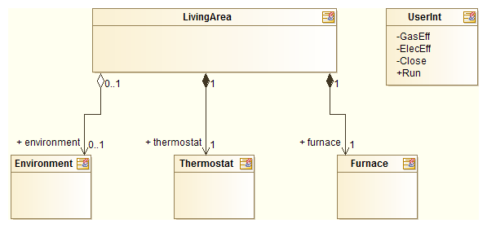

Figure-1 : Overview

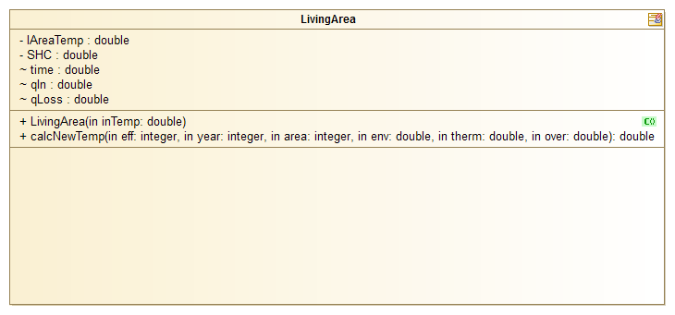

Figure-2 : Living Area Details

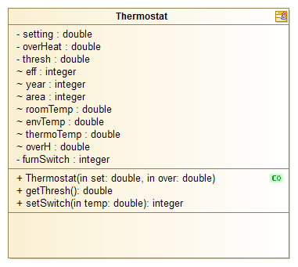

Figure-3 : Thermostat Details

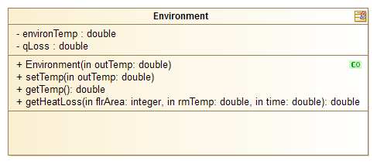

Figure-4 : Environment Details

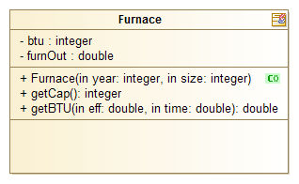

Figure-5 : Furnace Details

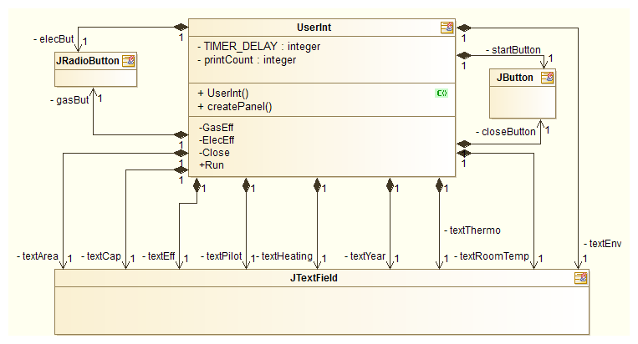

Figure-6 : UserInt Details

***Variation 1:***

Gas Furnace: Capacity = 50000 Efficiency = 90 Pilot = on Heating = false

Room: Year built = 2000 Temperature = 22.0 Area(sq. ft.) = 2000 SHC = 4.0 BLC = 1.0

Environment Temperature = 10.0 Thermostat: Desired Temperature = 22.0 OverHeat setting = 2.0

Simulation: Frequency = 5 Runtime = 7200

300 22.22 10.0 ON

600 22.65 10.0 ON

900 23.26 10.0 ON

1200 24.03 10.0 OFF

1500 22.57 10.0 OFF

1800 23.81 10.0 ON

2100 25.08 10.0 OFF

2400 22.57 10.0 OFF

2700 24.43 10.0 OFF

3000 21.42 10.0 ON

3300 23.96 10.0 ON

3600 26.10 10.0 OFF

3900 21.74 10.0 ON

4200 24.88 10.0 OFF

4500 20.23 10.0 ON

4800 24.32 10.0 OFF

5100 19.25 10.0 ON

5400 24.22 10.0 OFF

5700 18.59 10.0 ON

6000 24.39 10.0 OFF

6300 18.09 10.0 ON

6600 24.70 10.0 OFF

6900 17.65 10.0 ON

7200 25.08 10.0 OFF

***Variation 2:***

Gas Furnace: Capacity = 80000 Efficiency = 92 Pilot = on Heating = false

Room: Year built = 1900 Temperature = 20.0 Area(sq. ft.) = 3000 SHC = 4.0 BLC = 1.0

Environment Temperature = 5.0 Thermostat: Desired Temperature = 20.0 OverHeat setting = 3.0

Simulation: Frequency = 5 Runtime = 7200

300 20.20 5.0 ON

600 20.59 5.0 ON

900 21.15 5.0 ON

1200 21.85 5.0 ON

1500 22.65 5.0 ON

1800 23.51 5.0 OFF

2100 20.81 5.0 OFF

2400 22.26 5.0 ON

2700 23.63 5.0 OFF

3000 19.75 5.0 ON

3300 21.99 5.0 ON

3600 23.87 5.0 OFF

3900 18.76 5.0 ON

4200 21.90 5.0 ON

4500 24.29 5.0 OFF

4800 17.86 5.0 ON

5100 21.99 5.0 ON

5400 24.82 5.0 OFF

5700 16.98 5.0 ON

6000 22.21 5.0 ON

6300 25.41 5.0 OFF

6600 16.06 5.0 ON

6900 22.51 5.0 ON

7200 26.02 5.0 OFF

***Variation 3:***

Gas Furnace: Capacity = 55000 Efficiency = 90 Pilot = on Heating = false

Room: Year built = 1980 Temperature = 25.0 Area(sq. ft.) = 1500SHC = 4.0/tBLC = 1.0

Environment Temperature = 12.0 Thermostat: Desired Temperature = 25.0 OverHeat setting = 1.0

Simulation: Frequency = 5 Runtime = 7200

300 25.42 12.0 ON

600 26.23 12.0 OFF

900 25.34 12.0 OFF

1200 26.98 12.0 OFF

1500 25.42 12.0 OFF

1800 27.87 12.0 OFF

2100 25.55 12.0 OFF

2400 28.79 12.0 OFF

2700 25.65 12.0 OFF

3000 29.68 12.0 OFF

3300 25.63 12.0 OFF

3600 30.47 12.0 OFF

3900 25.47 12.0 OFF

4200 31.16 12.0 OFF

4500 25.18 12.0 OFF

4800 31.78 12.0 OFF

5100 24.78 12.0 ON

5400 32.36 12.0 OFF

5700 24.30 12.0 ON

6000 32.93 12.0 OFF

6300 23.77 12.0 ON

6600 33.50 12.0 OFF

6900 23.20 12.0 ON

7200 34.10 12.0 OFF