Raspberry Pi Pico W Generic Keyboard Controller

This document will describe how to make a USB and Bluetooth controller for a generic laptop keyboard with 26 or less FPC pins using a Raspberry Pi Pico W. There are pads to solder either a 1.0mm, 0.8mm, or 0.5mm pitch FPC connector. This is an ongoing project that has not been built or tested yet. I’m providing my design information to help others and perhaps they can help me too (especially with the software). All associated files are at my Github repository.

The Pico 26 pin keyboard controller board is shown below as depicted by OSHPark.

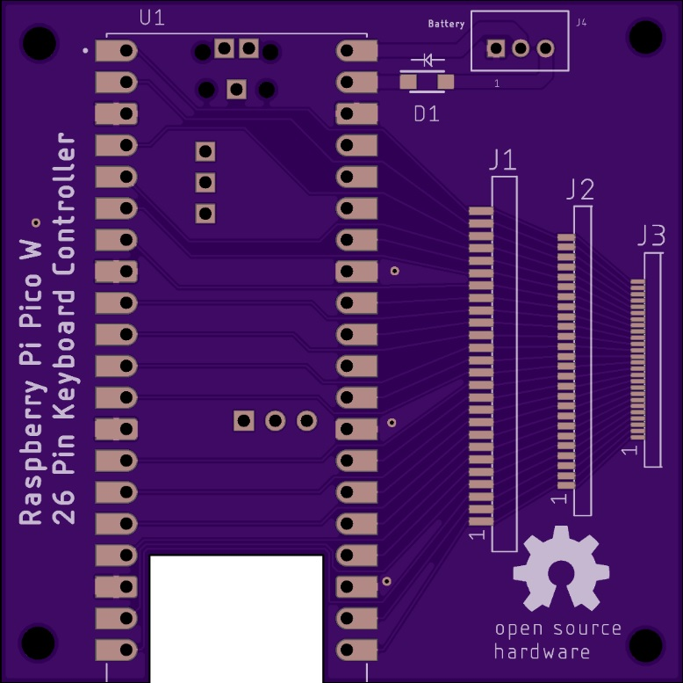

The cutout in the board gives better reception for the Bluetooth antenna on the Pico. The Pico can be mounted with header pins or soldered directly to the board for a lower profile.

The “Pico_26Pin_Keyboard.brd” Eagle file and “Pico_26Pin_Keyboard.zip” Gerber file at my repo can be fabricated by OSH Park or other fab houses like JLCPCB. The Eagle layout (without area fill) is shown below.

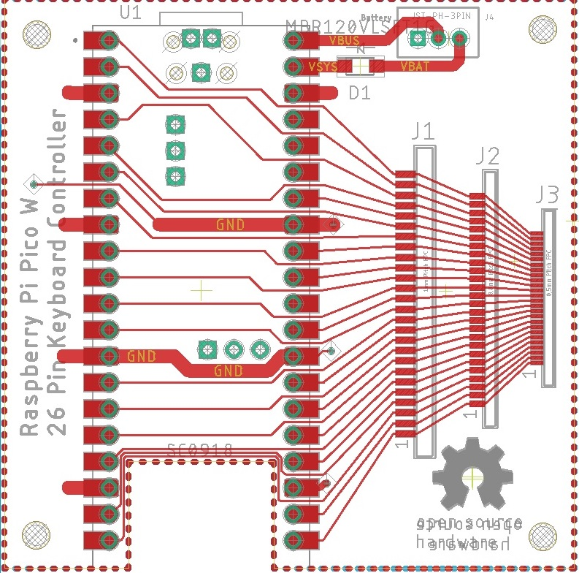

The circuit board measures 55mm x 55mm (2.17” x 2.17”).

Bluetooth operation implies the controller will be running from a separate [lithium battery](https://www.adafruit.com/product/258) with a [charging circuit](https://www.adafruit.com/product/259#technical-details). USB 5 volts on the Pico VBUS pin is routed to pin 2 on J4 which is a 3 pin JST connector. This should be cabled (along with ground) to an off board battery charger circuit. The nominal 3.7 volt battery output should be cabled to the JST connector J4 pin 3. This feeds an [MBR120VLSFT1G](https://www.mouser.com/ProductDetail/onsemi/MBR120VLSFT1G?qs=3JMERSakebpX%252BkItPpFCkg%3D%3D) Schottky diode that “or-ties” the battery voltage to the Pico’s VSYS pin. There is another Schottky diode in the Pico that brings USB power to VSYS when the USB cable is attached.

The Eagle schematic “Pico_26Pin_Keyboard.sch” at my repo is shown below.

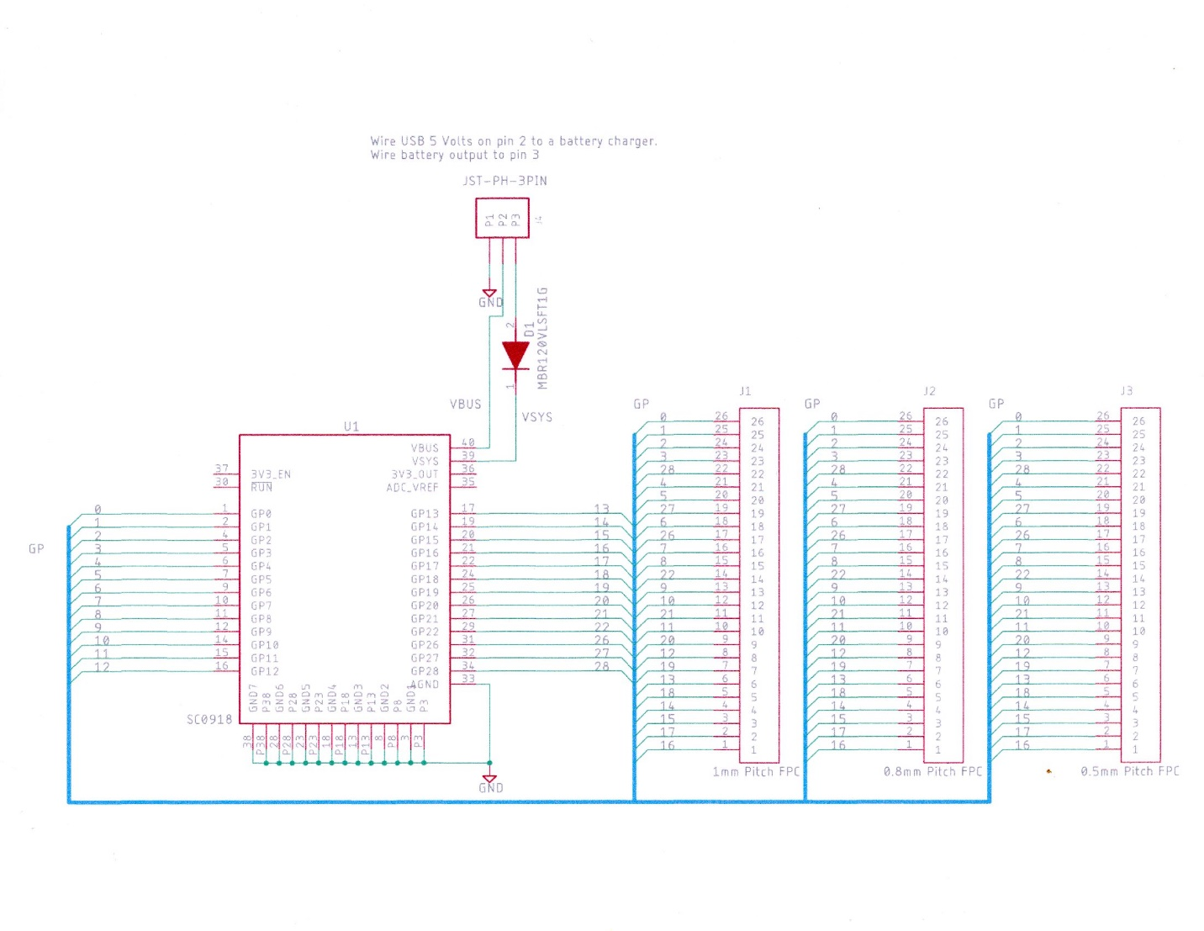

If the keyboard will only be used for USB, it will always have power. The Schottky diode and the 3 pin JST connector are not needed.

The keyboard connections to the Pico GP I/O are shown below.

|  |  |
| --- | --- |
| FPC Connector  pin number | Pico GP I/O number |
| 1 | 16 |
| 2 | 17 |
| 3 | 15 |
| 4 | 14 |
| 5 | 18 |
| 6 | 13 |
| 7 | 19 |
| 8 | 12 |
| 9 | 20 |
| 10 | 11 |
| 11 | 21 |
| 12 | 10 |
| 13 | 9 |
| 14 | 22 |
| 15 | 8 |
| 16 | 7 |
| 17 | 26 |
| 18 | 6 |
| 19 | 27 |
| 20 | 5 |
| 21 | 4 |
| 22 | 28 |
| 23 | 3 |
| 24 | 2 |
| 25 | 1 |
| 26 | 0 |