Raspberry Pi Pico W Keyboard Controller

This document will describe how to make a USB and Bluetooth controller for the Thinkpad T61 keyboard shown below using a Raspberry Pi Pico W. This is an ongoing project that has not been built or tested yet. I’m providing my design information to help others and perhaps they can help me too (especially with the software). All associated files are at my Github repository.

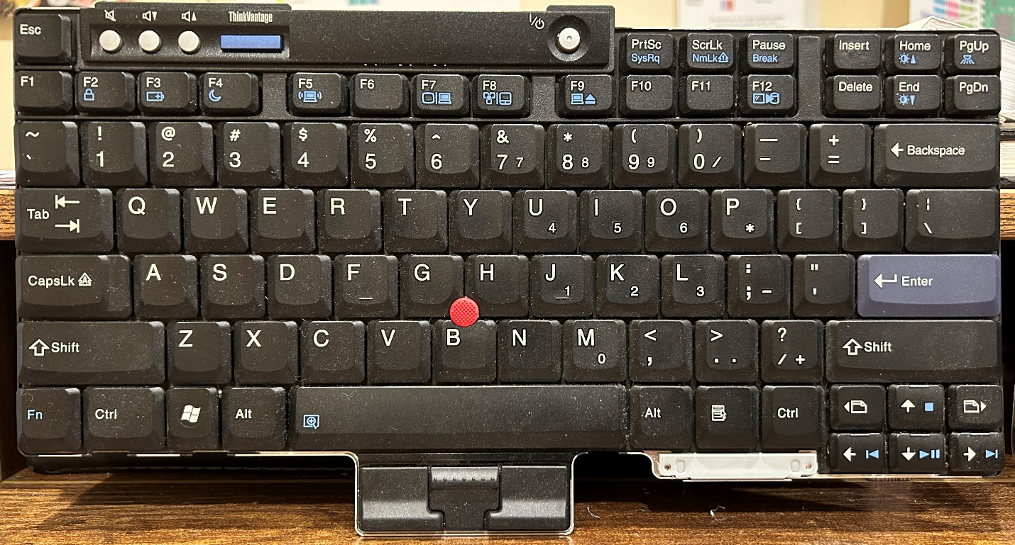

Lenovo T60, T61, T400, T500 laptops and their variants have a 44 pin connector soldered to the end of their keyboard’s FPC cable. The 4 corner pins are not used and the Thinkpad motherboard has a 40 pin mating connector, part number AA01B-S040 available at [AliExpress](https://www.aliexpress.us/item/2251832744037829.html?spm=a2g0o.order_list.order_list_main.5.7c4c1802MsdpBk&gatewayAdapt=glo2usa). The following pages document the circuit board I designed that connects a Pi Pico W (with or without header pins) to the 40 pin keyboard connector.

The Pico T61 keyboard controller board is shown below as depicted by OSHPark.

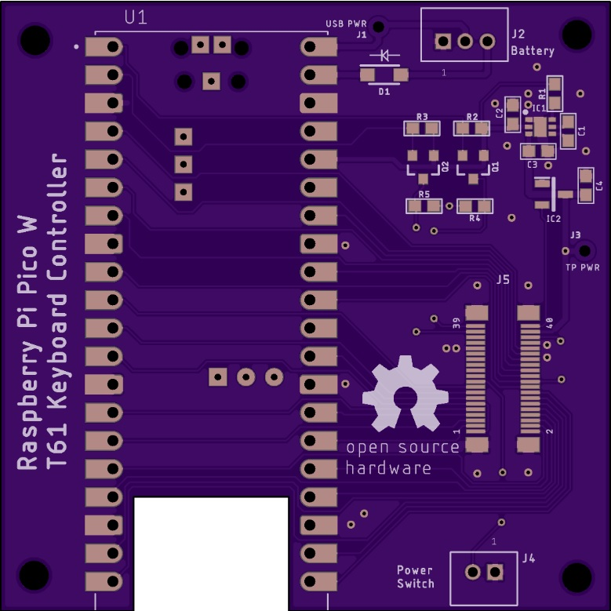

The cutout in the board gives better reception for the Bluetooth antenna on the Pico. The Pico can be mounted with header pins or soldered directly to the board for a lower profile.

The “Pico_T61_Keyboard.brd” Eagle file and “Pico_T61_Keyboard.zip” Gerber file at my repo can be fabricated by OSH Park or other fab houses like JLCPCB. The Eagle layout (without area fill) is shown below.

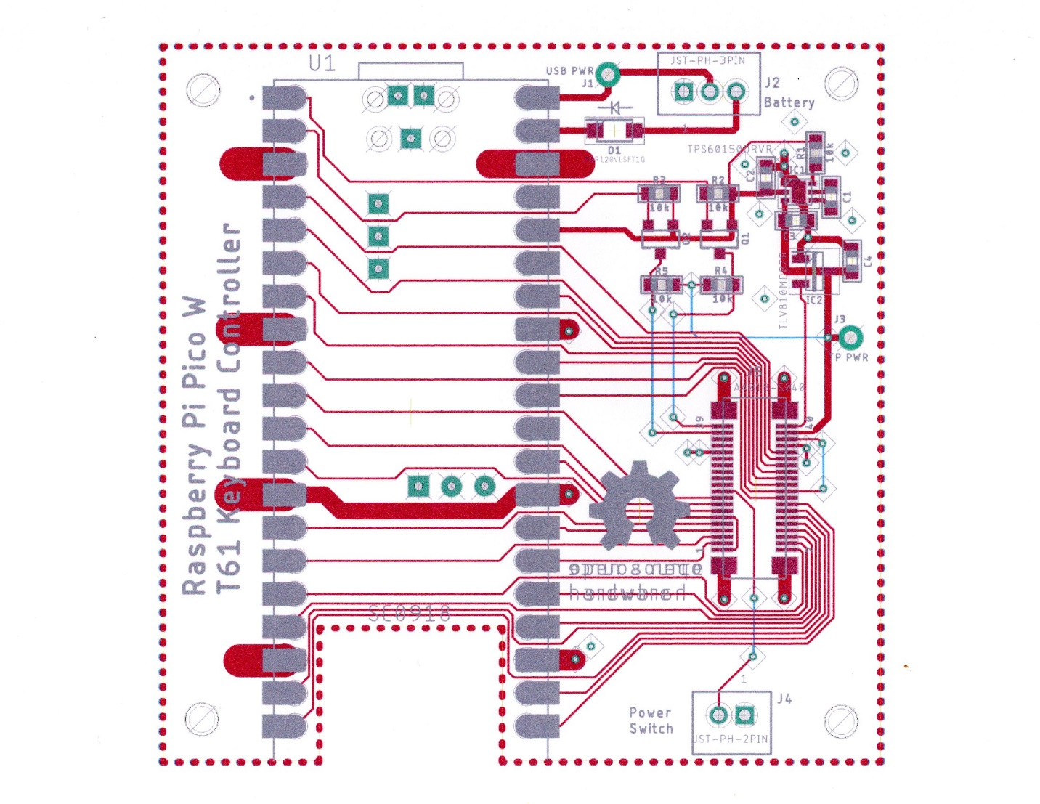

The trackpoint circuitry in the keyboard is powered with 5 volts. The Pico GP I/O’s are not 5 volt tolerant so there are level translators for the trackpoint Clock and Data signals.

Bluetooth operation implies the controller will be running from a separate lithium battery with a charging circuit. USB 5 volts on the Pico VBUS pin is routed to the 3 pin JST connector for an off board battery charger circuit. The nominal 3.7 volt battery output should be connected to VBAT on the 3 pin JST connector. A Schottky diode “or-ties” the battery voltage to the Pico’s VSYS pin. There is another Schottky diode in the Pico that brings USB power to VSYS when the USB cable is attached.

A TPS60150 switched capacitor charge pump boosts the 3.3 volts from the Pico up to 5 volts to power the trackpoint. The trackpoint reset signal can be created with a resistor and capacitor but to be more robust, I’ve included a TLV810 reset generator.

If the keyboard will only be used for USB, solder a jumper wire from J1 to J3. This provides USB 5 volts to the trackpoint. Do not install the charge pump or its associated components. Do not install the Schottky diode or 3 pin JST connector (these are for battery operation).

The Eagle schematic “Pico_T61_Keyboard.sch” at my repo is shown below.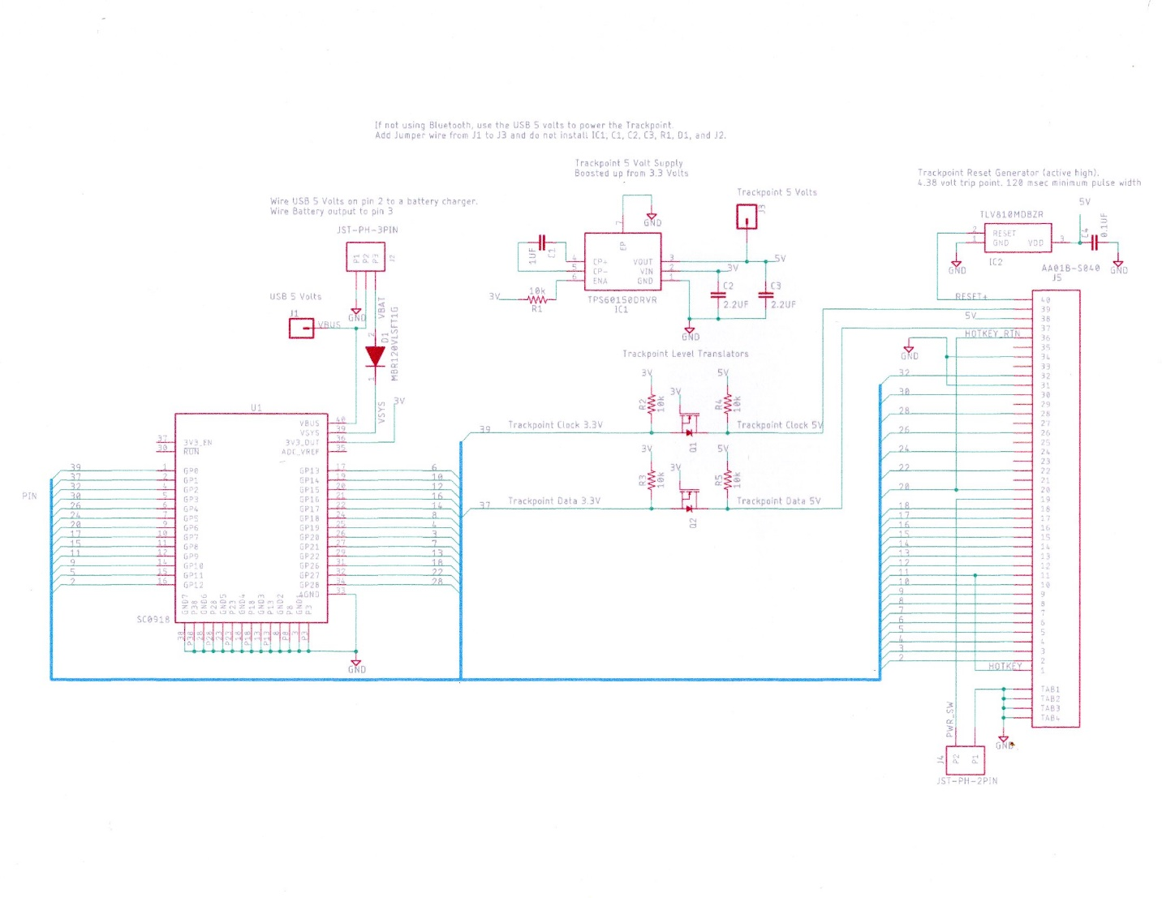

The 2 pin JST connector at J4 is provided so the “Power” button on the keyboard can be wired to an off board power latch circuit.

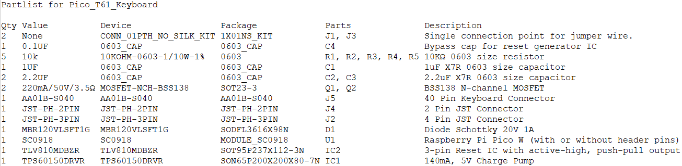

The keyboard connections to the Pico GP I/O and other devices are shown below.

|  |  |  |  |
| --- | --- | --- | --- |
| Lenovo ThinkPad T61 FPC Connector | Pico GP I/O number | Notes | T61 Schematic Signal Name |
| 1 | 9 | Added to key matrix | HOTKEY |
| 2 | 12 |  | DRV<4> |
| 3 | 20 |  | SENSE<5> |
| 4 | 19 |  | DRV<5> |
| 5 | 11 |  | SENSE<0> |
| 6 | 13 |  | DRV<8> |
| 7 | 21 |  | SENSE<3> |
| 8 | 18 |  | DRV<6> |
| 9 | 10 |  | SENSE<2> |
| 10 | 14 |  | DRV<3> |
| 11 | 9 |  | SENSE<4> |
| 12 | 15 |  | DRV<7> |
| 13 | 22 |  | SENSE<1> |
| 14 | 17 |  | DRV<2> |
| 15 | 8 |  | SENSE<6> |
| 16 | 16 |  | DRV<10> |
| 17 | 7 |  | SENSE<7> |
| 18 | 26 |  | DRV<1> |
| 19 |  | PWR SW – J4 Pin 2 | PWR SW |
| 20 | 6 |  | DRV<9> |
| 21 | No connect |  | NC |
| 22 | 27 |  | DRV<0> |
| 23 | No connect |  | NC |
| 24 | 5 |  | DRV<11> |
| 25 | No connect |  | KBDID0 |
| 26 | 4 |  | DRV<14> |
| 27 | No connect |  | KBDID1 |
| 28 | 28 |  | DRV<12> |
| 29 | No connect |  | KBDID2 |
| 30 | 3 |  | DRV<15> |
| 31 | Pico GND |  | KBDID RTN |
| 32 | 2 |  | DRV<13> |
| 33 | No connect |  | NC |
| 34 | Pico GND |  | KBDID RTN |
| 35 | No connect |  | NC |
| 36 | 6 | Added to key matrix | HOTKEY RTN |
| 37 | 1 | Level Translated | TP_DATA |
| 38 |  | 5 volts from TPS60150 | TP_5V |
| 39 | 0 | Level Translated | TP_CLK |
| 40 |  | TLV810 Reset Generator | TP_RESET |

The Pico inputs are the Sense<0> thru <7> columns across the top which must be programmed with pullup resistors. The Pico outputs are the Drive<0> thru <15> rows on the side and are either driven low or floated. Floating a pin is done by making it an input.

Matrix for the Lenovo ThinkPad T61 Keyboard

|  |  |  |  |  |  |  |  |  |
| --- | --- | --- | --- | --- | --- | --- | --- | --- |
| **Pico GP I/O Number** | **Sense<0>**  **GP 11** | **Sense<1> GP 22** | **Sense<2> GP 10** | **Sense<3> GP 21** | **Sense<4>**  **GP 9** | **Sense<5> GP 20** | **Sense<6> GP 8** | **Sense<7> GP 7** |
| **Drive<0> GP 27** | Back-Tick | 1 | Q | Tab | A | Esc | Z |  |
| **Drive<1> GP 26** | F1 | 2 | W | Caps-Lock | S |  | X |  |
| **Drive<2> GP 17** | F2 | 3 | E | F3 | D | F4 | C |  |
| **Drive<3> GP 14** | 5 | 4 | R | T | F | G | V | B |
| **Drive<4> GP 12** | 6 | 7 | U | Y | J | H | M | N |
| **Drive<5> GP 19** | Equal | 8 | I | Right-Brace | K | F6 | Comma |  |
| **Drive<6> GP 18** | F8 | 9 | O | F7 | L |  | Period |  |
| **Drive<7> GP 15** | Minus | 0 | P | Left-Brace | Semi-colon | Quote |  | Forward-Slash |
| **Drive<8> GP 13** | F9 | F10 |  | Back-Space | Back-Slash | F5 | Enter | Space |
| **Drive<9> GP 6** | Insert | F12 |  |  | **Fn added here** |  |  | Arrow-Right |
| **Drive<10> GP 16** | Delete | F11 | Volume-Up | Volume-Down | Mute | Think-Vantage |  | Arrow-Down |
| **Drive<11> GP 5** | Page-Up | Page-Down | **GUI** |  | Menu |  | Page-Left | Page-Right |
| **Drive<12> GP 28** | Home | End |  |  |  | Arrow-Up | Pause | Arrow-Left |
| **Drive<13> GP 2** |  | Print-Screen | Scroll-Lock |  |  | **Alt-L** |  | **Alt-R** |
| **Drive<14> GP 4** |  |  |  | **Shift-L** |  |  | **Shift-R** |  |
| **Drive<15> GP 3** | **Cntrl-L** |  |  |  |  |  | **Cntrl_R** |  |

The keyboard will use 24 Pico GP I/O’s and the trackpoint will use 2 GP I/O’s. There are no spare GP I/O’s for the Fn “Hotkey” so it has been wired into the matrix at the location shown above.

The LED on the Pico can be programmed as a CAPS LOCK LED.